Debaryomyces Assembly

Validation Report.

Summary:

Sample P1260_1001:

Sample P1260_1002:

Sample P1260_1003:

Sample P1260_1004:

Sample P1260_1005:

Sample P1260_1006:

Sample P1260_1007:

Sample P1260_1008:

Sample P1260_1009:

Sample P1260_1010:

Sample P1260_1011:

Sample P1260_1012:

Sample P1260_1013:

Sample P1260_1014:

Sample P1260_1015:

Sample P1260_1016:

Sample P1260_1017:

Sample P1260_1018:

Sample P1260_1019:

Details:

Sample P1260_1001:

Methodology:

Assembly Quality Assessment - Quast:

Assembly Quality Assessment - Compass:

Assembly Quality Assessment - KAT:

Assembly Quality Assessment - FRCBAM:

Assembly Quality Assessment - CEGMA:

Assembly Quality Assessment - BUSCO:

Assembly Quality Assessment - Blobology:

Assembly Quality Assessment - Kraken:

Sample P1260_1002:

Assembly Quality Assessment - Quast:

Assembly Quality Assessment - Compass:

Assembly Quality Assessment - KAT:

Assembly Quality Assessment - FRCBAM:

Assembly Quality Assessment - CEGMA:

Assembly Quality Assessment - BUSCO:

Assembly Quality Assessment - Blobology:

Assembly Quality Assessment - Kraken:

Sample P1260_1003:

Assembly Quality Assessment - Quast:

Assembly Quality Assessment - Compass:

Assembly Quality Assessment - KAT:

Assembly Quality Assessment - FRCBAM:

Assembly Quality Assessment - CEGMA:

Assembly Quality Assessment - BUSCO:

Assembly Quality Assessment - Blobology:

Assembly Quality Assessment - Kraken:

Sample P1260_1004:

Assembly Quality Assessment - Quast:

Assembly Quality Assessment - Compass:

Assembly Quality Assessment - KAT:

Assembly Quality Assessment - FRCBAM:

Assembly Quality Assessment - CEGMA:

Assembly Quality Assessment - BUSCO:

Assembly Quality Assessment - Blobology:

Assembly Quality Assessment - Kraken:

Sample P1260_1005:

Assembly Quality Assessment - Quast:

Assembly Quality Assessment - Compass:

Assembly Quality Assessment - KAT:

Assembly Quality Assessment - FRCBAM:

Assembly Quality Assessment - CEGMA:

Assembly Quality Assessment - BUSCO:

Assembly Quality Assessment - Blobology:

Assembly Quality Assessment - Kraken:

Sample P1260_1006:

Assembly Quality Assessment - Quast:

Assembly Quality Assessment - Compass:

Assembly Quality Assessment - KAT:

Assembly Quality Assessment - FRCBAM:

Assembly Quality Assessment - CEGMA:

Assembly Quality Assessment - BUSCO:

Assembly Quality Assessment - Blobology:

Assembly Quality Assessment - Kraken:

Sample P1260_1007:

Assembly Quality Assessment - Quast:

Assembly Quality Assessment - Compass:

Assembly Quality Assessment - KAT:

Assembly Quality Assessment - FRCBAM:

Assembly Quality Assessment - CEGMA:

Assembly Quality Assessment - BUSCO:

Assembly Quality Assessment - Blobology:

Assembly Quality Assessment - Kraken:

Sample P1260_1008:

Assembly Quality Assessment - Quast:

Assembly Quality Assessment - Compass:

Assembly Quality Assessment - KAT:

Assembly Quality Assessment - FRCBAM:

Assembly Quality Assessment - CEGMA:

Assembly Quality Assessment - BUSCO:

Assembly Quality Assessment - Blobology:

Assembly Quality Assessment - Kraken:

Sample P1260_1009:

Assembly Quality Assessment - Quast:

Assembly Quality Assessment - Compass:

Assembly Quality Assessment - KAT:

Assembly Quality Assessment - FRCBAM:

Assembly Quality Assessment - CEGMA:

Assembly Quality Assessment - BUSCO:

Assembly Quality Assessment - Blobology:

Assembly Quality Assessment - Kraken:

Sample P1260_1010:

Assembly Quality Assessment - Quast:

Assembly Quality Assessment - Compass:

Assembly Quality Assessment - KAT:

Assembly Quality Assessment - FRCBAM:

Assembly Quality Assessment - CEGMA:

Assembly Quality Assessment - BUSCO:

Assembly Quality Assessment - Blobology:

Assembly Quality Assessment - Kraken:

Sample P1260_1011:

Assembly Quality Assessment - Quast:

Assembly Quality Assessment - Compass:

Assembly Quality Assessment - KAT:

Assembly Quality Assessment - FRCBAM:

Assembly Quality Assessment - CEGMA:

Assembly Quality Assessment - BUSCO:

Assembly Quality Assessment - Blobology:

Assembly Quality Assessment - Kraken:

Sample P1260_1012:

Assembly Quality Assessment - Quast:

Assembly Quality Assessment - Compass:

Assembly Quality Assessment - KAT:

Assembly Quality Assessment - FRCBAM:

Assembly Quality Assessment - CEGMA:

Assembly Quality Assessment - BUSCO:

Assembly Quality Assessment - Blobology:

Assembly Quality Assessment - Kraken:

Sample P1260_1013:

Assembly Quality Assessment - Quast:

Assembly Quality Assessment - Compass:

Assembly Quality Assessment - KAT:

Assembly Quality Assessment - FRCBAM:

Assembly Quality Assessment - CEGMA:

Assembly Quality Assessment - BUSCO:

Assembly Quality Assessment - Blobology:

Assembly Quality Assessment - Kraken:

Sample P1260_1014:

Assembly Quality Assessment - Quast:

Assembly Quality Assessment - Compass:

Assembly Quality Assessment - KAT:

Assembly Quality Assessment - FRCBAM:

Assembly Quality Assessment - CEGMA:

Assembly Quality Assessment - BUSCO:

Assembly Quality Assessment - Blobology:

Assembly Quality Assessment - Kraken:

Sample P1260_1015:

Assembly Quality Assessment - Quast:

Assembly Quality Assessment - Compass:

Assembly Quality Assessment - KAT:

Assembly Quality Assessment - FRCBAM:

Assembly Quality Assessment - CEGMA:

Assembly Quality Assessment - BUSCO:

Assembly Quality Assessment - Blobology:

Assembly Quality Assessment - Kraken:

Sample P1260_1016:

Assembly Quality Assessment - Quast:

Assembly Quality Assessment - Compass:

Assembly Quality Assessment - KAT:

Assembly Quality Assessment - FRCBAM:

Assembly Quality Assessment - CEGMA:

Assembly Quality Assessment - BUSCO:

Assembly Quality Assessment - Blobology:

Assembly Quality Assessment - Kraken:

Sample P1260_1017:

Assembly Quality Assessment - Quast:

Assembly Quality Assessment - Compass:

Assembly Quality Assessment - KAT:

Assembly Quality Assessment - FRCBAM:

Assembly Quality Assessment - CEGMA:

Assembly Quality Assessment - BUSCO:

Assembly Quality Assessment - Blobology:

Assembly Quality Assessment - Kraken:

Sample P1260_1018:

Assembly Quality Assessment - Quast:

Assembly Quality Assessment - Compass:

Assembly Quality Assessment - KAT:

Assembly Quality Assessment - FRCBAM:

Assembly Quality Assessment - CEGMA:

Assembly Quality Assessment - BUSCO:

Assembly Quality Assessment - Blobology:

Assembly Quality Assessment - Kraken:

Sample P1260_1019:

Assembly Quality Assessment - Quast:

Assembly Quality Assessment - Compass:

Assembly Quality Assessment - KAT:

Assembly Quality Assessment - FRCBAM:

Assembly Quality Assessment - CEGMA:

Assembly Quality Assessment - BUSCO:

Assembly Quality Assessment - Blobology:

Assembly Quality Assessment - Kraken:

# 

# 

# Summary:

## Sample P1260_1001:

Spades followed by MaSuRCA gives the best assembly measured by comparing Cumulative length and Nx in Quast.

Compass shows that although the assembly is similar in size to the reference, a good portion does not align well, indicating contamination or a very large degree of divergence. The proportion of differing contigs is not clear due to the potential of multiple assembly contigs aligning to the same place on the reference.

KAT copy number plots indicate that all the covered data in the genome is present in the Spades and MaSuRCA assemblies. The MaSuRCA assembly is slightly over assembled.

The CEGMA report of the Spades assembly shows 96% completeness.

Blobology indicates that while most contigs are likely Debaryomyces, bacteria may also be present. The blob plot shows a cluster of similar GC content contigs but with lower coverage that potentially indicates contamination. Contamination assessment is a difficult task, and should be interpreted as indicative rather than truth.

## Sample P1260_1002:

Spades followed by MaSuRCA gives the best assembly measured by comparing Cumulative length and Nx in Quast.

Compass shows that the assembly is similar in size to the reference and aligns well.

KAT copy number plots indicate that all the covered data in the genome is present in the Spades and MaSuRCA assemblies. The MaSuRCA assembly is slightly over assembled.

The CEGMA report of the Spades assembly shows 95% completeness.

Blobology indicates that most contigs are likely Debaryomyces, very little contamination may also be present. The blob plot shows some low coverage unannotated contigs that potentially indicates contamination. Contamination assessment is a difficult task, and should be interpreted as indicative rather than truth.

## Sample P1260_1003:

Spades followed by MaSuRCA gives the best assembly measured by comparing Cumulative length and Nx in Quast.

Compass shows that although the assembly is similar in size to the reference, a large portion does not align well, indicating contamination or a very large degree of divergence. The proportion of differing contigs is not clear due to the potential of multiple assembly contigs aligning to the same place on the reference.

KAT copy number plots indicate that all the covered data in the genome is present in the Spades and MaSuRCA assemblies. The MaSuRCA assembly is slightly over assembled.

The CEGMA report of the Spades assembly shows 96% completeness.

Blobology indicates that while most contigs are likely Debaryomyces, bacteria may also be present. The blob plot shows a cluster of similar GC content contigs but with lower coverage that potentially indicates contamination. Contamination assessment is a difficult task, and should be interpreted as indicative rather than truth.

## Sample P1260_1004:

MaSuRCA followed by spades gives the best assembly measured by comparing Cumulative length and Nx in Quast.

Compass shows that the assembly is greater in size to the reference, and aligns to a good degree to the reference. The portion that does not align well indicates contamination or a very large degree of divergence. The proportion of differing contigs is not clear due to the potential of multiple assembly contigs aligning to the same place on the reference.

KAT copy number plots indicate incomplete assemblies with much of the covered sequence present in the data absent in the assemblies. Some portions are also over assembled.

The CEGMA report of the MaSuRCA assembly shows 93% completeness.

Blobology indicates that while most contigs are likely Debaryomyces, bacteria may also be present. Contamination assessment is a difficult task, and should be interpreted as indicative rather than truth.

## Sample P1260_1005:

Spades followed by MaSuRCA gives the best assembly measured by comparing Cumulative length and Nx in Quast.

Compass shows that although the assembly is similar in size to the reference, a small portion does not align well, indicating contamination or a very large degree of divergence. The proportion of differing contigs is not clear due to the potential of multiple assembly contigs aligning to the same place on the reference.

The CEGMA report of the Spades assembly shows 95% completeness.

Blobology indicates that while most contigs are likely Debaryomyces, bacteria may also be present. The blob plot shows a cluster of similar GC content contigs but with lower coverage that potentially indicates contamination. Contamination assessment is a difficult task, and should be interpreted as indicative rather than truth.

## Sample P1260_1006:

Spades followed by MaSuRCA gives the best assembly measured by comparing Cumulative length and Nx in Quast.

Compass shows that although the assembly is similar in size to the reference, a largel portion does not align well, indicating contamination or a very large degree of divergence. The proportion of differing contigs is not clear due to the potential of multiple assembly contigs aligning to the same place on the reference.

The CEGMA report of the Spades assembly shows 95% completeness.

Blobology indicates that while most contigs are likely Debaryomyces, bacteria may also be present. The blob plot shows a cluster of similar GC content contigs but with lower coverage that potentially indicates contamination. Contamination assessment is a difficult task, and should be interpreted as indicative rather than truth.

## Sample P1260_1007:

Spades followed by MaSuRCA gives the best assembly measured by comparing Cumulative length and Nx in Quast.

Compass shows that although the assembly is similar in size to the reference, a small portion does not align well, indicating contamination or a very large degree of divergence. The proportion of differing contigs is not clear due to the potential of multiple assembly contigs aligning to the same place on the reference.

The CEGMA report of the Spades assembly shows 94% completeness.

Blobology indicates that while most contigs are likely Debaryomyces, bacteria may also be present. The blob plot shows a cluster of similar GC content contigs but with lower coverage that potentially indicates contamination. Contamination assessment is a difficult task, and should be interpreted as indicative rather than truth.

## Sample P1260_1008:

Spades followed by MaSuRCA gives the best assembly measured by comparing Cumulative length and Nx in Quast.

Compass shows that although the assembly is similar in size to the reference, a small portion does not align well, indicating contamination or a very large degree of divergence. The proportion of differing contigs is not clear due to the potential of multiple assembly contigs aligning to the same place on the reference.

The CEGMA report of the Spades assembly shows 95% completeness.

Blobology indicates that while most contigs are likely Debaryomyces, bacteria may also be present. The blob plot shows a cluster of similar GC content contigs but with lower coverage that potentially indicates contamination. Contamination assessment is a difficult task, and should be interpreted as indicative rather than truth.

## Sample P1260_1009:

MaSuRCA followed by Soap de novo (k=49) gives the best assembly measured by comparing Cumulative length and Nx in Quast.

Compass shows that the assembly is greater in size to the reference, and aligns to a good degree to the reference. The portion that does not align well indicates contamination or a very large degree of divergence. The proportion of differing contigs is not clear due to the potential of multiple assembly contigs aligning to the same place on the reference.

The CEGMA report of the MaSuRCA assembly shows 96% completeness.

Blobology indicates that most contigs are likely Debaryomyces. Contamination assessment is a difficult task, and should be interpreted as indicative rather than truth.

## Sample P1260_1010:

Spades followed by MaSuRCA gives the best assembly measured by comparing Cumulative length and Nx in Quast.

Compass shows that although the assembly is similar in size to the reference, a large portion does not align well, indicating contamination or a very large degree of divergence. The proportion of differing contigs is not clear due to the potential of multiple assembly contigs aligning to the same place on the reference.

The CEGMA report of the Spades assembly shows 96% completeness.

Blobology indicates that while most contigs are likely Debaryomyces, bacteria and virus may also be present. The blob plot shows a cluster of similar GC content contigs with similar coverage that potentially indicates contamination. Contamination assessment is a difficult task, and should be interpreted as indicative rather than truth.

## Sample P1260_1011:

MaSuRCA followed by Soap de novo (k=43 & 37) gives the best assembly measured by comparing Cumulative length and Nx in Quast.

Compass shows that the assembly is greater in size to the reference, and aligns to a good degree to the reference. The portion that does not align well indicates contamination or a very large degree of divergence. The proportion of differing contigs is not clear due to the potential of multiple assembly contigs aligning to the same place on the reference.

The CEGMA report of the MaSuRCA assembly shows 96% completeness.

Blobology indicates that most contigs are likely Debaryomyces. The increased density could indicate multiple strains. Contamination assessment is a difficult task, and should be interpreted as indicative rather than truth.

## Sample P1260_1012:

Spades followed by MaSuRCA gives the best assembly measured by comparing Cumulative length and Nx in Quast.

Compass shows that although the assembly is similar in size to the reference, a large portion does not align well, indicating contamination or a very large degree of divergence. The proportion of differing contigs is not clear due to the potential of multiple assembly contigs aligning to the same place on the reference.

The CEGMA report of the Spades assembly shows 95% completeness.

Blobology indicates that while most contigs are likely Debaryomyces, bacteria may also be present. The blob plot shows a cluster of similar GC content contigs with similar coverage that potentially indicates contamination. Contamination assessment is a difficult task, and should be interpreted as indicative rather than truth.

## Sample P1260_1013:

Spades followed by MaSuRCA gives the best assembly measured by comparing Cumulative length and Nx in Quast.

Compass shows that although the assembly is similar in size to the reference, a large portion does not align well, indicating contamination or a very large degree of divergence. The proportion of differing contigs is not clear due to the potential of multiple assembly contigs aligning to the same place on the reference.

The CEGMA report of the Spades assembly shows 94% completeness.

Blobology indicates that while most contigs are likely Debaryomyces, bacteria may also be present. The blob plot shows a cluster of similar GC content contigs but with lower coverage that potentially indicates contamination. Contamination assessment is a difficult task, and should be interpreted as indicative rather than truth.

## Sample P1260_1014:

Spades followed by MaSuRCA gives the best assembly measured by comparing Cumulative length and Nx in Quast.

Compass shows that although the assembly is similar in size to the reference, a large portion does not align well, indicating contamination or a very large degree of divergence. The proportion of differing contigs is not clear due to the potential of multiple assembly contigs aligning to the same place on the reference.

The CEGMA report of the Spades assembly shows 94% completeness.

Blobology indicates that while most contigs are likely Debaryomyces, bacteria may also be present. The blob plot shows a cluster of similar GC content contigs but with lower coverage that potentially indicates contamination. Contamination assessment is a difficult task, and should be interpreted as indicative rather than truth.

## Sample P1260_1015:

Spades followed by MaSuRCA gives the best assembly measured by comparing Cumulative length and Nx in Quast.

Compass shows that although the assembly is similar in size to the reference, a large portion does not align well, indicating contamination or a very large degree of divergence. The proportion of differing contigs is not clear due to the potential of multiple assembly contigs aligning to the same place on the reference.

The CEGMA report of the Spades assembly shows 94% completeness.

Blobology indicates that while most contigs are likely Debaryomyces, bacteria may also be present. The blob plot shows a cluster of similar GC content contigs but with lower coverage that potentially indicates contamination. Contamination assessment is a difficult task, and should be interpreted as indicative rather than truth.

## Sample P1260_1016:

Spades followed by MaSuRCA gives the best assembly measured by comparing Cumulative length and Nx in Quast.

Compass shows that although the assembly is similar in size to the reference, a large portion does not align well, indicating contamination or a very large degree of divergence. The proportion of differing contigs is not clear due to the potential of multiple assembly contigs aligning to the same place on the reference.

The CEGMA report of the Spades assembly shows 96% completeness.

Blobology indicates that while most contigs are likely Debaryomyces, bacteria may also be present. The blob plot shows a cluster of similar GC content contigs but with lower coverage that potentially indicates contamination. Contamination assessment is a difficult task, and should be interpreted as indicative rather than truth.

## Sample P1260_1017:

MaSuRCA followed by Spades gives the best assembly measured by comparing Cumulative length and Nx in Quast.

Compass shows that although the assembly is similar in size to the reference, but it does not align, indicating a different organism, or contamination or a very large degree of divergence. The proportion of differing contigs is not clear due to the potential of multiple assembly contigs aligning to the same place on the reference.

The CEGMA report of the MaSuRCA assembly shows 98% completeness.

Blobology indicates that most contigs are likely Saccharomyces cerevisiae. Contamination assessment is a difficult task, and should be interpreted as indicative rather than truth.

## Sample P1260_1018:

MaSuRCA followed by Spades gives the best assembly measured by comparing Cumulative length and Nx in Quast.

Compass shows that although the assembly is similar in size to the reference, but it does not align, indicating a different organism, or contamination or a very large degree of divergence. The proportion of differing contigs is not clear due to the potential of multiple assembly contigs aligning to the same place on the reference.

The CEGMA report of the MaSuRCA assembly shows 98% completeness.

Blobology indicates that most contigs are likely Saccharomyces cerevisiae. Contamination assessment is a difficult task, and should be interpreted as indicative rather than truth.

## Sample P1260_1019:

Spades followed by MaSuRCA gives the best assembly measured by comparing Cumulative length and Nx in Quast.

Compass shows that the assembly is similar in size to the reference and aligns well.

The CEGMA report of the Spades assembly shows 94% completeness.

Blobology indicates that while most contigs are likely Debaryomyces, bacteria may also be present. The blob plot shows a cluster of similar GC content contigs but with lower coverage that potentially indicates contamination. Contamination assessment is a difficult task, and should be interpreted as indicative rather than truth.

# Details:

## Sample P1260_1001:

### Methodology:

Sequence data was inspected using FastQC (Version), KAT (Version), and Kraken (Version, standard database - bacteria, archaea, viruses). Nextera adapters were detected and removed using Cutadapt (Version).

Filtered reads were then assembled using Soap de novo (Version, k={31, 37, 43, 49, 55, 61, 67, 73, 79}), Abyss (Version, k={31, 37, 43, 49, 55, 61, 67, 73, 79}), Spades (Version), and MaSuRCA (Version). The best assembly was determined using metrics from Quast (Version), Compass (Version), KAT (version), FRCBAM (version), CEGMA (Version), Busco (Version), Blobology (Version), and Kraken (Version, standard database - bacteria, archaea, viruses). The reference used is Debaryomyces Hansenii (version). The results from each tool are presented below.

### Assembly Quality Assessment - Quast:

Spades followed by MaSuRCA gives the best assembly measured by comparing Cumulative length and Nx.

|  |  |
| --- | --- |
| Assembler | **Spades** |
| Number of contigs | 296 |
| Largest contig | 1,037,140 |
| Total assembly length | 12,065,416 |
| N50 | 247,422 |

Spades produced an assembly length of 12,065,416bp, comprised of 296 contigs with an N50 of 247,422bp.

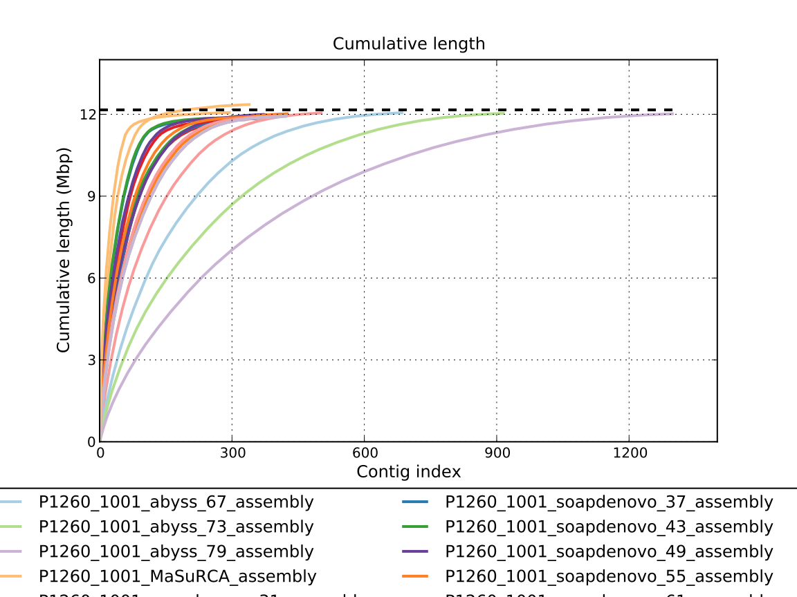

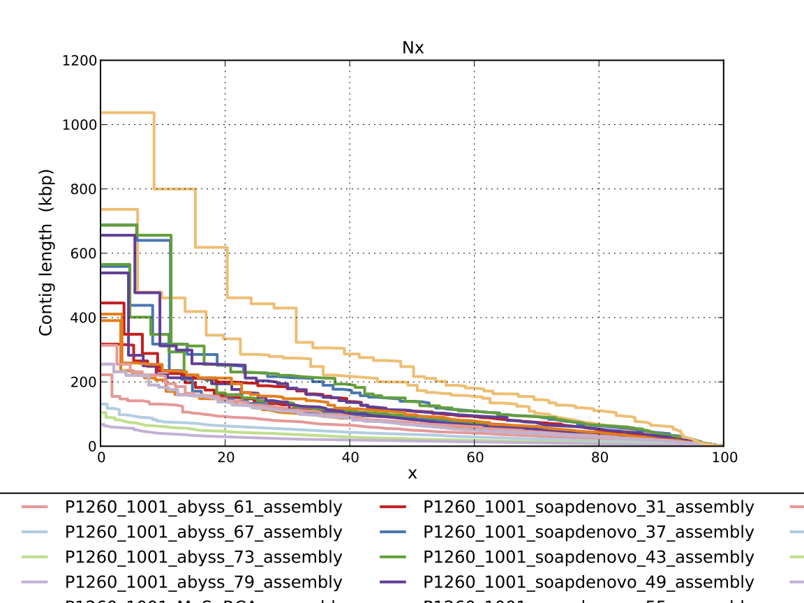

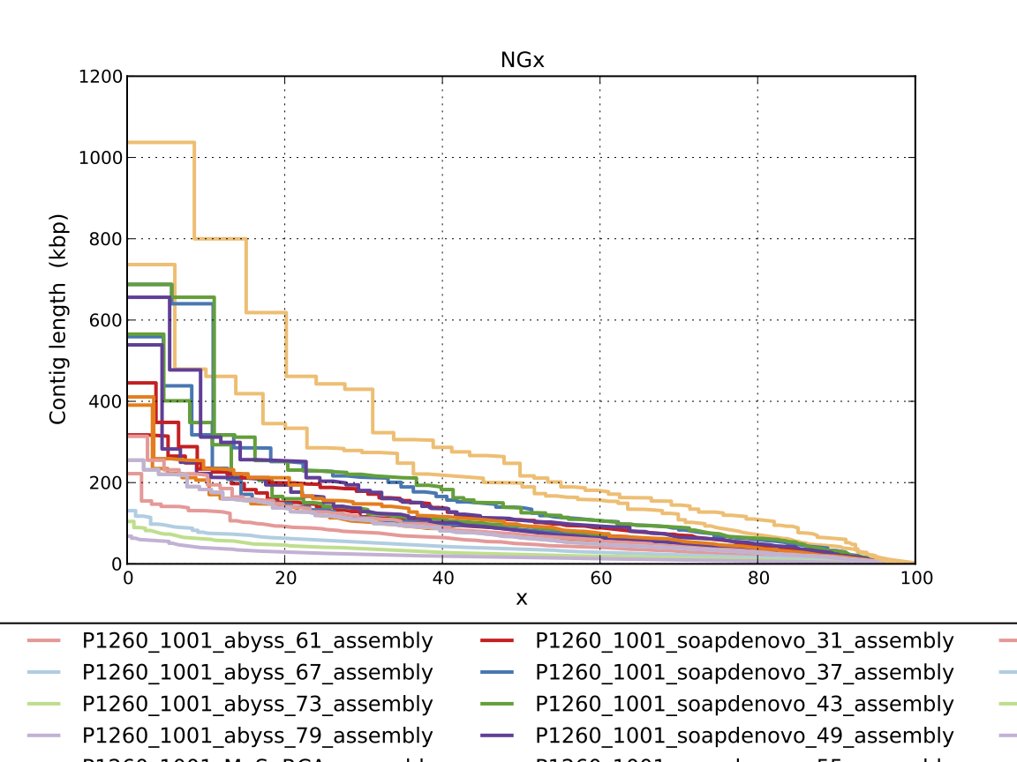

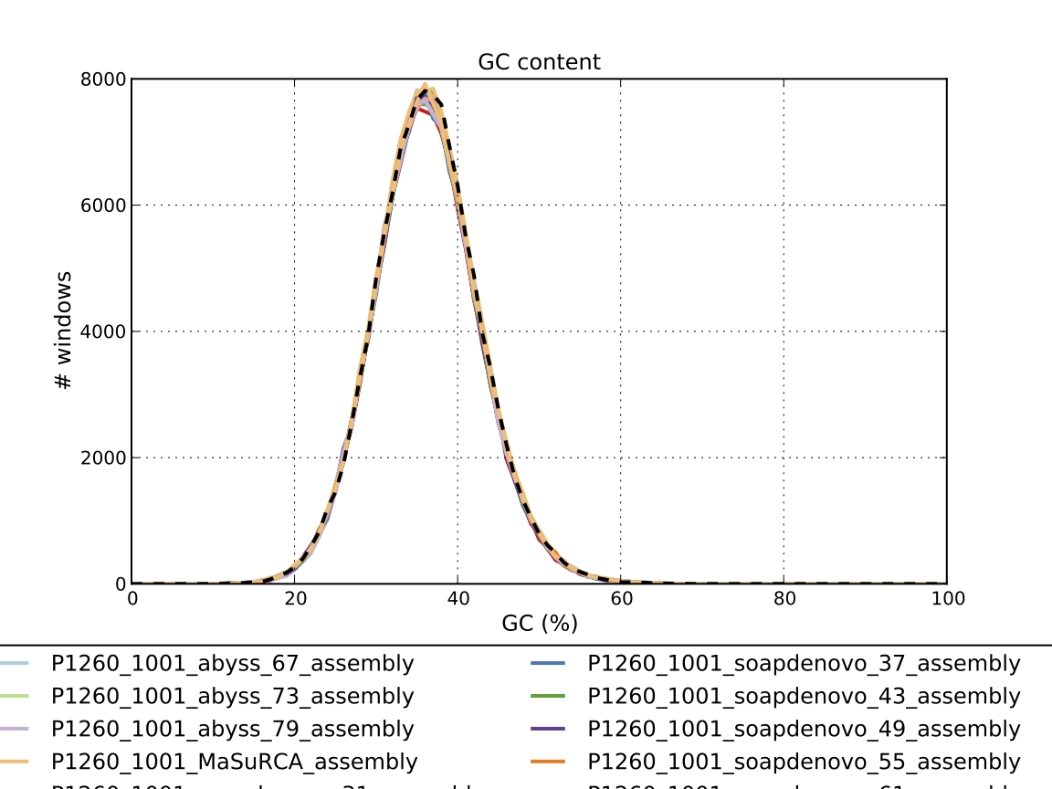

### Assembly Quality Assessment - Compass:

Compass shows that although the assembly is similar in size to the reference, a good portion does not align well, indicating contamination or a very large degree of divergence. The proportion of differing contigs is not clear due to the potential of multiple assembly contigs aligning to the same place on the reference.

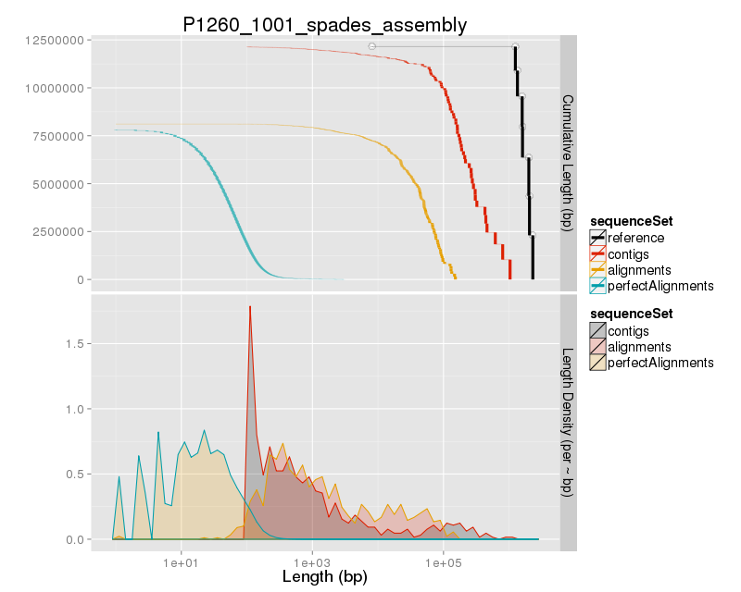

### Assembly Quality Assessment - KAT:

KAT copy number plots indicate that all the covered data in the genome is present in the Spades and MaSuRCA assemblies. The MaSuRCA assembly is slightly over assembled.

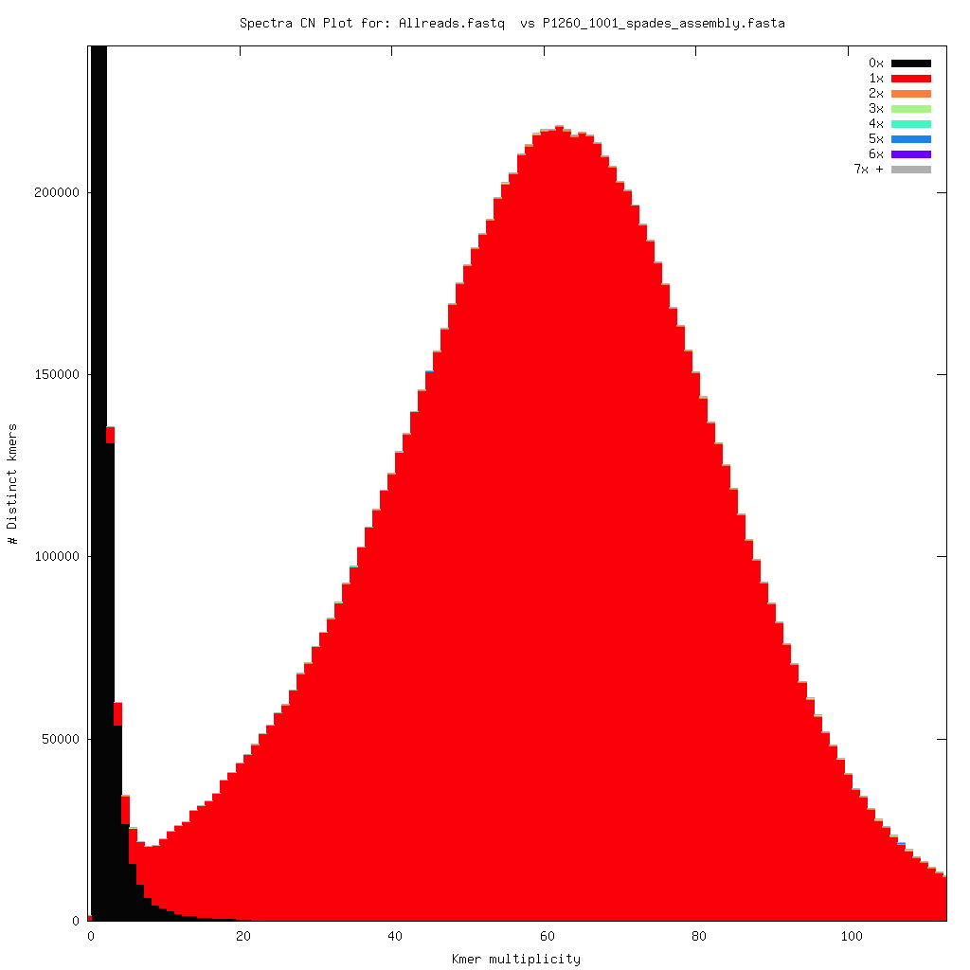

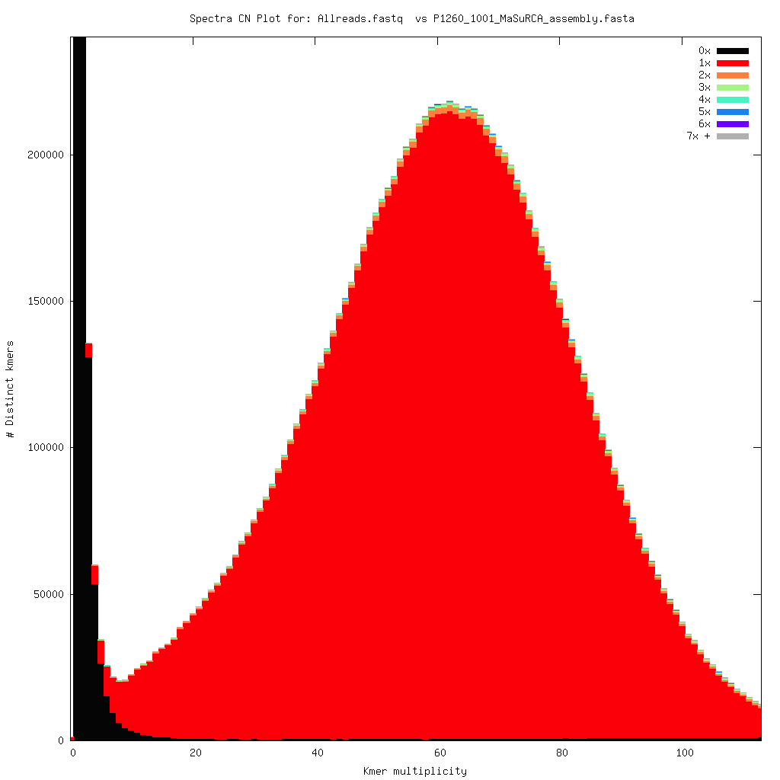

### Assembly Quality Assessment - FRCBAM:

### Assembly Quality Assessment - CEGMA:

CEGMA and BUSCO both attempt to validate the completeness of an assembly by looking at a known gene space, selected to be highly conserved, and present if most, if not all, organisms. CEGMA uses a gene space specifically designed for eukaryotic organisms, while BUSCO can be set for a number of taxonomic groups. Large variation within the completeness between assemblies may indicate that the data was hard to assemble, and thus might run a higher risk of misassembly. BUSCO will also report on duplications of genes, which may indicate chimera in the assembly, and mayneed to be further investigated after annotation.

The CEGMA report of the Spades assembly shows 96% completeness. The CEGMA completeness scores varied between 95.16% (Abyss k=37) to 96.37% (Abyss k=73,79).

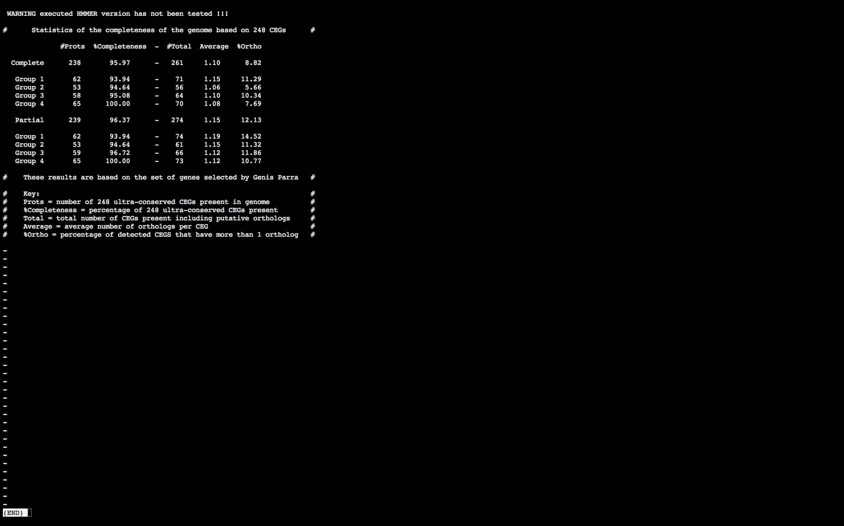

### Assembly Quality Assessment - BUSCO:

The BUSCO report of the Spades assembly shows 96% completeness and 10% duplication. The scores range from 95% (SOAPdenovo k=31) to 97% (Abyss k=31).

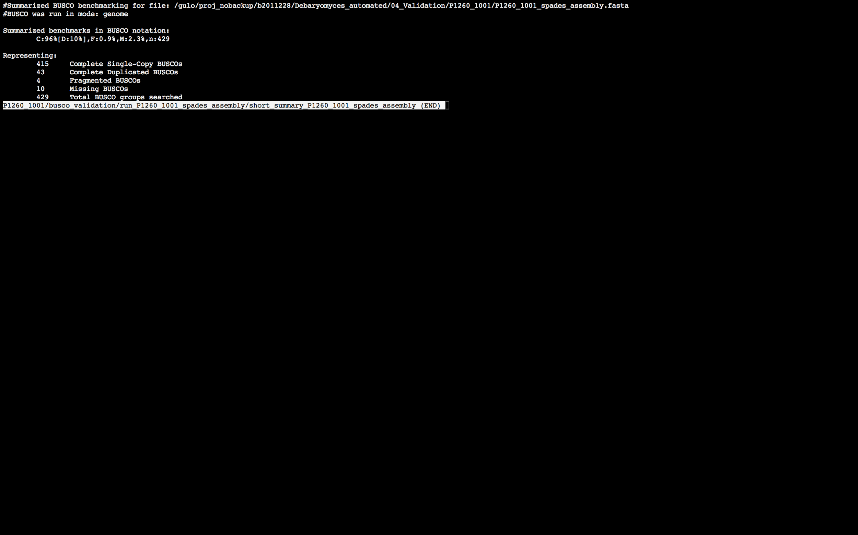

### Assembly Quality Assessment - Blobology:

Blobology indicates that while most contigs are likely Debaryomyces, bacteria may also be present. The blob plot shows a cluster of similar GC content contigs but with lower coverage that potentially indicates contamination. Contamination assessment is a difficult task, and should be interpreted as indicative rather than truth.

|  |  |
| --- | --- |
| # Contigs | Megablast hit |
| 1 | Apteryx australis |
| 409 | Debaryomyces hansenii |
| 1 | Diphyllobothrium latum |
| 4 | Glaciecola nitratireducens |
| 33 | Not annotated |
| 1 | Scheffersomyces stipitis |

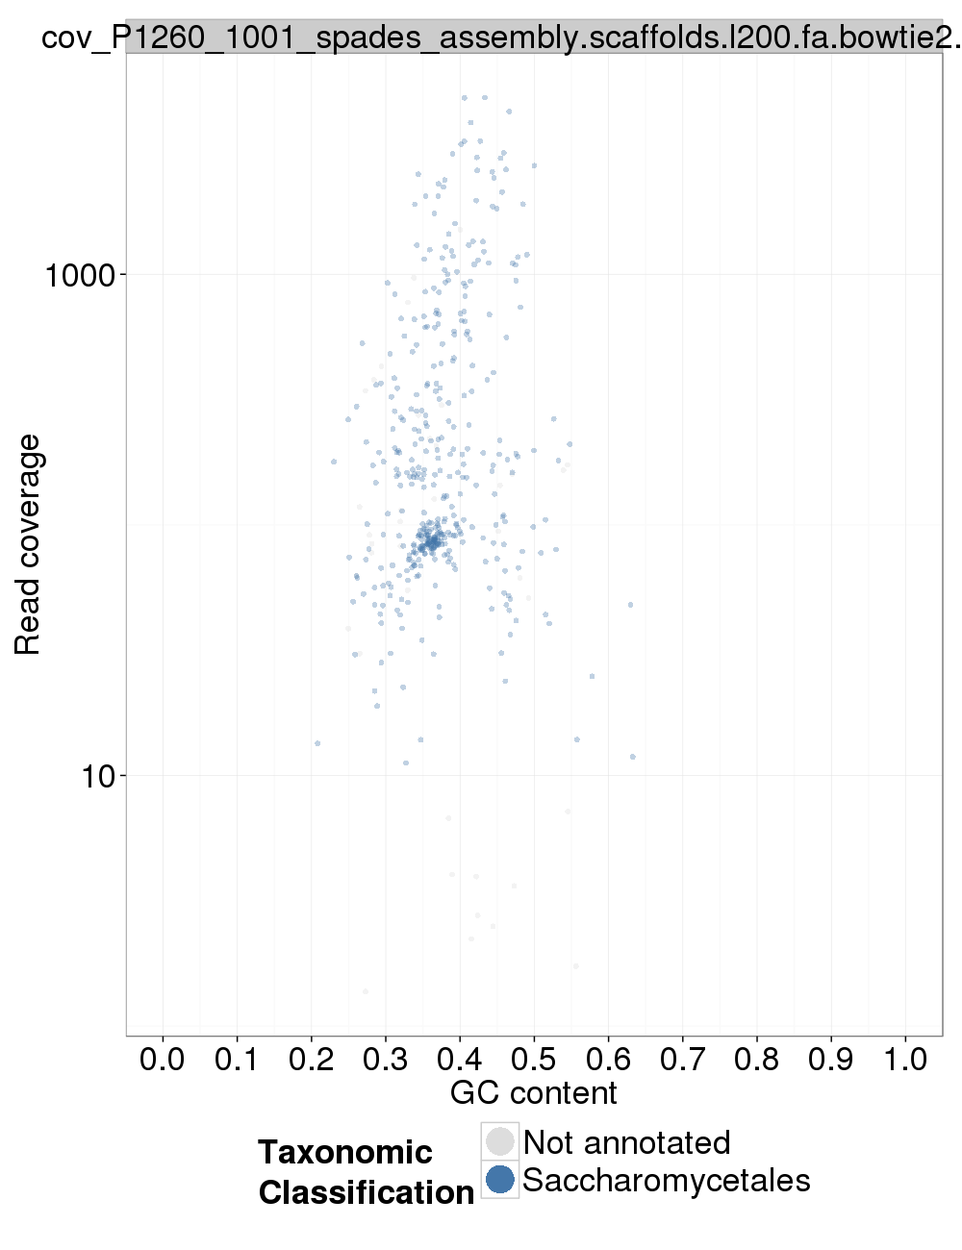

### Assembly Quality Assessment - Kraken:

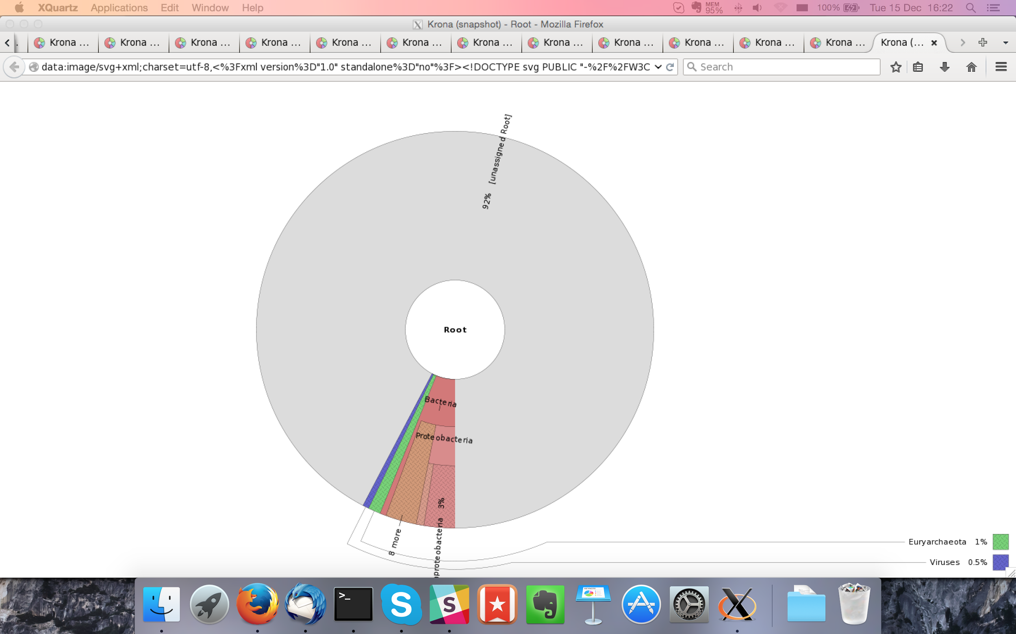

## Sample P1260_1002:

### Assembly Quality Assessment - Quast:

Spades followed by MaSuRCA gives the best assembly measured by comparing Cumulative length and Nx.

|  |  |
| --- | --- |
| Assembler | **Spades** |
| Number of contigs | 302 |
| Largest contig | 677,917 |
| Total assembly length | 12,148,644 |
| N50 | 234,611 |

Spades produced an assembly length of 12,148,644bp, comprised of 302 contigs with an N50 of 234,611bp.

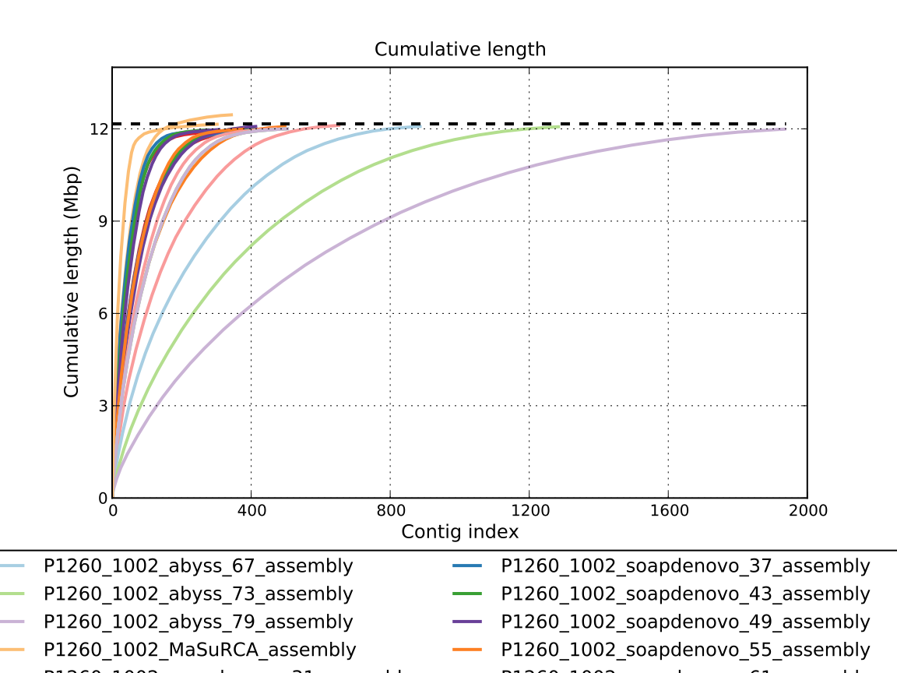

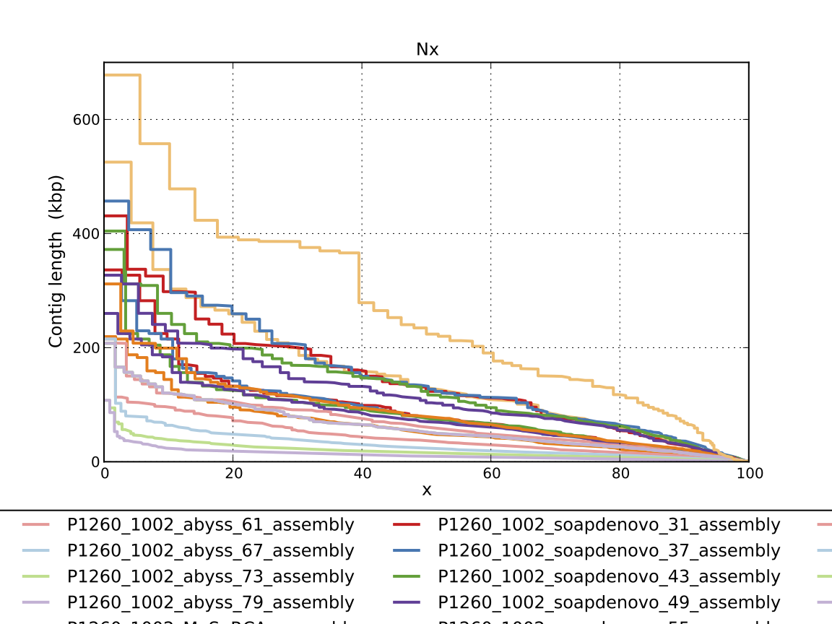

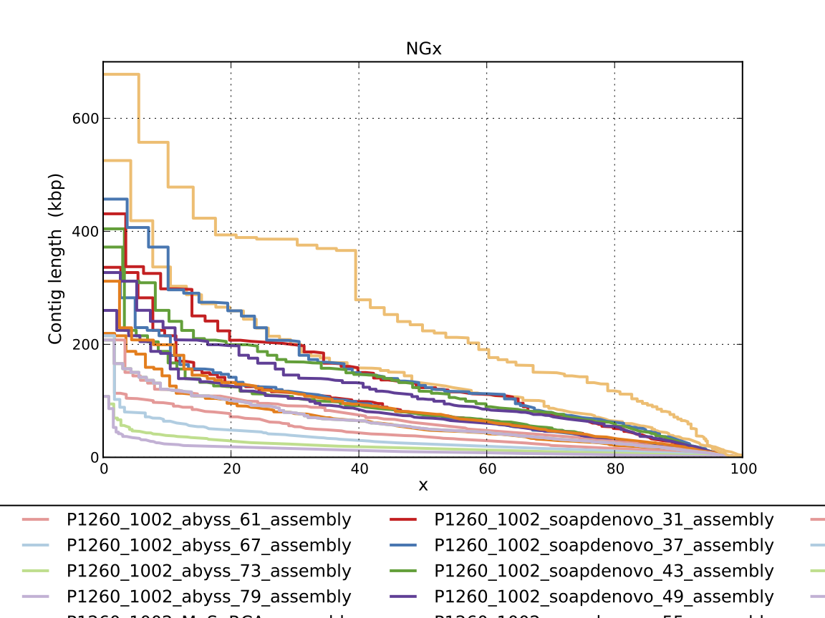

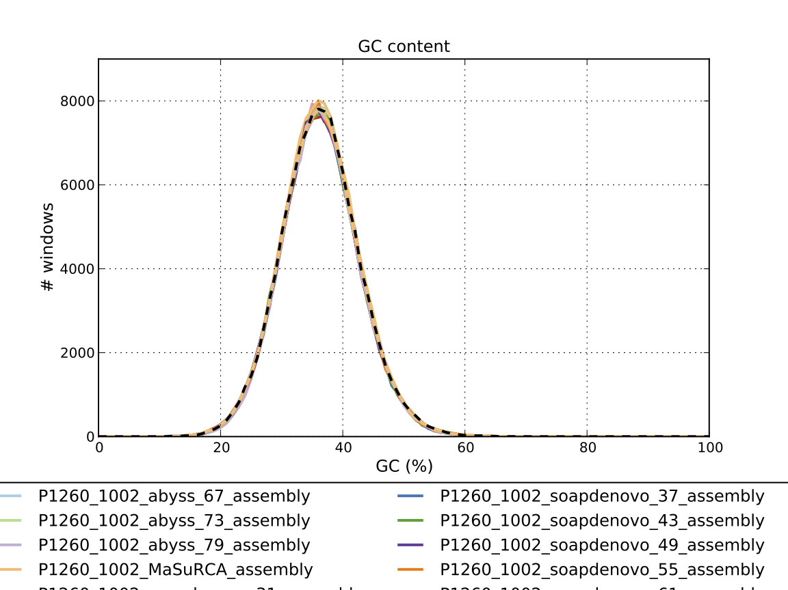

### Assembly Quality Assessment - Compass:

Compass shows that the assembly is similar in size to the reference and aligns well.

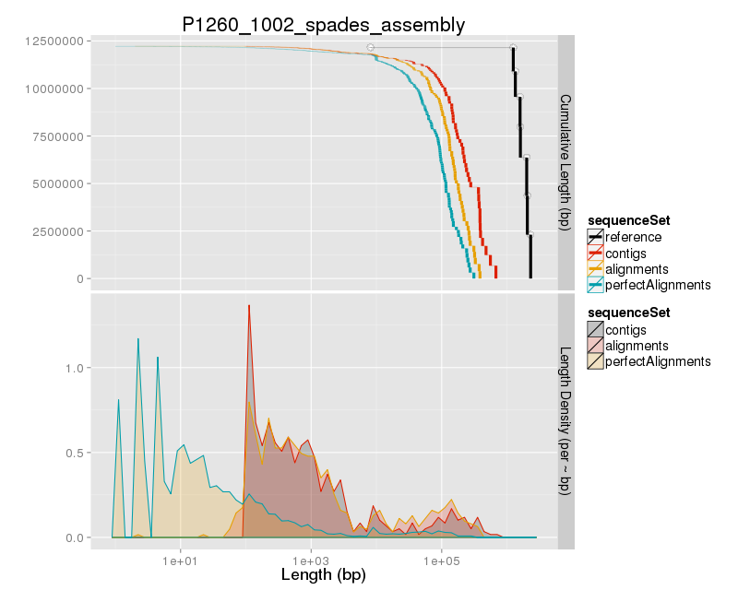

### Assembly Quality Assessment - KAT:

KAT copy number plots indicate that all the covered data in the genome is present in the Spades and MaSuRCA assemblies. The MaSuRCA assembly is slightly over assembled.

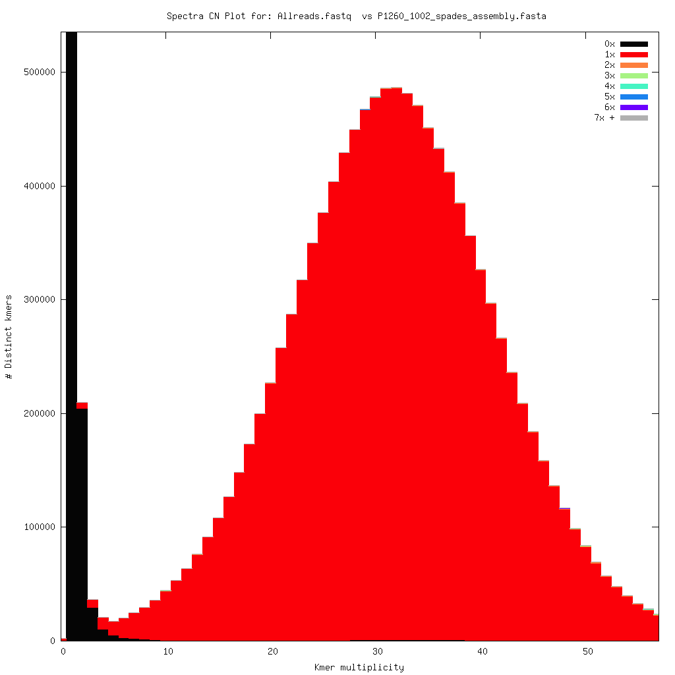

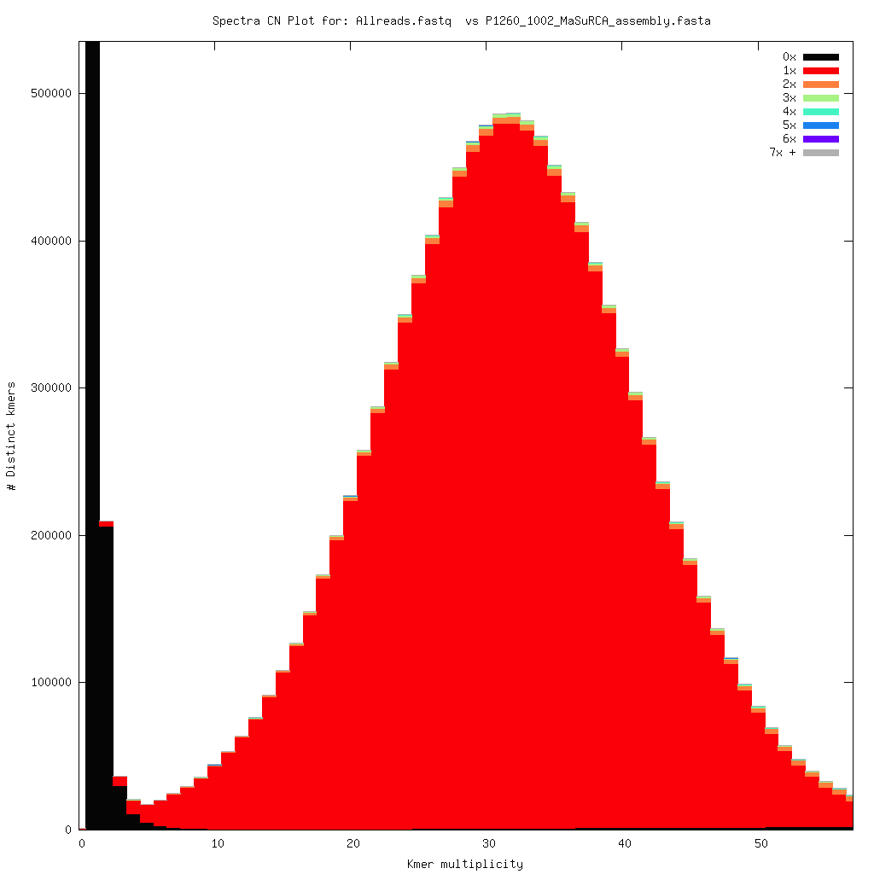

### Assembly Quality Assessment - FRCBAM:

### Assembly Quality Assessment - CEGMA:

CEGMA and BUSCO both attempt to validate the completeness of an assembly by looking at a known gene space, selected to be highly conserved, and present if most, if not all, organisms. CEGMA uses a gene space specifically designed for eukaryotic organisms, while BUSCO can be set for a number of taxonomic groups. Large variation within the completeness between assemblies may indicate that the data was hard to assemble, and thus might run a higher risk of misassembly. BUSCO will also report on duplications of genes, which may indicate chimera in the assembly, and mayneed to be further investigated after annotation.

The CEGMA report of the Spades assembly shows 95% completeness. The CEGMA completeness scores varied between 93.15% (MaSuRCA) to 95.16% (Spades).

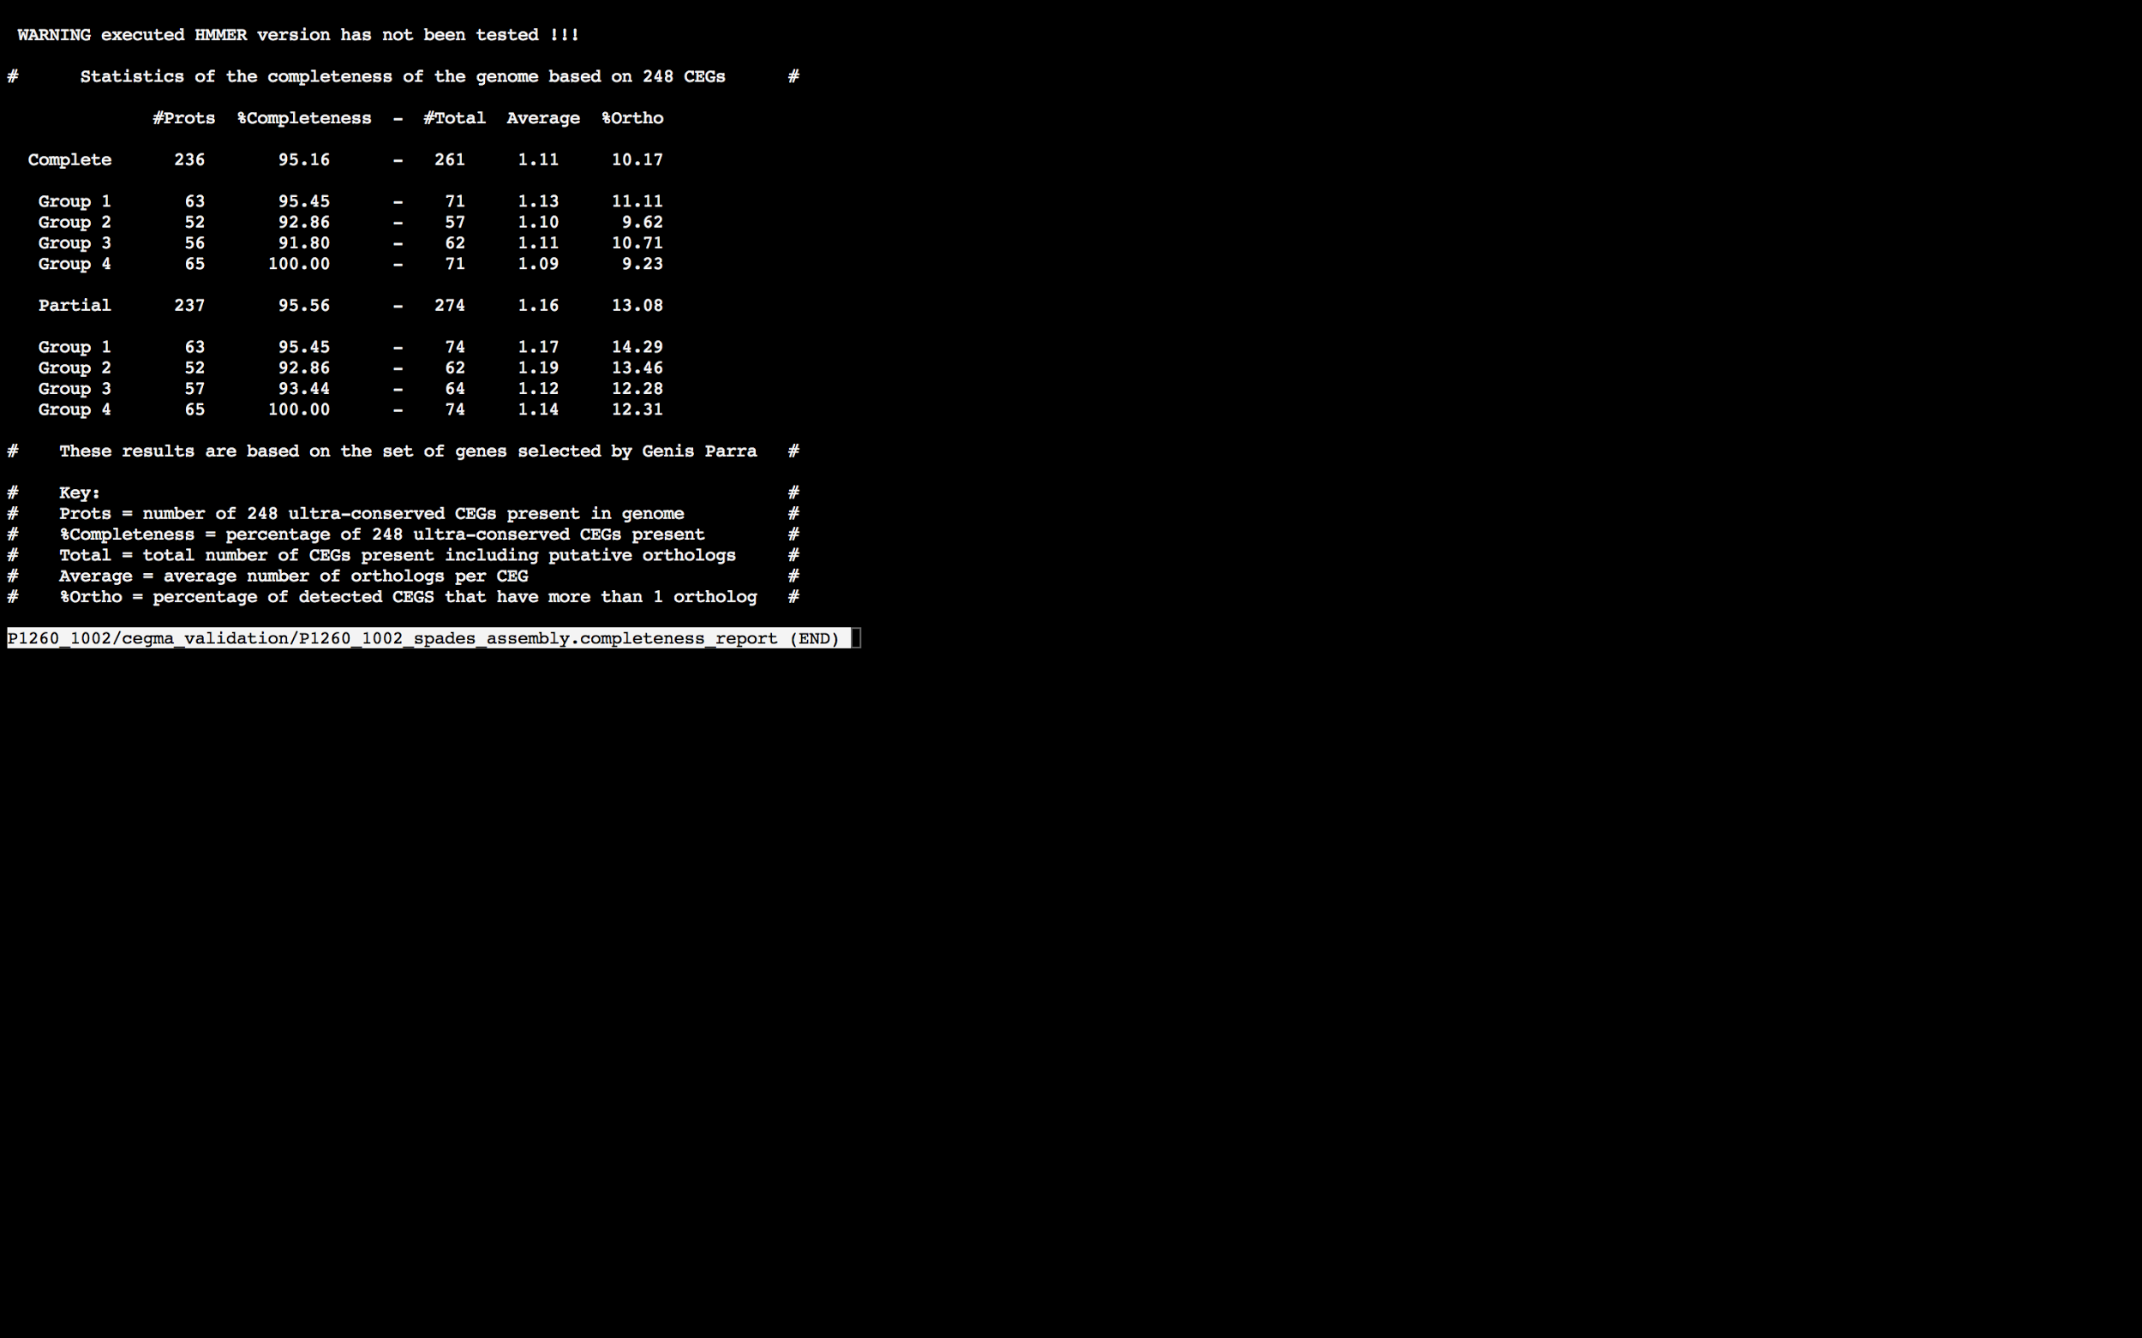

### Assembly Quality Assessment - BUSCO:

The BUSCO report of the Spades assembly shows 97% completeness and 10% duplication. The scores range from 93% (Abyss k=79) to 97% (Abyss k=31,37,43,55,67, SOAPdenovo k=37,55,61,67,73,79, and Spades).

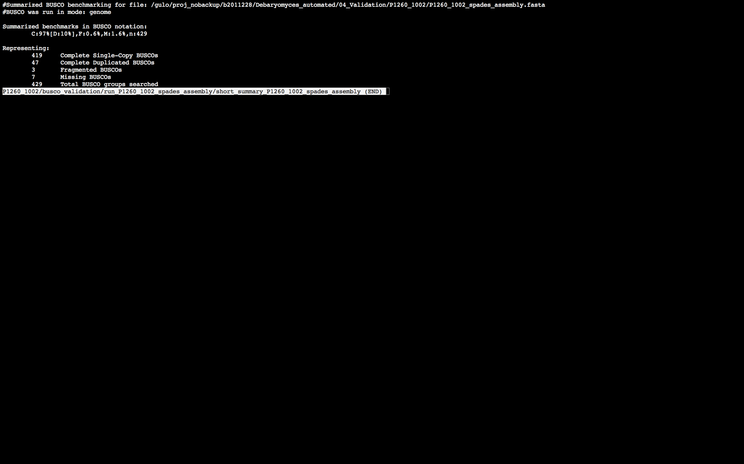

### Assembly Quality Assessment - Blobology:

Blobology indicates that most contigs are likely Debaryomyces, very little contamination may also be present. The blob plot shows some low coverage unannotated contigs that potentially indicates contamination. Contamination assessment is a difficult task, and should be interpreted as indicative rather than truth.

|  |  |
| --- | --- |
| # Contigs | Megablast hit |
| 1 | Apteryx australis |
| 418 | Debaryomyces hansenii |
| 3 | Homo sapiens |
| 15 | Not annotated |
| 1 | Saccharomyces cerevisiae |
| 1 | Scheffersomyces stipitis |

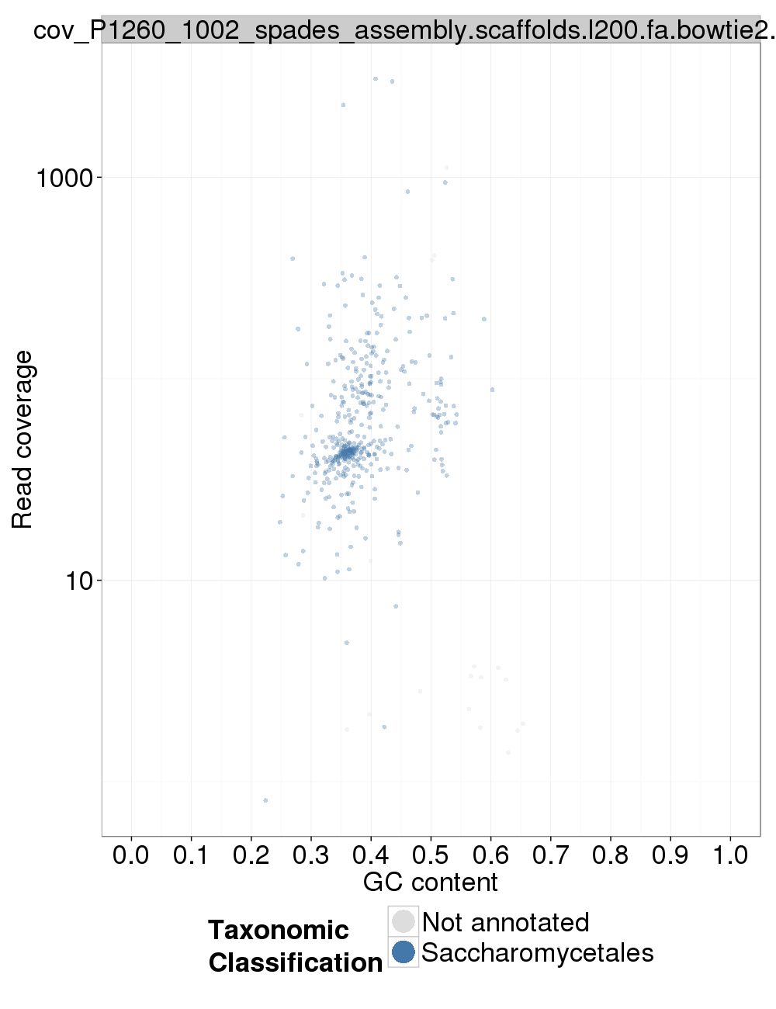

### Assembly Quality Assessment - Kraken:

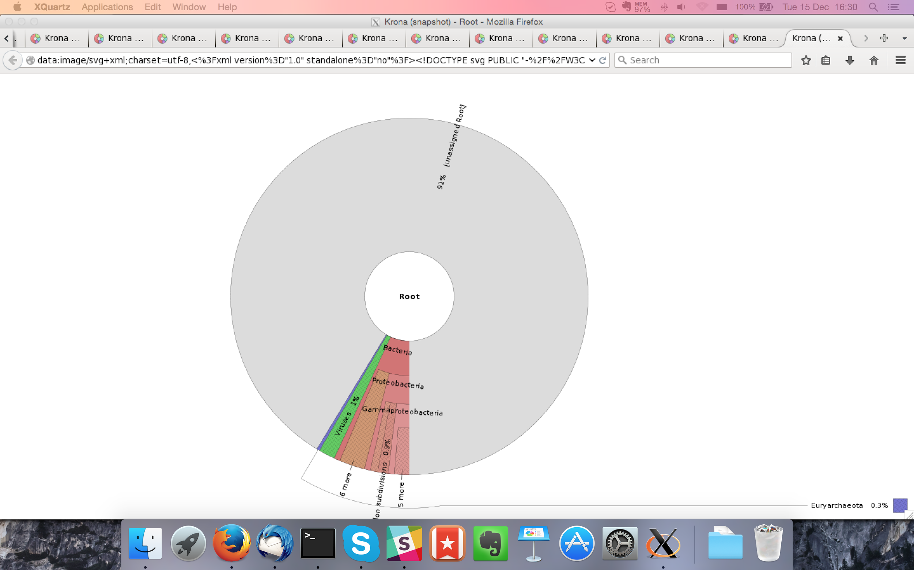

## Sample P1260_1003:

### Assembly Quality Assessment - Quast:

Spades followed by MaSuRCA gives the best assembly measured by comparing Cumulative length and Nx.

|  |  |
| --- | --- |
| Assembler | **Spades** |
| Number of contigs | 253 |
| Largest contig | 929,172 |
| Total assembly length | 11,995,037 |
| N50 | 286,017 |

Spades produced an assembly length of 11,995,037bp, comprised of 253 contigs with an N50 of 286,017bp.

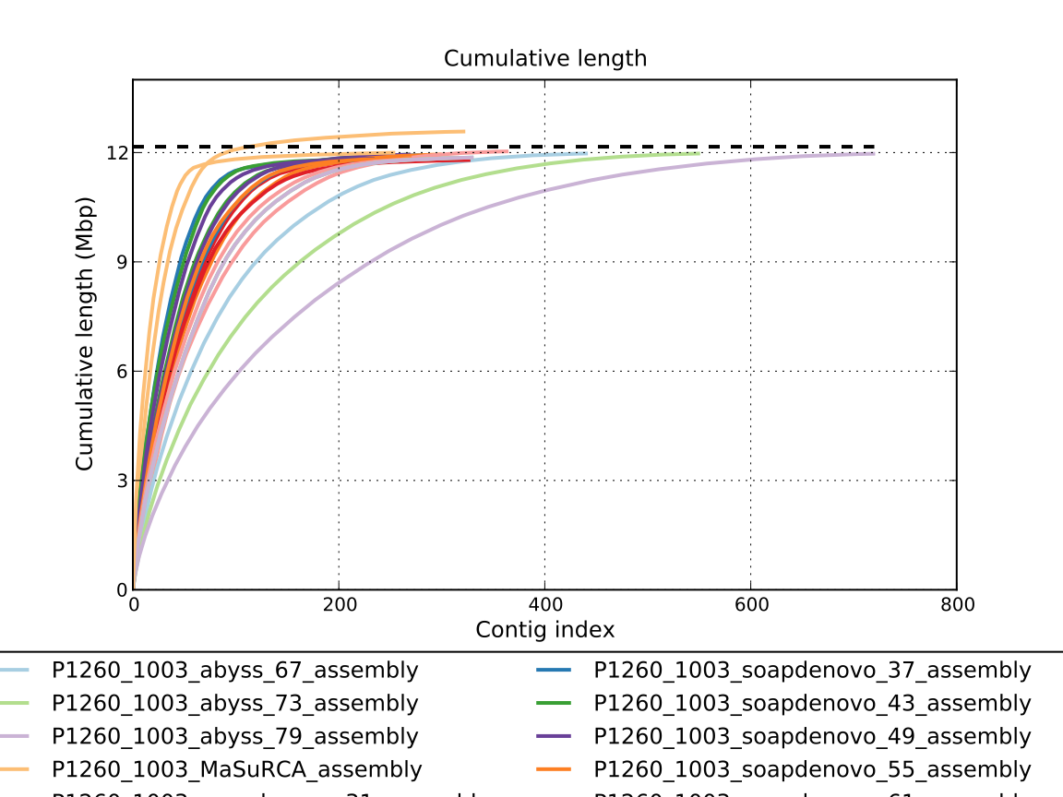

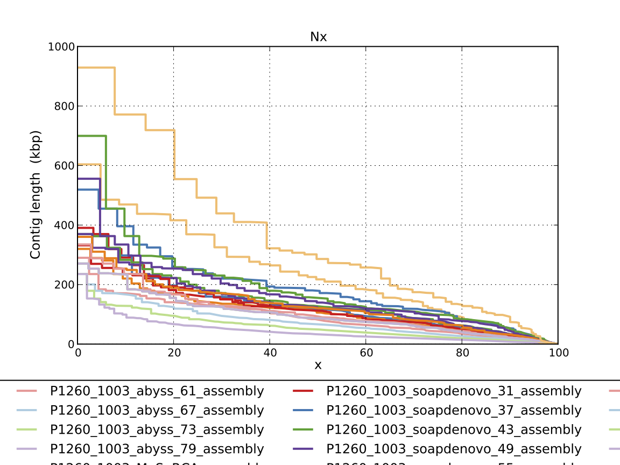

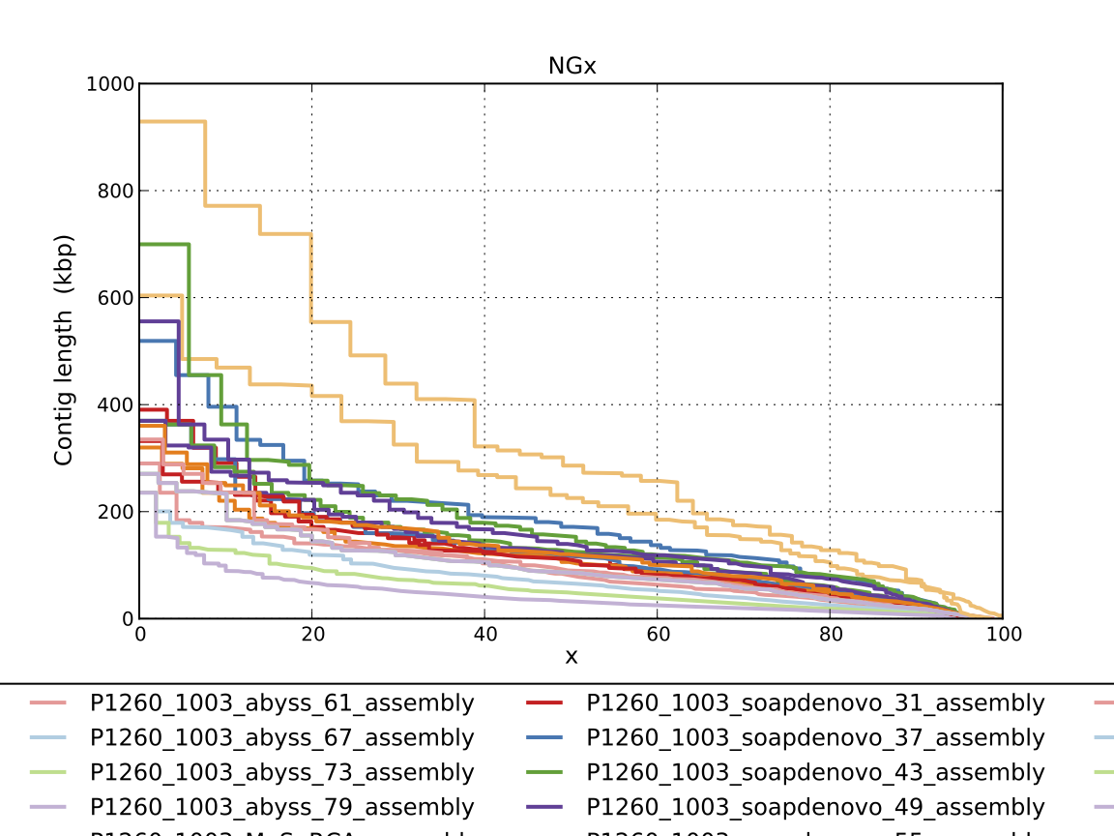

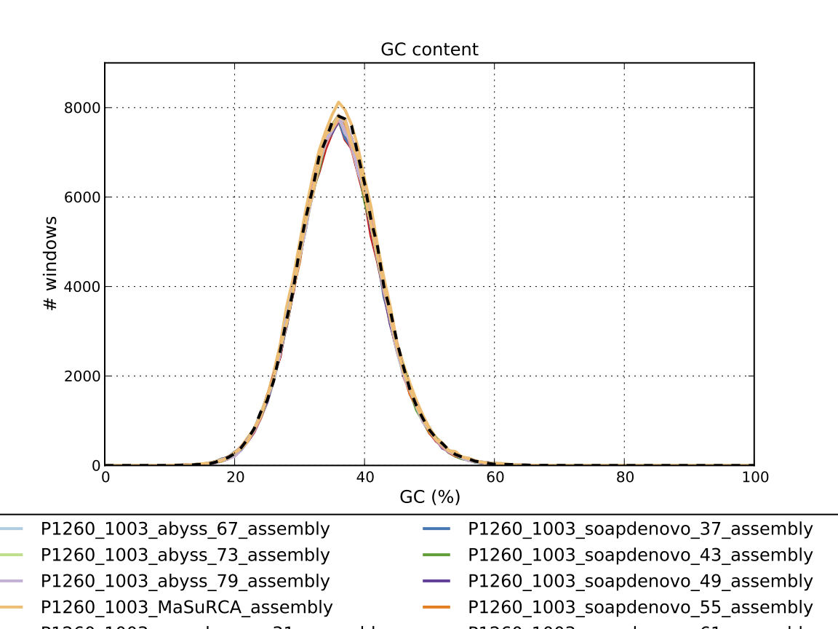

### Assembly Quality Assessment - Compass:

Compass shows that although the assembly is similar in size to the reference, a large portion does not align well, indicating contamination or a very large degree of divergence. The proportion of differing contigs is not clear due to the potential of multiple assembly contigs aligning to the same place on the reference.

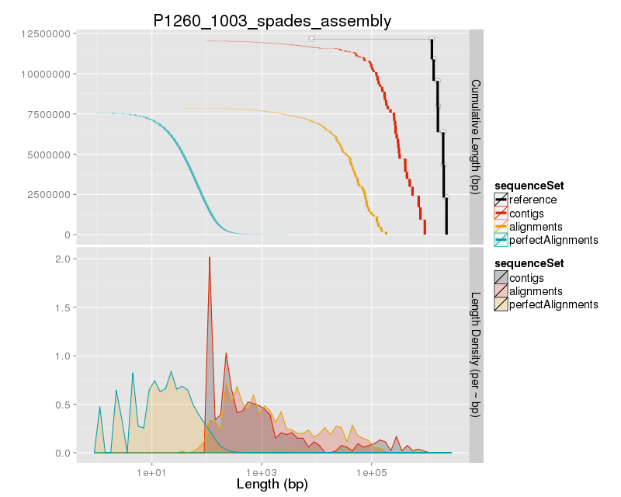

### Assembly Quality Assessment - KAT:

KAT copy number plots indicate that all the covered data in the genome is present in the Spades and MaSuRCA assemblies. The MaSuRCA assembly is slightly over assembled.

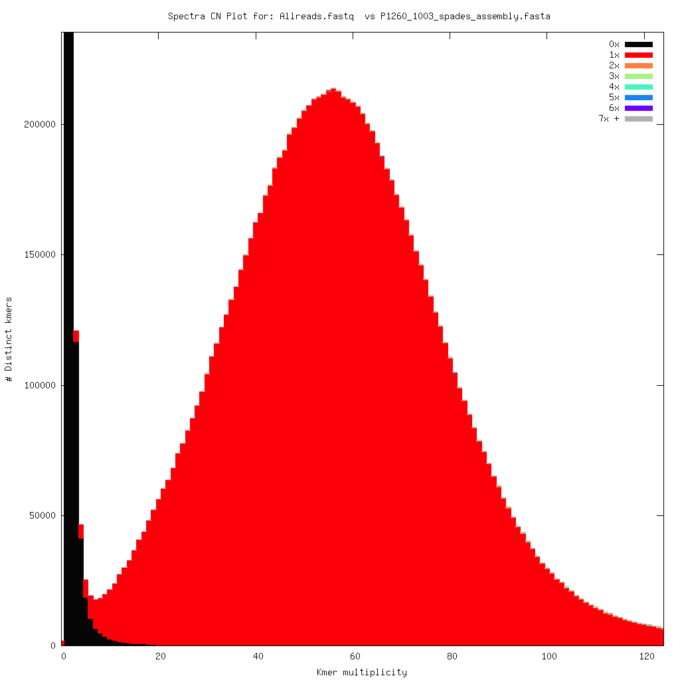

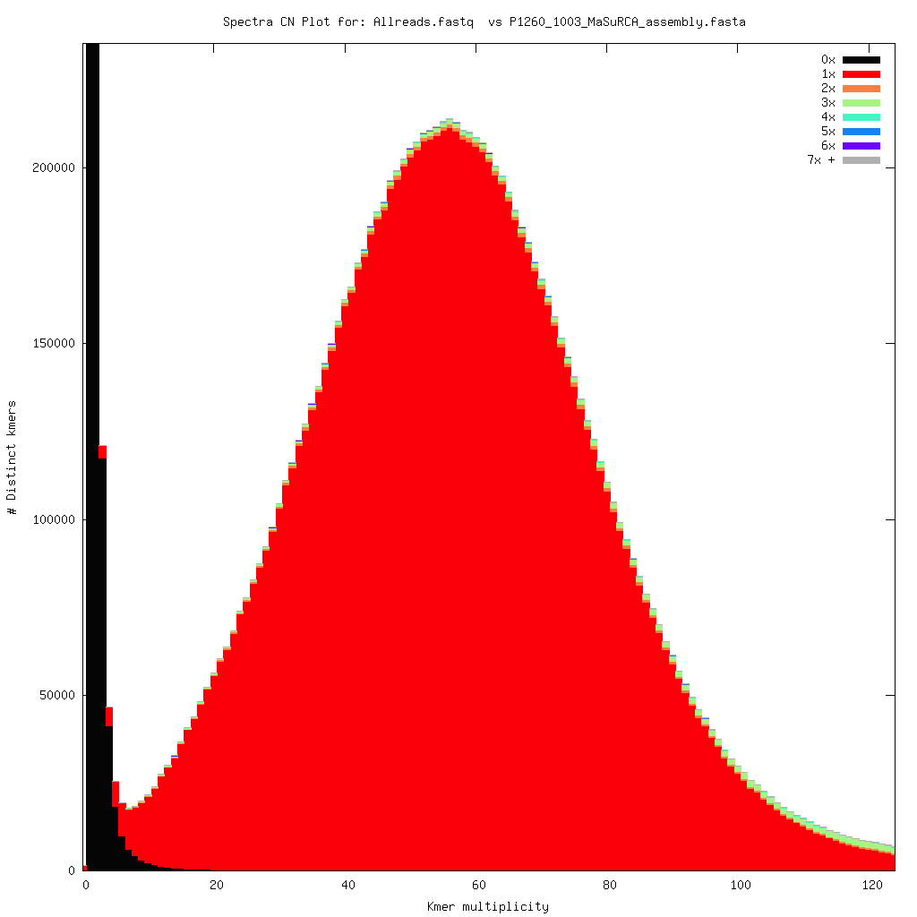

### Assembly Quality Assessment - FRCBAM:

### Assembly Quality Assessment - CEGMA:

CEGMA and BUSCO both attempt to validate the completeness of an assembly by looking at a known gene space, selected to be highly conserved, and present if most, if not all, organisms. CEGMA uses a gene space specifically designed for eukaryotic organisms, while BUSCO can be set for a number of taxonomic groups. Large variation within the completeness between assemblies may indicate that the data was hard to assemble, and thus might run a higher risk of misassembly. BUSCO will also report on duplications of genes, which may indicate chimera in the assembly, and mayneed to be further investigated after annotation.

The CEGMA report of the Spades assembly shows 96% completeness. The CEGMA completeness scores varied between 94.35% (SOAPdenovo k=31) to 95.97% (Abyss k=61,67,73,79, and SOAPdenovo k=61).

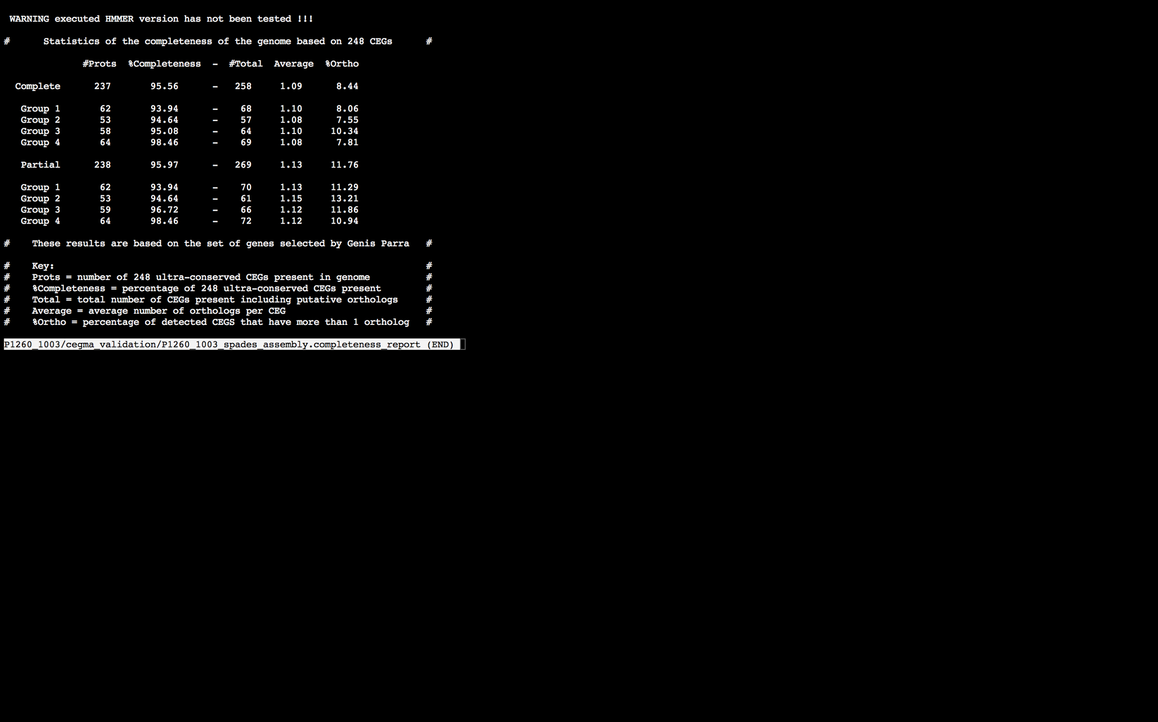

### Assembly Quality Assessment - BUSCO:

The BUSCO report of the Spades assembly shows 94% completeness and 9.5% duplication. The scores range from 93% (Abyss k=55,67,73,79) to 97% (Abyss k=31).

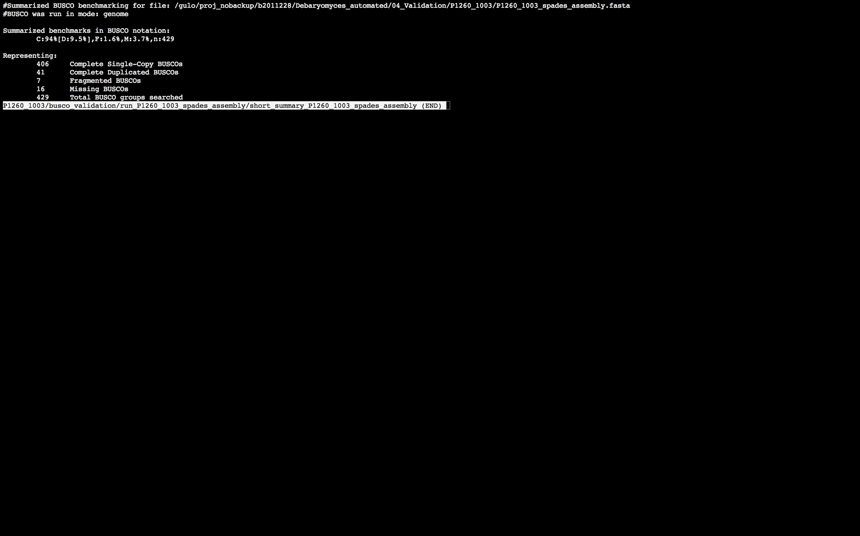

### Assembly Quality Assessment - Blobology:

Blobology indicates that while most contigs are likely Debaryomyces, bacteria may also be present. The blob plot shows a cluster of similar GC content contigs but with lower coverage that potentially indicates contamination. Contamination assessment is a difficult task, and should be interpreted as indicative rather than truth.

|  |  |
| --- | --- |
| # Contigs | Megablast hit |
| 2 | Carnobacterium sp. 17-4 |
| 1 | Carnobacterium sp. BBDP71 |
| 1 | Citrobacter freundii |
| 315 | Debaryomyces hansenii |
| 1 | Echinostoma caproni |
| 1 | Klebsiella oxytoca |
| 1 | Listeria monocytogenes |
| 62 | Not annotated |
| 1 | Pseudomonas phage OBP |
| 1 | Scheffersomyces stipitis |
| 1 | Streptomyces avermitilis |
| 1 | uncultured Enterococcus sp. |

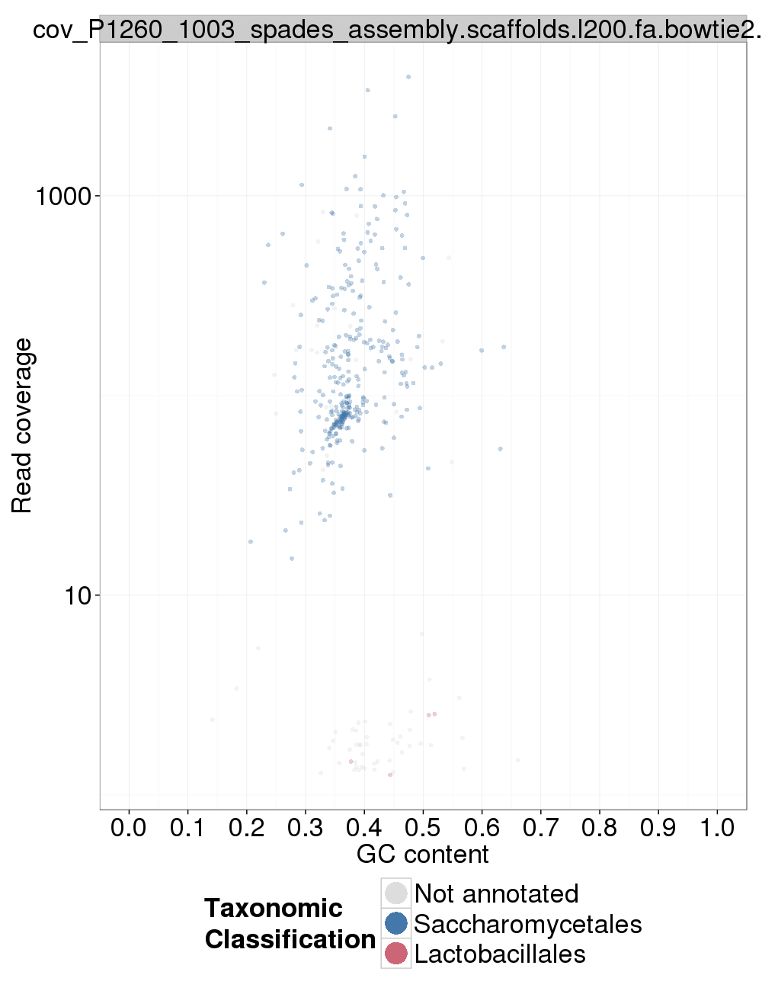

### Assembly Quality Assessment - Kraken:

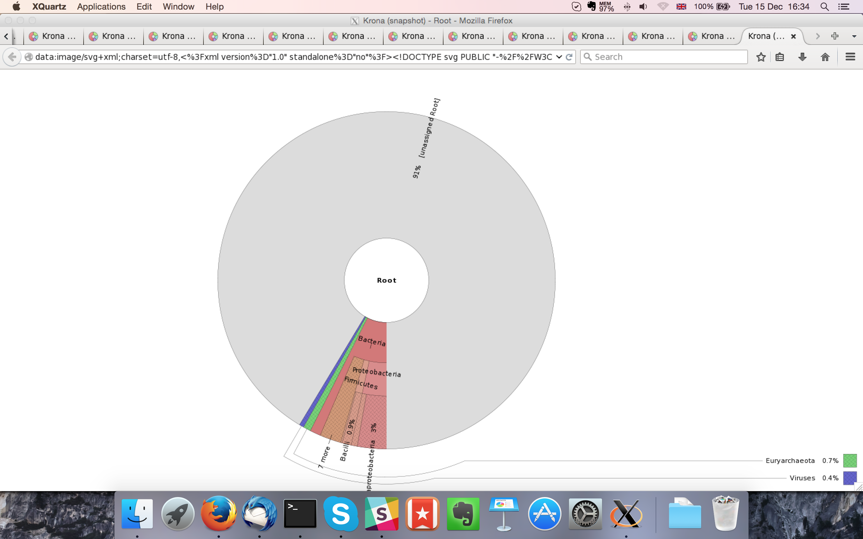

## Sample P1260_1004:

### Assembly Quality Assessment - Quast:

MaSuRCA followed by spades gives the best assembly measured by comparing Cumulative length and Nx.

|  |  |
| --- | --- |
| Assembler | **MaSuRCA** |
| Number of contigs | 818 |
| Largest contig | 299,666 |
| Total assembly length | 14,324,956 |
| N50 | 57,817 |

Spades produced an assembly length of 14,324,956bp, comprised of 818 contigs with an N50 of 57,817bp.

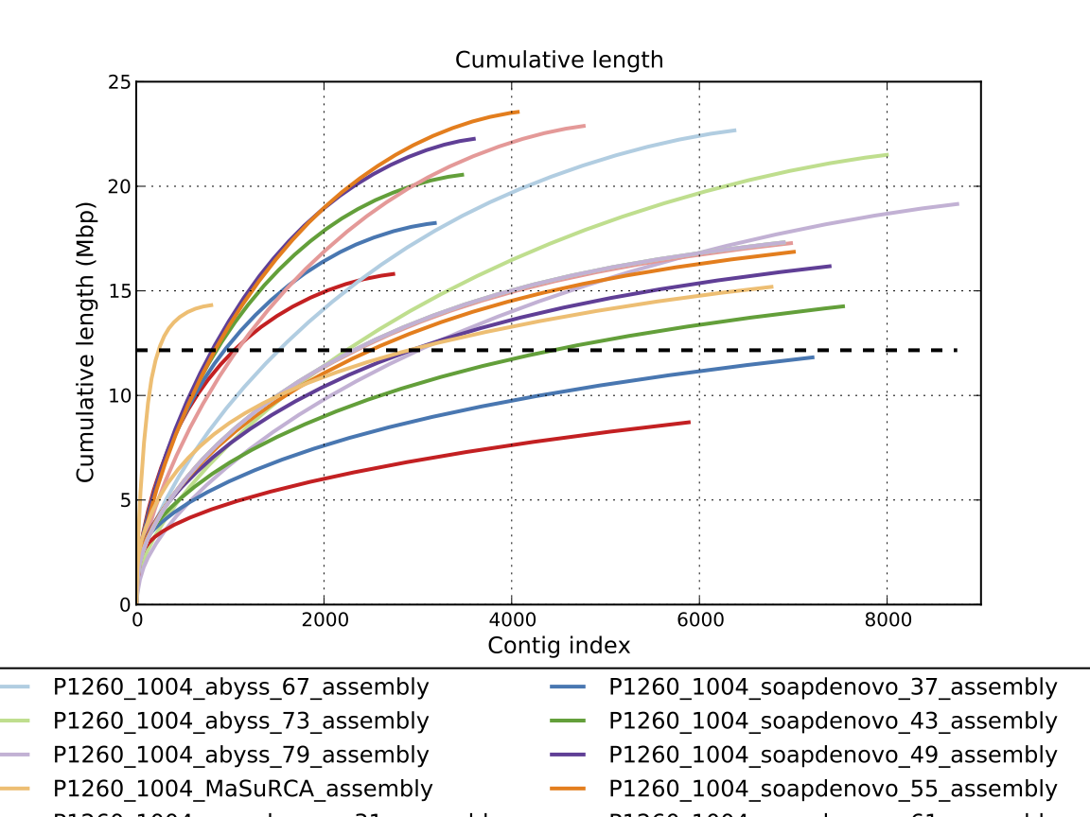

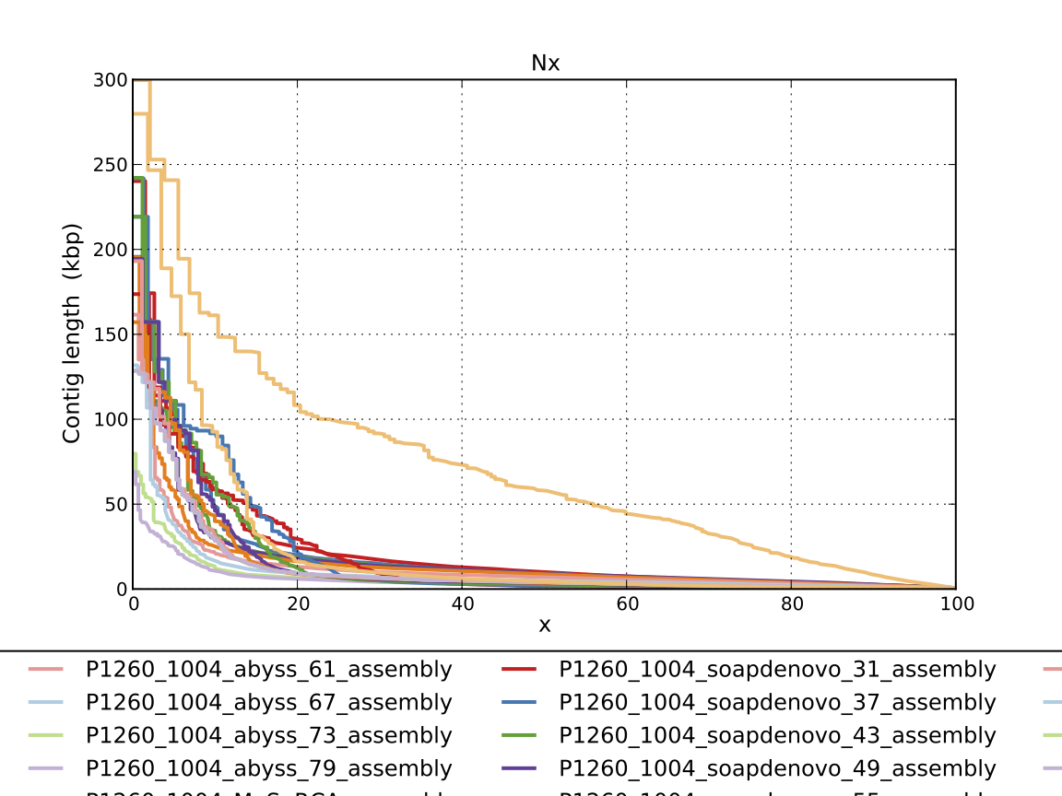

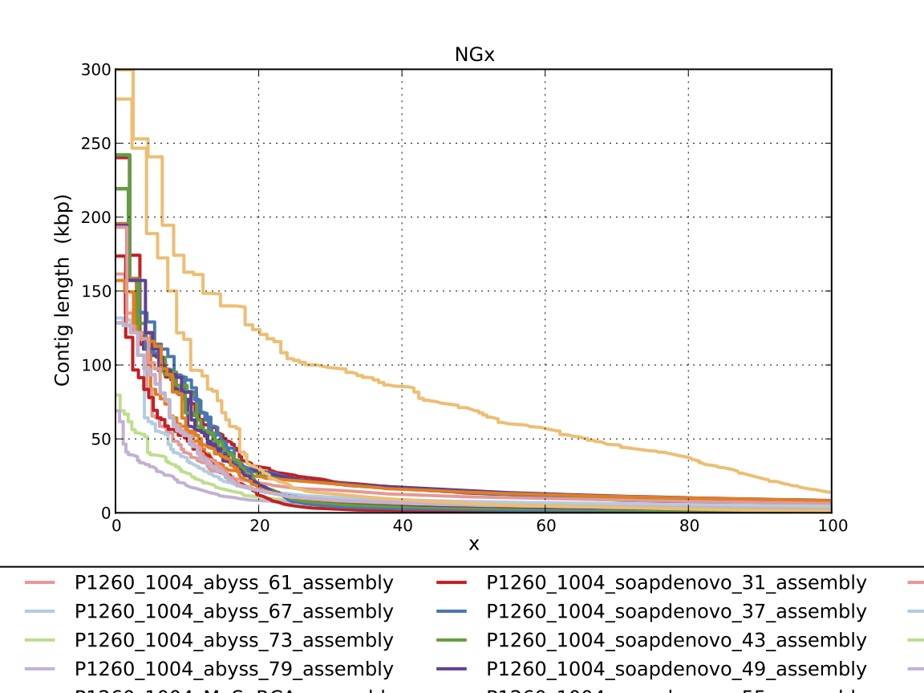

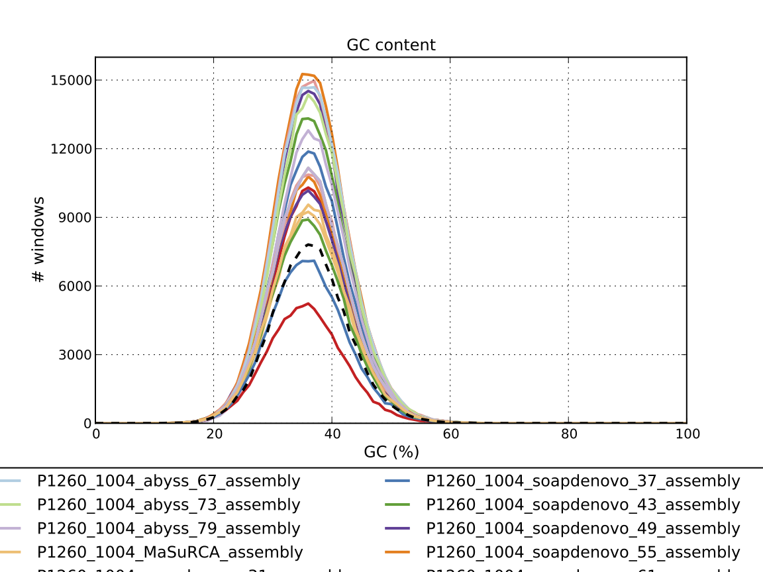

### Assembly Quality Assessment - Compass:

Compass shows that the assembly is greater in size to the reference, and aligns to a good degree to the reference. The portion that does not align well indicates contamination or a very large degree of divergence. The proportion of differing contigs is not clear due to the potential of multiple assembly contigs aligning to the same place on the reference.

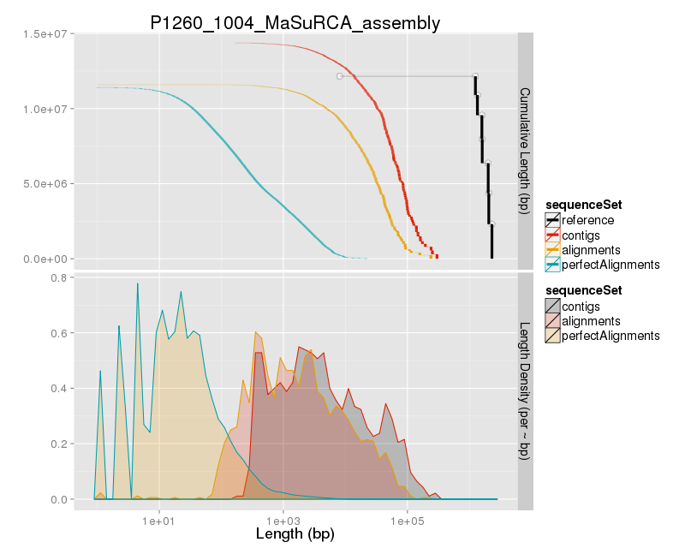

### Assembly Quality Assessment - KAT:

KAT copy number plots indicate incomplete assemblies with much of the covered sequence present in the data absent in the assemblies. Some portions are also over assembled. Other assemblers performed just as poorly or worse.

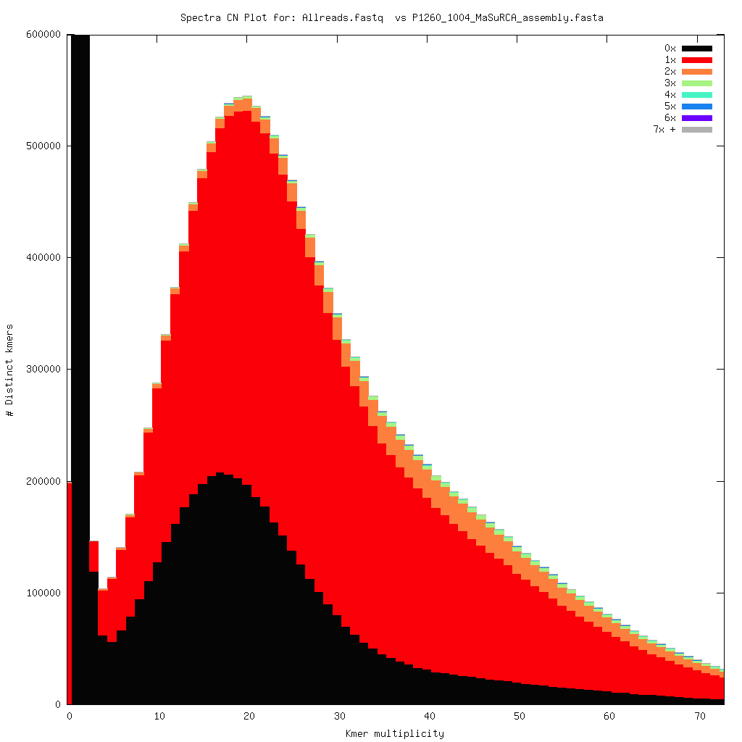

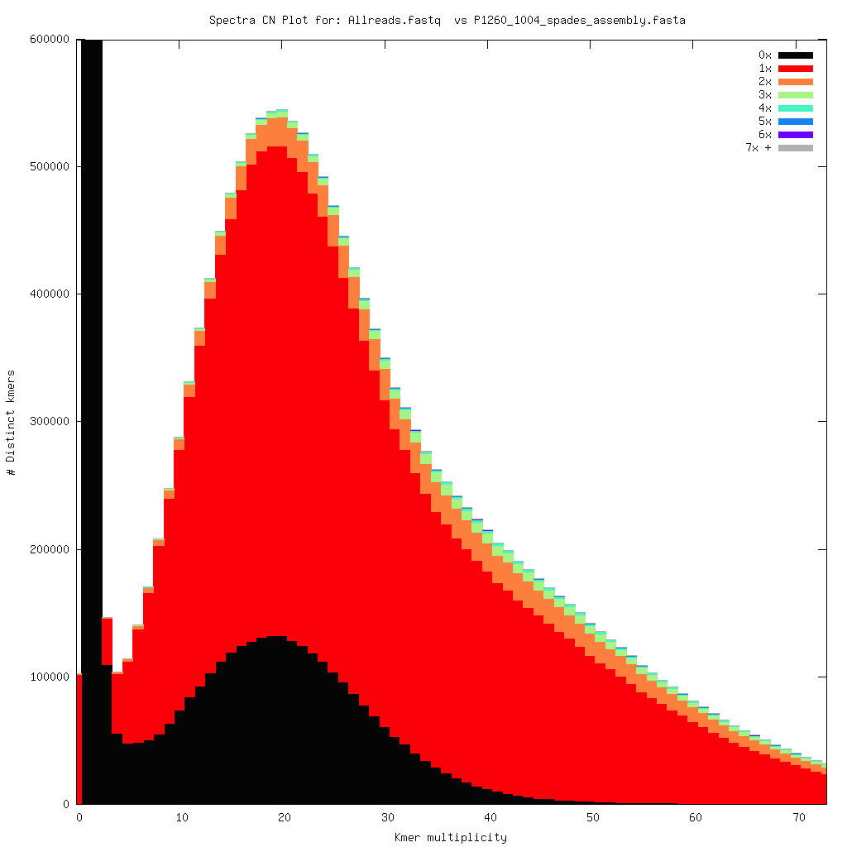

### Assembly Quality Assessment - FRCBAM:

### Assembly Quality Assessment - CEGMA:

CEGMA and BUSCO both attempt to validate the completeness of an assembly by looking at a known gene space, selected to be highly conserved, and present if most, if not all, organisms. CEGMA uses a gene space specifically designed for eukaryotic organisms, while BUSCO can be set for a number of taxonomic groups. Large variation within the completeness between assemblies may indicate that the data was hard to assemble, and thus might run a higher risk of misassembly. BUSCO will also report on duplications of genes, which may indicate chimera in the assembly, and mayneed to be further investigated after annotation.

The CEGMA report of the MaSuRCA assembly shows 93% completeness. The CEGMA completeness scores varied between 27.82% (SOAPdenovo k=31) to 96.77% (Abyss k=31).

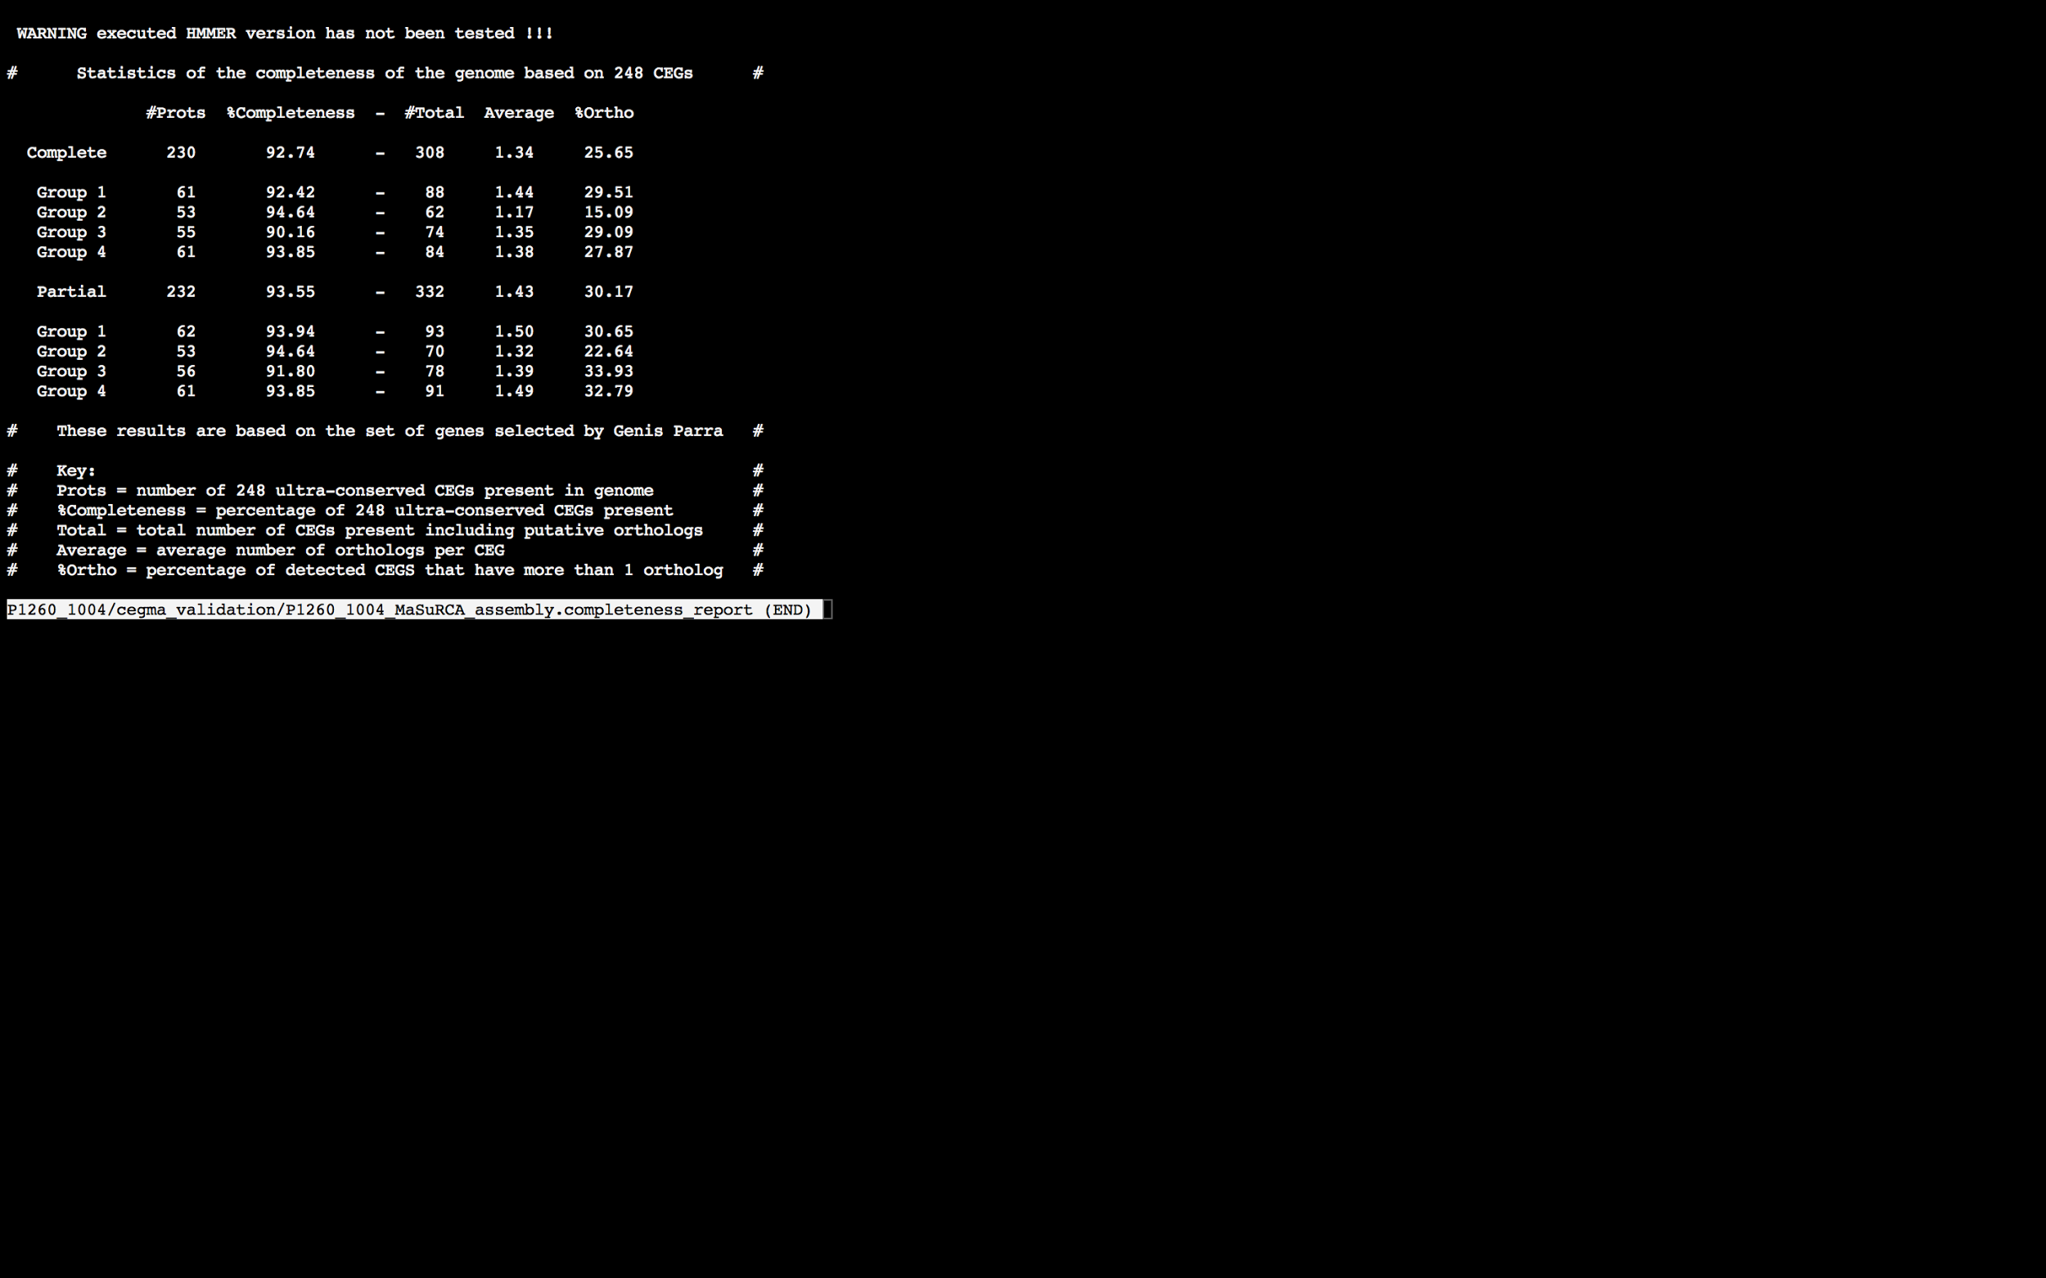

### Assembly Quality Assessment - BUSCO:

The BUSCO report of the MaSuRCA assembly shows 91% completeness and 18% duplication. The scores range from 25% (SOAPdenovo k=31) to 96% (Abyss k=31,43).

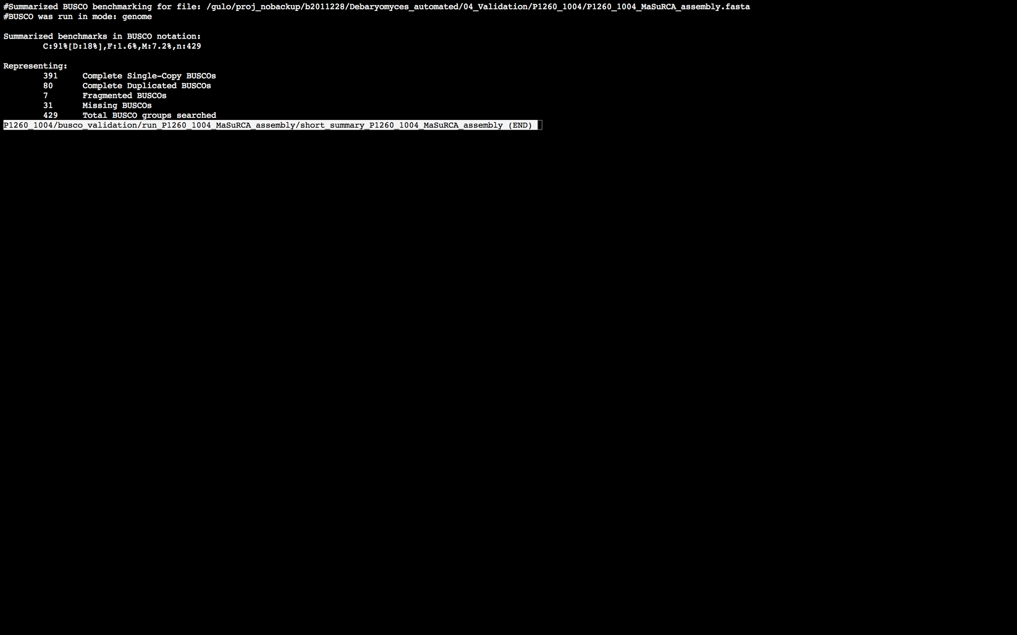

### Assembly Quality Assessment - Blobology:

Blobology indicates that while most contigs are likely Debaryomyces, bacteria may also be present. Contamination assessment is a difficult task, and should be interpreted as indicative rather than truth.

|  |  |
| --- | --- |
| # Contigs | Megablast hit |
| 1 | Carnobacterium sp. 12266/2009 |
| 3 | Carnobacterium sp. WN1359 |
| 906 | Debaryomyces hansenii |
| 1 | Nectria haematococca |
| 14 | Not annotated |
| 1 | Schwanniomyces capriottii |
| 1 | uncultured fungus |

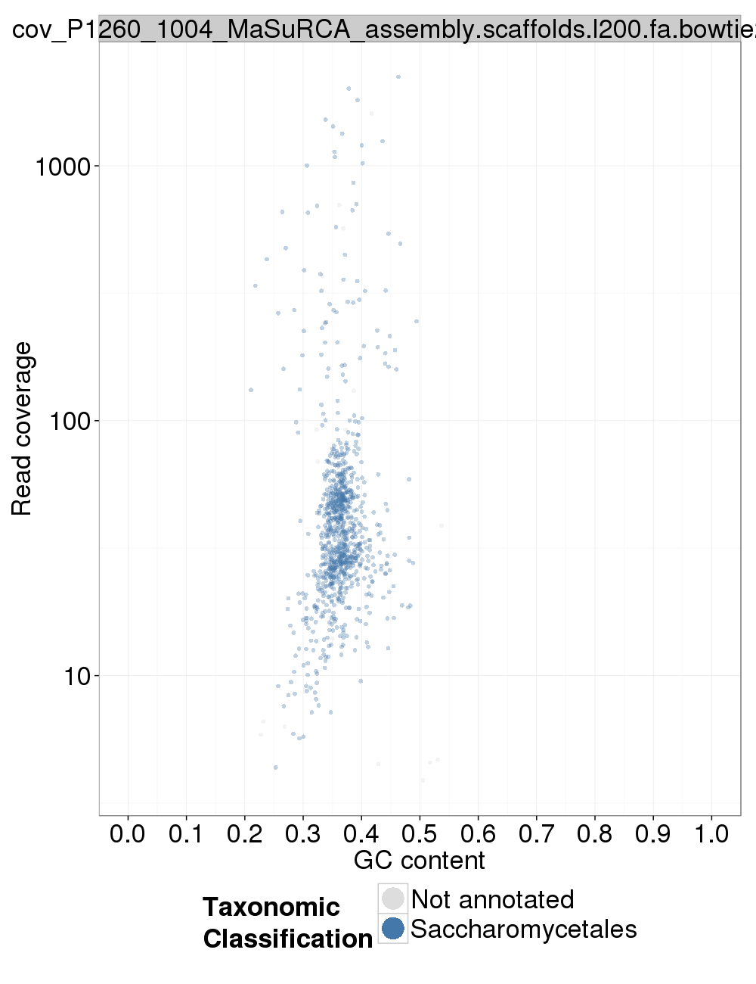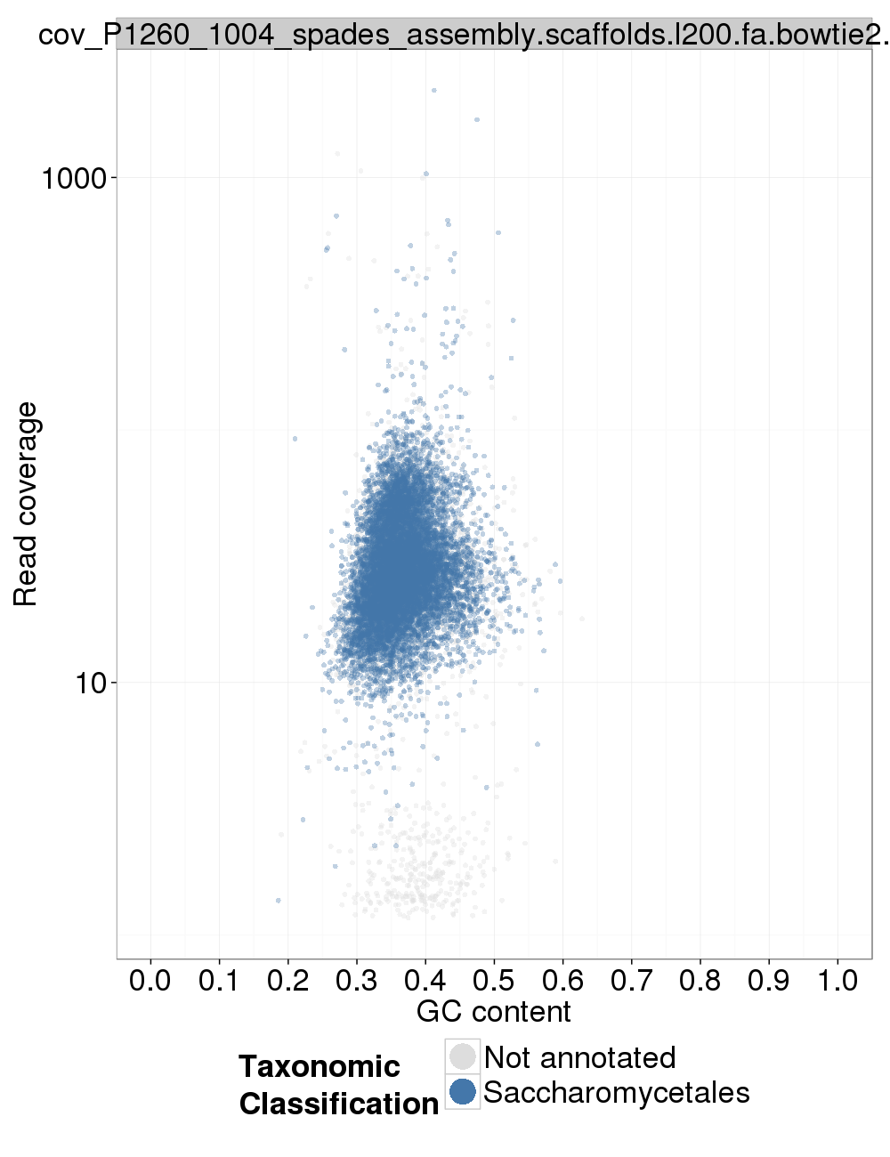

### Assembly Quality Assessment - Kraken:

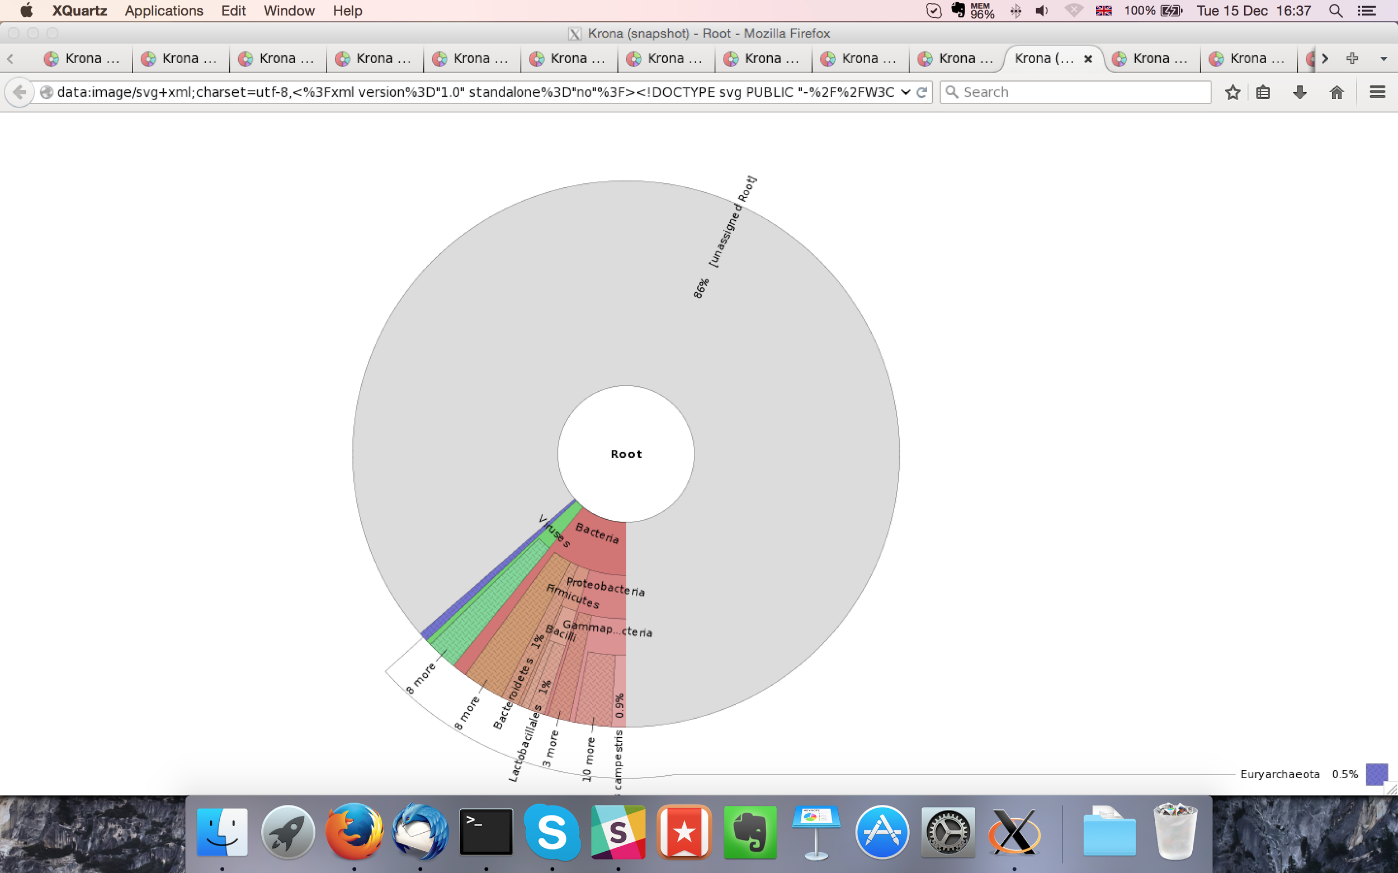

## Sample P1260_1005:

### Assembly Quality Assessment - Quast:

Spades followed by MaSuRCA gives the best assembly measured by comparing Cumulative length and Nx.

|  |  |
| --- | --- |
| Assembler | **Spades** |
| Number of contigs | 314 |
| Largest contig | 893,132 |
| Total assembly length | 12,134,166 |
| N50 | 312,846 |

Spades produced an assembly length of 12,134,166bp, comprised of 314 contigs with an N50 of 312,846bp.

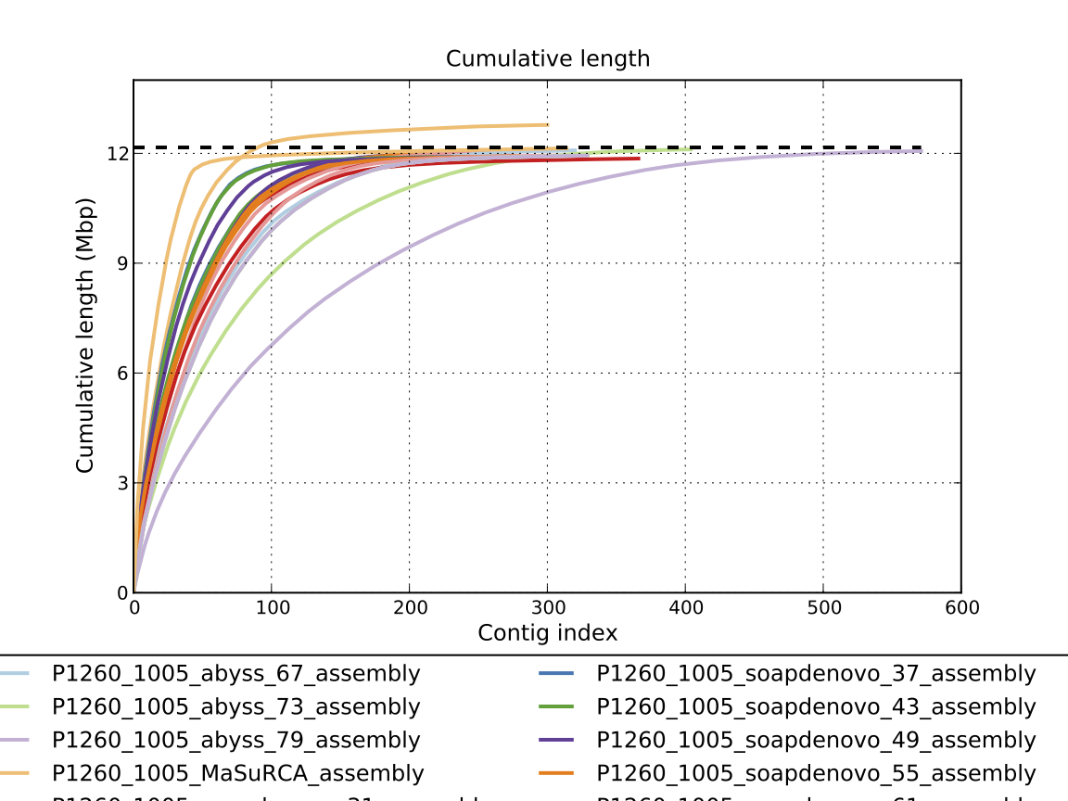

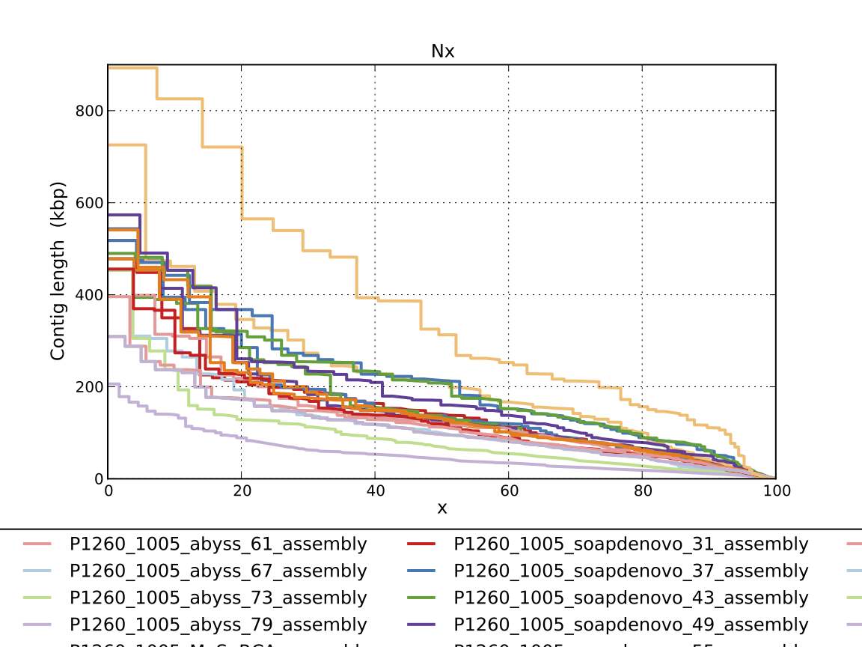

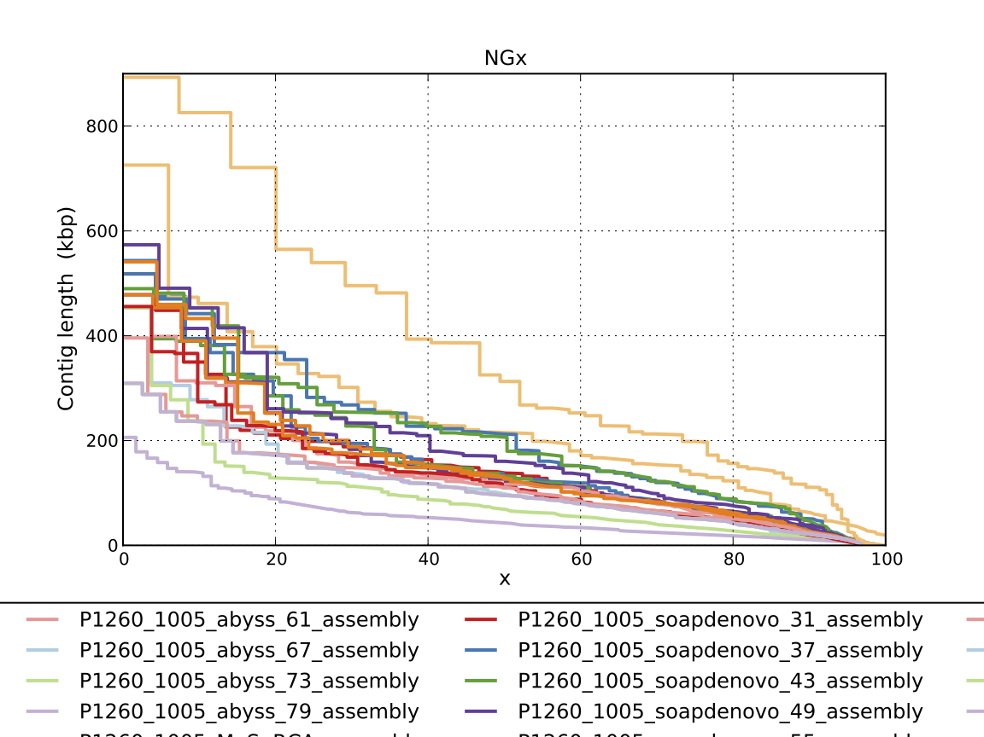

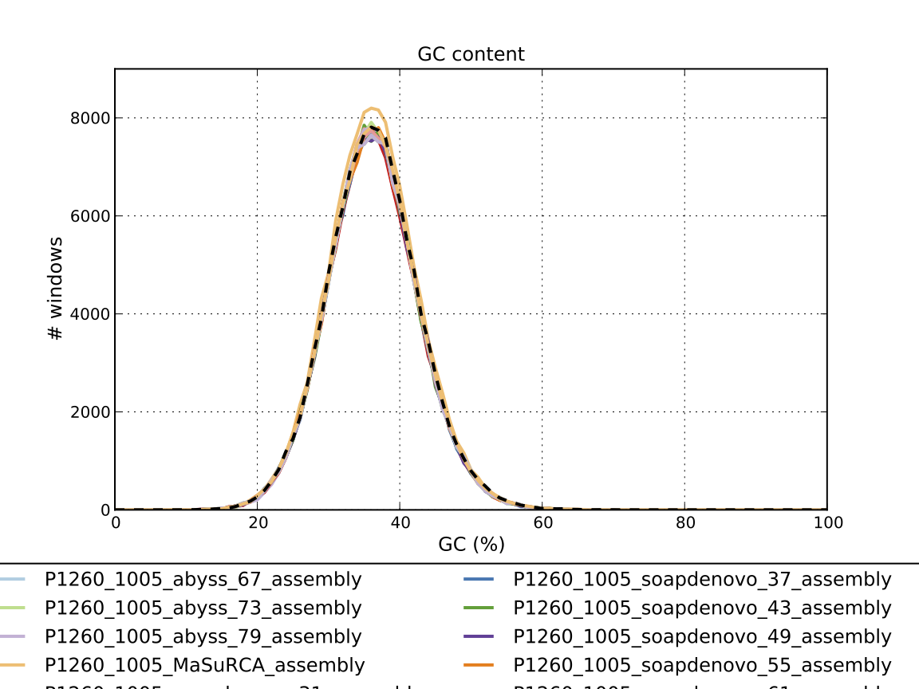

### Assembly Quality Assessment - Compass:

Compass shows that although the assembly is similar in size to the reference, a small portion does not align well, indicating contamination or a very large degree of divergence. The proportion of differing contigs is not clear due to the potential of multiple assembly contigs aligning to the same place on the reference.

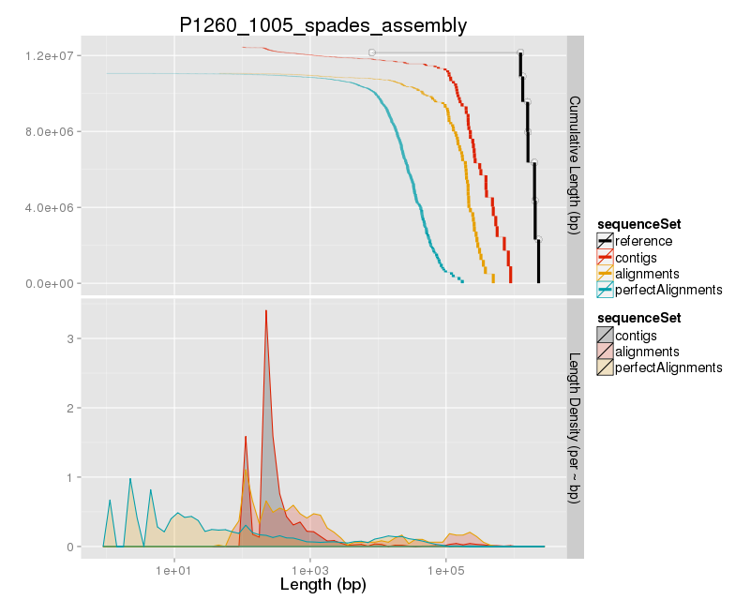

### Assembly Quality Assessment - KAT:

### Assembly Quality Assessment - FRCBAM:

### Assembly Quality Assessment - CEGMA:

CEGMA and BUSCO both attempt to validate the completeness of an assembly by looking at a known gene space, selected to be highly conserved, and present if most, if not all, organisms. CEGMA uses a gene space specifically designed for eukaryotic organisms, while BUSCO can be set for a number of taxonomic groups. Large variation within the completeness between assemblies may indicate that the data was hard to assemble, and thus might run a higher risk of misassembly. BUSCO will also report on duplications of genes, which may indicate chimera in the assembly, and mayneed to be further investigated after annotation.

The CEGMA report of the Spades assembly shows 95% completeness. The CEGMA completeness scores varied between 94.76% (Abyss k=55,61, SOAPdenovo k=37,49,55, and spades) to 95.16% (all others).

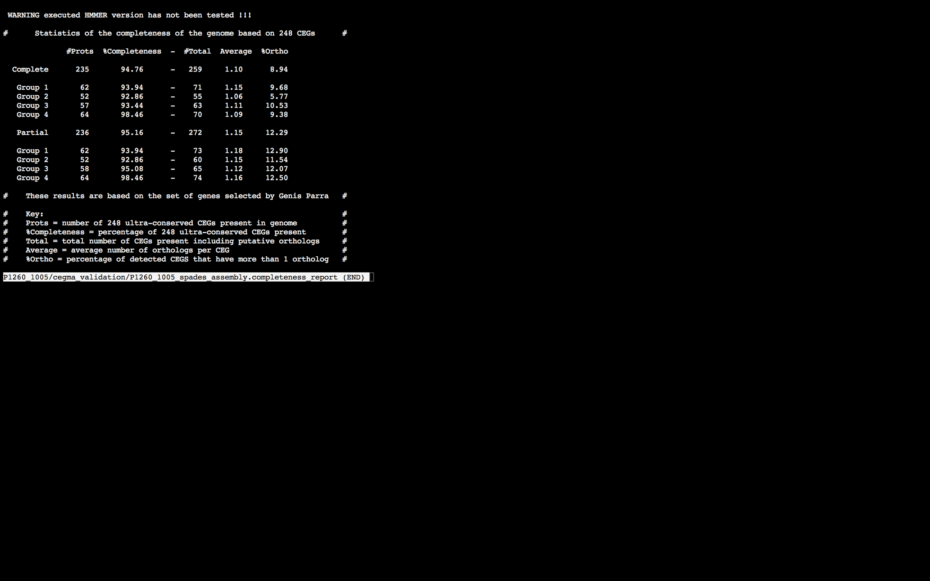

### Assembly Quality Assessment - BUSCO:

The BUSCO report of the Spades assembly shows 96% completeness and 10% duplication. The scores range from 96% (MaSuRCA, Abyss k=55,73,79, SOAPdenovo k=31,37,43,55,61,67,73,79, and spades) to 97% (all others).

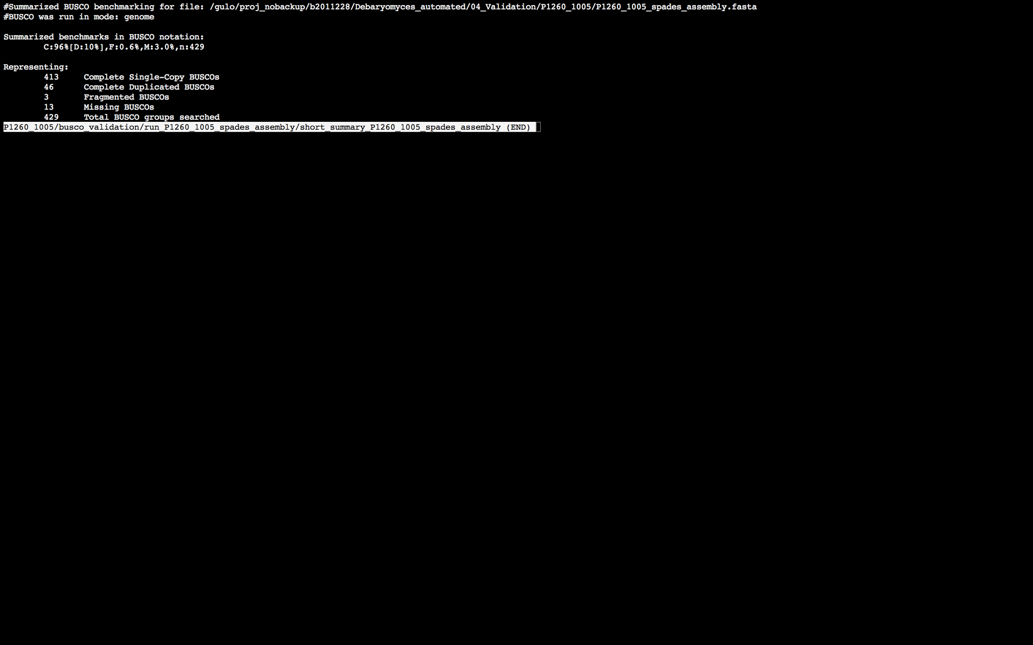

### Assembly Quality Assessment - Blobology:

Blobology indicates that while most contigs are likely Debaryomyces, bacteria may also be present. The blob plot shows a cluster of similar GC content contigs but with lower coverage that potentially indicates contamination. Contamination assessment is a difficult task, and should be interpreted as indicative rather than truth.

|  |  |
| --- | --- |
| # Contigs | Megablast hit |
| 1 | Acinetobacter sp. ADP1 |
| 1 | Agrobacterium vitis |
| 1 | Aliivibrio salmonicida |
| 1 | Bacillus anthracis |
| 2 | Bacillus cereus |
| 1 | Bacillus megaterium |
| 3 | Bacillus pumilus |
| 1 | Bacillus sp. BH072 |
| 1 | Bacillus sp. OxB-1 |
| 2 | Bacillus thuringiensis |
| 1 | Beutenbergia cavernae |
| 1 | Brugia pahangi |
| 9 | Carnobacterium maltaromaticum |
| 30 | Carnobacterium sp. 17-4 |
| 28 | Carnobacterium sp. WN1359 |
| 2 | Citrobacter freundii |
| 1 | Clostridium saccharoperbutylacetonicum |
| 303 | Debaryomyces hansenii |
| 1 | Dinoroseobacter shibae |
| 2 | Enterobacter cloacae |
| 2 | Enterobacteriaceae bacterium bta3-1 |
| 4 | Enterococcus durans |
| 3 | Enterococcus faecalis |
| 6 | Enterococcus faecium |
| 1 | Enterococcus haemoperoxidus |
| 1 | Enterococcus hirae |
| 2 | Enterococcus mundtii |
| 1 | Enterococcus sp. 7L76 |
| 2 | Escherichia coli |
| 1 | Escherichia coli O157 typing phage 7 |
| 1 | Escherichia fergusonii |
| 1 | Fusobacterium nucleatum |
| 1 | Geminocystis sp. NIES-3708 |
| 1 | Halobacillus halophilus |
| 1 | Homo sapiens |
| 1 | Klebsiella phage 0507-KN2-1 |
| 1 | Lactobacillus acetotolerans |
| 1 | Lactobacillus brevis |
| 1 | Lactobacillus buchneri |
| 1 | Lactobacillus helveticus |
| 1 | Lactobacillus sakei |
| 1 | Lactobacillus salivarius |
| 1 | Leuconostoc mesenteroides |
| 1 | Listeria monocytogenes |
| 1 | Listeria seeligeri |
| 1 | Listeria welshimeri |
| 1 | Mannheimia haemolytica |
| 1 | Melissococcus plutonius |
| 1 | Meyerozyma guilliermondii |
| 2 | Morganella morganii |
| 836 | Not annotated |
| 1 | Photorhabdus asymbiotica |
| 1 | Photorhabdus temperata |
| 1 | Pragia fontium |
| 1 | Proteus mirabilis |
| 2 | Providencia rettgeri |
| 13 | Providencia stuartii |
| 14 | Pseudomonas phage OBP |
| 1 | Rahnella aquatilis |
| 1 | Salmonella enterica |
| 1 | Scheffersomyces stipitis |
| 1 | Serratia plymuthica |
| 1 | Shewanella pealeana |
| 1 | Solibacillus silvestris |
| 1 | Spiroplasma taiwanense |
| 1 | Staphylococcus aureus |
| 1 | Staphylococcus hominis |
| 1 | Staphylococcus xylosus |
| 1 | Streptococcus anginosus |
| 1 | Streptococcus dysgalactiae |
| 1 | Streptococcus mutans |
| 1 | Streptococcus parauberis |
| 1 | Streptococcus sp. VT 162 |
| 1 | Streptococcus suis |
| 1 | Streptococcus uberis |
| 1 | Sulfobacillus acidophilus |
| 1 | uncultured Klebsiella sp. |
| 1 | Veillonella montpellierensis |
| 1 | Vibrio nigripulchritudo |
| 1 | Vibrio vulnificus |
| 1 | Weissella thailandensis |
| 1 | Xenorhabdus doucetiae |
| 1 | Xenorhabdus poinarii |
| 1 | Yersinia kristensenii |
| 1 | Yersinia pseudotuberculosis |

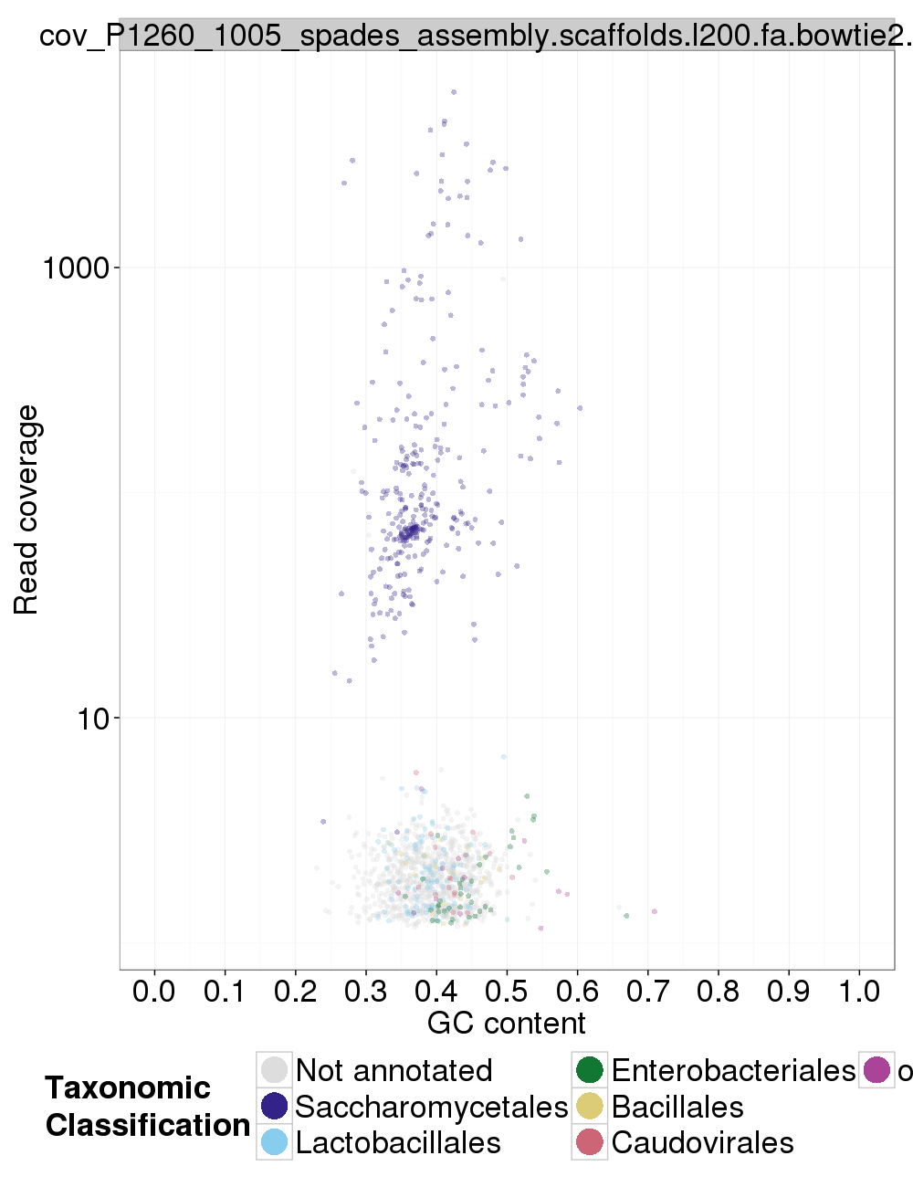

### Assembly Quality Assessment - Kraken:

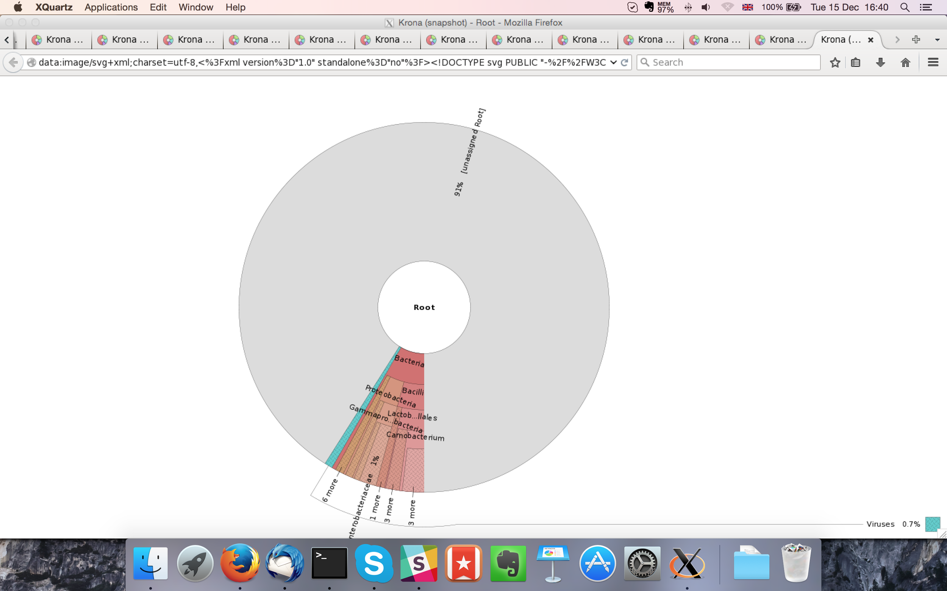

## Sample P1260_1006:

### Assembly Quality Assessment - Quast:

Spades followed by MaSuRCA gives the best assembly measured by comparing Cumulative length and Nx.

|  |  |
| --- | --- |
| Assembler | **Spades** |
| Number of contigs | 158 |
| Largest contig | 868,079 |
| Total assembly length | 11,756,082 |
| N50 | 281,259 |

Spades produced an assembly length of 11,756,082bp, comprised of 158 contigs with an N50 of 281,259bp.

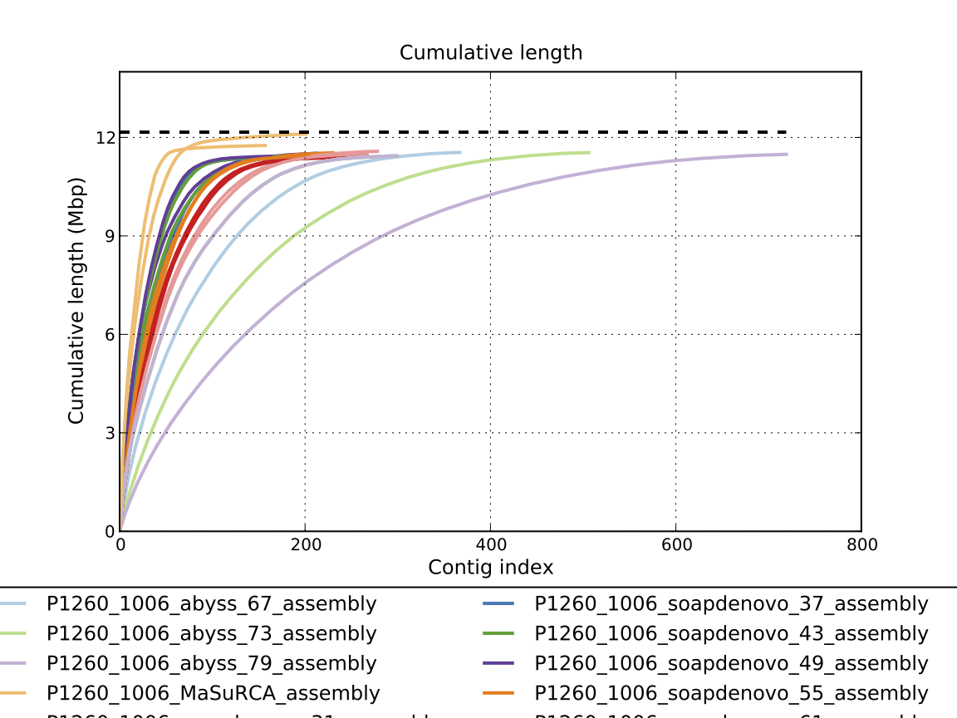

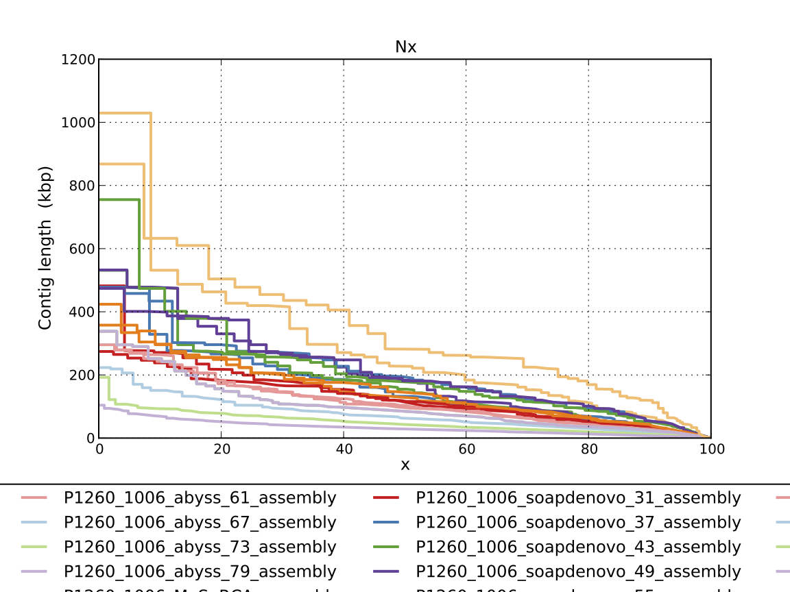

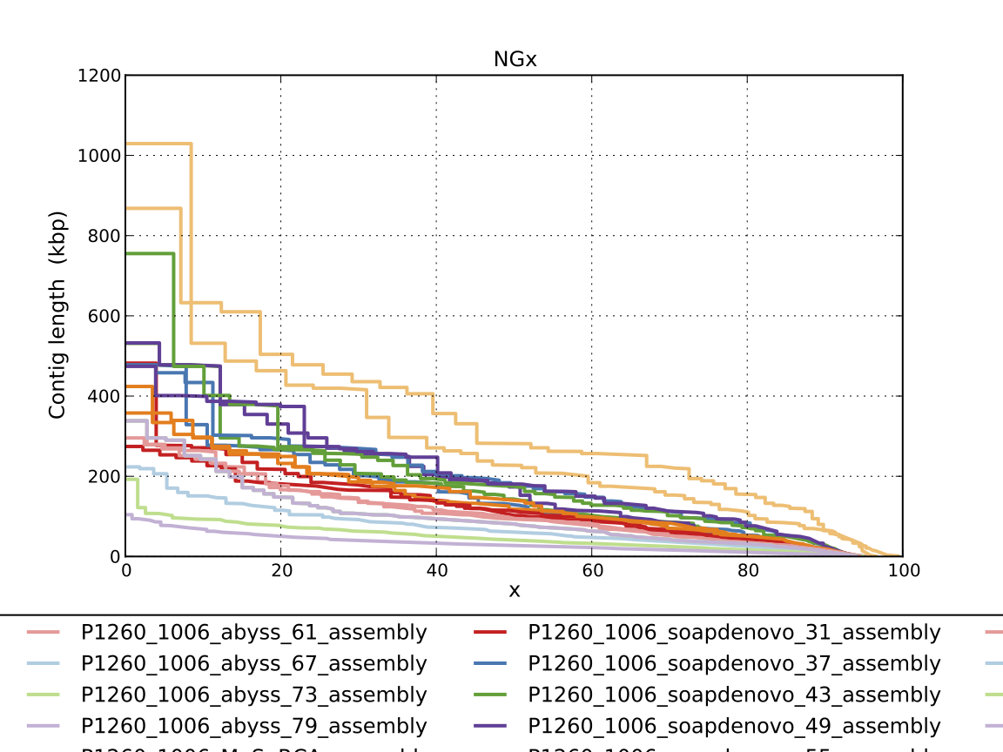

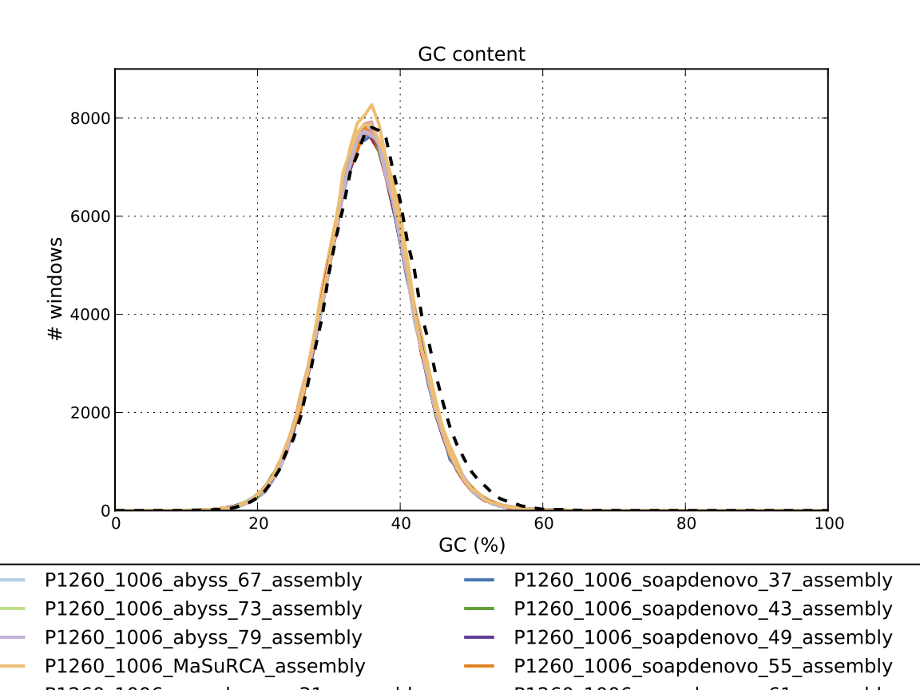

### Assembly Quality Assessment - Compass:

Compass shows that although the assembly is similar in size to the reference, a large portion does not align well, indicating contamination or a very large degree of divergence. The proportion of differing contigs is not clear due to the potential of multiple assembly contigs aligning to the same place on the reference.

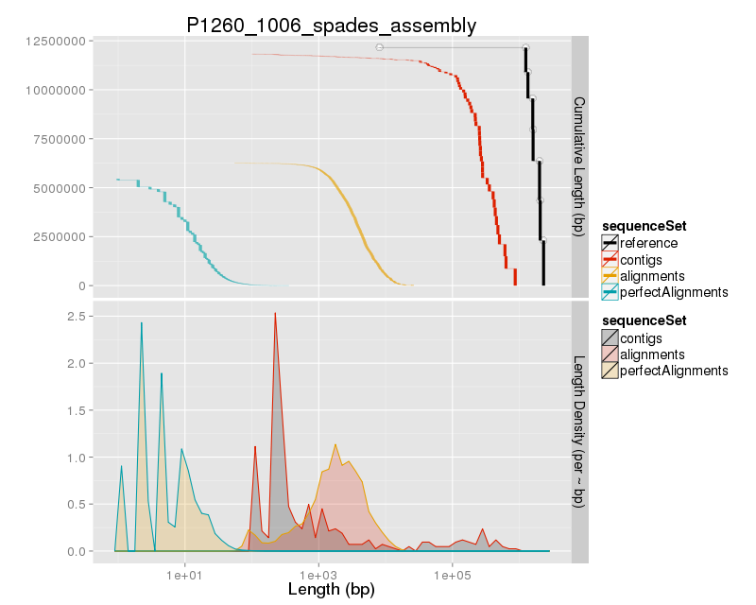

### Assembly Quality Assessment - KAT:

### Assembly Quality Assessment - FRCBAM:

### Assembly Quality Assessment - CEGMA:

CEGMA and BUSCO both attempt to validate the completeness of an assembly by looking at a known gene space, selected to be highly conserved, and present if most, if not all, organisms. CEGMA uses a gene space specifically designed for eukaryotic organisms, while BUSCO can be set for a number of taxonomic groups. Large variation within the completeness between assemblies may indicate that the data was hard to assemble, and thus might run a higher risk of misassembly. BUSCO will also report on duplications of genes, which may indicate chimera in the assembly, and mayneed to be further investigated after annotation.

The CEGMA report of the Spades assembly shows 95% completeness. The CEGMA completeness scores varied between 94.35% (Abyss k=31,79) to 95.16% (MaSuRCA, and SOAPdenovo k=55).

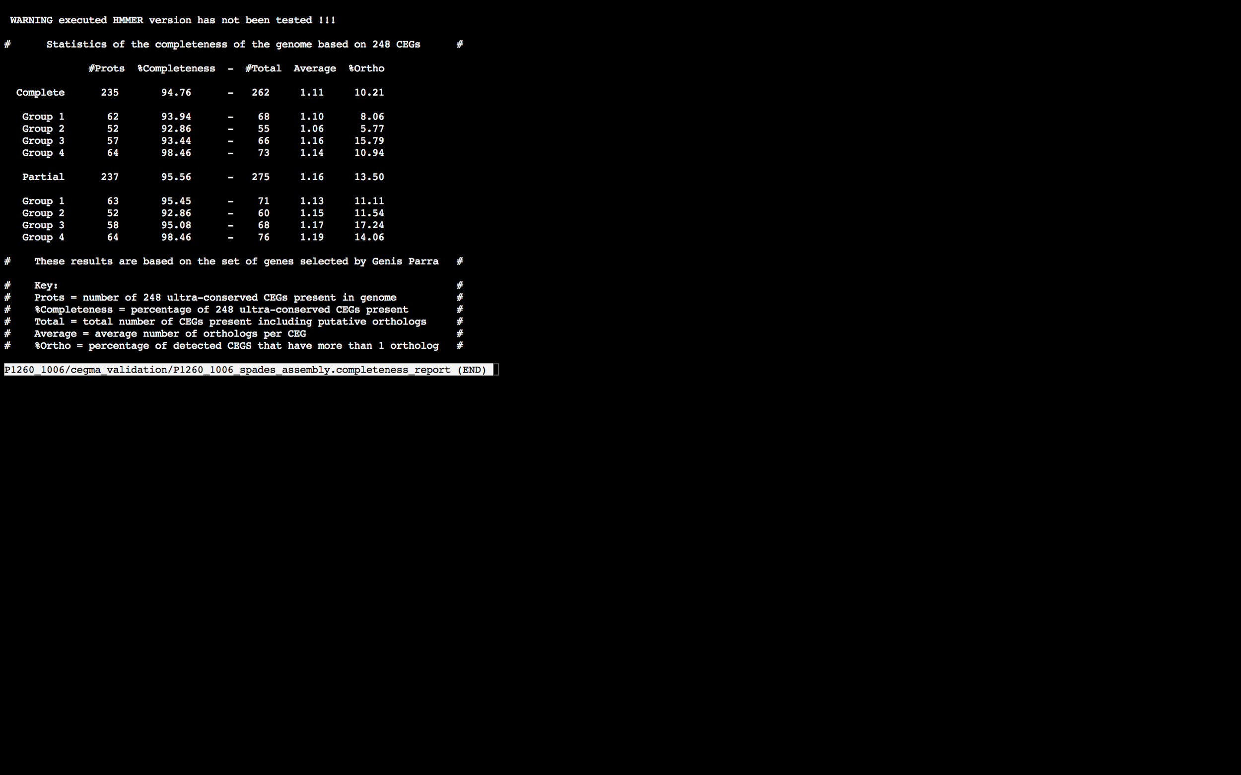

### Assembly Quality Assessment - BUSCO:

The BUSCO report of the Spades assembly shows 97% completeness and 10% duplication. The scores range from 93% (Abyss k=79) to 97% (Abyss k=37,49,55, SOAPdenovo k=37,43,49,61, and Spades).

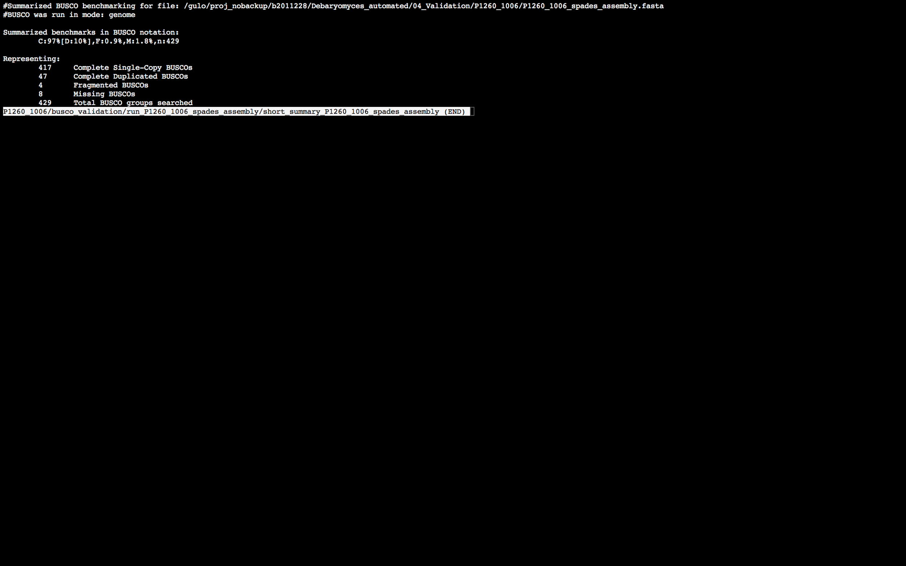

### Assembly Quality Assessment - Blobology:

Blobology indicates that while most contigs are likely Debaryomyces, bacteria may also be present. The blob plot shows a cluster of similar GC content contigs but with lower coverage that potentially indicates contamination. Contamination assessment is a difficult task, and should be interpreted as indicative rather than truth.

|  |  |
| --- | --- |
| # Contigs | Megablast hit |
| 1 | Bacillus sp. 1NLA3E |
| 1 | Bacillus sp. X1(2014) |
| 1 | Candida glabrata |
| 1 | Carnobacterium sp. 17-4 |
| 10 | Carnobacterium sp. WN1359 |
| 1 | Cellulophaga algicola |
| 1 | Chlamydophila felis |
| 1 | Citrobacter freundii |
| 145 | Debaryomyces hansenii |
| 1 | Debaryomyces subglobosus |
| 1 | Dictyostelium discoideum |
| 1 | Hoeflea sp. IMCC20628 |
| 1 | Klebsiella phage 0507-KN2-1 |
| 1 | Meyerozyma guilliermondii |
| 177 | Not annotated |
| 1 | Pasteurella multocida |
| 1 | Proteus vulgaris |
| 1 | Providencia rettgeri |
| 2 | Providencia stuartii |
| 4 | Pseudomonas phage OBP |
| 2 | Scheffersomyces stipitis |
| 1 | Trichobilharzia regenti |
| 1 | uncultured bacterium |
| 1 | Vibrio coralliilyticus |
| 1 | Xenorhabdus bovienii |
| 1 | Yersinia similis |

### 

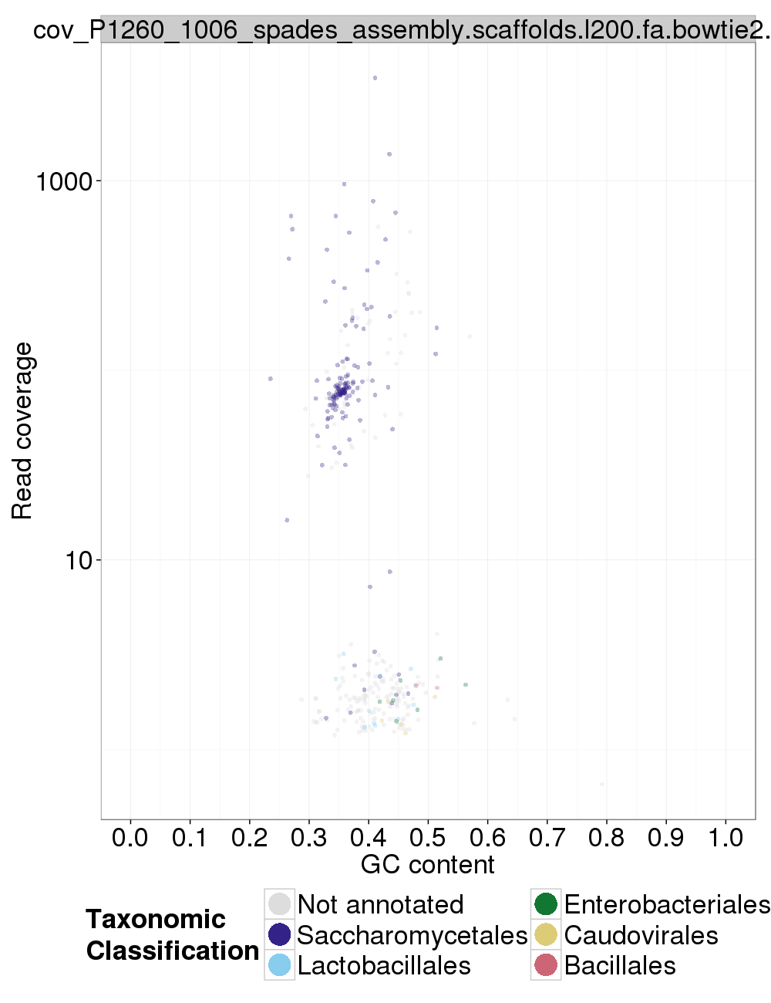

### Assembly Quality Assessment - Kraken:

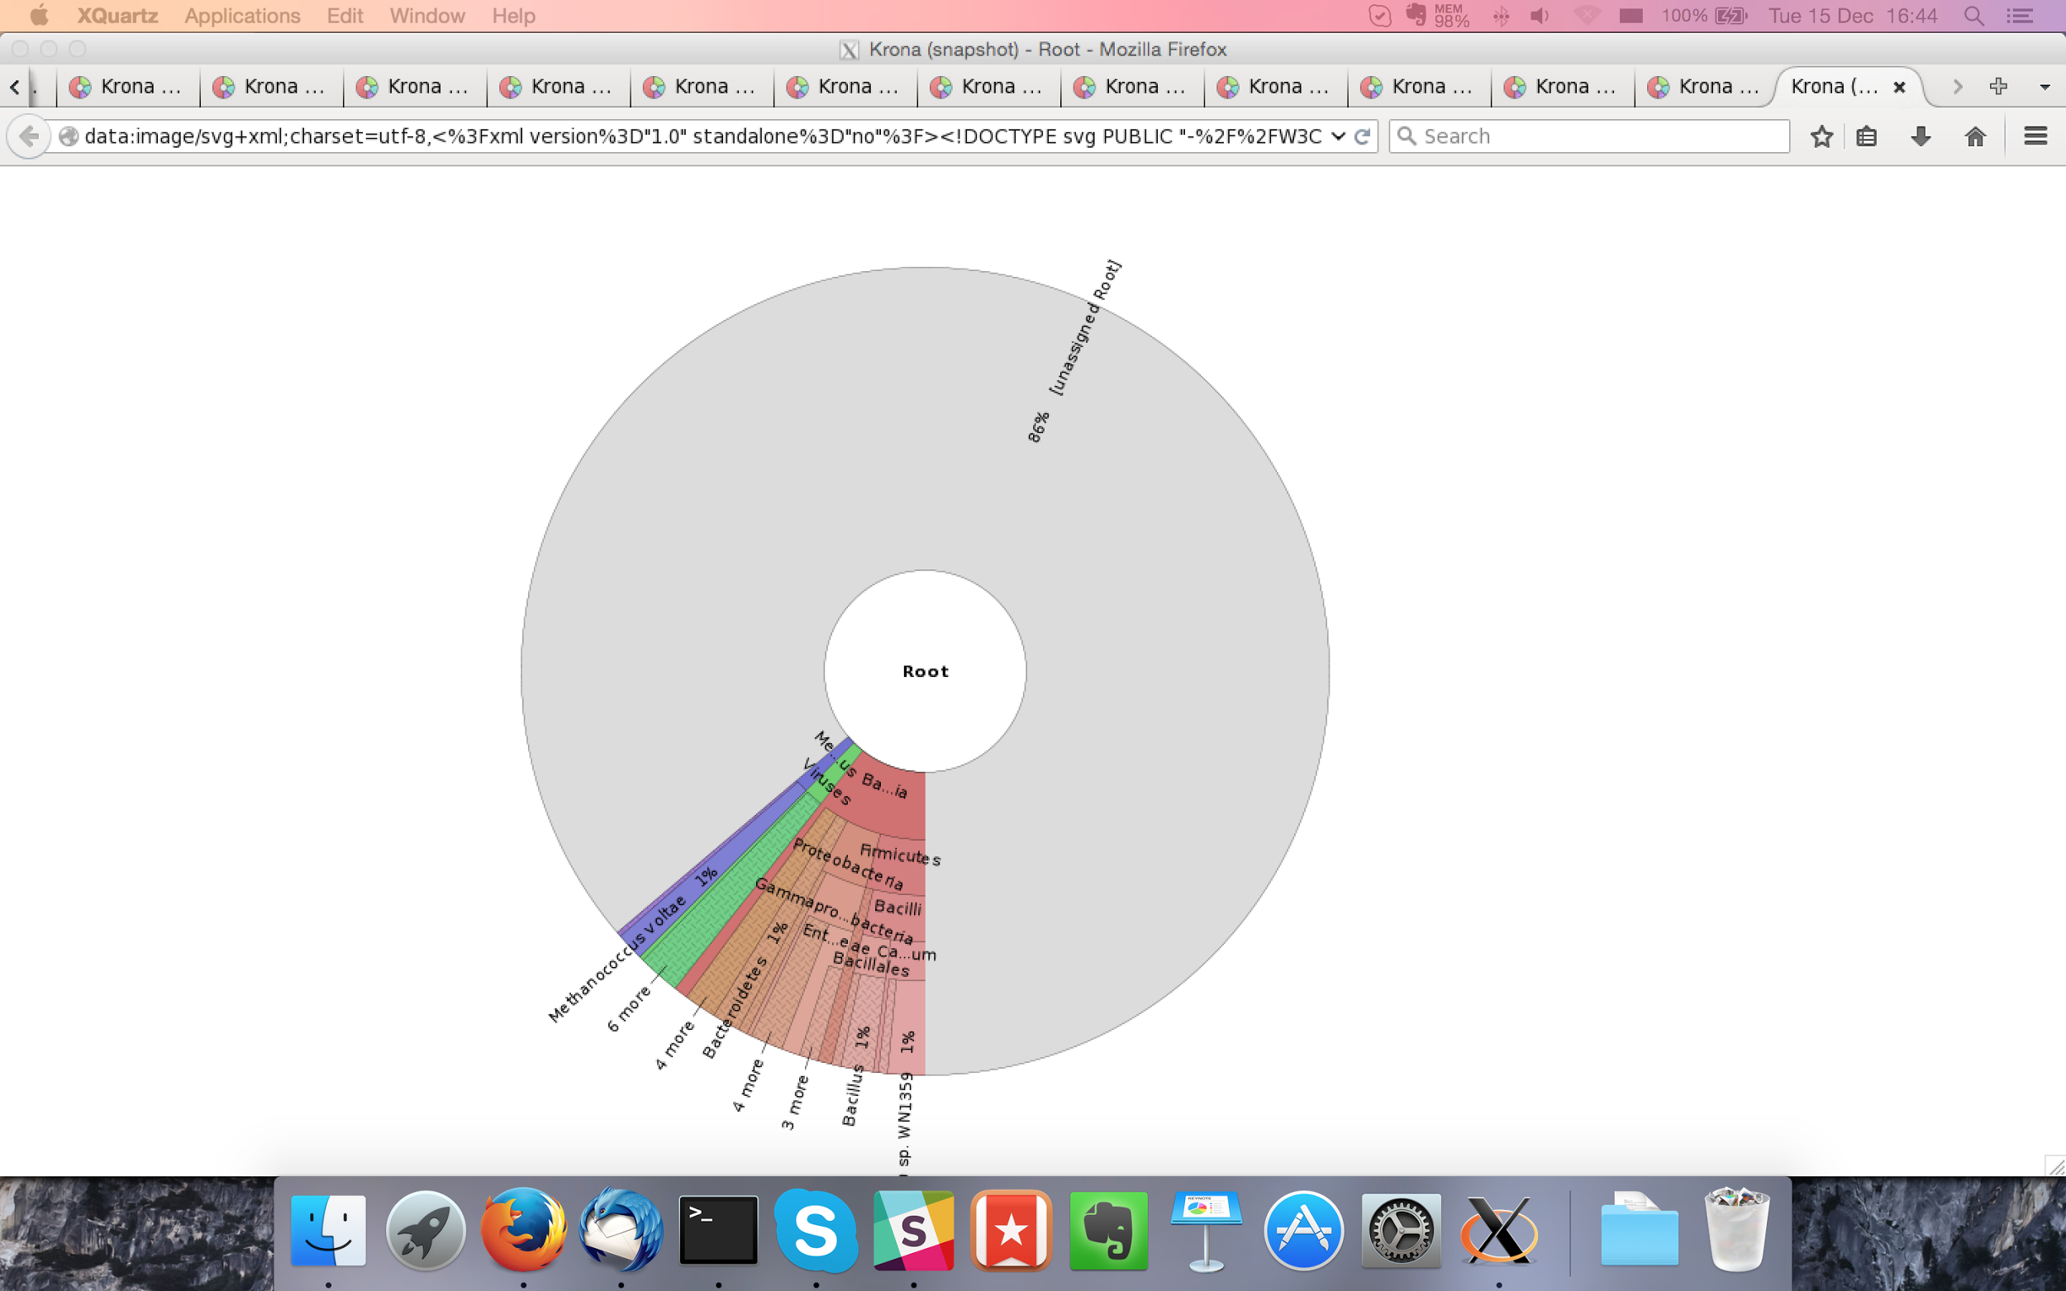

## Sample P1260_1007:

### Assembly Quality Assessment - Quast:

Spades followed by MaSuRCA gives the best assembly measured by comparing Cumulative length and Nx.

|  |  |
| --- | --- |
| Assembler | **Spades** |
| Number of contigs | 273 |
| Largest contig | 879,299 |
| Total assembly length | 11,893,461 |
| N50 | 347,577 |

Spades produced an assembly length of 11,893,461bp, comprised of 273 contigs with an N50 of 347,577bp.

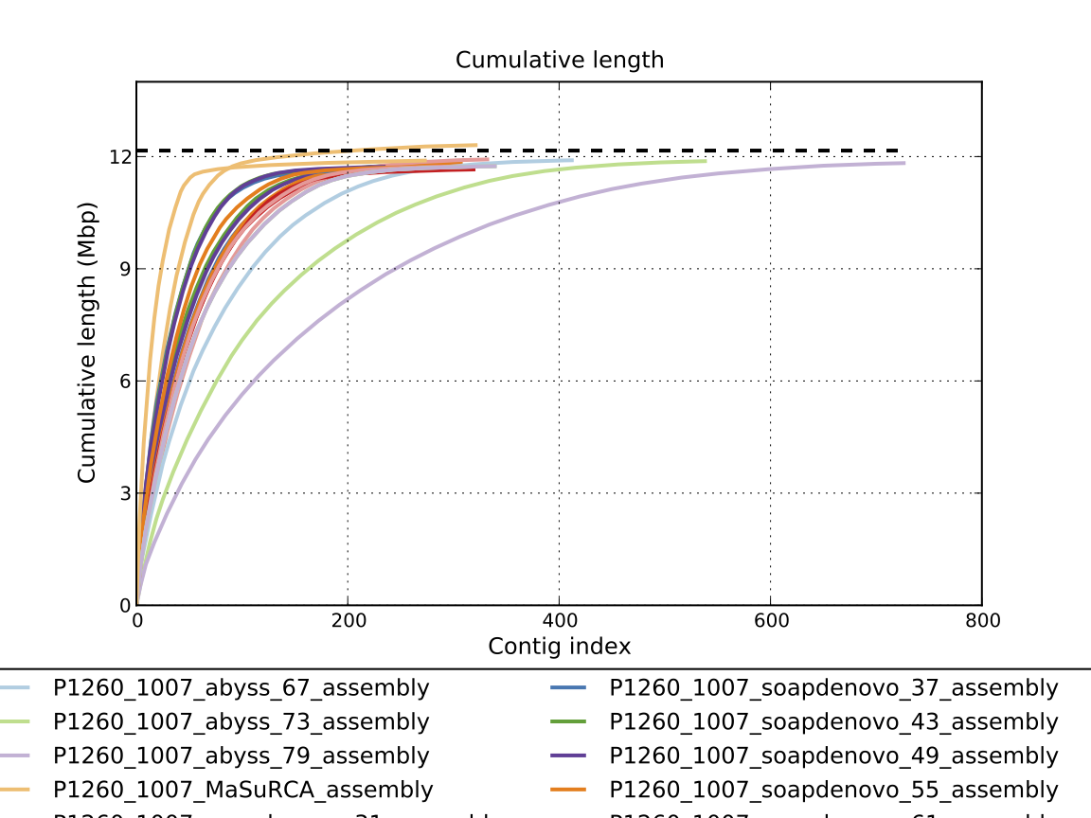

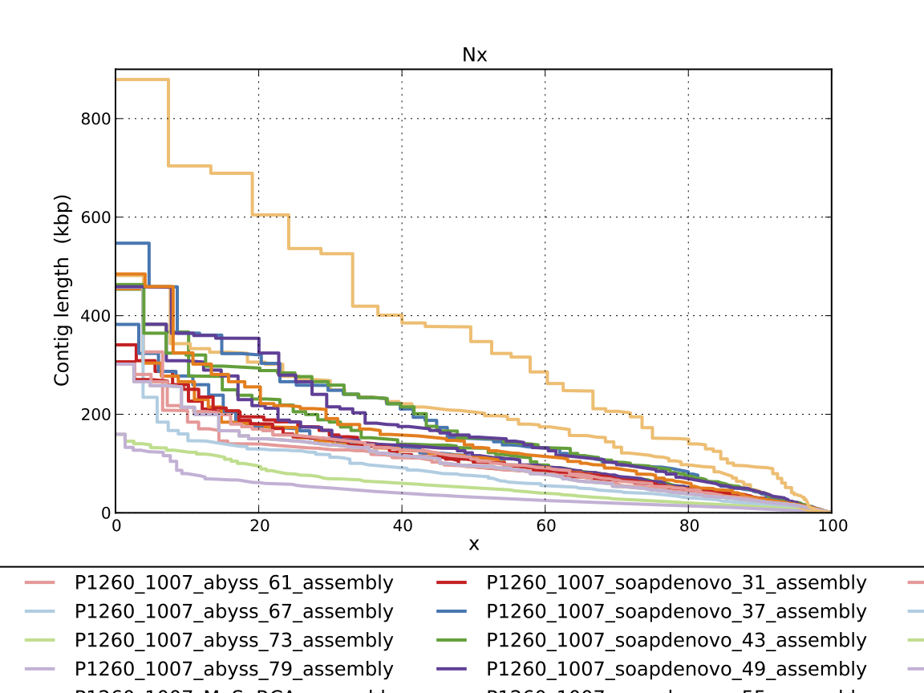

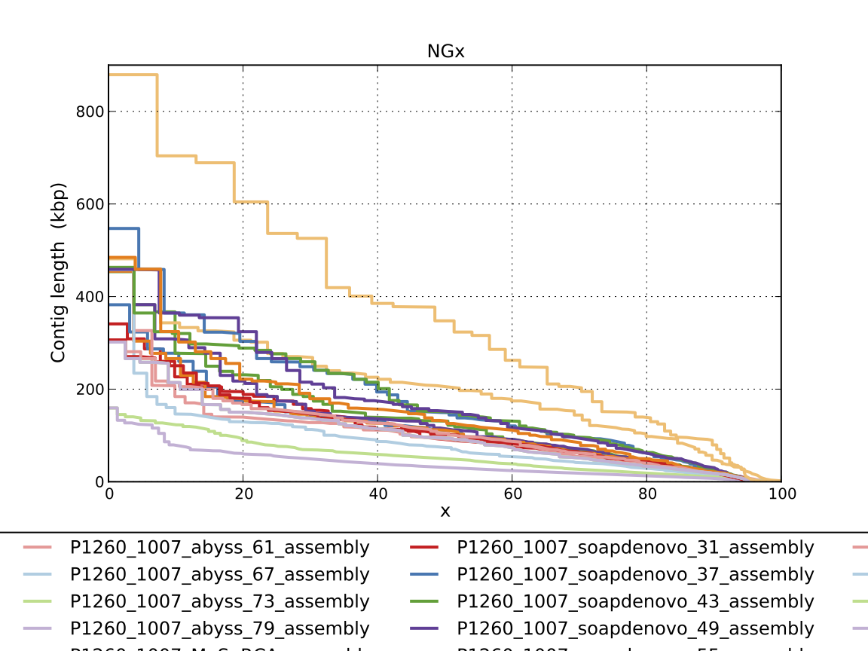

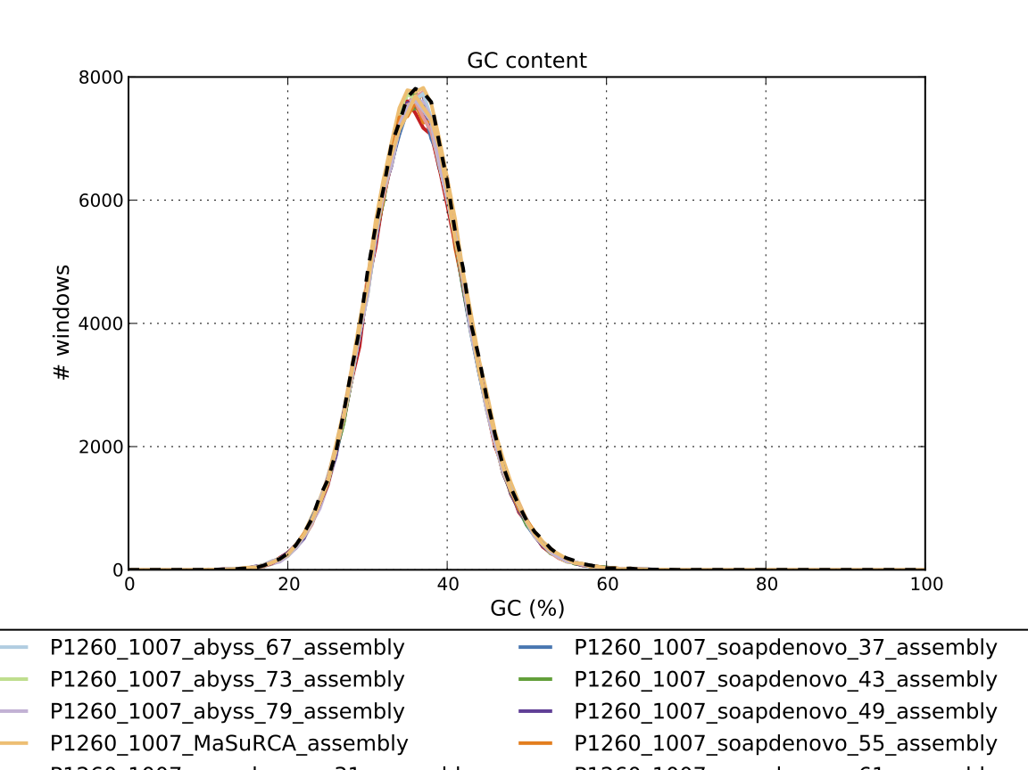

### Assembly Quality Assessment - Compass:

Compass shows that although the assembly is similar in size to the reference, a small portion does not align well, indicating contamination or a very large degree of divergence. The proportion of differing contigs is not clear due to the potential of multiple assembly contigs aligning to the same place on the reference.

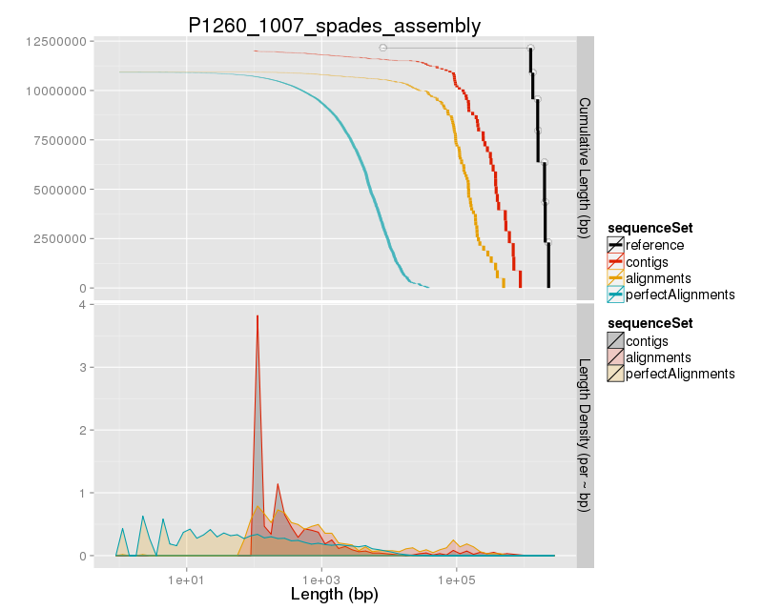

### Assembly Quality Assessment - KAT:

### Assembly Quality Assessment - FRCBAM:

### Assembly Quality Assessment - CEGMA:

CEGMA and BUSCO both attempt to validate the completeness of an assembly by looking at a known gene space, selected to be highly conserved, and present if most, if not all, organisms. CEGMA uses a gene space specifically designed for eukaryotic organisms, while BUSCO can be set for a number of taxonomic groups. Large variation within the completeness between assemblies may indicate that the data was hard to assemble, and thus might run a higher risk of misassembly. BUSCO will also report on duplications of genes, which may indicate chimera in the assembly, and mayneed to be further investigated after annotation.

The CEGMA report of the Spades assembly shows 94% completeness. The CEGMA completeness scores varied between 94.35% (Spades, Abyss k=49,55,61,67, and SOAPdenovo k=31,43,49,55) to 95.16% (MaSuRCA, Abyss k=79).

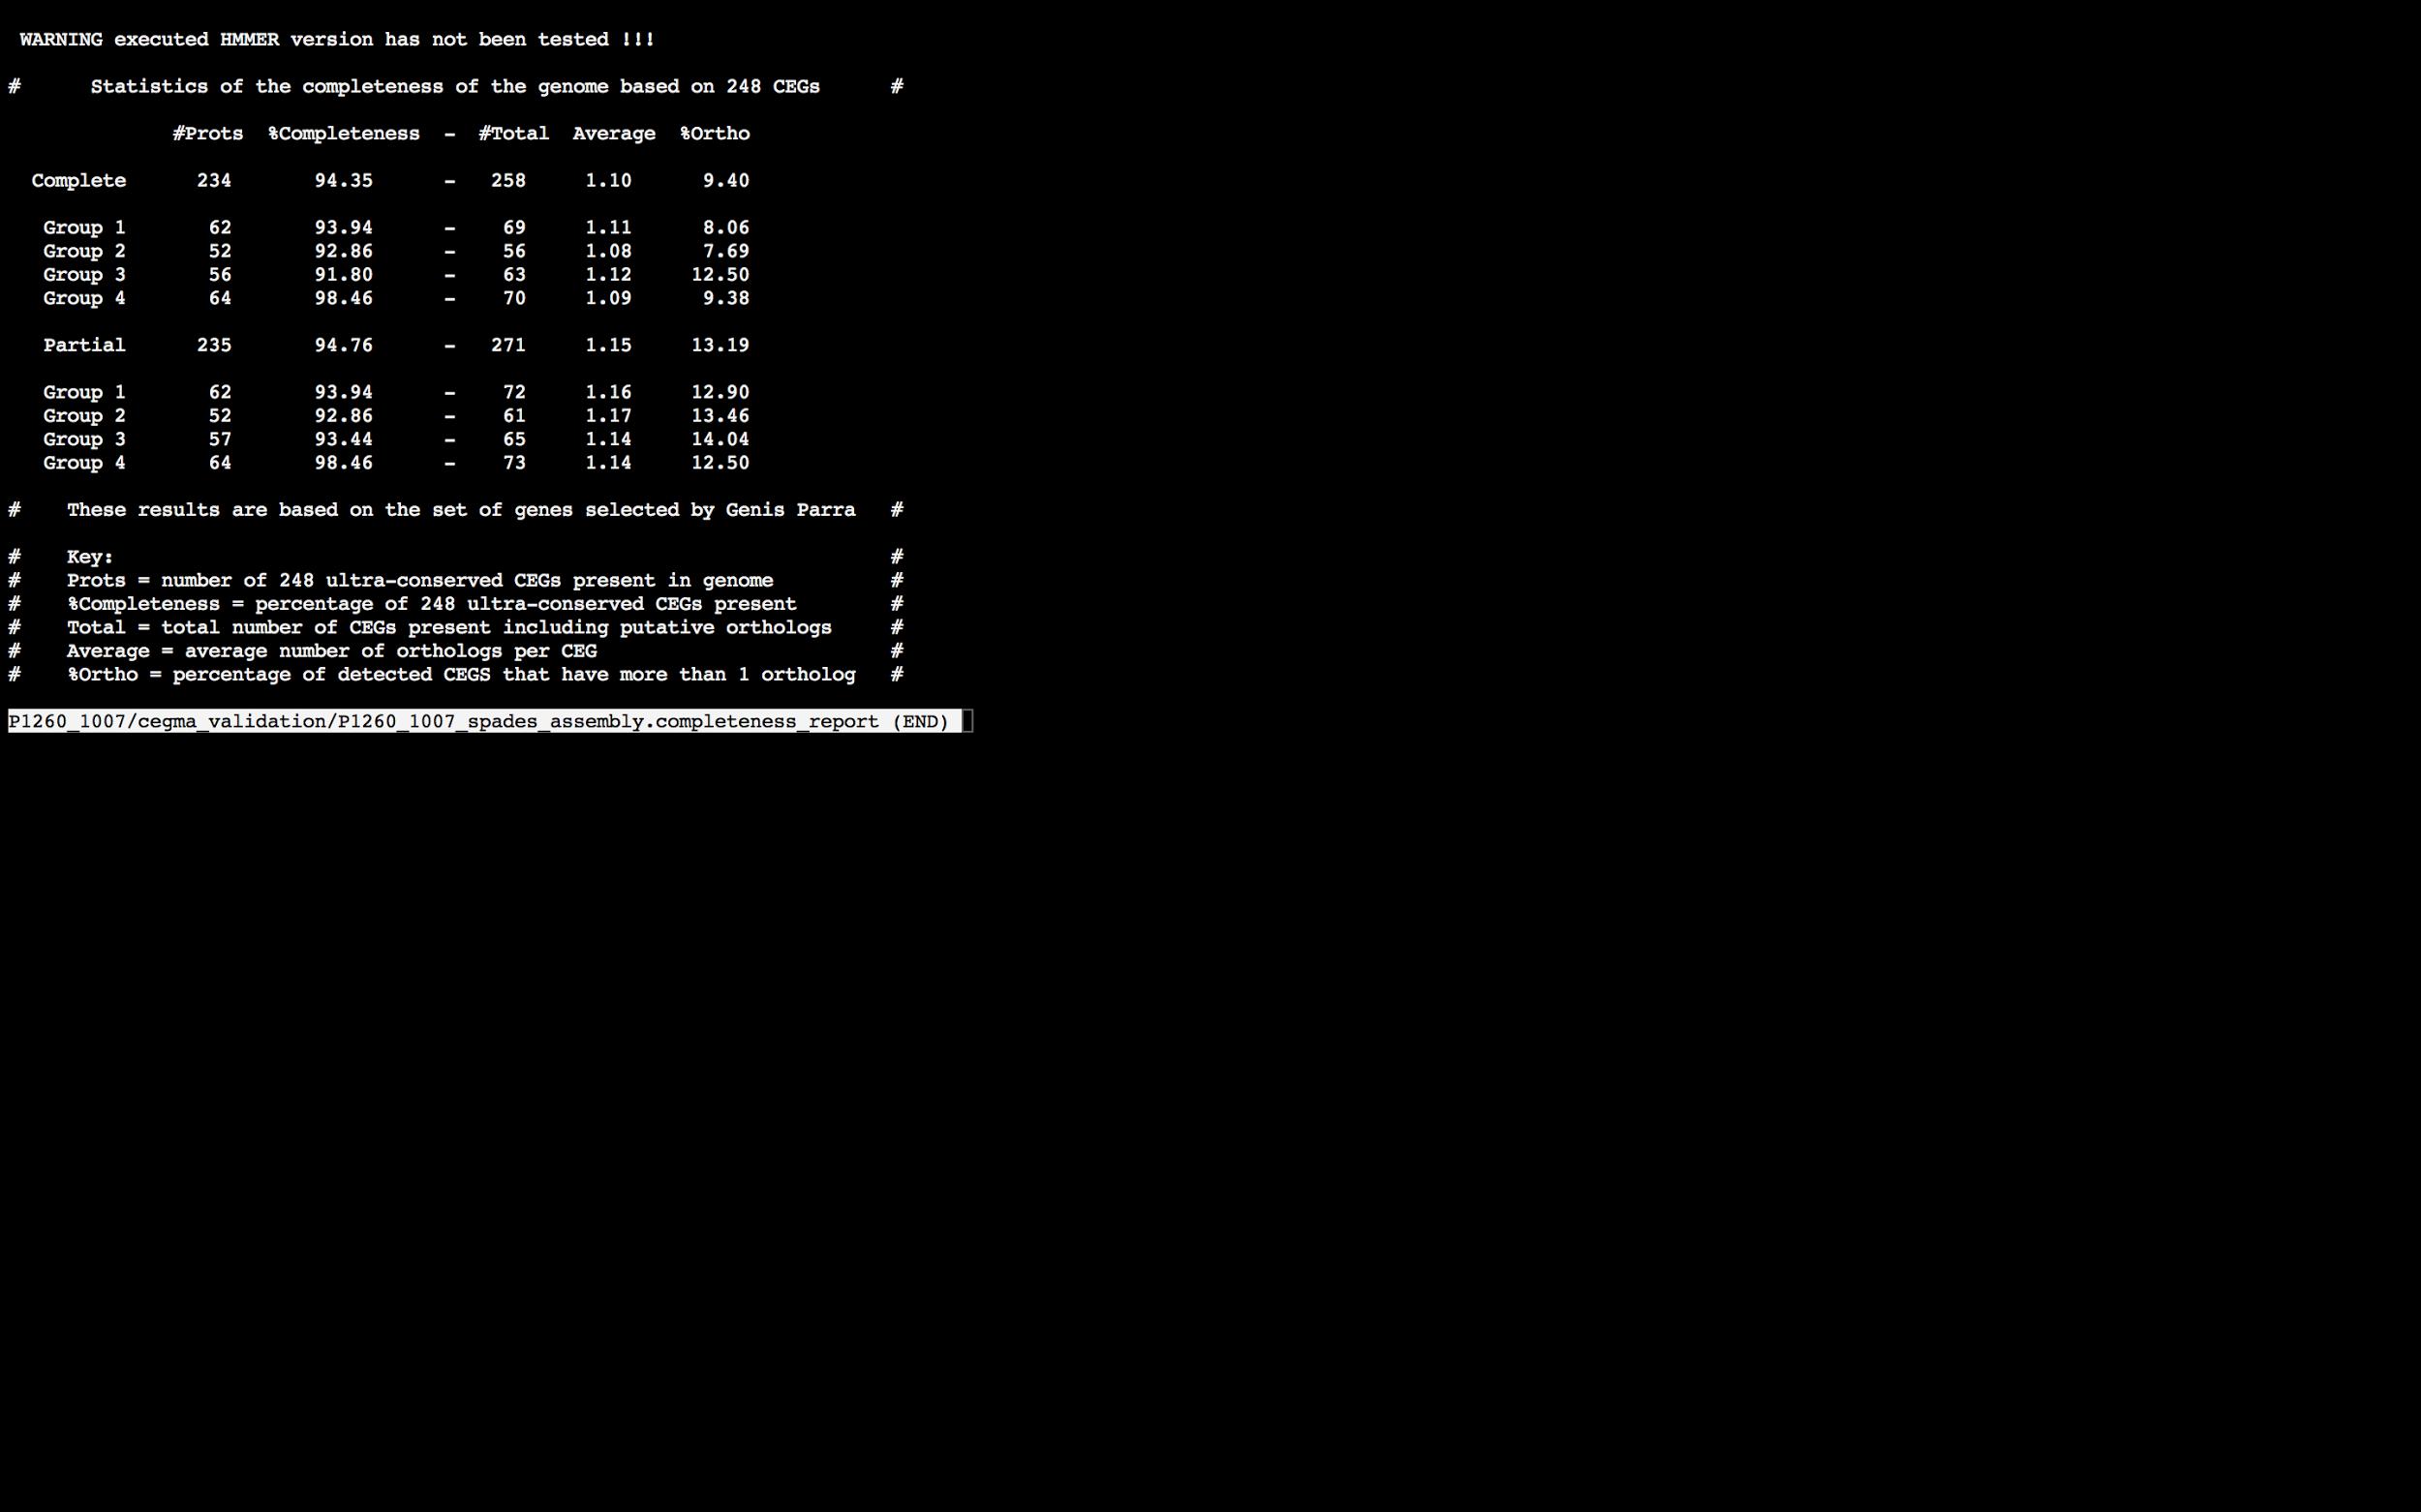

### Assembly Quality Assessment - BUSCO:

The BUSCO report of the Spades assembly shows 97% completeness and 11% duplication. The scores range from 94% (SOAPdenovo k=31) to 97% (MaSuRCA, Abyss k=31,37,43,49,55,61,73, SOAPdenovo k=37,43,49,55,61, and Spades).

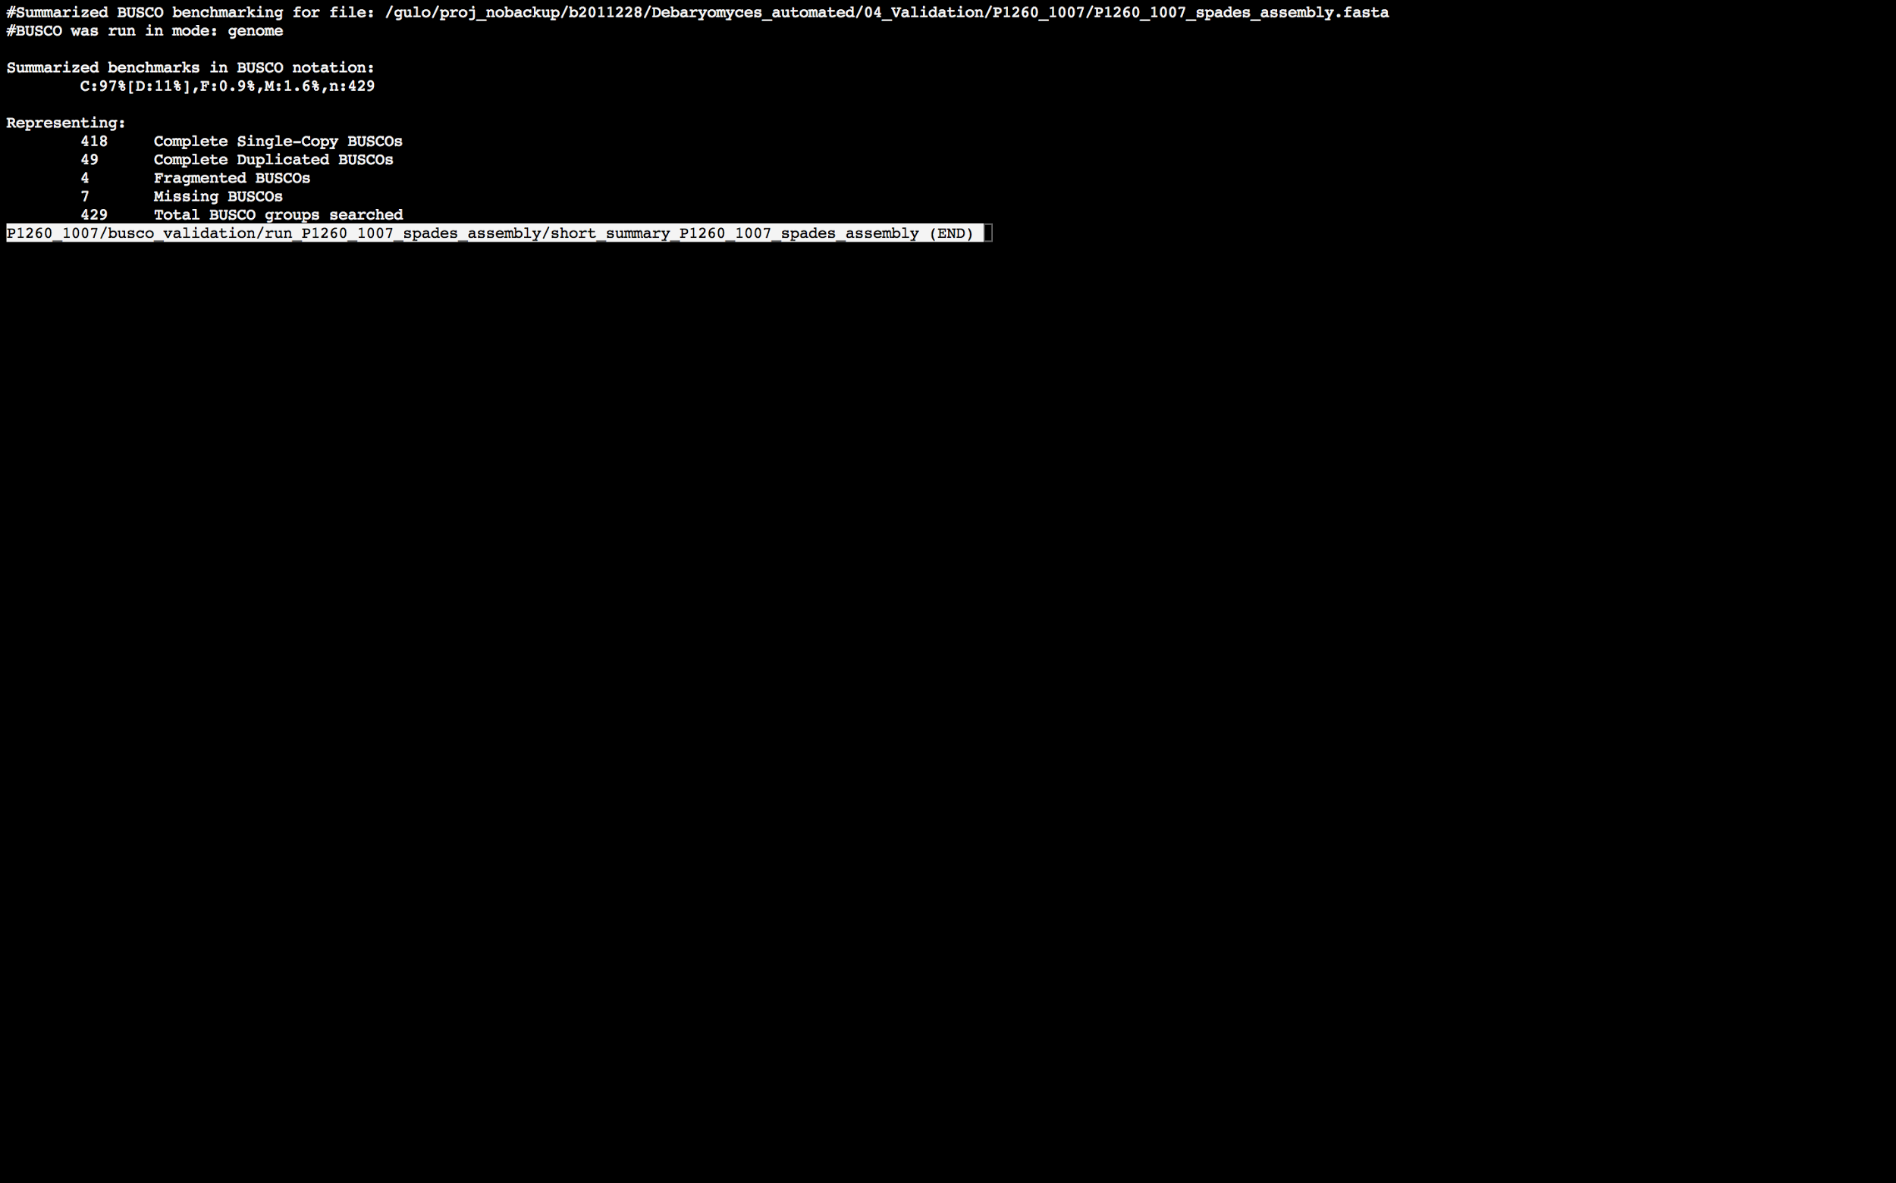

### Assembly Quality Assessment - Blobology:

Blobology indicates that while most contigs are likely Debaryomyces, bacteria may also be present. The blob plot shows a cluster of similar GC content contigs but with lower coverage that potentially indicates contamination. Contamination assessment is a difficult task, and should be interpreted as indicative rather than truth.

|  |  |
| --- | --- |
| # Contigs | Megablast hit |
| 1 | Bacillus sp. FJAT-18017 |
| 1 | Bacillus sp. X1(2014) |
| 1 | Carnobacterium mobile |
| 3 | Carnobacterium sp. 17-4 |
| 1 | Carnobacterium sp. BBDP71 |
| 7 | Carnobacterium sp. WN1359 |
| 3 | Citrobacter freundii |
| 361 | Debaryomyces hansenii |
| 1 | Enterococcus casseliflavus |
| 1 | Enterococcus durans |
| 1 | Geobacillus sp. LC300 |
| 1 | Homo sapiens |
| 1 | Lactobacillus sakei |
| 1 | Lactococcus garvieae |
| 128 | Not annotated |
| 1 | Pan troglodytes |
| 1 | Providencia stuartii |
| 1 | Providencia vermicola |
| 1 | Rhodobacter sphaeroides |
| 1 | Salmonella bongori |
| 1 | Scheffersomyces stipitis |

.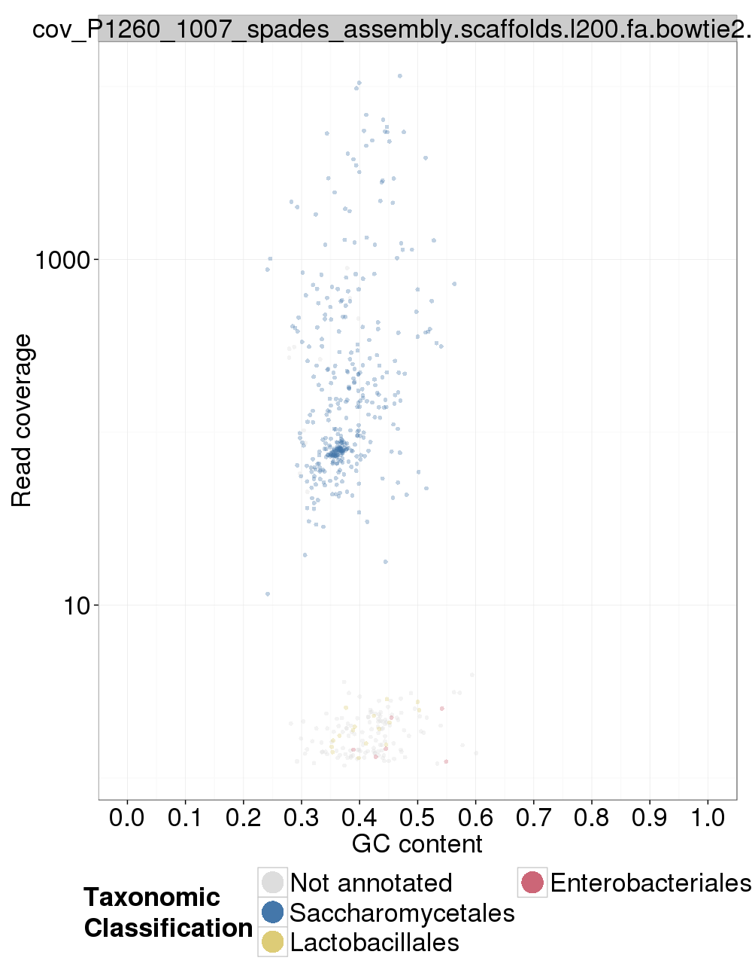

### Assembly Quality Assessment - Kraken:

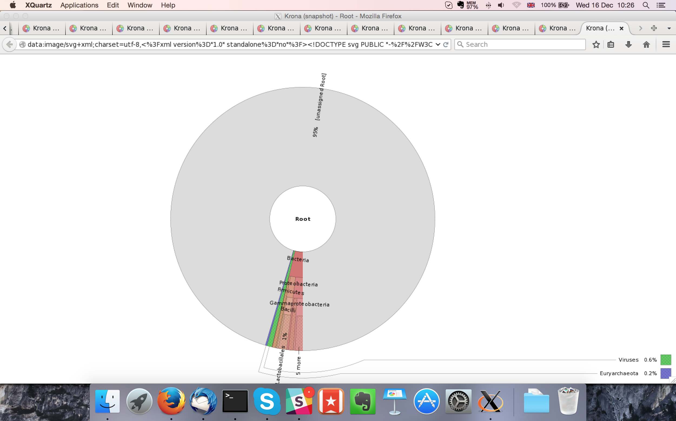

## Sample P1260_1008:

### Assembly Quality Assessment - Quast:

Spades followed by MaSuRCA gives the best assembly measured by comparing Cumulative length and Nx.

|  |  |
| --- | --- |
| Assembler | **Spades** |
| Number of contigs | 399 |
| Largest contig | 385,377 |
| Total assembly length | 12,179,345 |
| N50 | 132,180 |

Spades produced an assembly length of 12,179,345bp, comprised of 399 contigs with an N50 of 132,180bp.

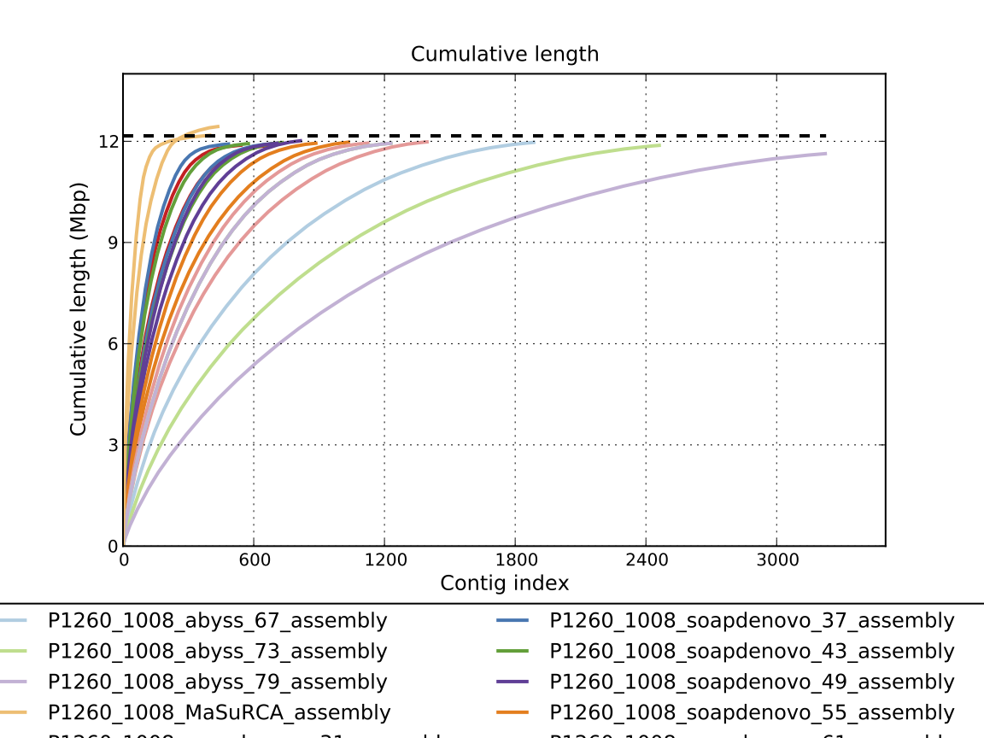

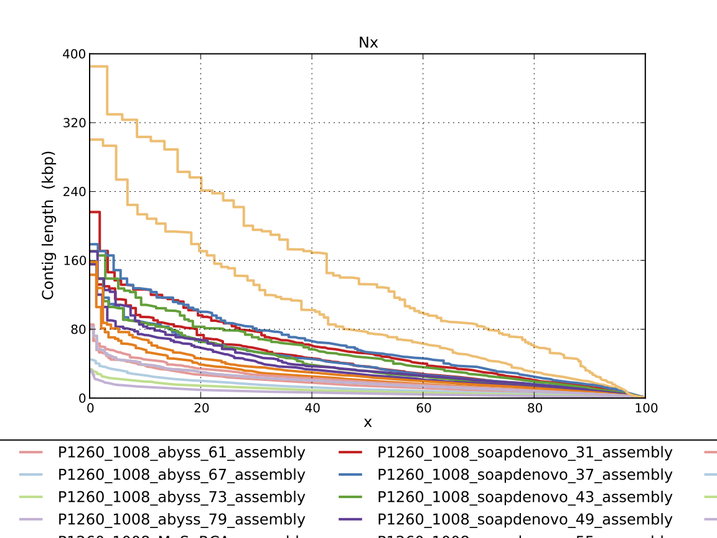

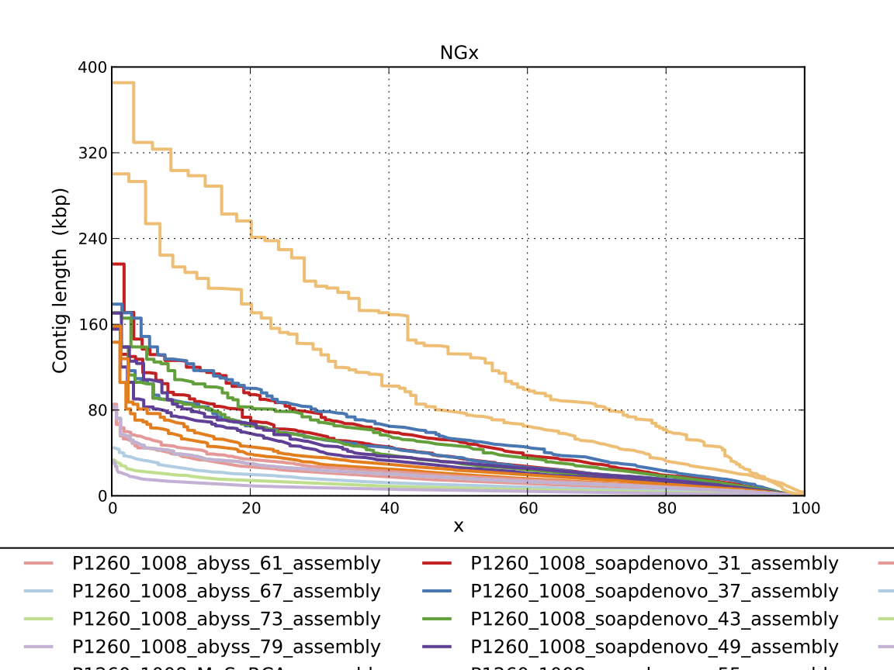

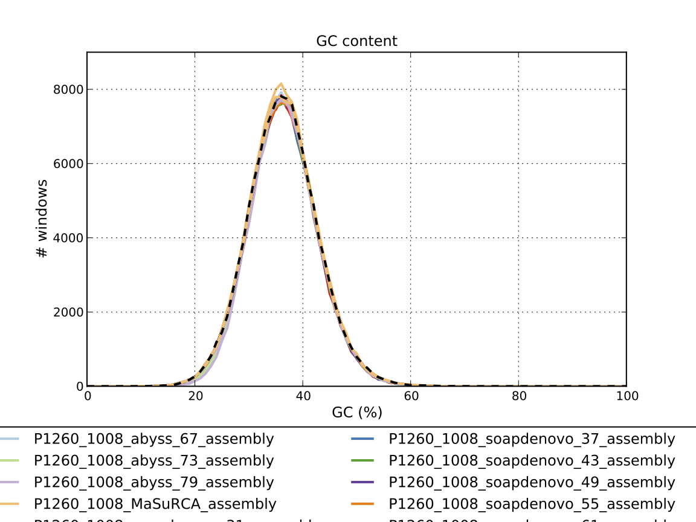

### Assembly Quality Assessment - Compass:

Compass shows that although the assembly is similar in size to the reference, a small portion does not align well, indicating contamination or a very large degree of divergence. The proportion of differing contigs is not clear due to the potential of multiple assembly contigs aligning to the same place on the reference.

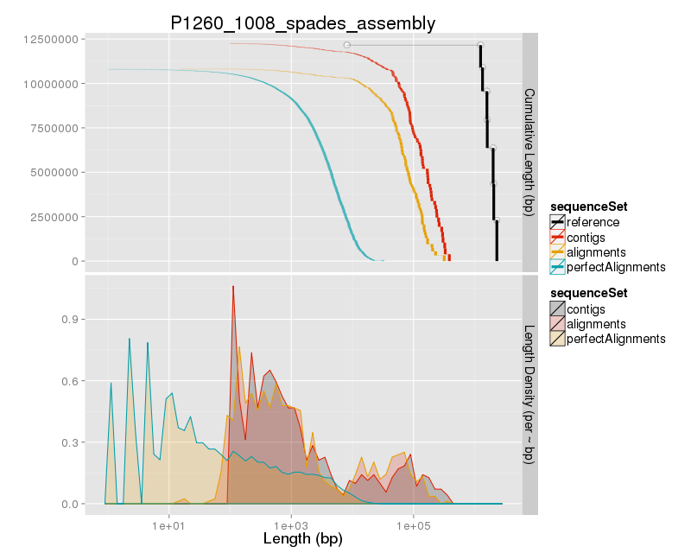

### Assembly Quality Assessment - KAT:

### Assembly Quality Assessment - FRCBAM:

### Assembly Quality Assessment - CEGMA:

CEGMA and BUSCO both attempt to validate the completeness of an assembly by looking at a known gene space, selected to be highly conserved, and present if most, if not all, organisms. CEGMA uses a gene space specifically designed for eukaryotic organisms, while BUSCO can be set for a number of taxonomic groups. Large variation within the completeness between assemblies may indicate that the data was hard to assemble, and thus might run a higher risk of misassembly. BUSCO will also report on duplications of genes, which may indicate chimera in the assembly, and mayneed to be further investigated after annotation.

The CEGMA report of the Spades assembly shows 95% completeness. The CEGMA completeness scores varied between 94.35% (MaSuRCA) to 96.37% (Abyss k=73).

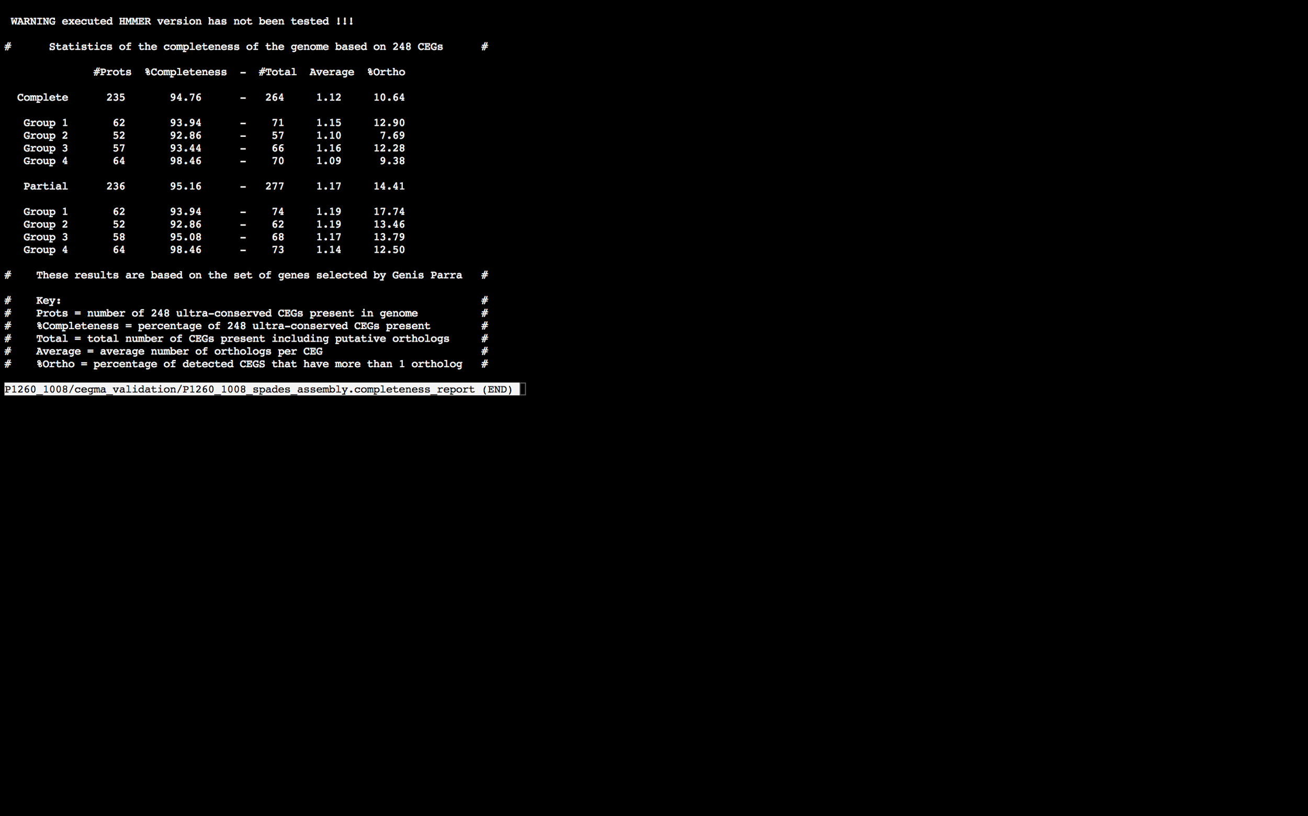

### Assembly Quality Assessment - BUSCO:

The BUSCO report of the Spades assembly shows 97% completeness and 11% duplication. The scores range from 86% (Abyss k=79) to 97% (Abyss k=49, SOAPdenovo k=43, and Spades).

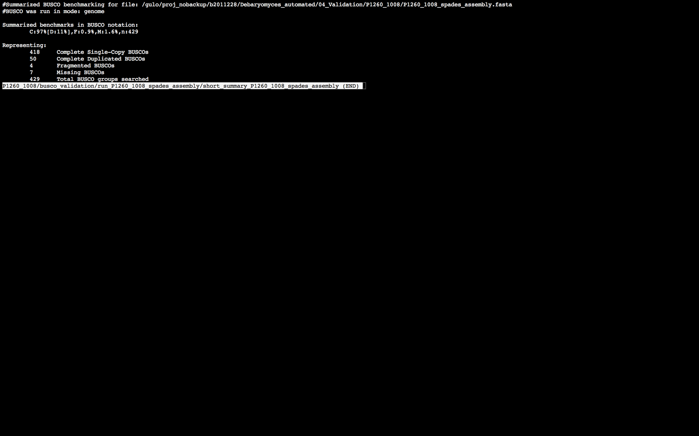

### Assembly Quality Assessment - Blobology:

Blobology indicates that while most contigs are likely Debaryomyces, bacteria may also be present. The blob plot shows a cluster of similar GC content contigs but with lower coverage that potentially indicates contamination. Contamination assessment is a difficult task, and should be interpreted as indicative rather than truth.

|  |  |
| --- | --- |
| # Contigs | Megablast hit |
| 1 | Cellulophaga baltica |
| 2 | Cyclotella sp. WC03_2 |
| 541 | Debaryomyces hansenii |
| 1 | Diphyllobothrium latum |
| 1 | Flavobacterium indicum |
| 1 | Homo sapiens |
| 23 | Not annotated |
| 1 | Scheffersomyces stipitis |
| 1 | Siansivirga zeaxanthinifaciens |
| 1 | Thalassiosira pseudonana |

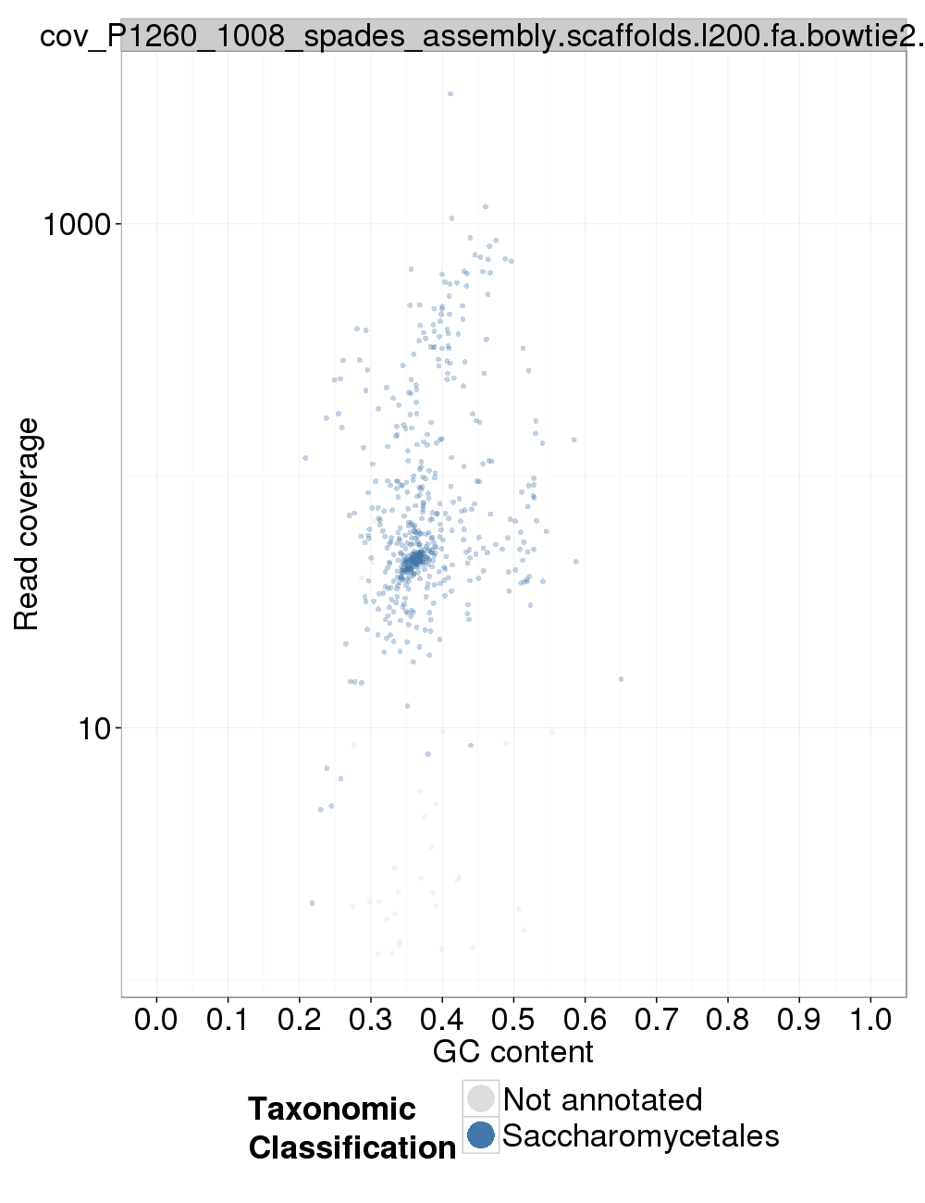

### Assembly Quality Assessment - Kraken:

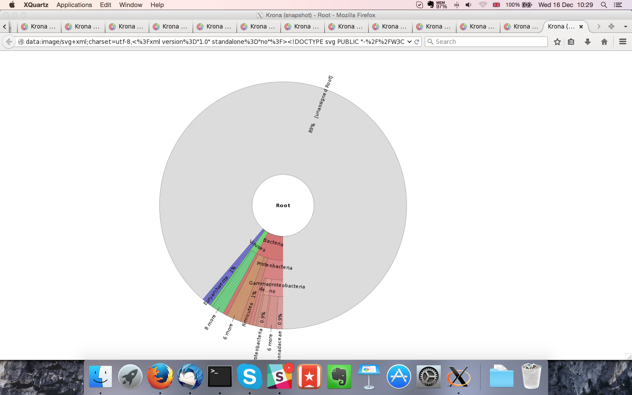

## Sample P1260_1009:

### Assembly Quality Assessment - Quast:

MaSuRCA followed by Soap de novo (k=49) gives the best assembly measured by comparing Cumulative length and Nx.

|  |  |
| --- | --- |
| Assembler | **MaSuRCA** |
| Number of contigs | 842 |
| Largest contig | 262,285 |
| Total assembly length | 21,881,046 |
| N50 | 56,094 |

MaSuRCA produced an assembly length of 21,881,046bp, comprised of 842 contigs with an N50 of 56,094bp.

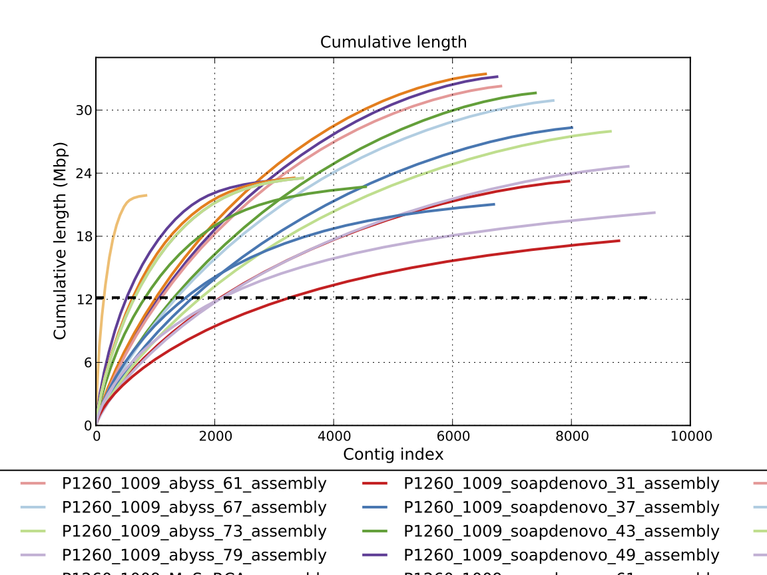

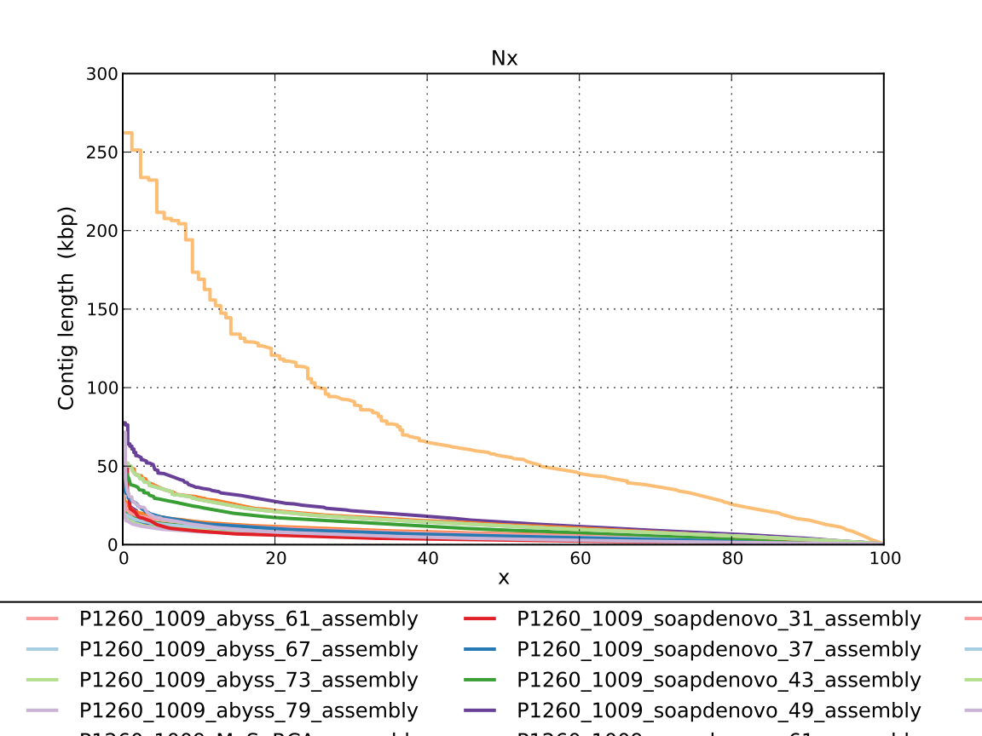

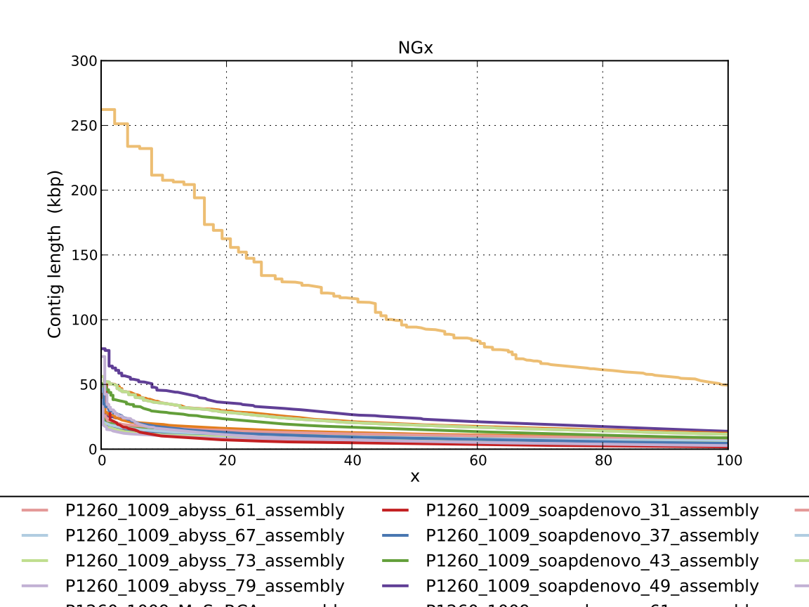

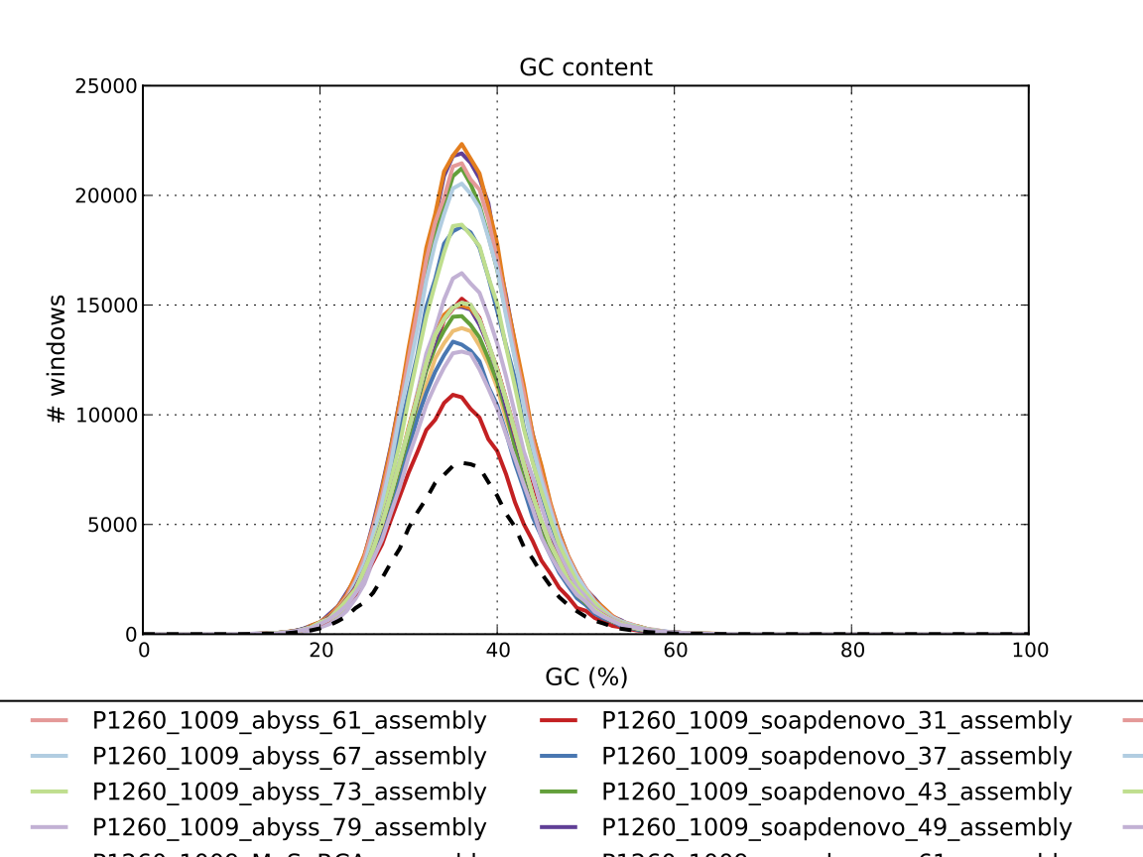

### Assembly Quality Assessment - Compass:

Compass shows that the assembly is greater in size to the reference, and aligns to a good degree to the reference. The portion that does not align well indicates contamination or a very large degree of divergence. The proportion of differing contigs is not clear due to the potential of multiple assembly contigs aligning to the same place on the reference.

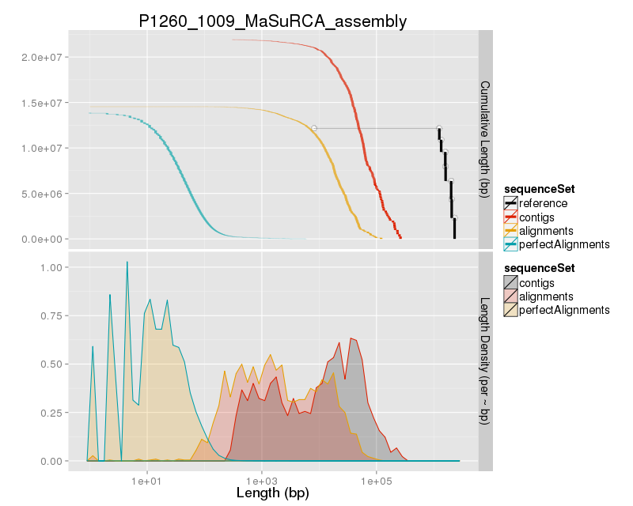

### Assembly Quality Assessment - KAT:

### Assembly Quality Assessment - FRCBAM:

### Assembly Quality Assessment - CEGMA:

CEGMA and BUSCO both attempt to validate the completeness of an assembly by looking at a known gene space, selected to be highly conserved, and present if most, if not all, organisms. CEGMA uses a gene space specifically designed for eukaryotic organisms, while BUSCO can be set for a number of taxonomic groups. Large variation within the completeness between assemblies may indicate that the data was hard to assemble, and thus might run a higher risk of misassembly. BUSCO will also report on duplications of genes, which may indicate chimera in the assembly, and mayneed to be further investigated after annotation.

The CEGMA report of the MaSuRCA assembly shows 96% completeness. The CEGMA completeness scores varied between 22.58% (SOAPdenovo k=31) to 96.37% (MaSuRCA, and Abyss k=55).

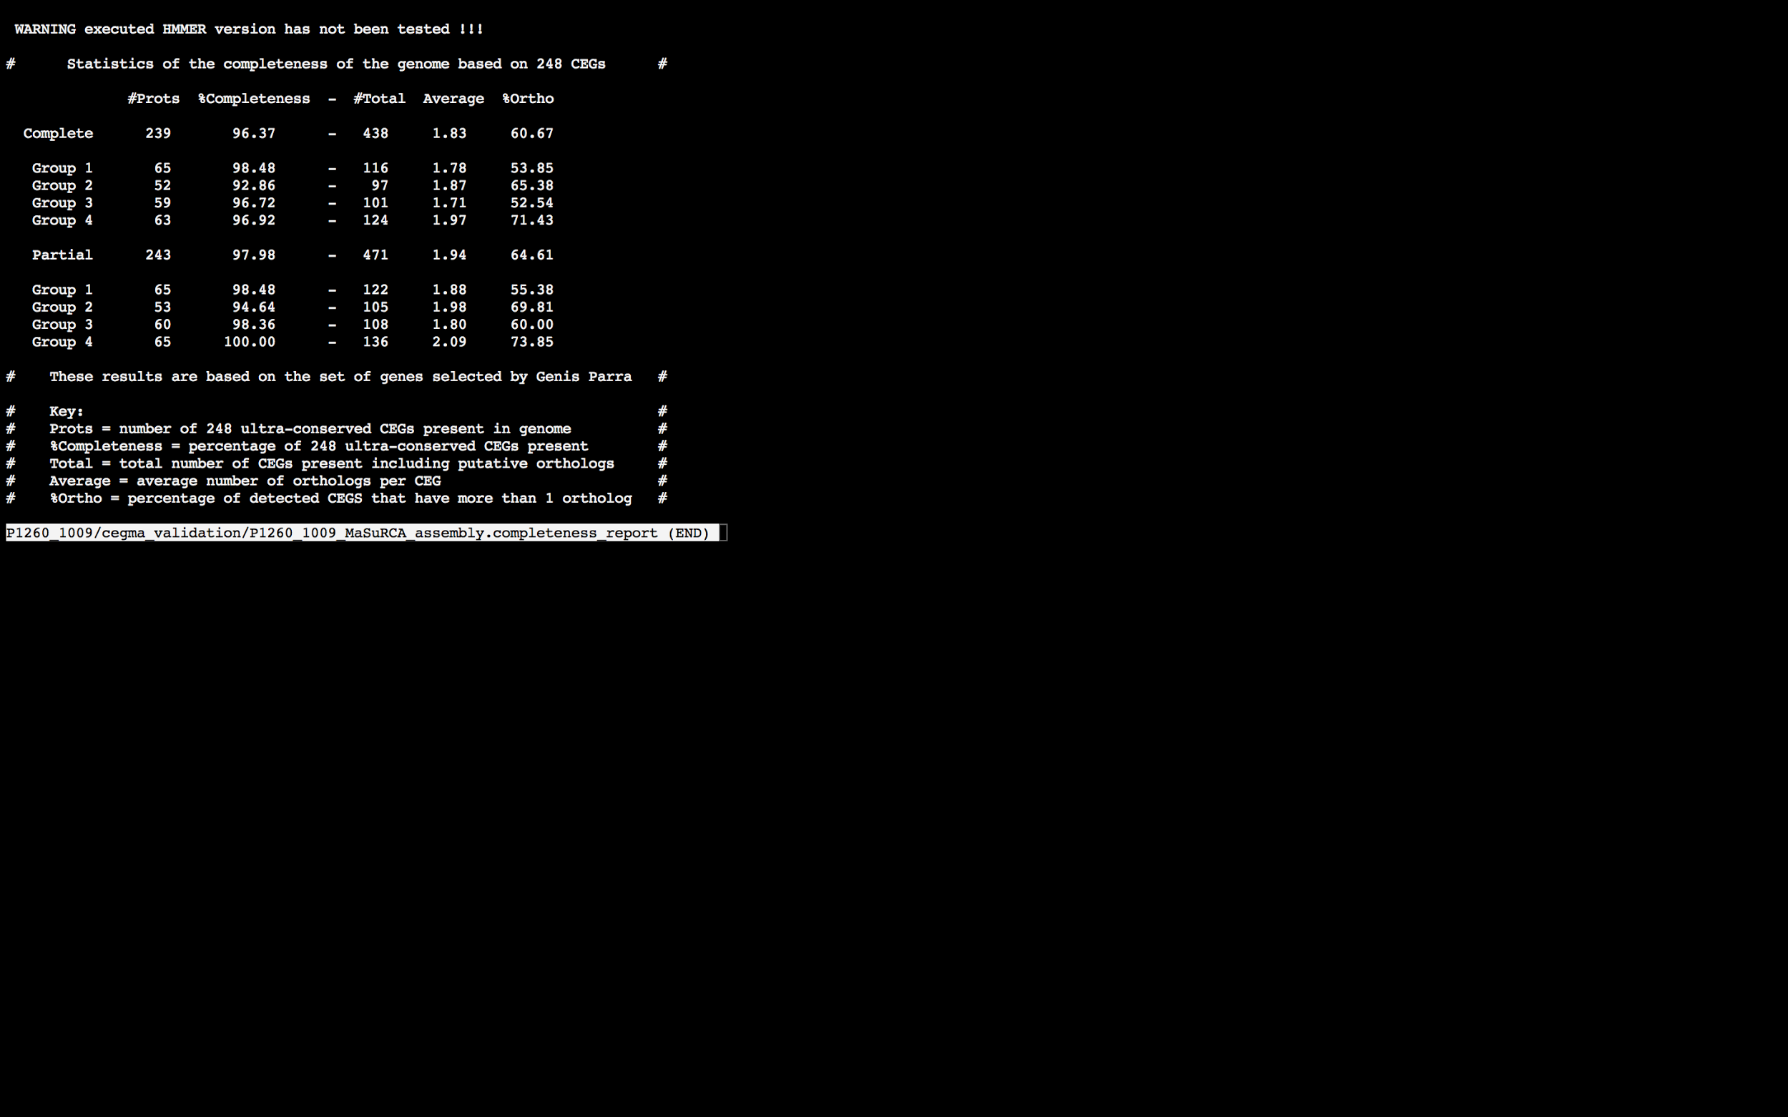

### Assembly Quality Assessment - BUSCO:

The BUSCO report of the MaSuRCA assembly shows 97% completeness and 62% duplication. The scores range from 16% (SOAPdenovo k=31) to 97% (MaSuRCA).

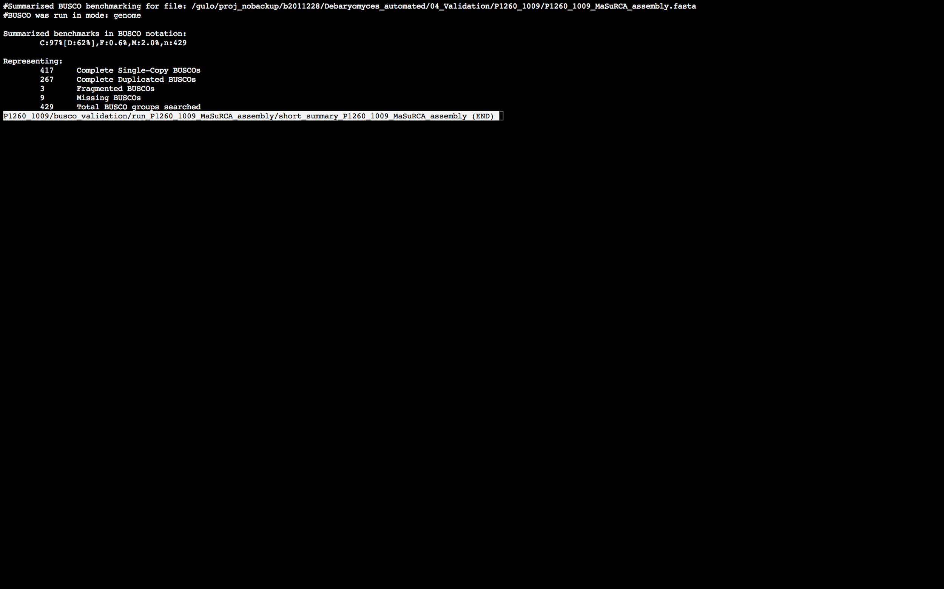

### Assembly Quality Assessment - Blobology:

Blobology indicates that most contigs are likely Debaryomyces. Contamination assessment is a difficult task, and should be interpreted as indicative rather than truth.

|  |  |
| --- | --- |
| # Contigs | Megablast hit |
| 870 | Debaryomyces hansenii |
| 2 | Debaryomyces tyrocola |
| 1 | Millerozyma farinosa |
| 22 | Not annotated |
| 1 | Scheffersomyces stipitis |
| 2 | uncultured Ascomycota |
| 2 | uncultured Saccharomycetales |

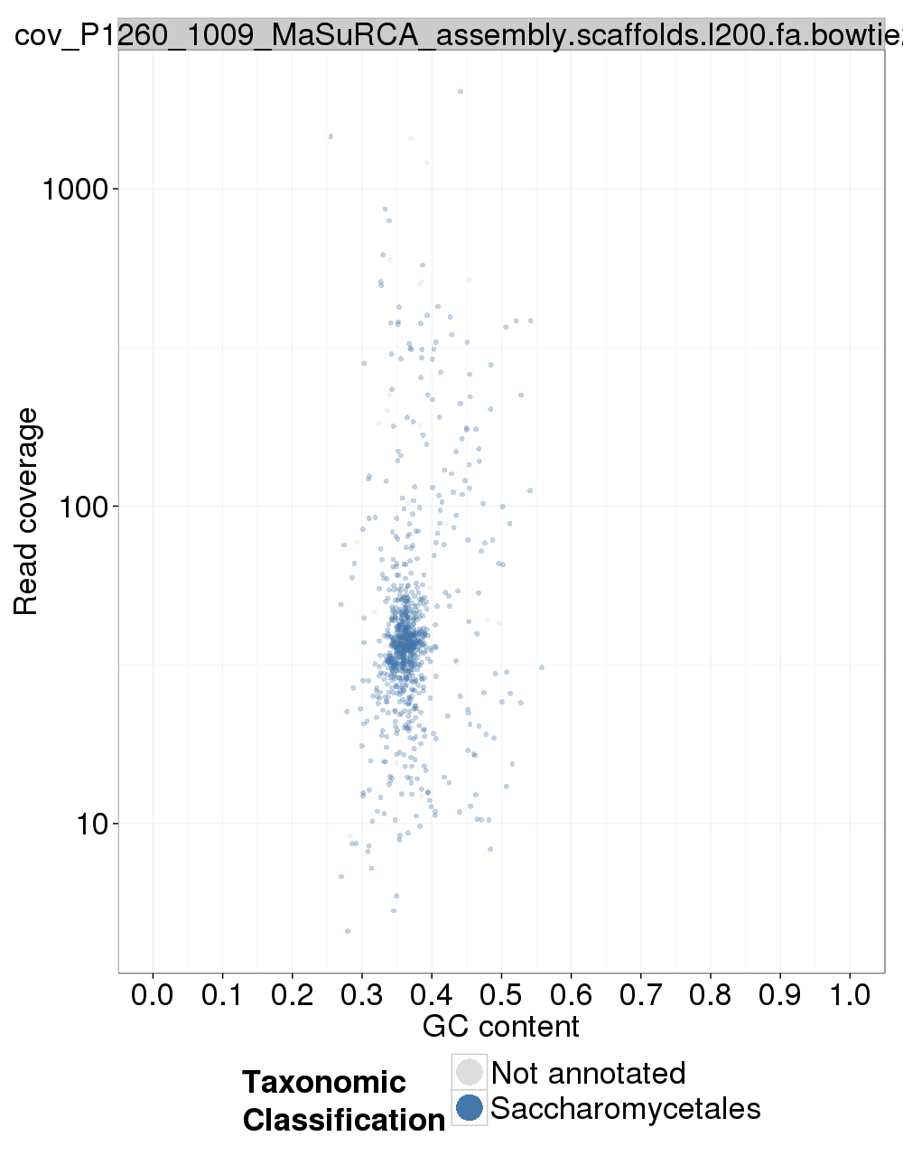

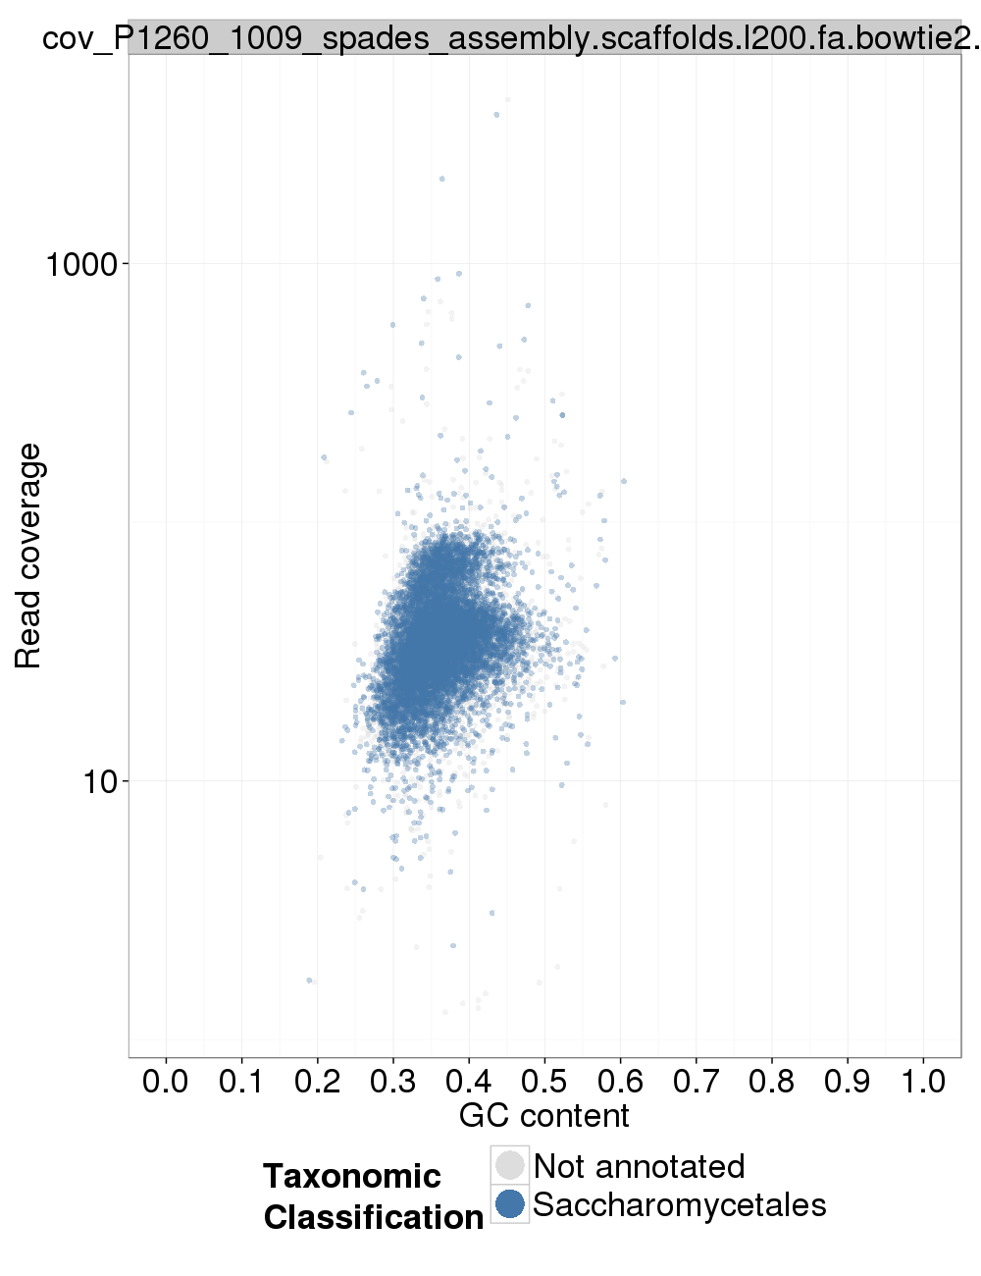

### Assembly Quality Assessment - Kraken:

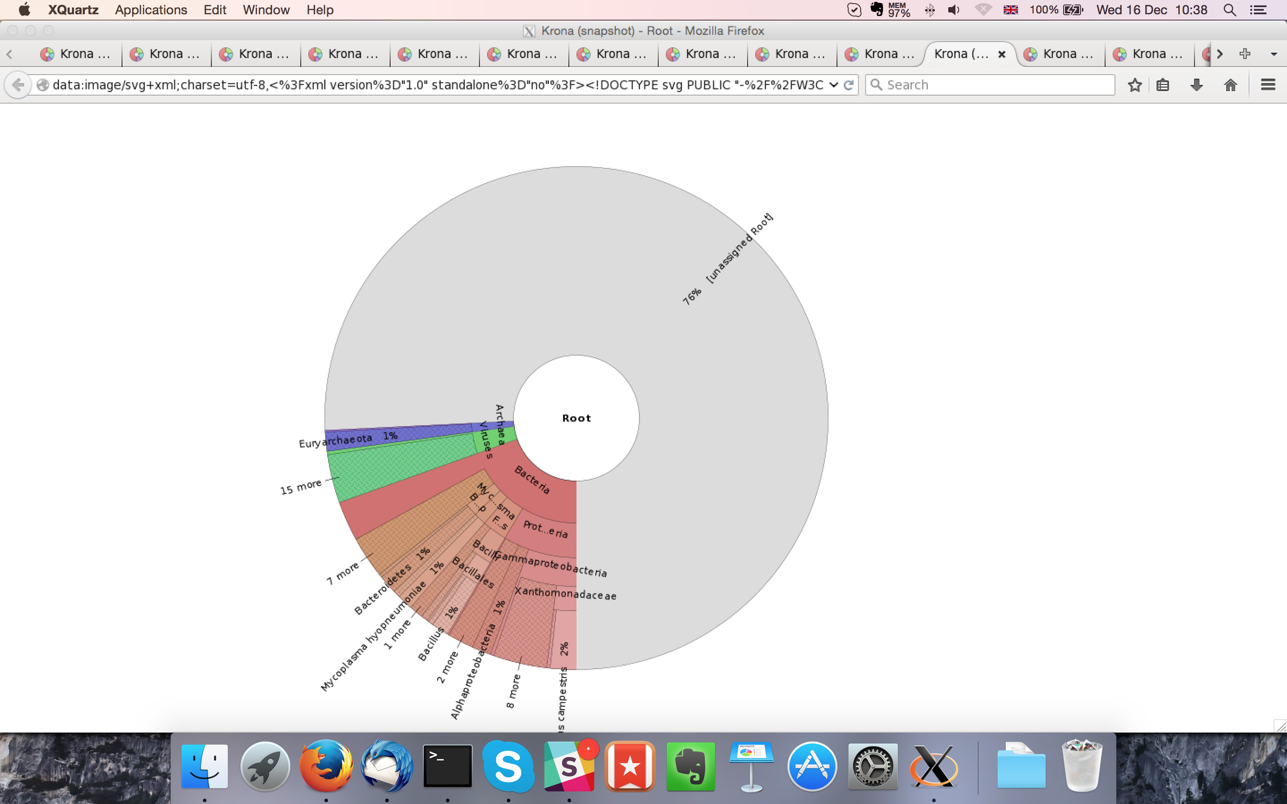

## Sample P1260_1010:

### Assembly Quality Assessment - Quast:

Spades followed by MaSuRCA gives the best assembly measured by comparing Cumulative length and Nx.

|  |  |
| --- | --- |
| Assembler | **Spades** |
| Number of contigs | 347 |
| Largest contig | 508,743 |
| Total assembly length | 12,466,050 |
| N50 | 168,672 |

Spades produced an assembly length of 12,466,050bp, comprised of 347 contigs with an N50 of 168,672bp.

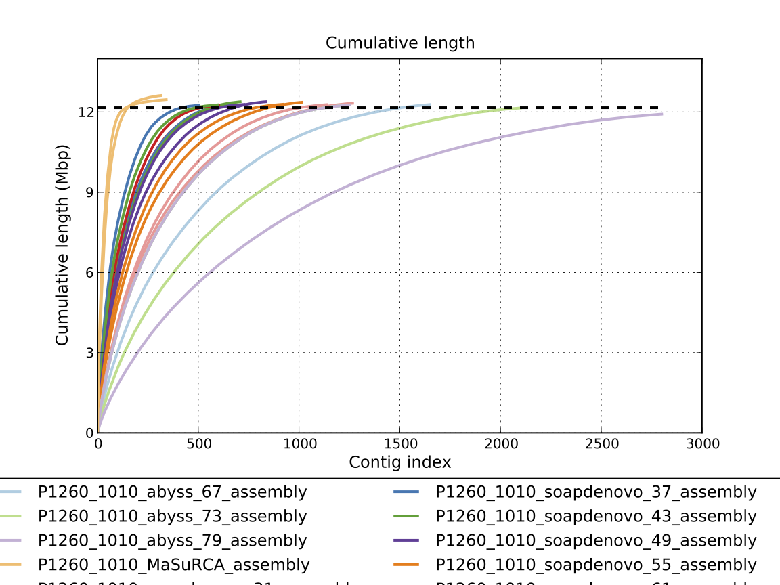

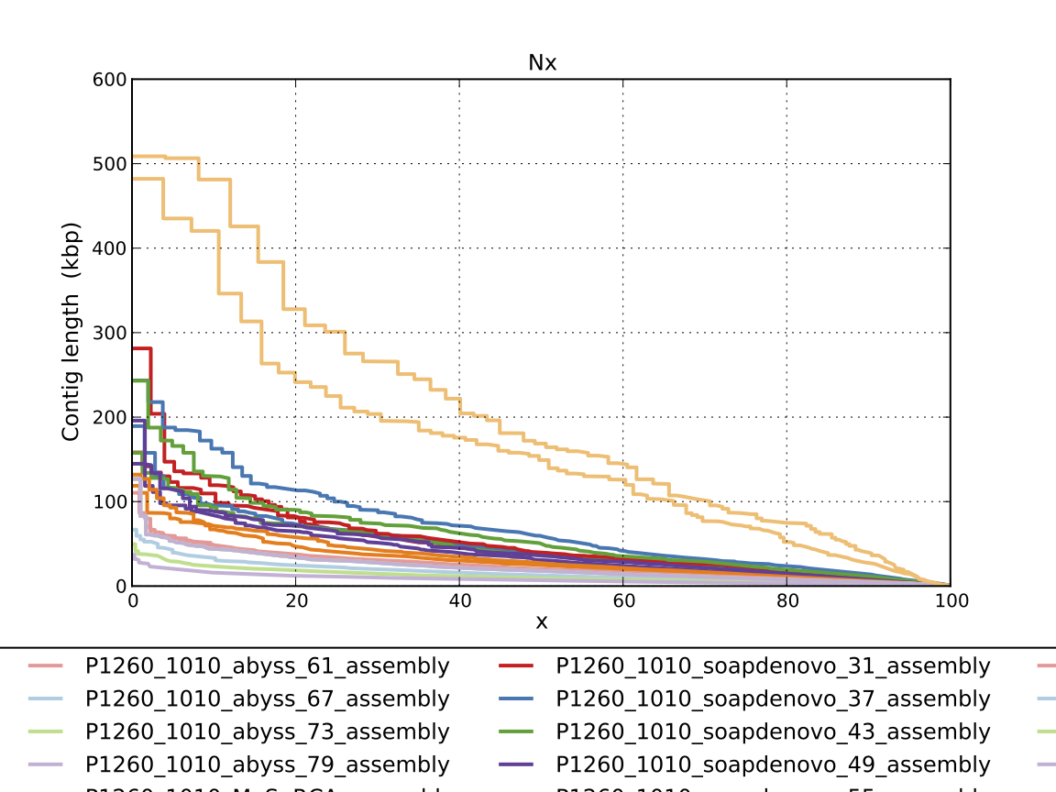

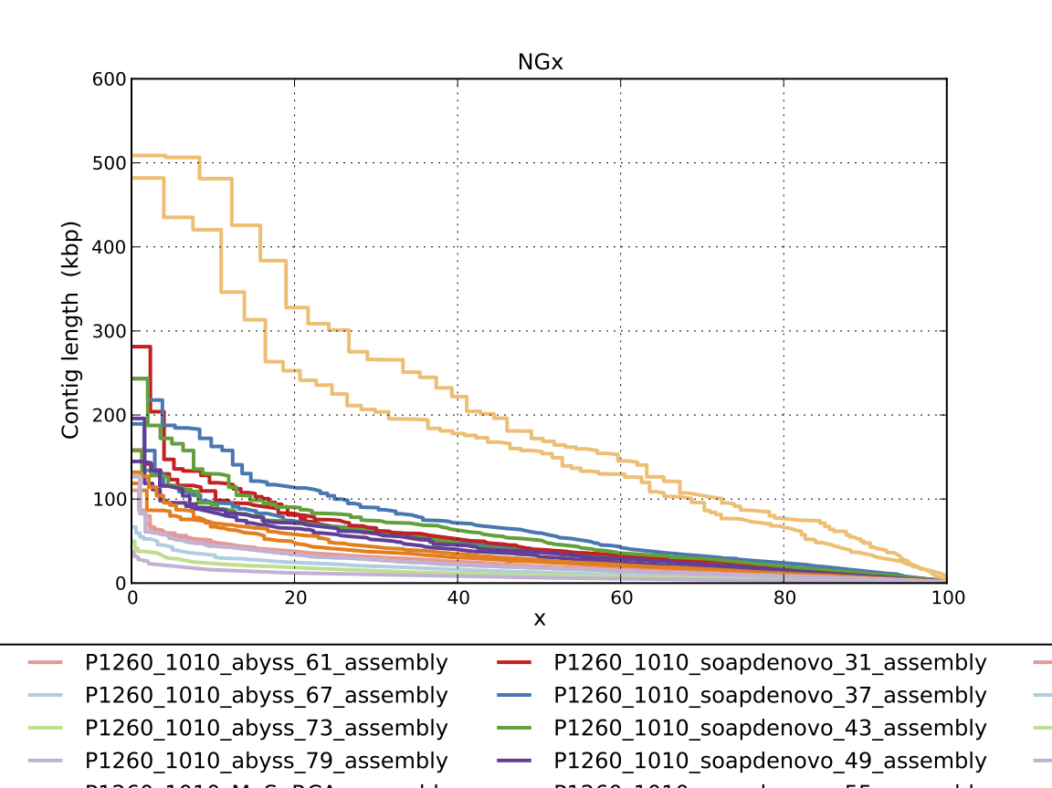

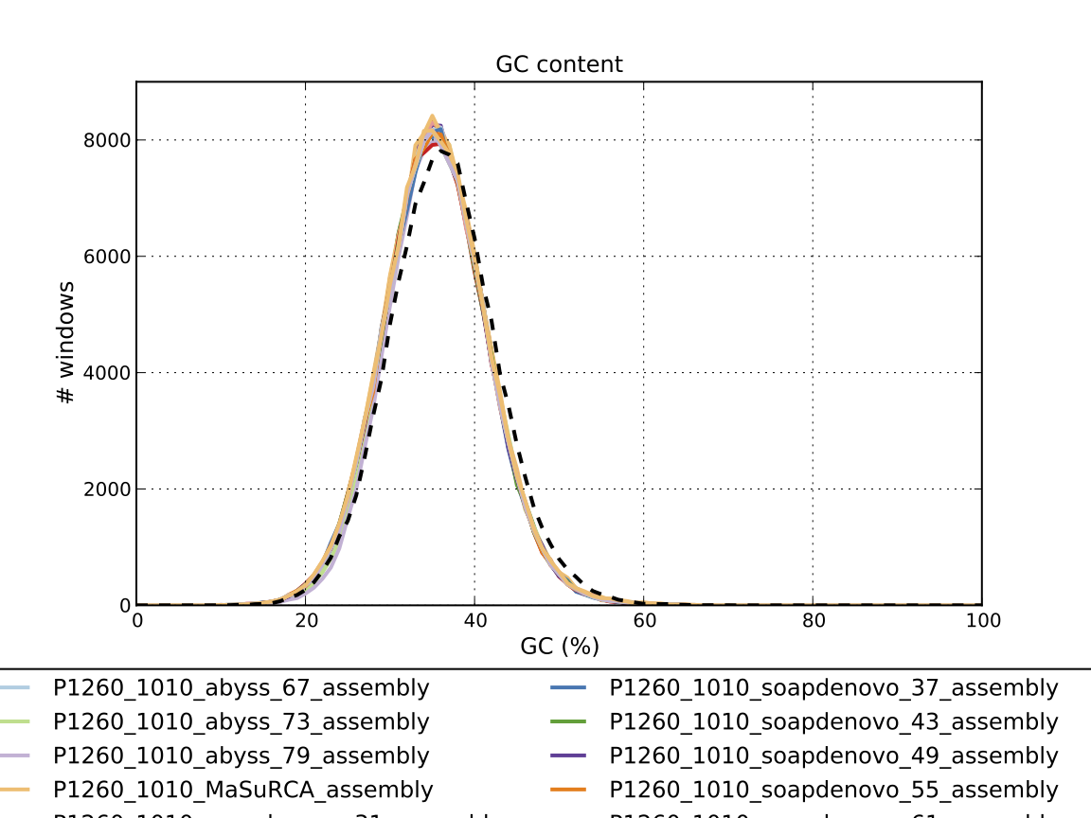

### Assembly Quality Assessment - Compass:

Compass shows that although the assembly is similar in size to the reference, a large portion does not align well, indicating contamination or a very large degree of divergence. The proportion of differing contigs is not clear due to the potential of multiple assembly contigs aligning to the same place on the reference.

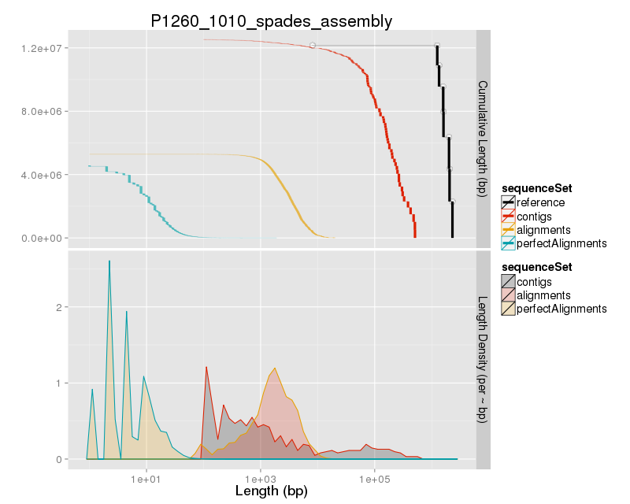

### Assembly Quality Assessment - KAT:

### Assembly Quality Assessment - FRCBAM:

### Assembly Quality Assessment - CEGMA:

CEGMA and BUSCO both attempt to validate the completeness of an assembly by looking at a known gene space, selected to be highly conserved, and present if most, if not all, organisms. CEGMA uses a gene space specifically designed for eukaryotic organisms, while BUSCO can be set for a number of taxonomic groups. Large variation within the completeness between assemblies may indicate that the data was hard to assemble, and thus might run a higher risk of misassembly. BUSCO will also report on duplications of genes, which may indicate chimera in the assembly, and mayneed to be further investigated after annotation.

The CEGMA report of the Spades assembly shows 96% completeness. The CEGMA completeness scores varied between 92.74% (Abyss k=79) to 97.18% (SOAPdenovo k=31).

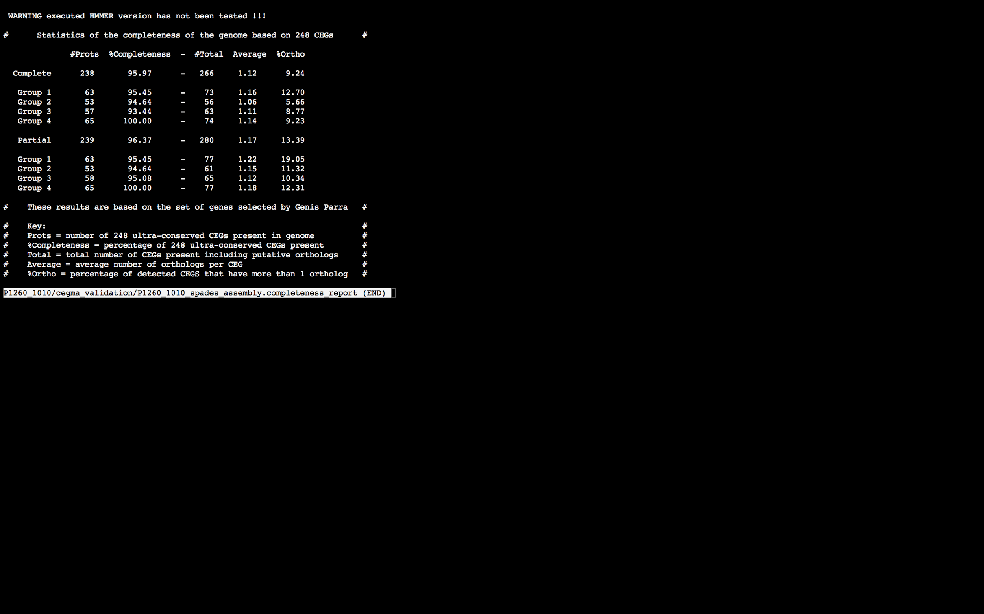

### Assembly Quality Assessment - BUSCO:

The BUSCO report of the Spades assembly shows 98% completeness and 9.7% duplication. The scores range from 87% (Abyss k=79) to 98% (MaSuRCA, and Spades).

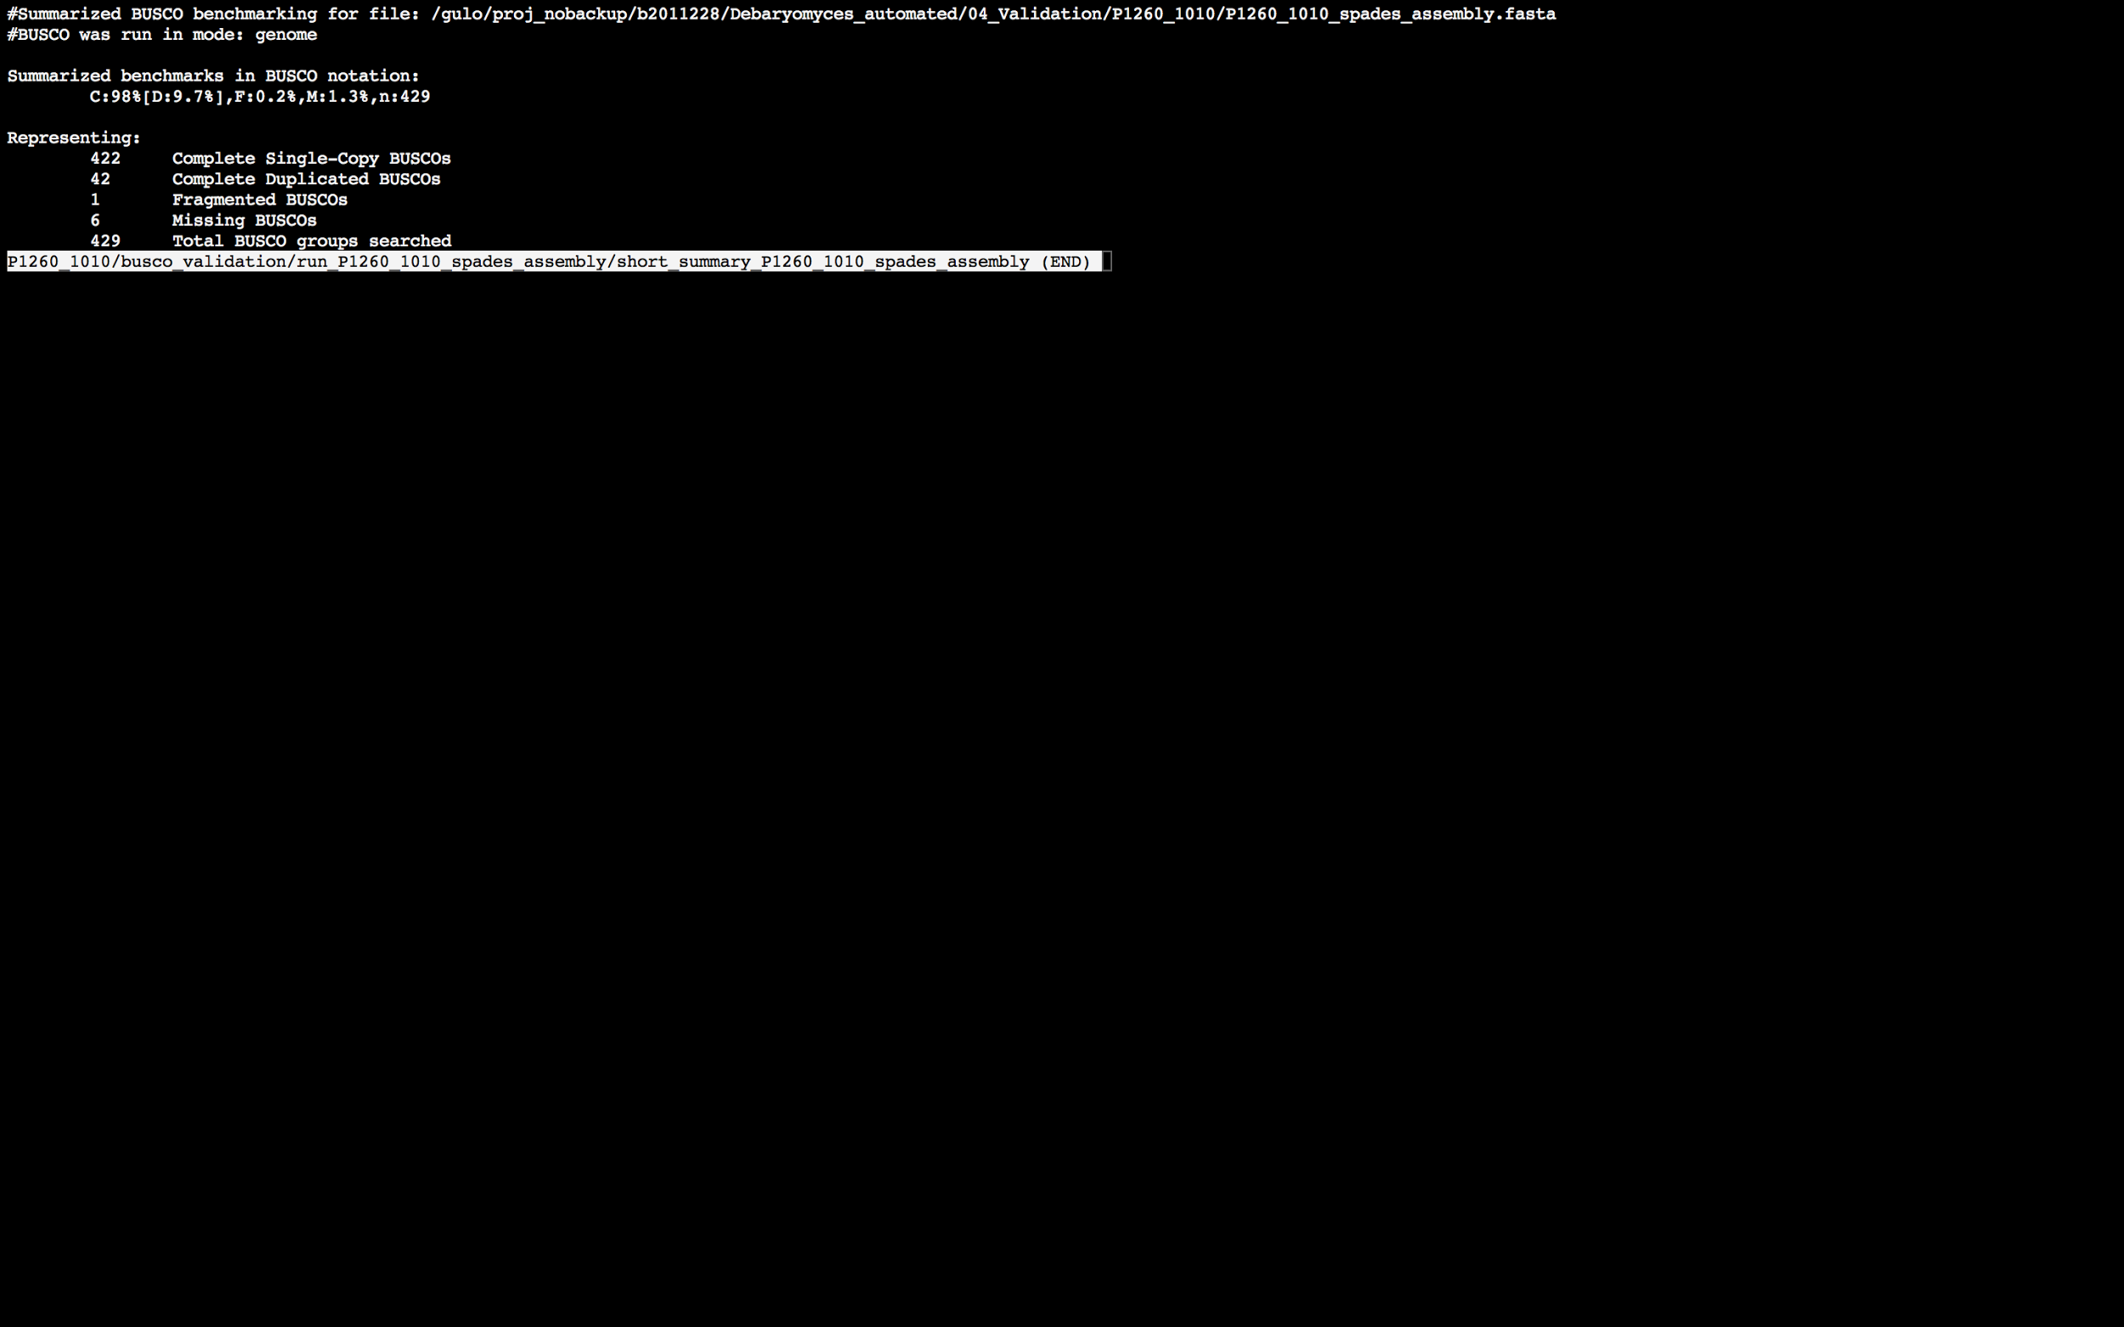

### Assembly Quality Assessment - Blobology:

Blobology indicates that while most contigs are likely Debaryomyces, bacteria and virus may also be present. The blob plot shows a cluster of similar GC content contigs with similar coverage that potentially indicates contamination. Contamination assessment is a difficult task, and should be interpreted as indicative rather than truth.

|  |  |
| --- | --- |
| # Contigs | Megablast hit |
| 1 | Apteryx australis |
| 1 | Candida maltosa |
| 1 | Candida orthopsilosis |
| 4 | Candida parapsilosis |
| 1 | Candida sake |
| 1 | Clavispora lusitaniae |
| 3 | Debaryomyces fabryi |
| 235 | Debaryomyces hansenii |
| 3 | Haemophilus influenzae |
| 1 | Komagataella pastoris |
| 1 | Millerozyma farinosa |
| 1 | Naumovozyma dairenensis |
| 223 | Not annotated |
| 1 | Phaeobacter gallaeciensis |
| 1 | Ruegeria sp. PR1b |
| 4 | Saccharomyces cerevisiae |
| 1 | Scheffersomyces stipitis |

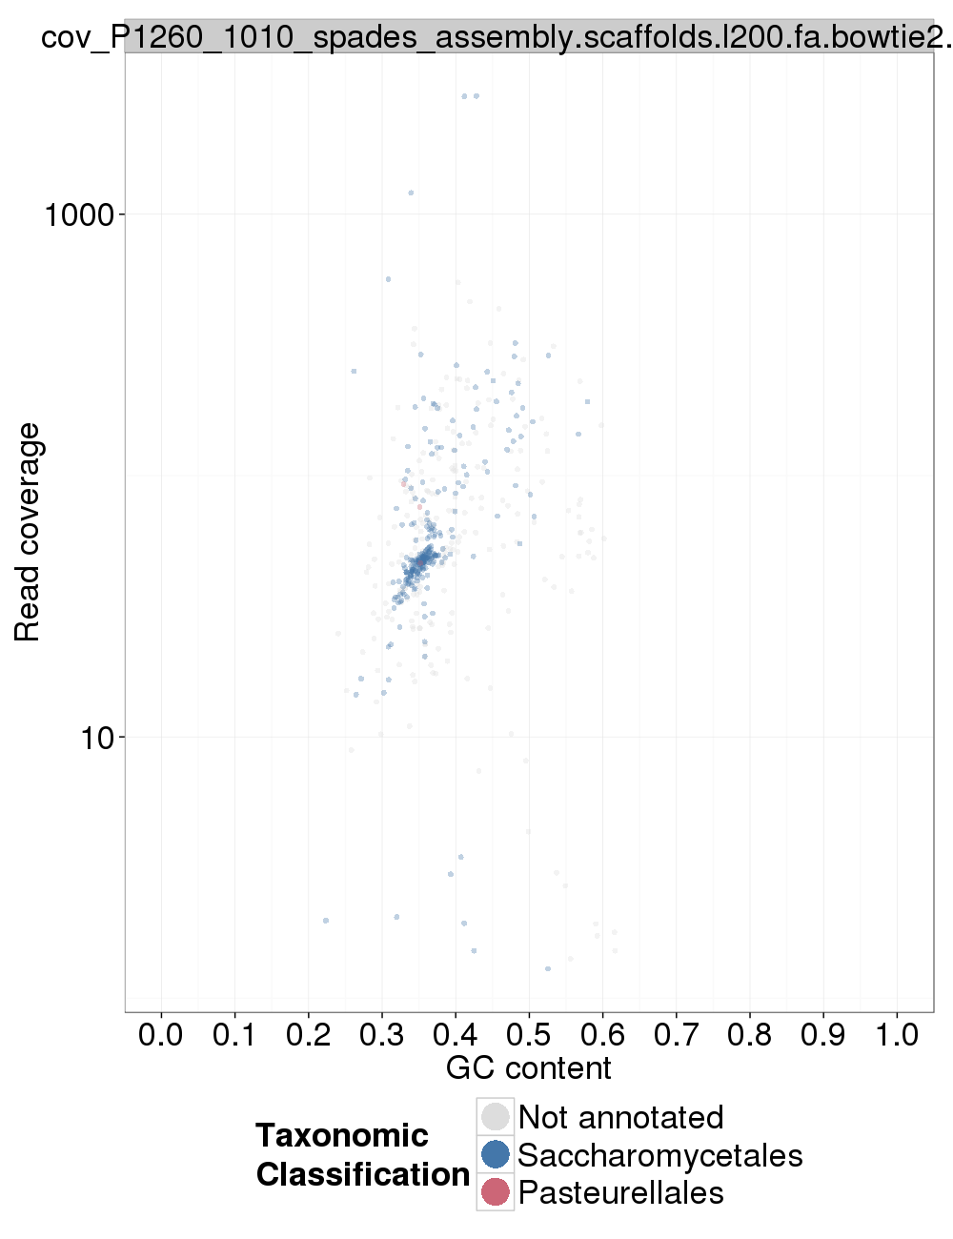

### Assembly Quality Assessment - Kraken:

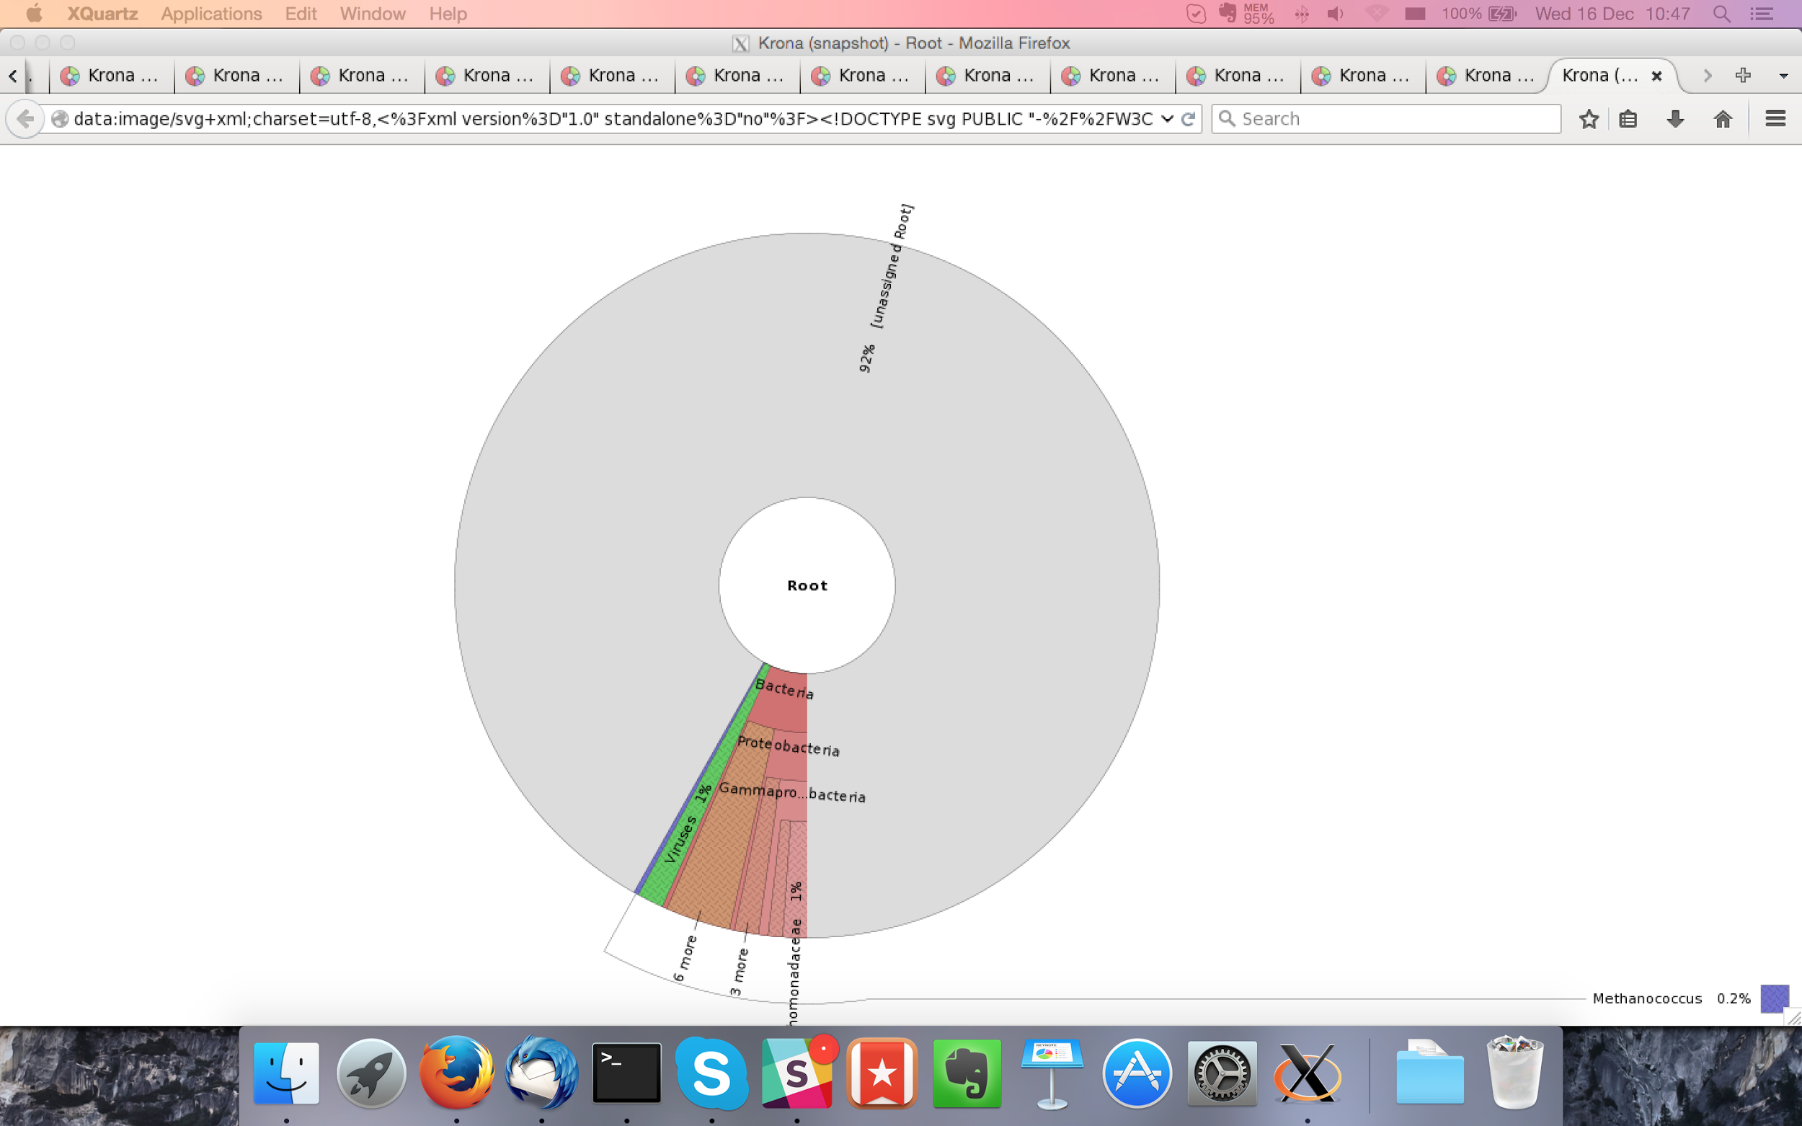

Masurca assembly contamination report below:

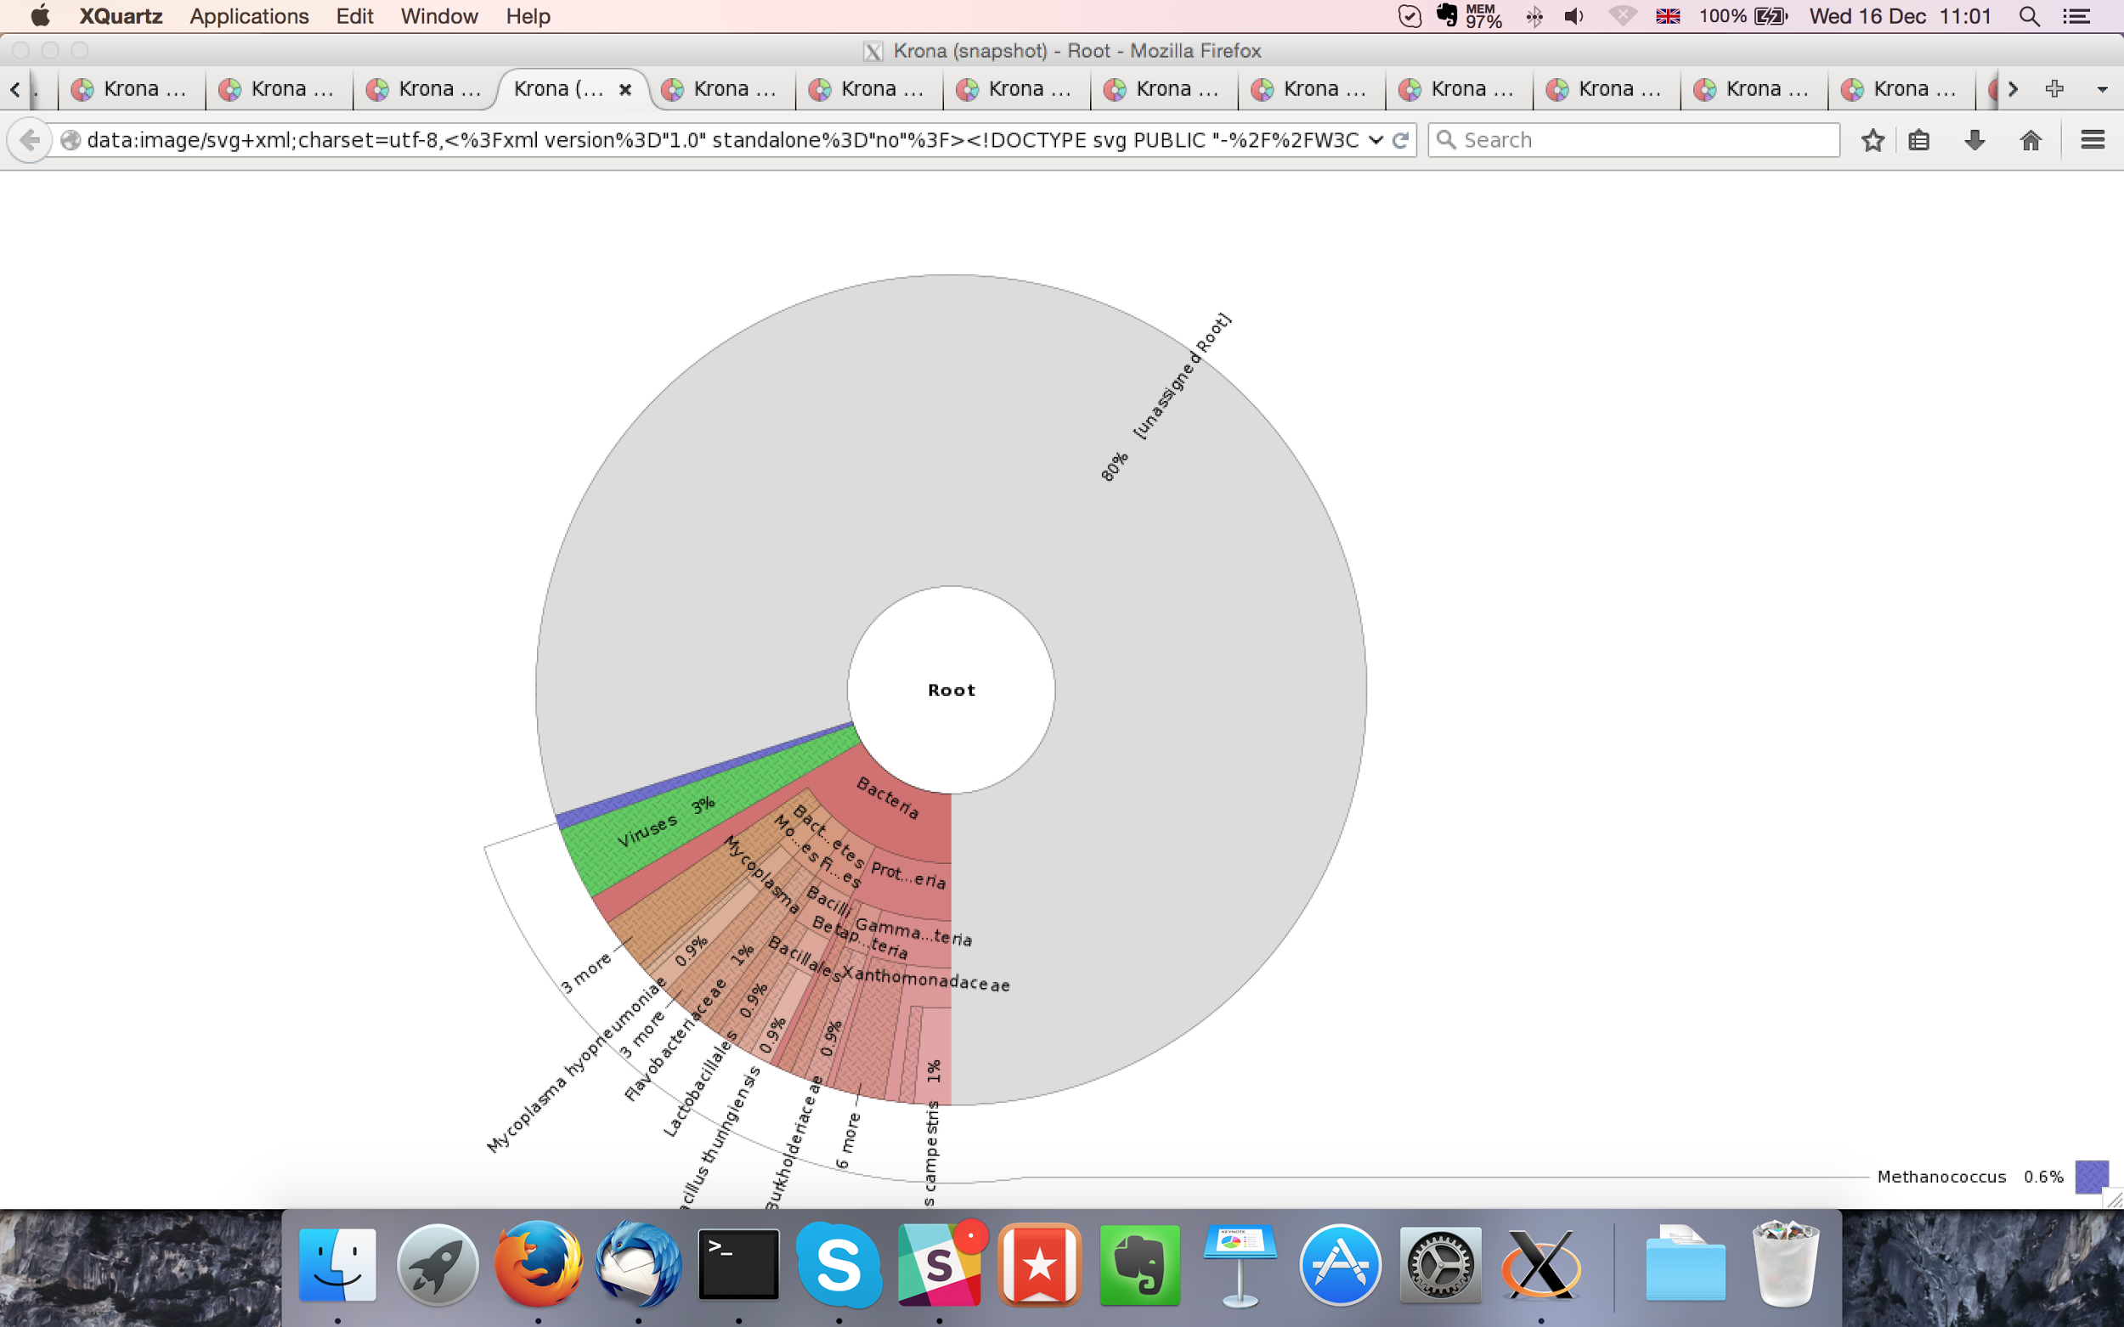

## Sample P1260_1011:

### Assembly Quality Assessment - Quast:

MaSuRCA followed by Soap de novo (k=43 & 37) gives the best assembly measured by comparing Cumulative length and Nx.

|  |  |
| --- | --- |
| Assembler | **MaSuRCA** |
| Number of contigs | 5,004 |
| Largest contig | 50,883 |
| Total assembly length | 21,129,126 |
| N50 | 6,161 |

MaSuRCA produced an assembly length of 21,129,126bp, comprised of 5,004 contigs with an N50 of 6,161bp.

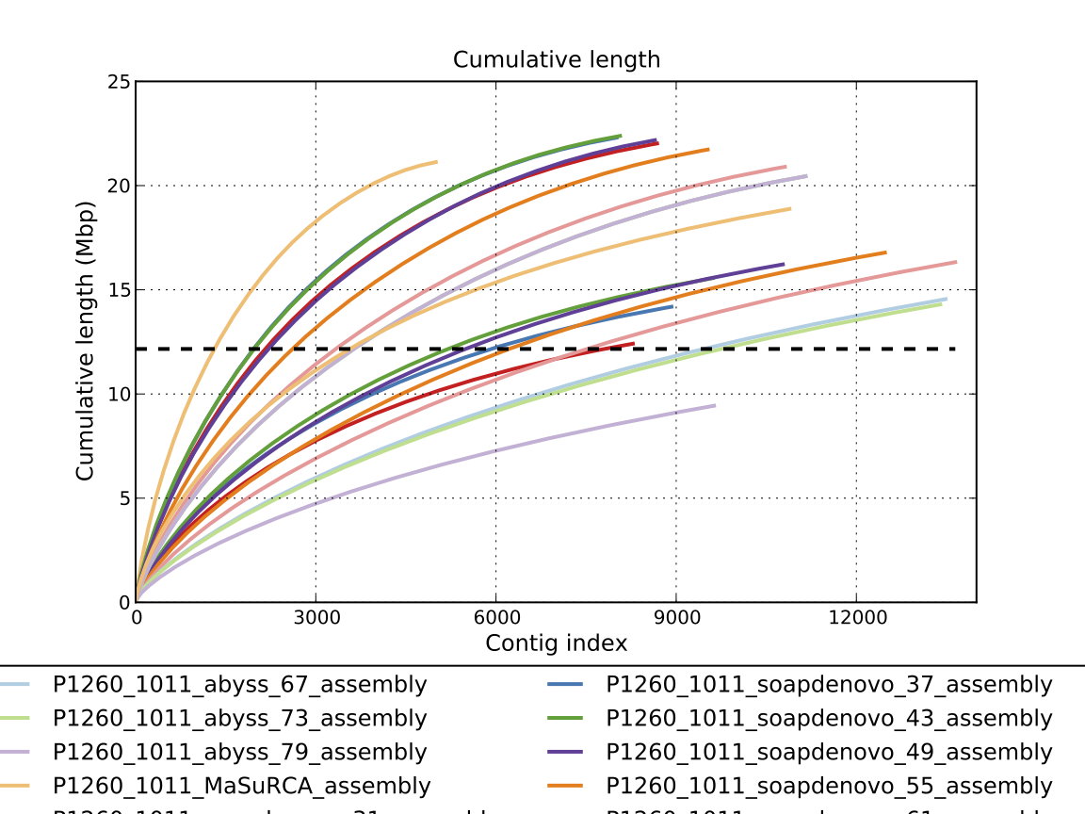

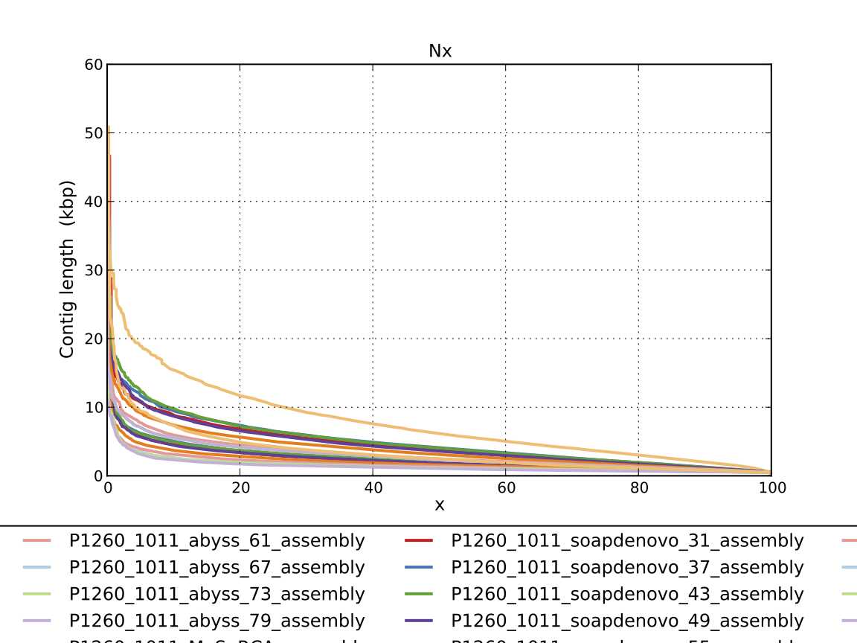

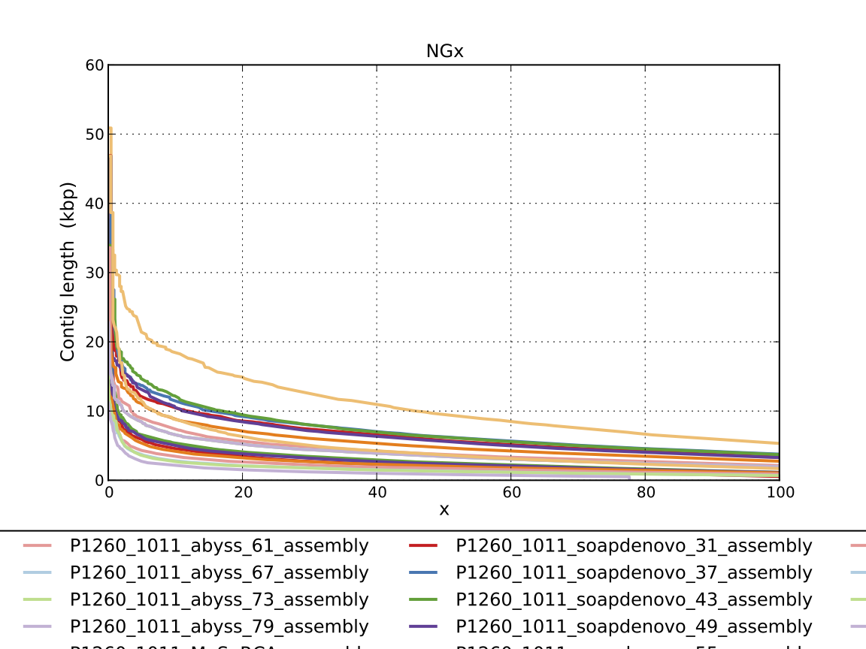

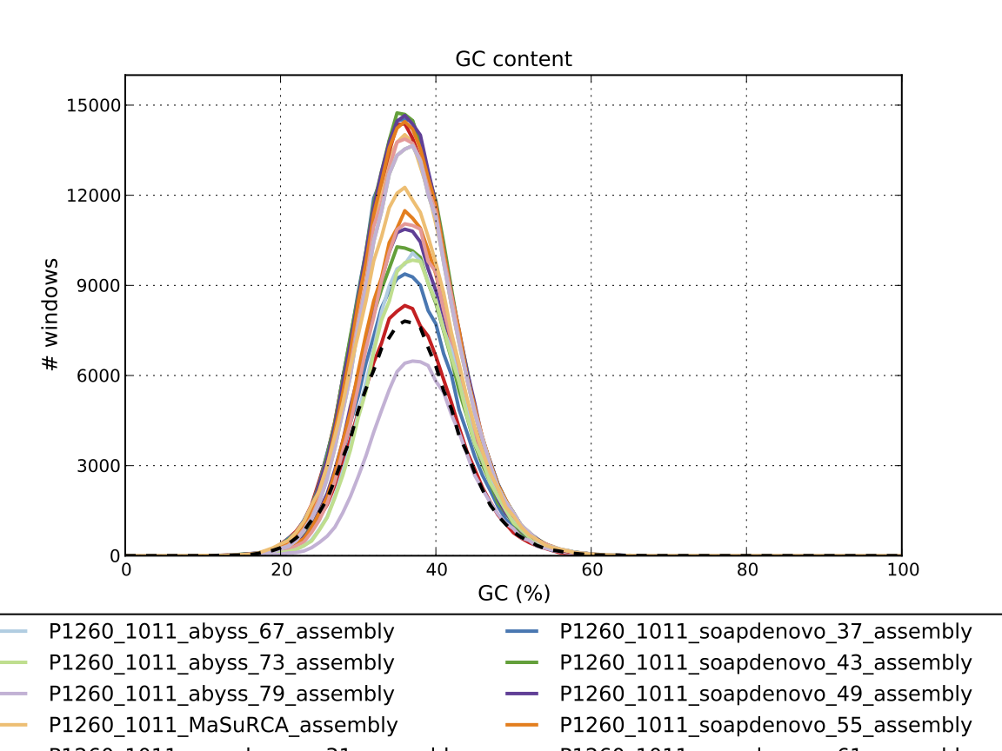

### Assembly Quality Assessment - Compass:

Compass shows that the assembly is greater in size to the reference, and aligns to a good degree to the reference. The portion that does not align well indicates contamination or a very large degree of divergence. The proportion of differing contigs is not clear due to the potential of multiple assembly contigs aligning to the same place on the reference.

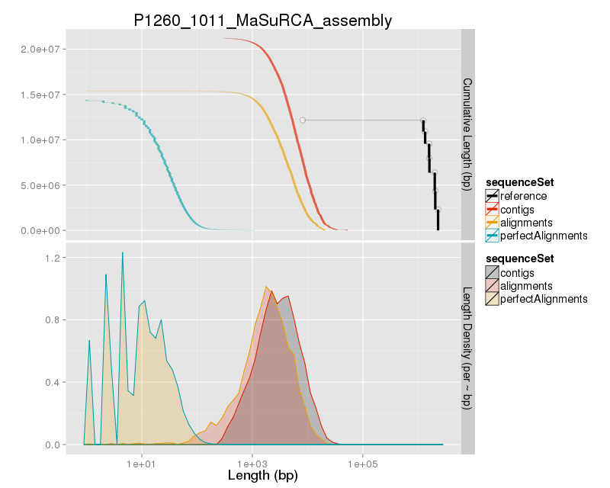

### Assembly Quality Assessment - KAT:

### Assembly Quality Assessment - FRCBAM:

### Assembly Quality Assessment - CEGMA:

CEGMA and BUSCO both attempt to validate the completeness of an assembly by looking at a known gene space, selected to be highly conserved, and present if most, if not all, organisms. CEGMA uses a gene space specifically designed for eukaryotic organisms, while BUSCO can be set for a number of taxonomic groups. Large variation within the completeness between assemblies may indicate that the data was hard to assemble, and thus might run a higher risk of misassembly. BUSCO will also report on duplications of genes, which may indicate chimera in the assembly, and mayneed to be further investigated after annotation.

The CEGMA report of the MaSuRCA assembly shows 96% completeness. The CEGMA completeness scores varied between 40.32% (Abyss k=79) to 96.37% (MaSuRCA).

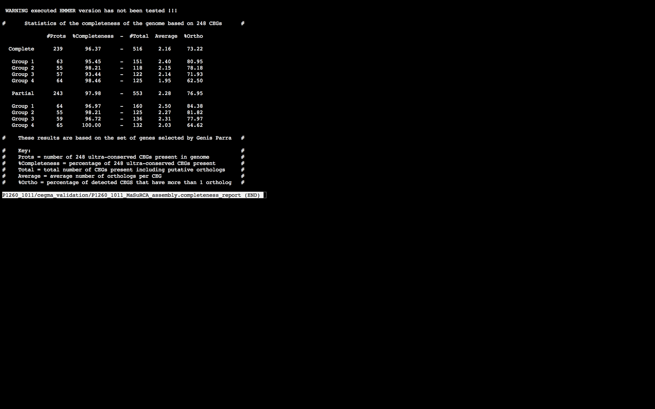

### Assembly Quality Assessment - BUSCO:

The BUSCO report of the MaSuRCA assembly shows 90% completeness and 58% duplication. The scores range from 25% (Abyss k=79) to 90% (MaSuRCA).

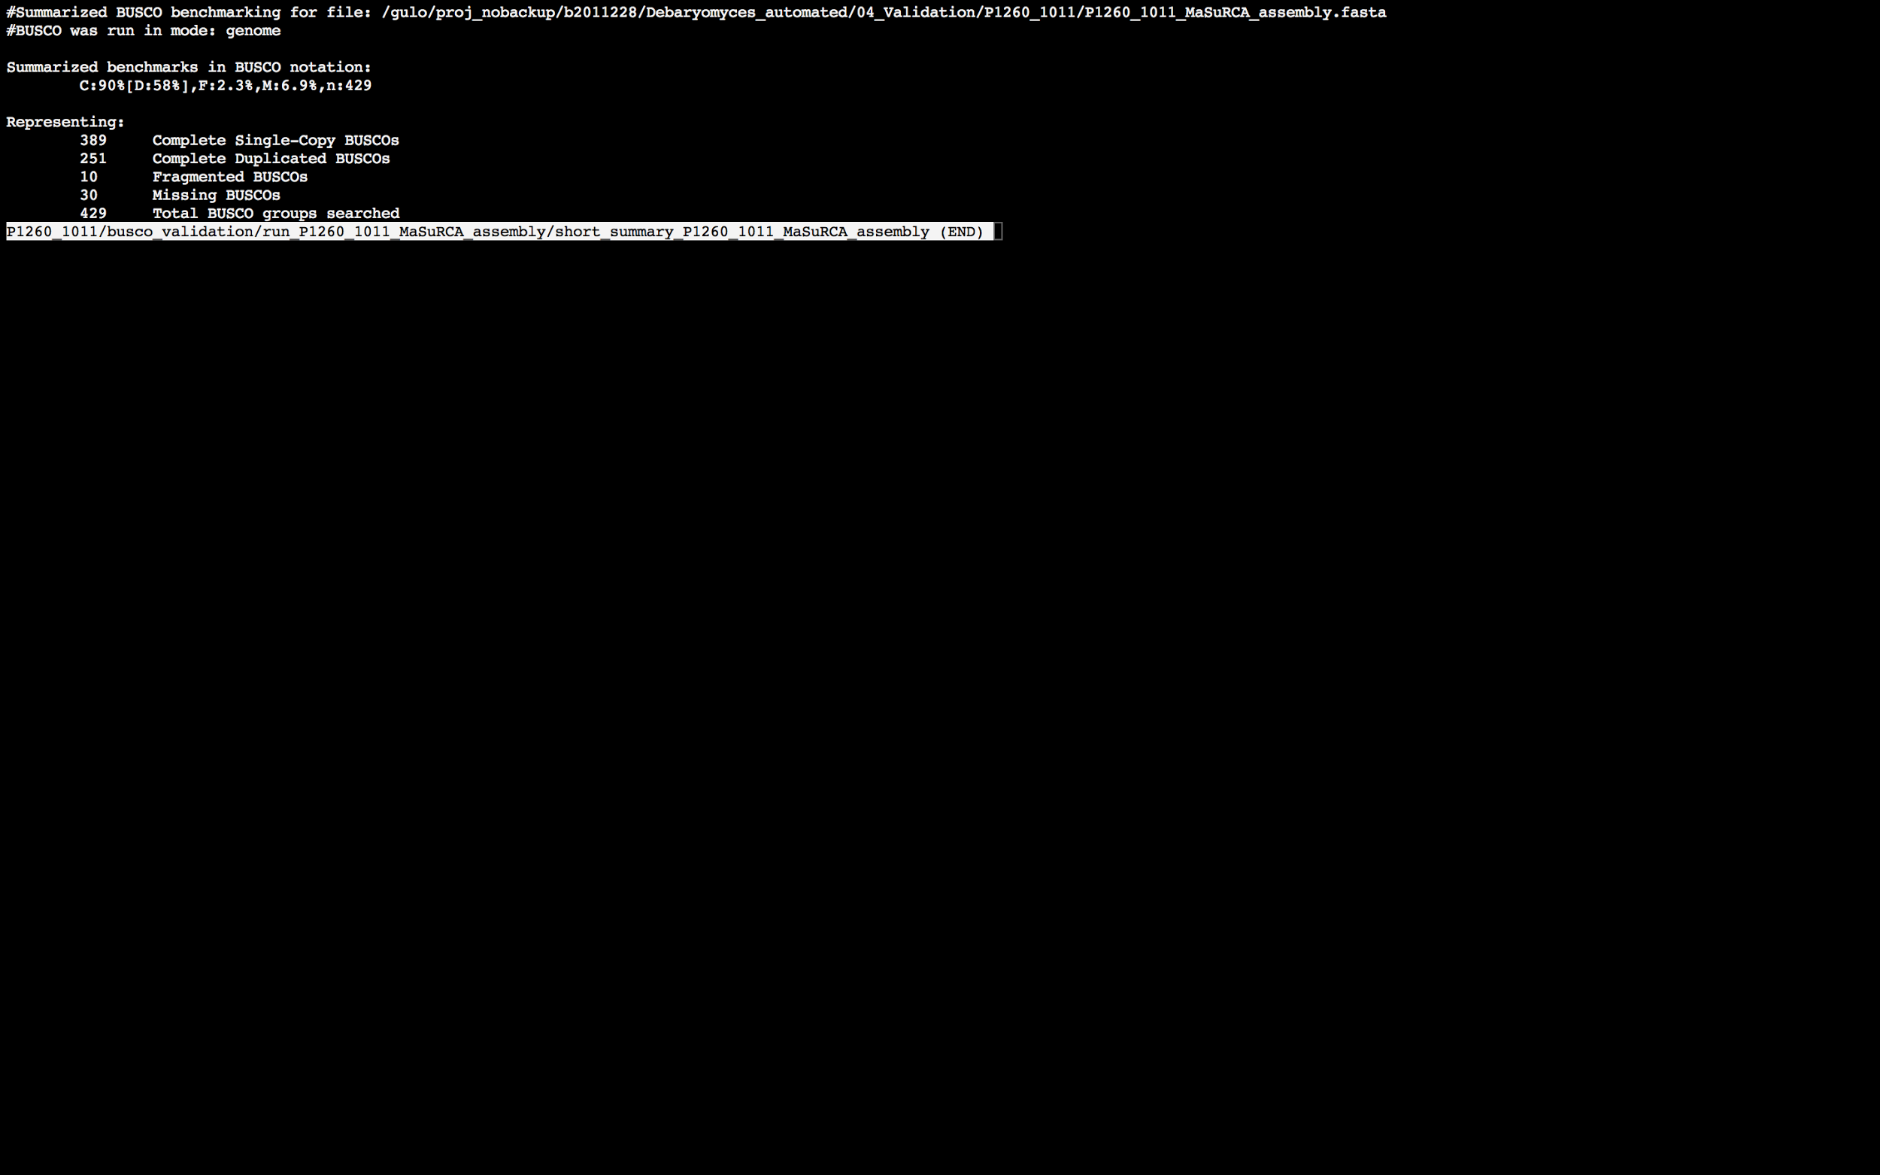

### Assembly Quality Assessment - Blobology:

Blobology indicates that most contigs are likely Debaryomyces. The increased density could indicate multiple strains. Contamination assessment is a difficult task, and should be interpreted as indicative rather than truth.

|  |  |
| --- | --- |
| # Contigs | Megablast hit |
| 1 | Candida tropicalis |
| 5032 | Debaryomyces hansenii |
| 2 | Debaryomyces sp. ApTucson-A44 |
| 1 | Debaryomyces tyrocola |
| 4 | Millerozyma farinosa |
| 121 | Not annotated |
| 1 | Scheffersomyces stipitis |
| 1 | Spathaspora passalidarum |
| 1 | uncultured Ascomycota |
| 1 | uncultured Debaryomyces |
| 2 | uncultured Saccharomycetales |

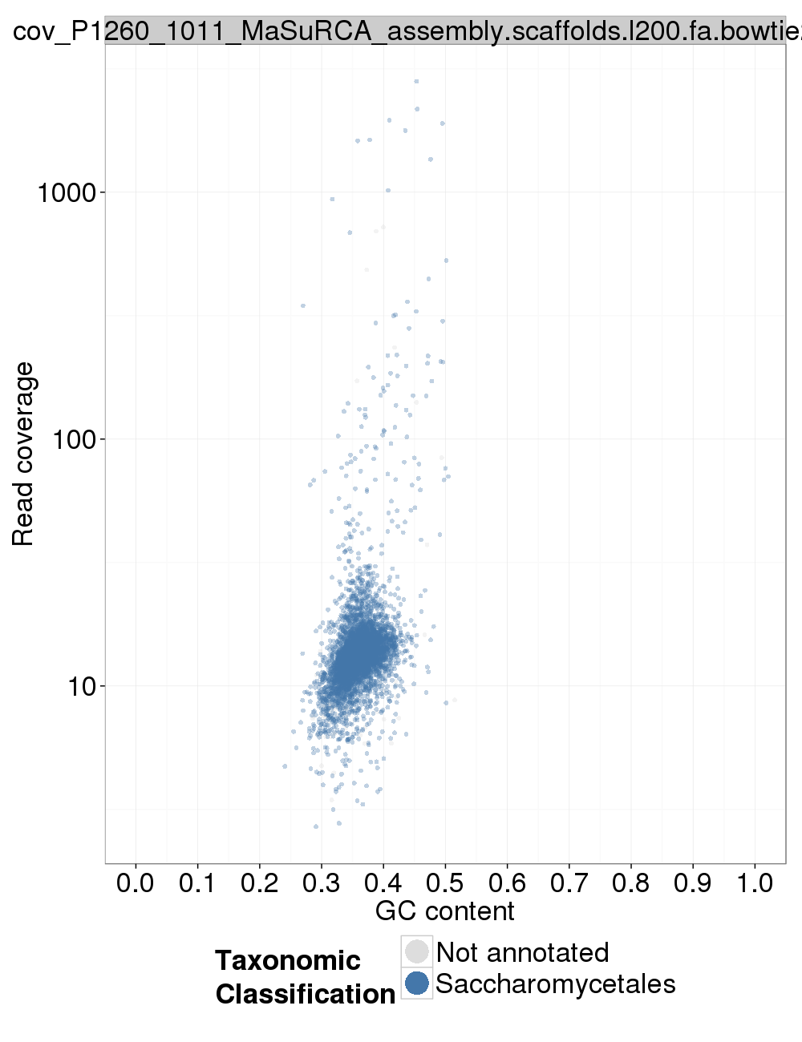

### Assembly Quality Assessment - Kraken:

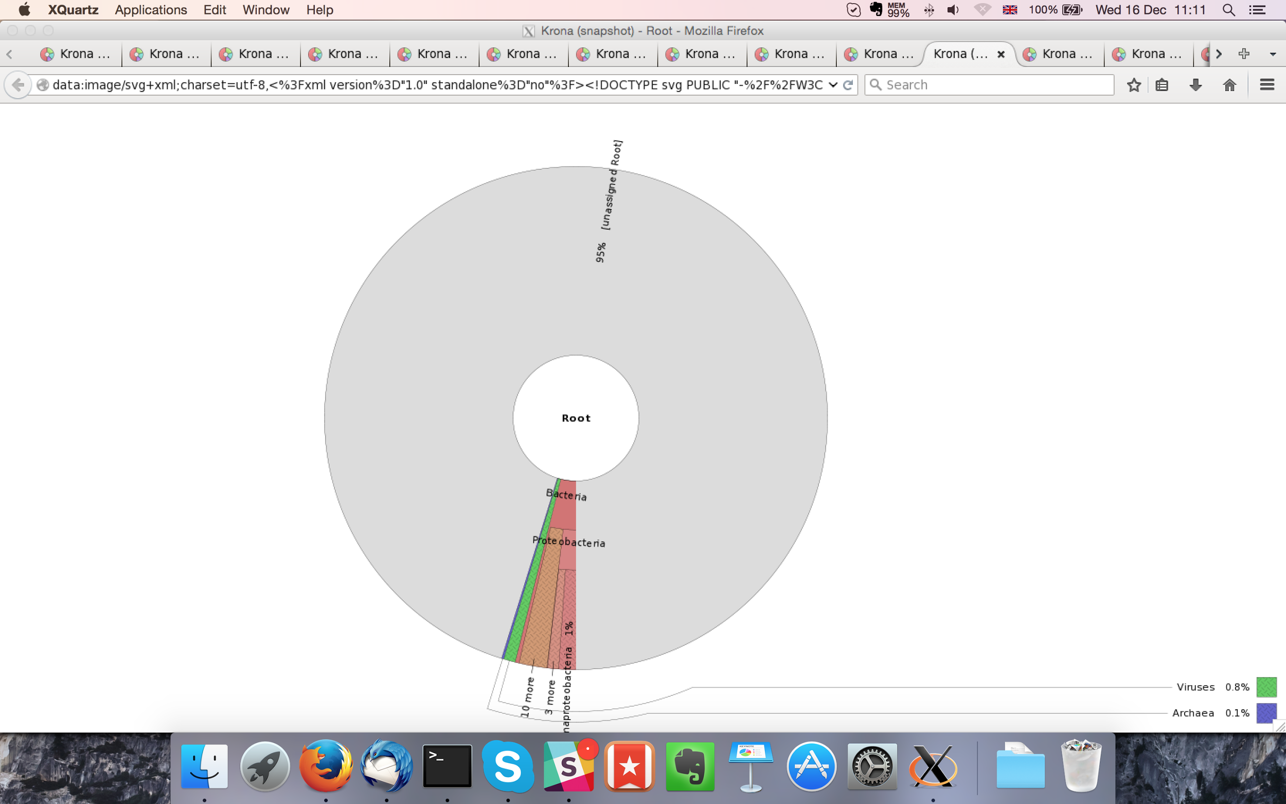

## Sample P1260_1012:

### Assembly Quality Assessment - Quast:

Spades followed by MaSuRCA gives the best assembly measured by comparing Cumulative length and Nx.

|  |  |
| --- | --- |
| Assembler | **Spades** |
| Number of contigs | 163 |
| Largest contig | 882,539 |
| Total assembly length | 11,571,675 |
| N50 | 366,480 |

Spades produced an assembly length of 11,571,675bp, comprised of 163 contigs with an N50 of 366,480bp.

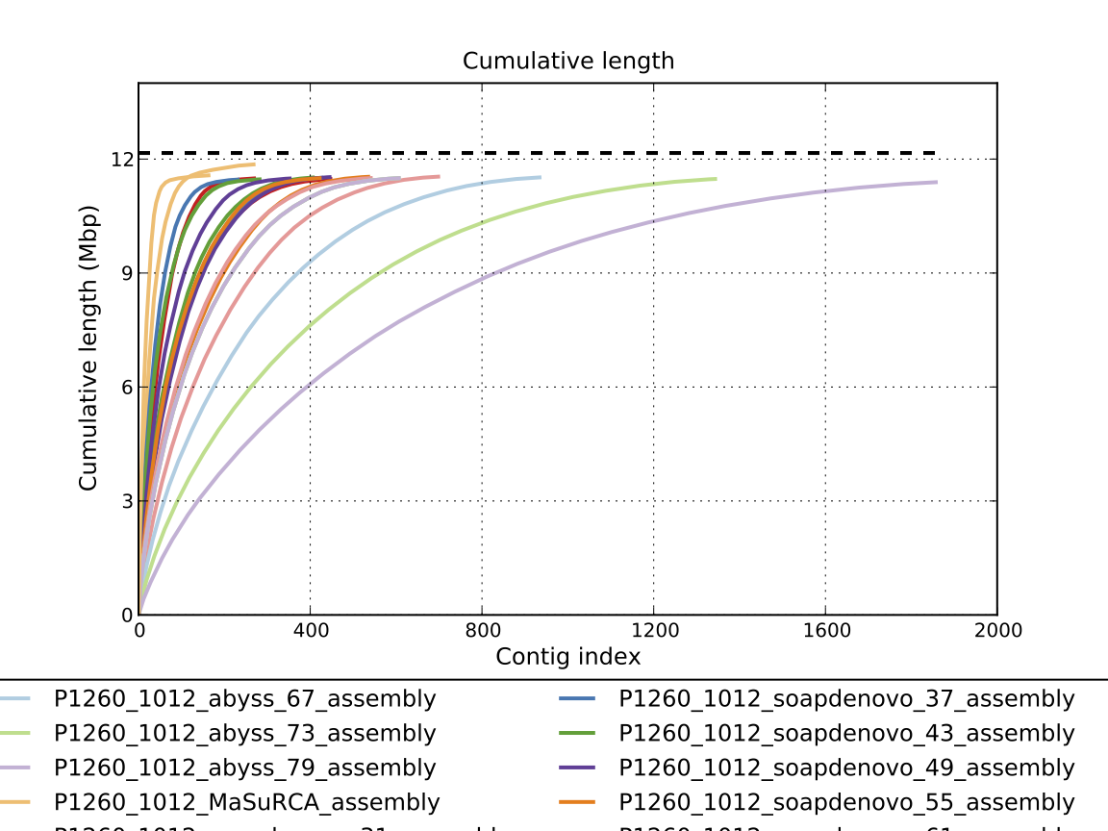

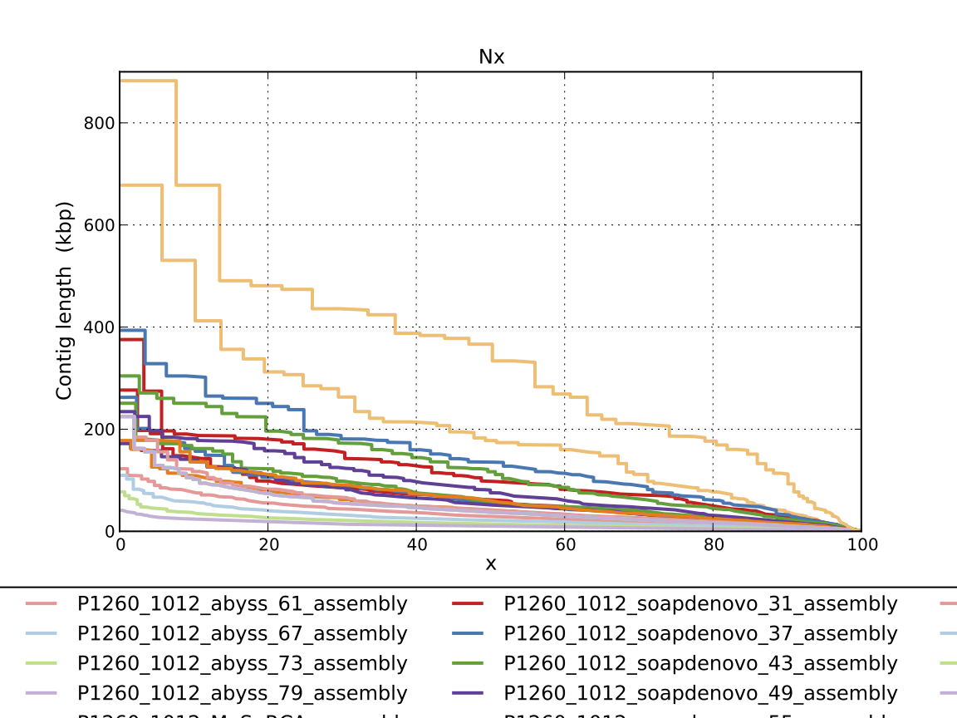

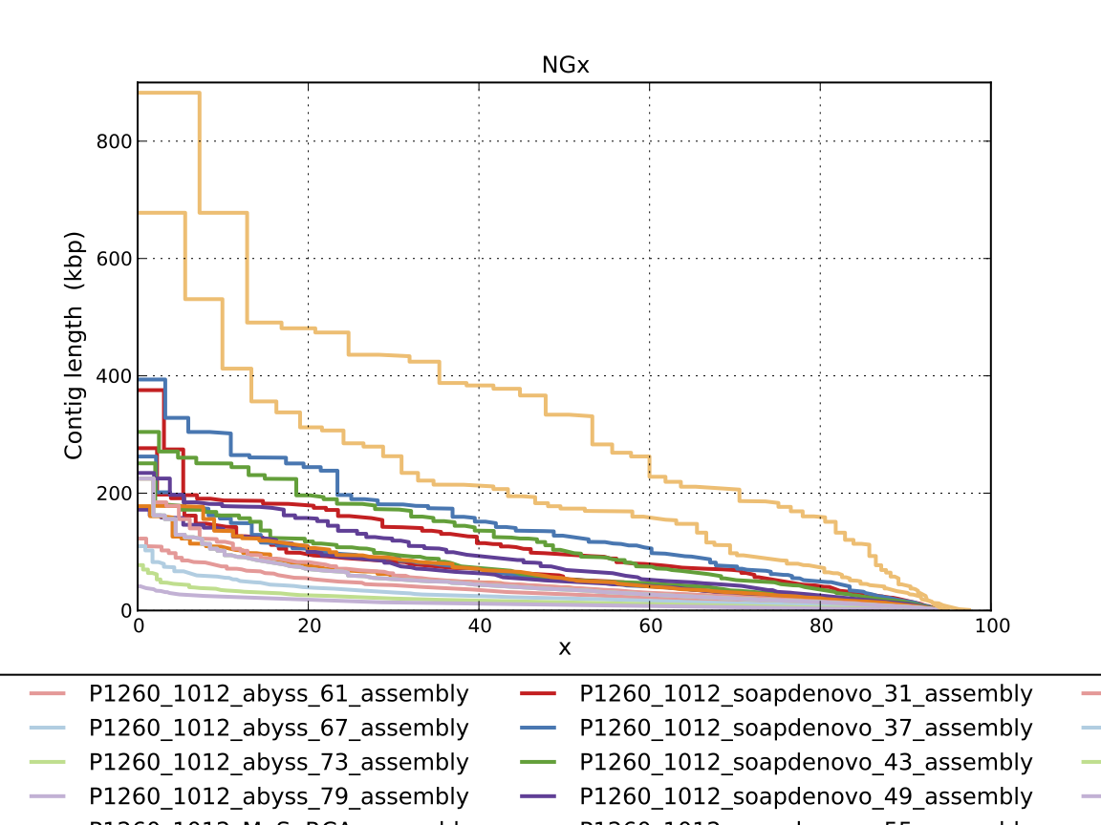

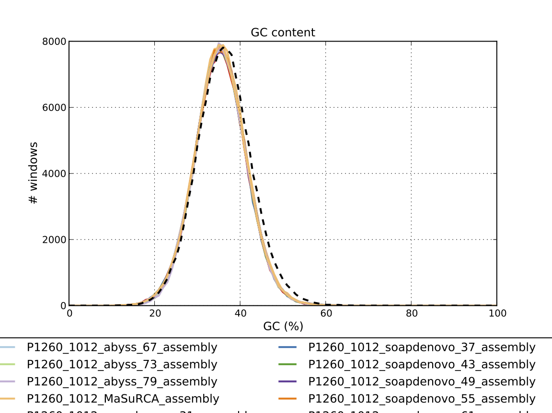

### Assembly Quality Assessment - Compass:

Compass shows that although the assembly is similar in size to the reference, a large portion does not align well, indicating contamination or a very large degree of divergence. The proportion of differing contigs is not clear due to the potential of multiple assembly contigs aligning to the same place on the reference.

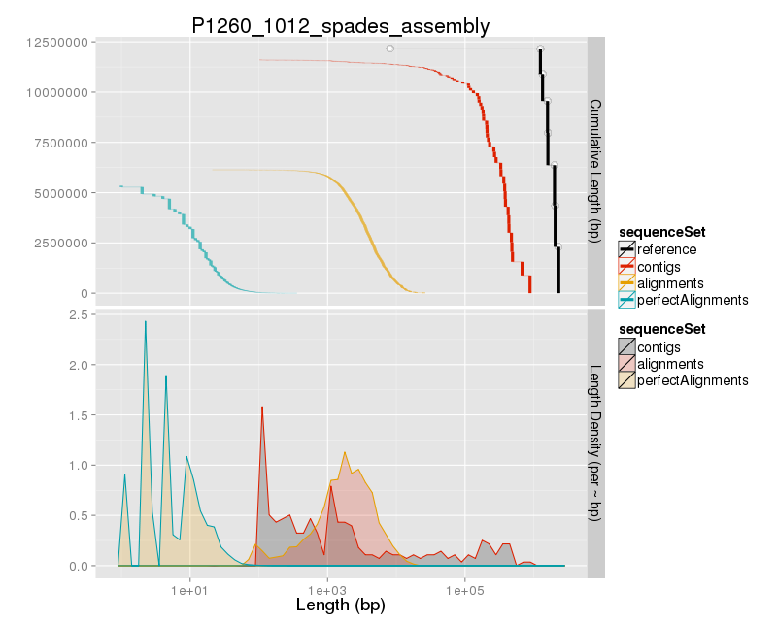

### Assembly Quality Assessment - KAT:

### Assembly Quality Assessment - FRCBAM:

### Assembly Quality Assessment - CEGMA:

CEGMA and BUSCO both attempt to validate the completeness of an assembly by looking at a known gene space, selected to be highly conserved, and present if most, if not all, organisms. CEGMA uses a gene space specifically designed for eukaryotic organisms, while BUSCO can be set for a number of taxonomic groups. Large variation within the completeness between assemblies may indicate that the data was hard to assemble, and thus might run a higher risk of misassembly. BUSCO will also report on duplications of genes, which may indicate chimera in the assembly, and mayneed to be further investigated after annotation.

The CEGMA report of the Spades assembly shows 95% completeness. The CEGMA completeness scores varied between 94.35% (Abyss k=31,43,67,73,79) to 95.56% (SOAPdenovo k=67,73,79).

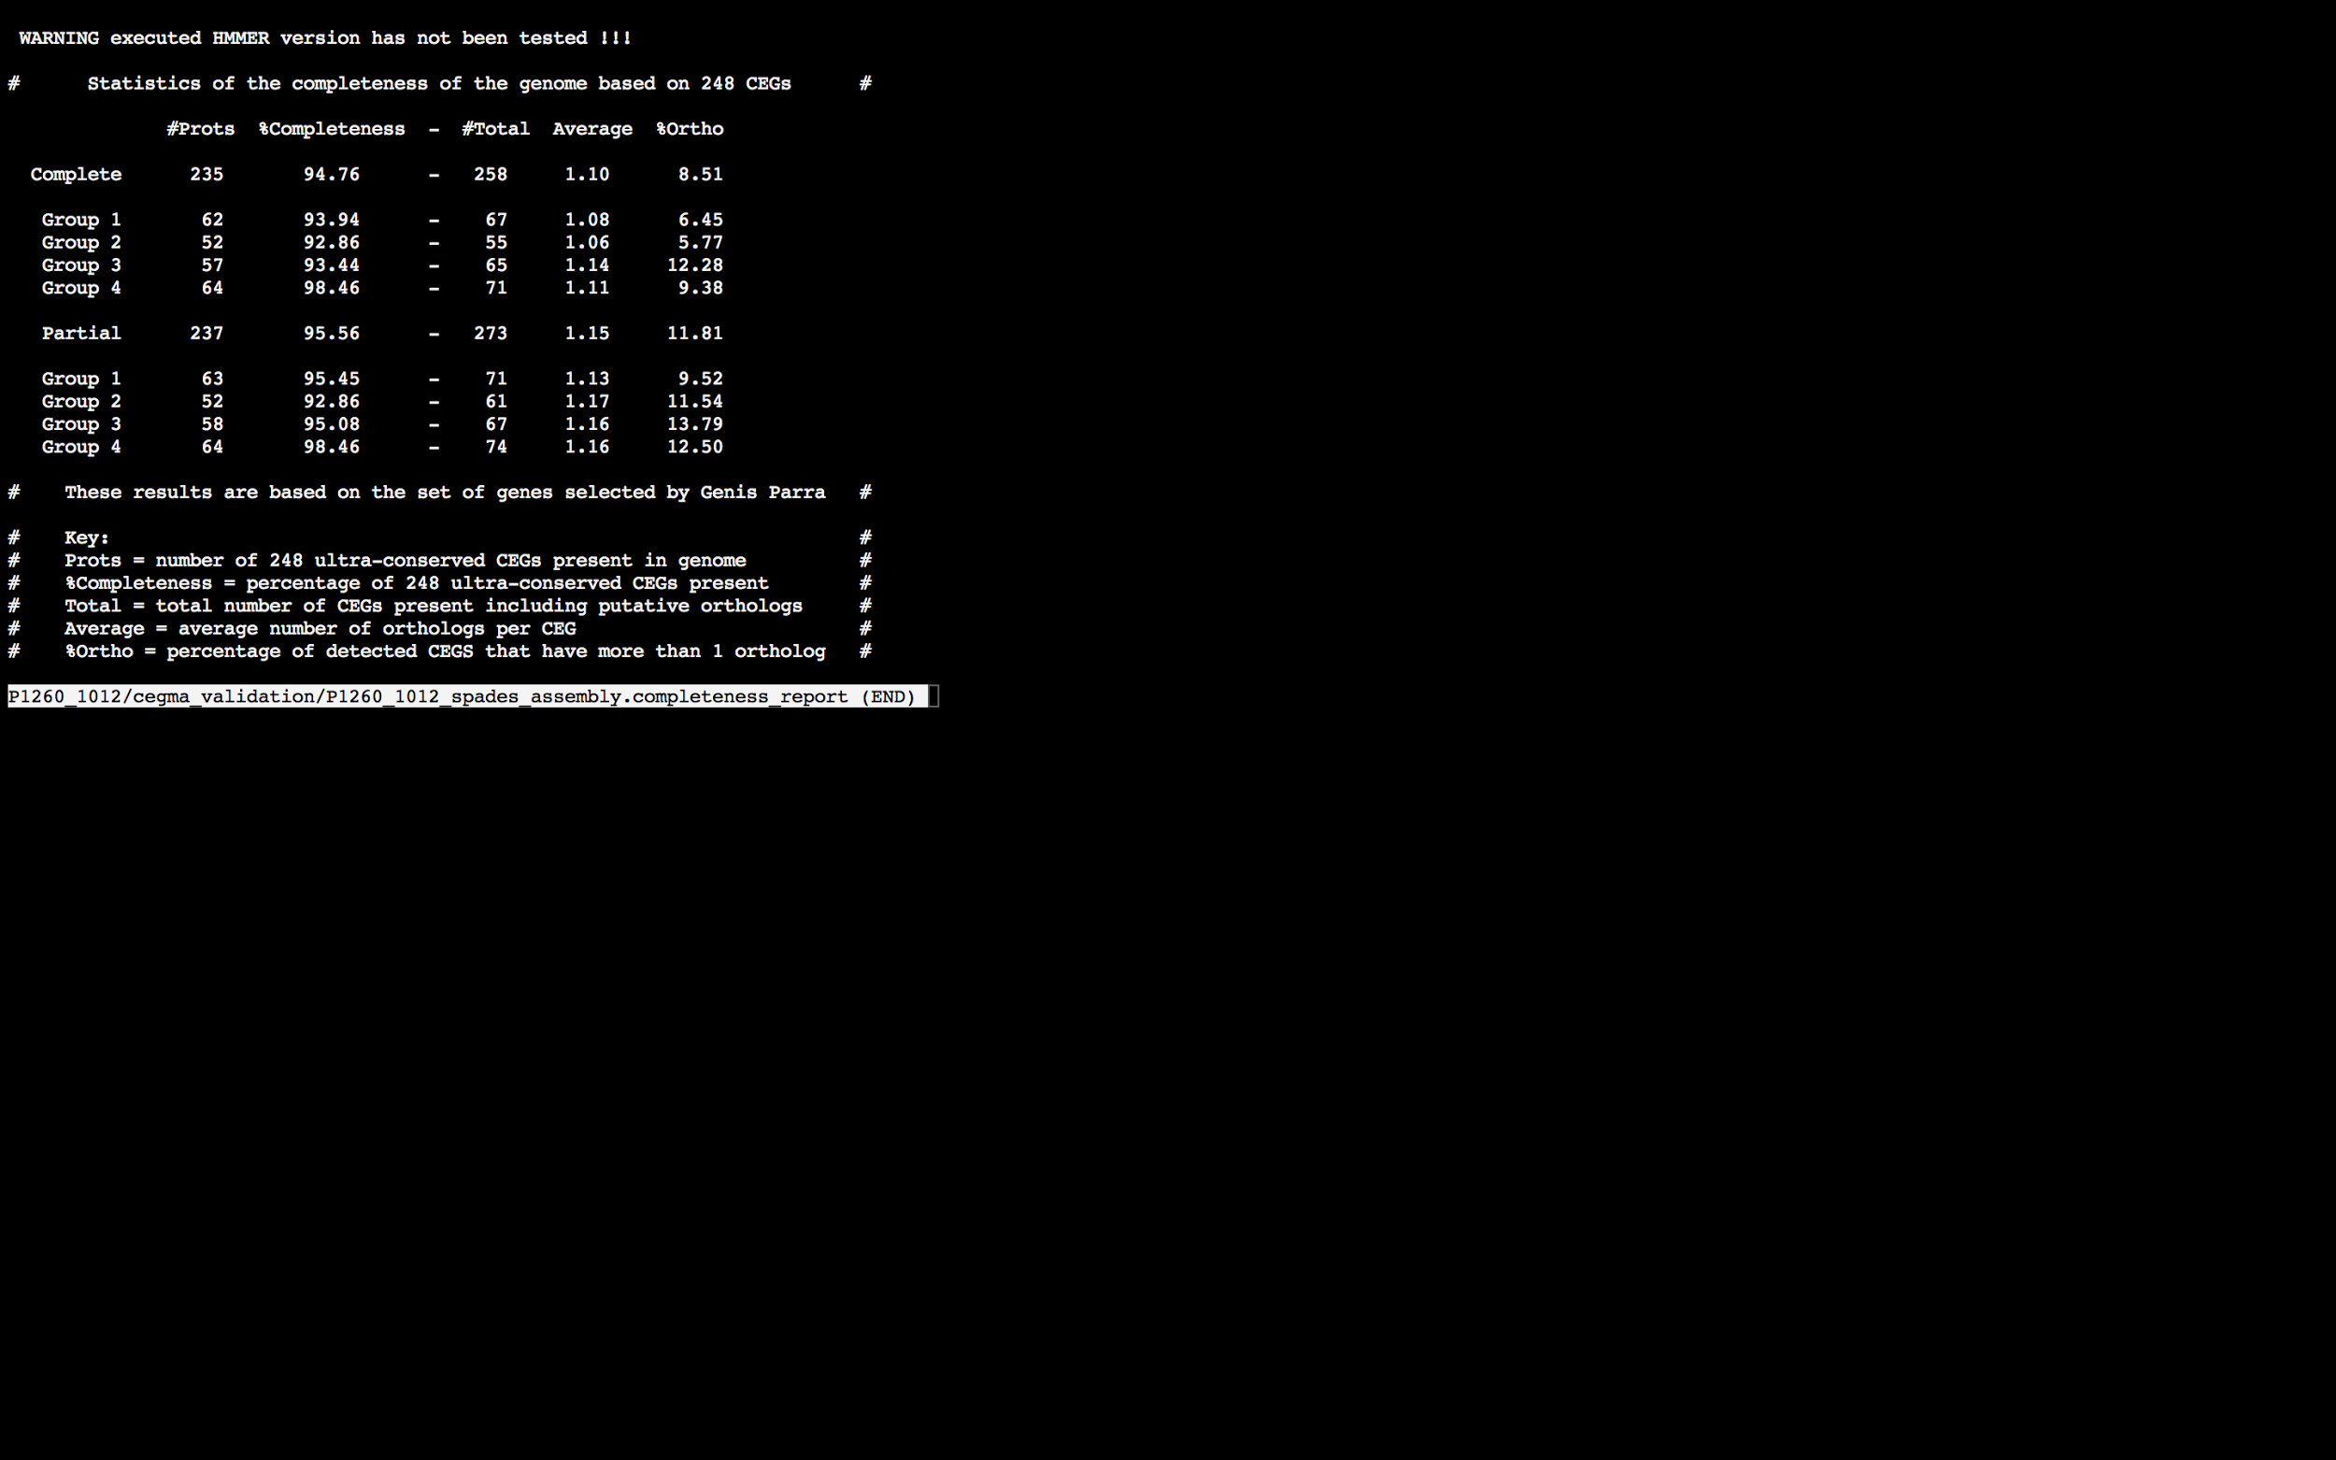

### Assembly Quality Assessment - BUSCO:

The BUSCO report of the Spades assembly shows 97% completeness and 8.8% duplication. The scores range from 92% (SOAPdenovo k=31) to 97% (MaSuRCA, Abyss k=43,49,55, SOAPdenovo k=43,49,55,67,73,79, and Spades).

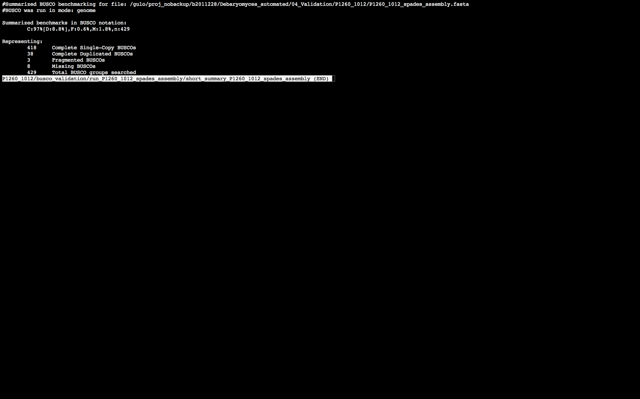

### Assembly Quality Assessment - Blobology:

Blobology indicates that while most contigs are likely Debaryomyces, bacteria may also be present. The blob plot shows a cluster of similar GC content contigs with similar coverage that potentially indicates contamination. Contamination assessment is a difficult task, and should be interpreted as indicative rather than truth.

|  |  |
| --- | --- |
| # Contigs | Megablast hit |
| 1 | Candida glabrata |
| 1 | Candida tropicalis |
| 1 | Clavispora lusitaniae |
| 140 | Debaryomyces hansenii |
| 1 | Dictyostelium discoideum |
| 61 | Not annotated |
| 1 | Pleurotus ostreatus |
| 2 | Scheffersomyces stipitis |

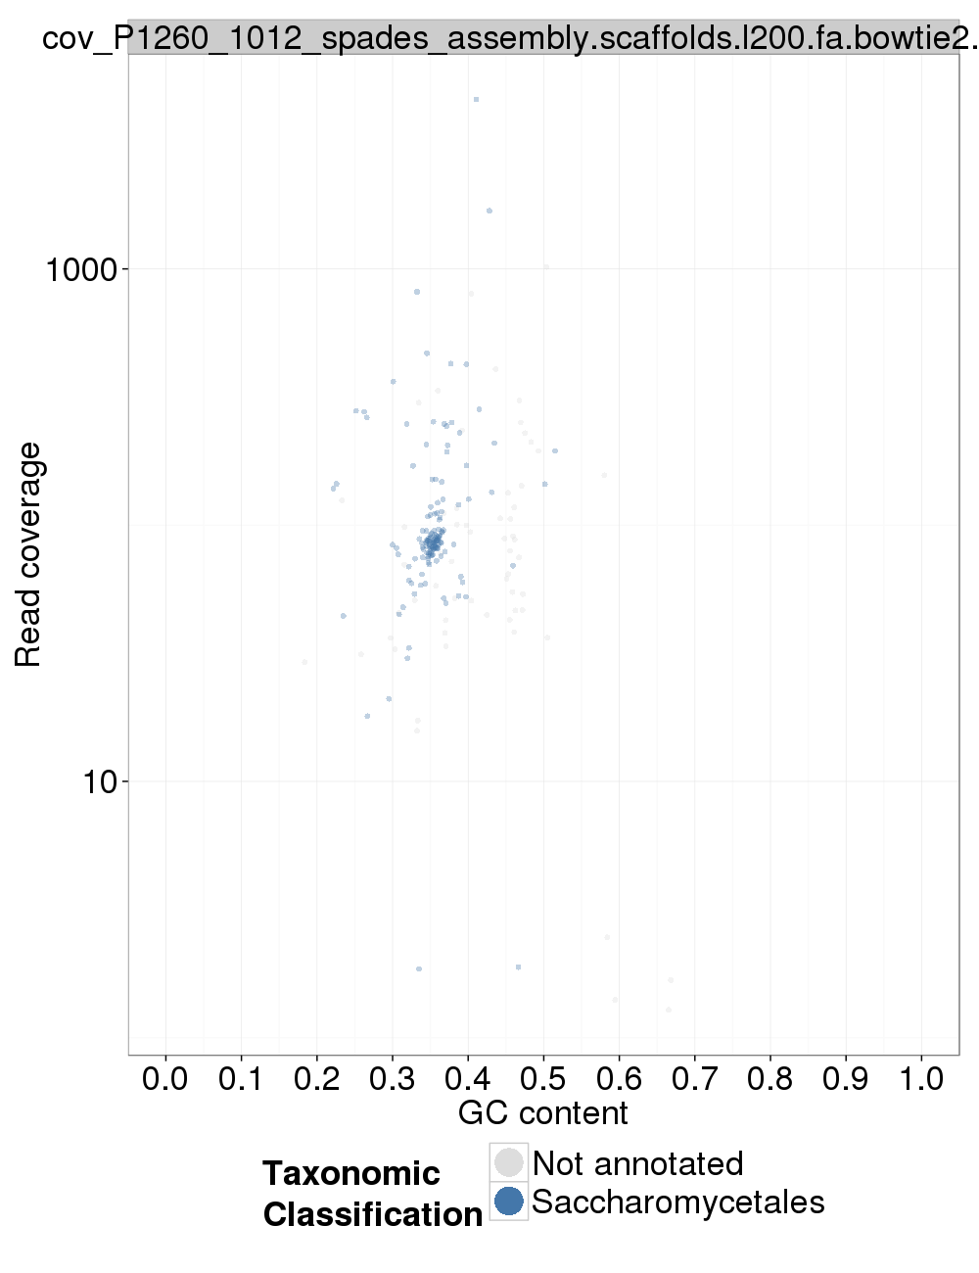

### Assembly Quality Assessment - Kraken:

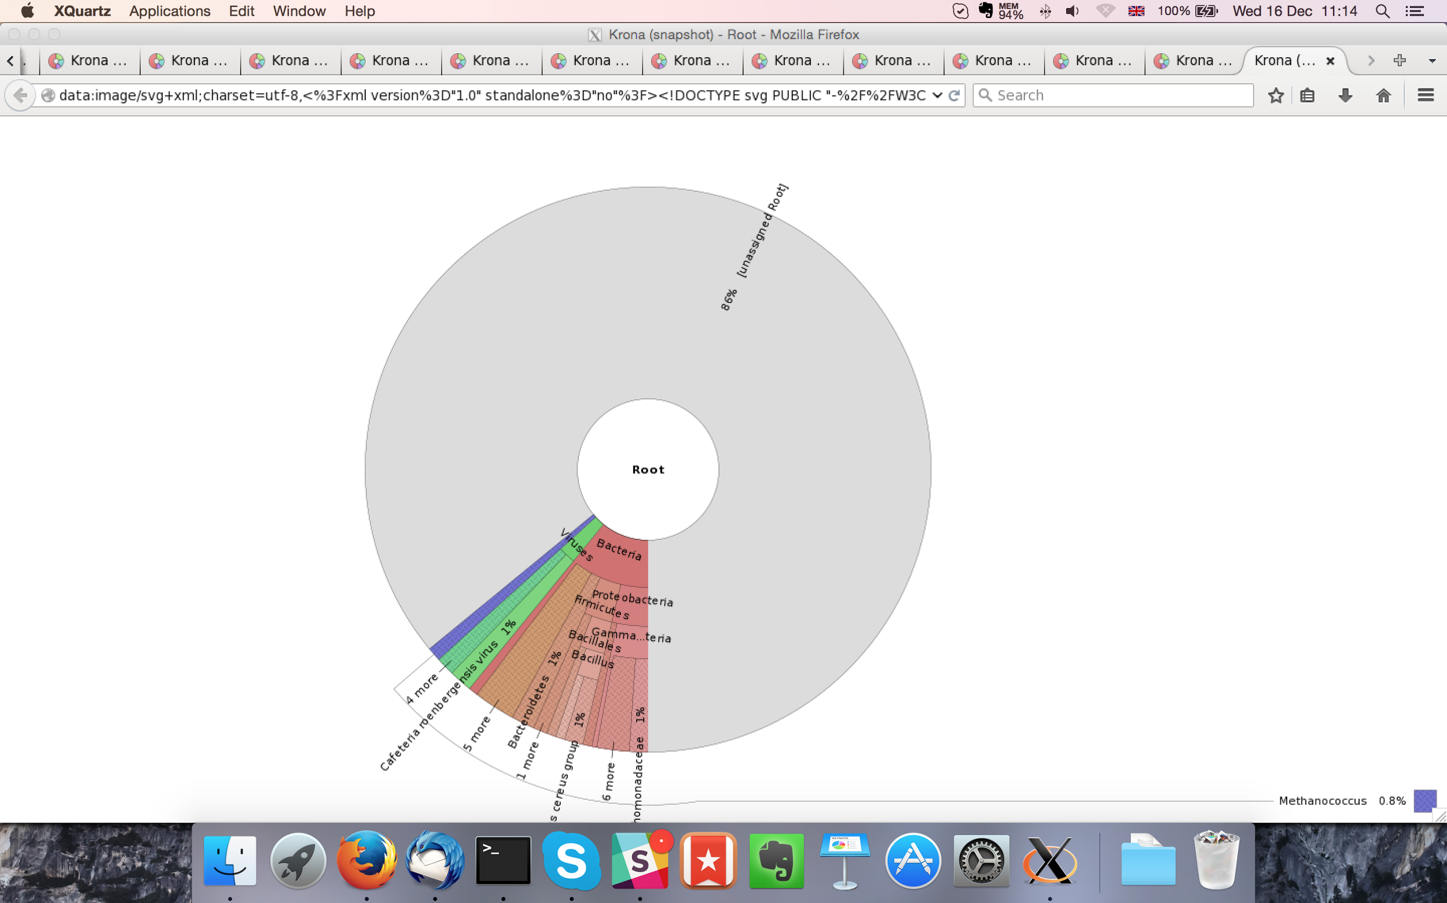

MaSuRCA kraken report below:

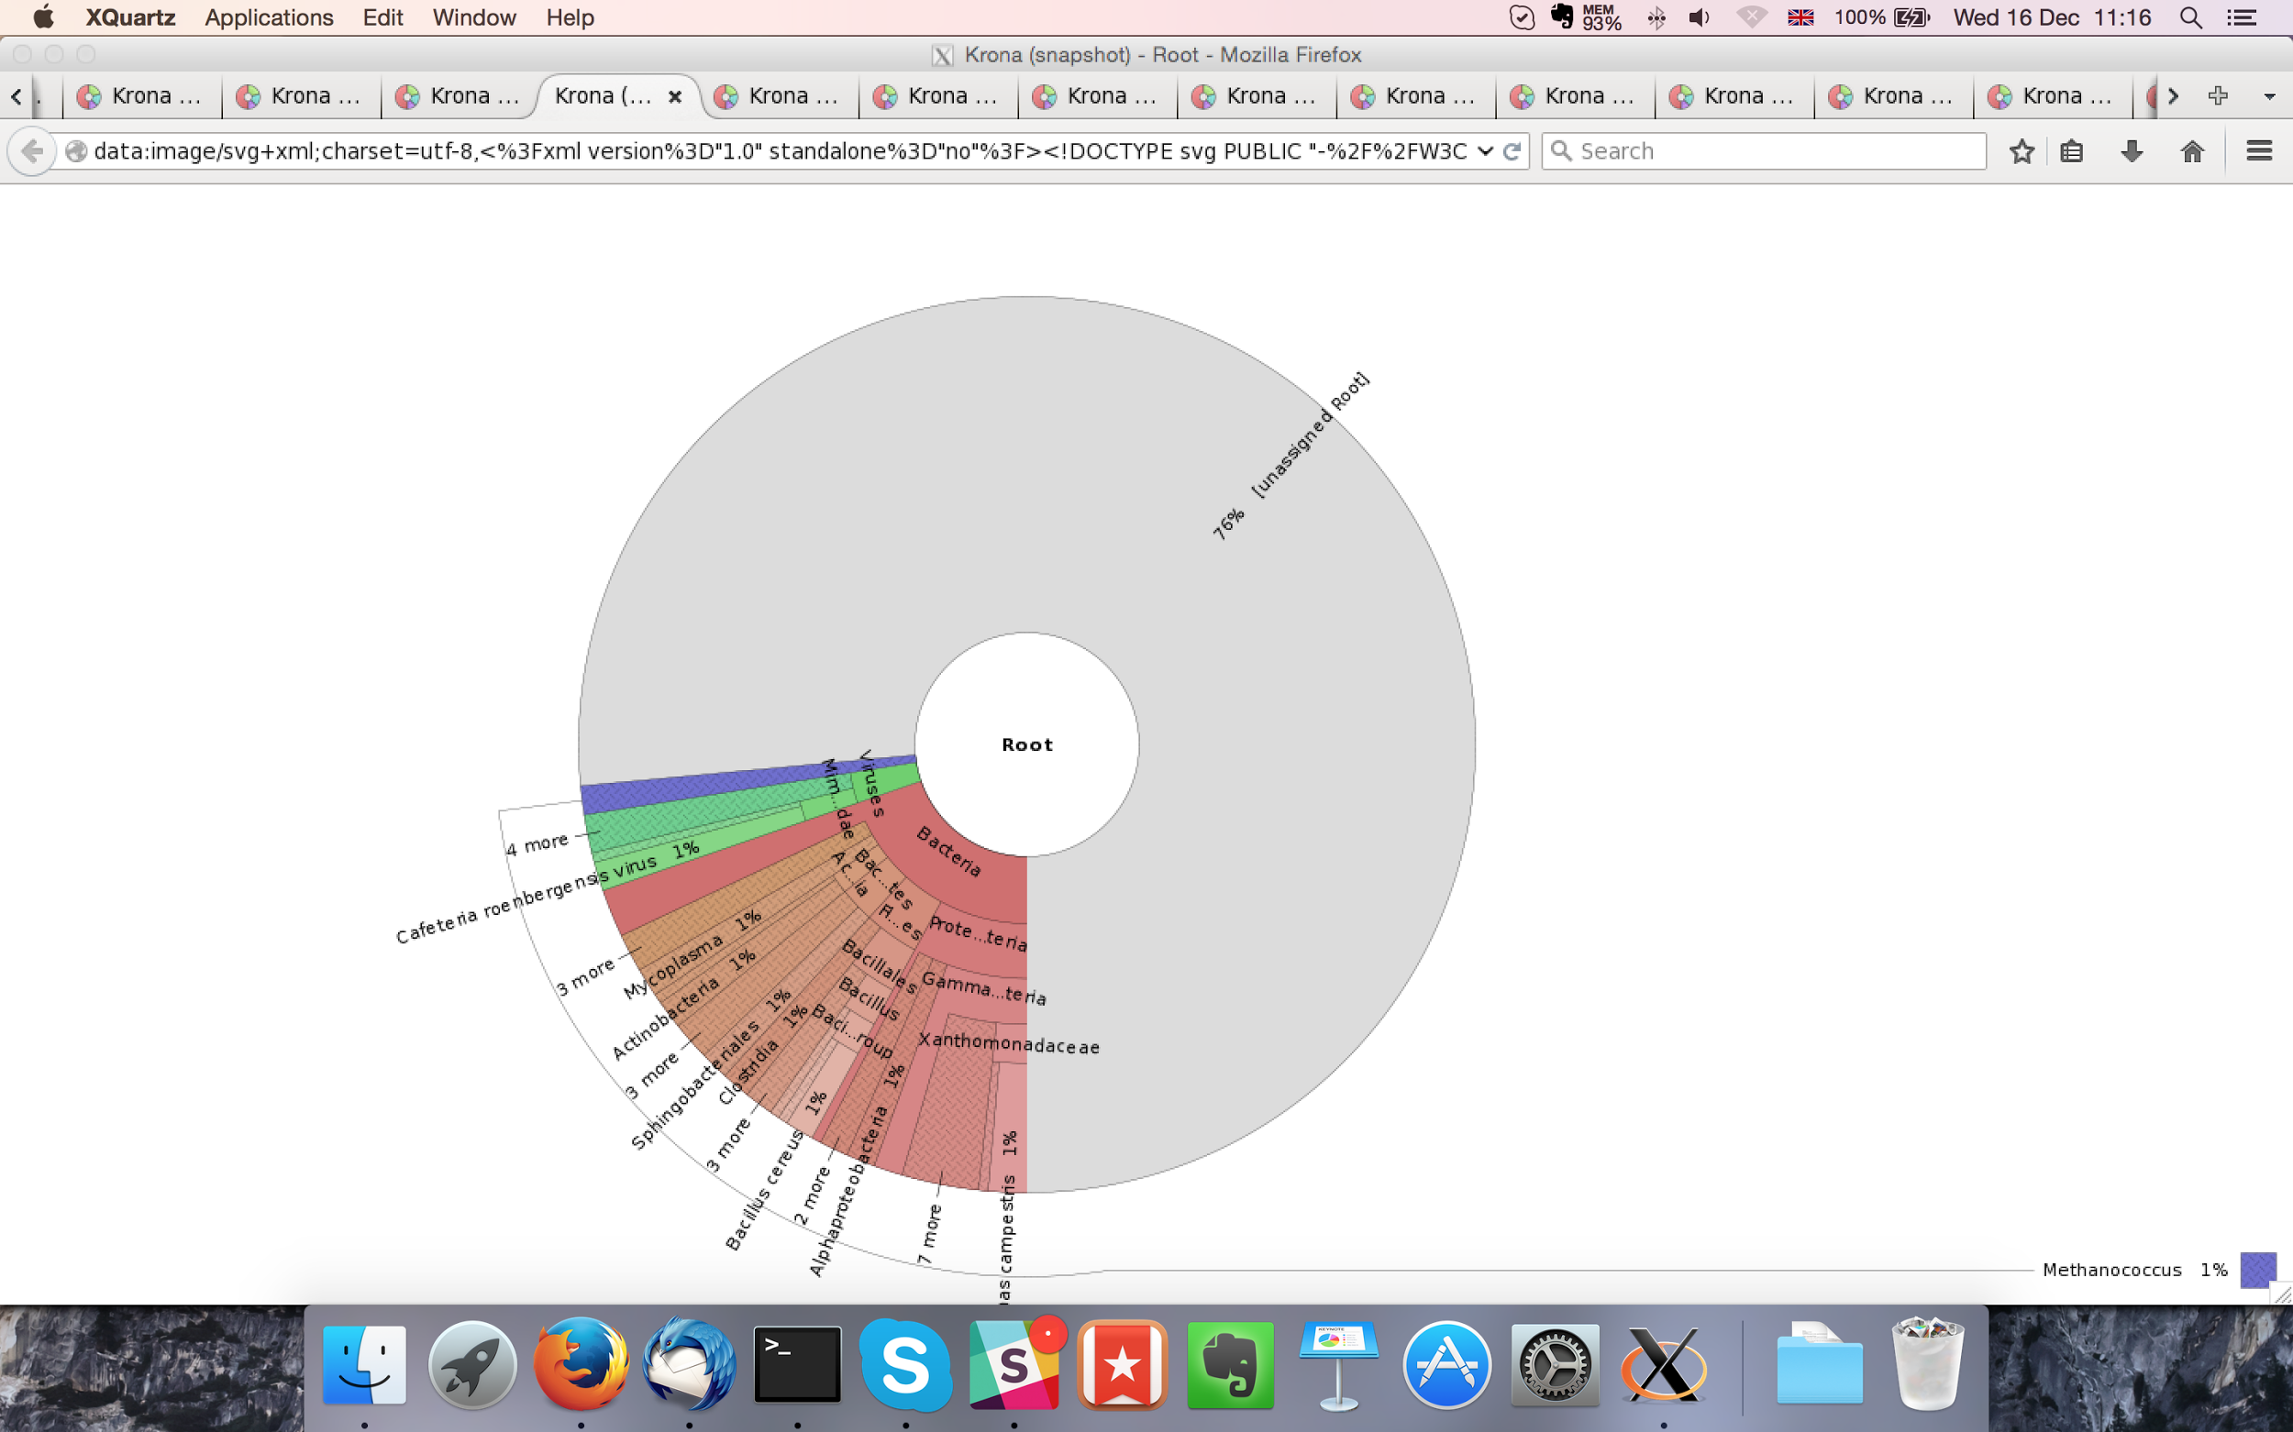

## Sample P1260_1013:

### Assembly Quality Assessment - Quast:

Spades followed by MaSuRCA gives the best assembly measured by comparing Cumulative length and Nx.

|  |  |
| --- | --- |
| Assembler | **Spades** |
| Number of contigs | 350 |
| Largest contig | 870,695 |
| Total assembly length | 12,382,746 |
| N50 | 287,282 |

Spades produced an assembly length of 12,382,746bp, comprised of 350 contigs with an N50 of 287,282bp.

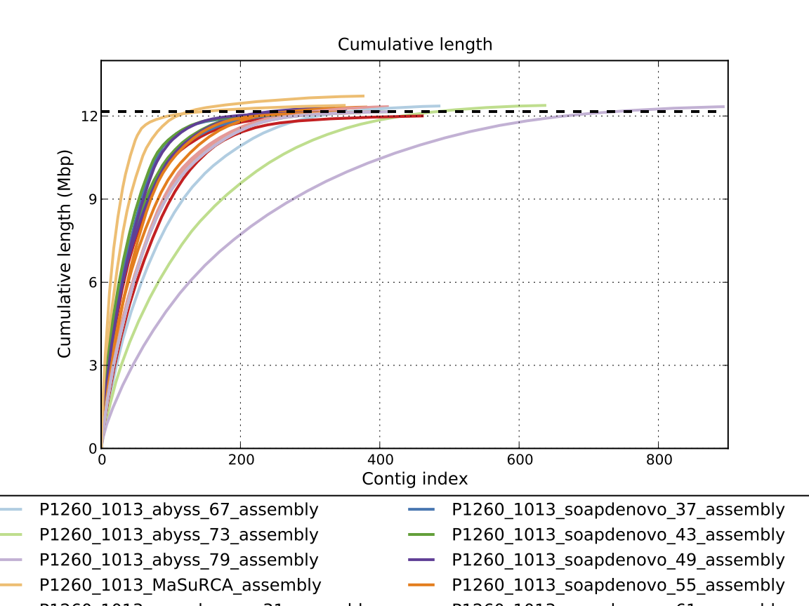

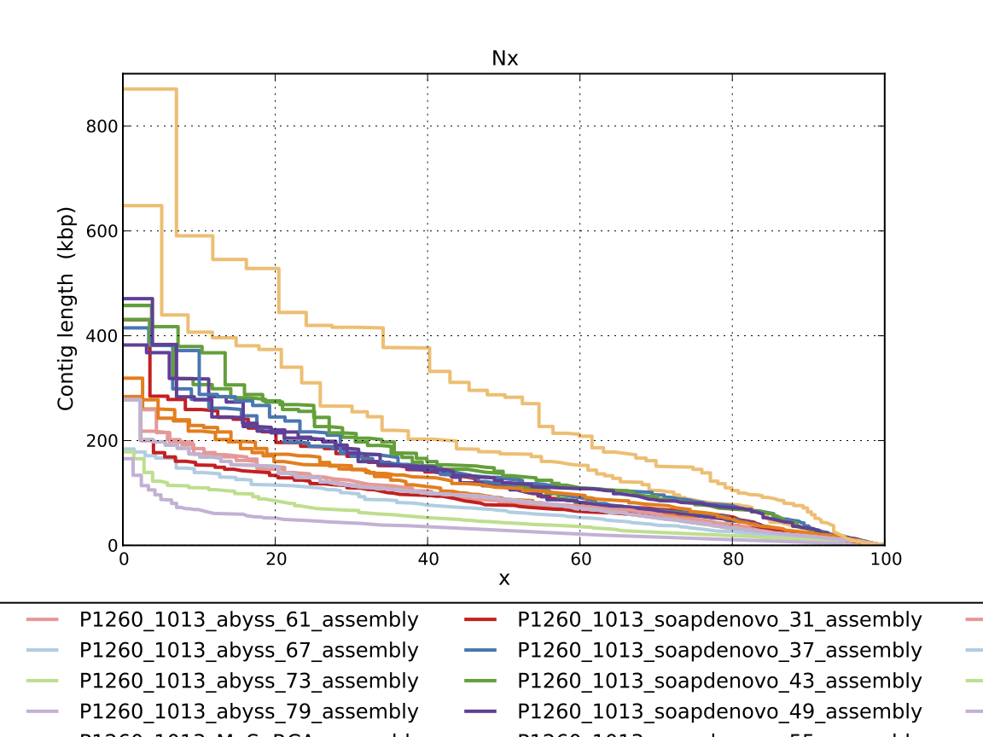

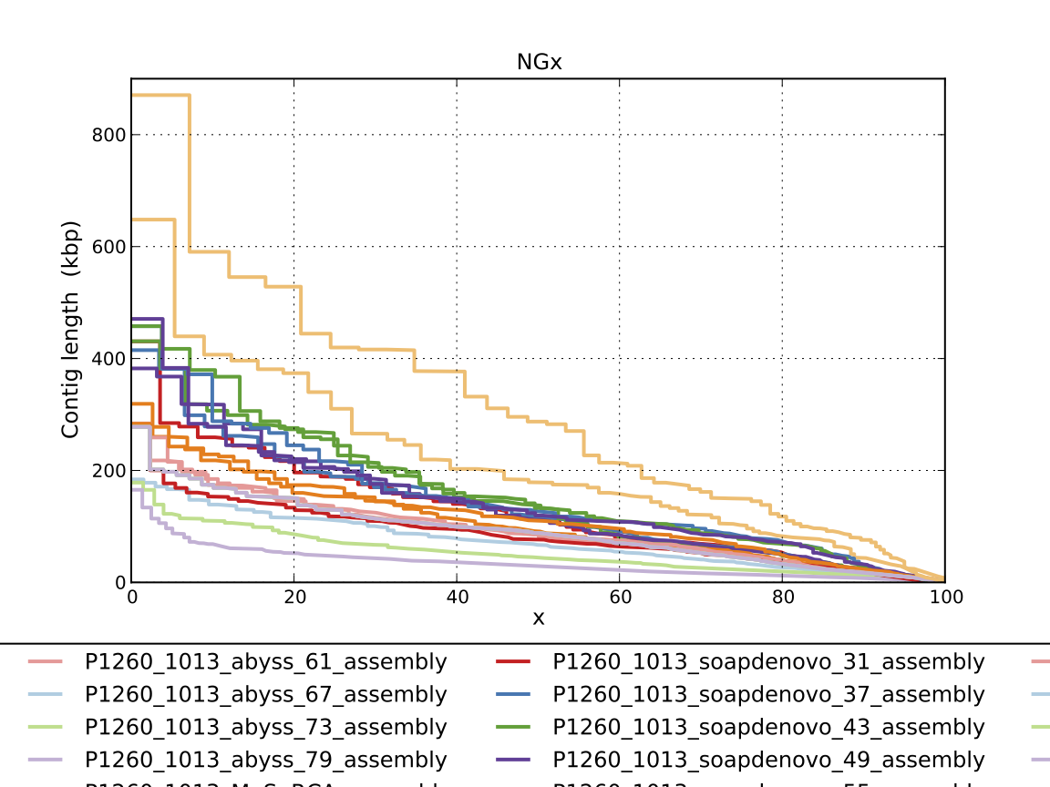

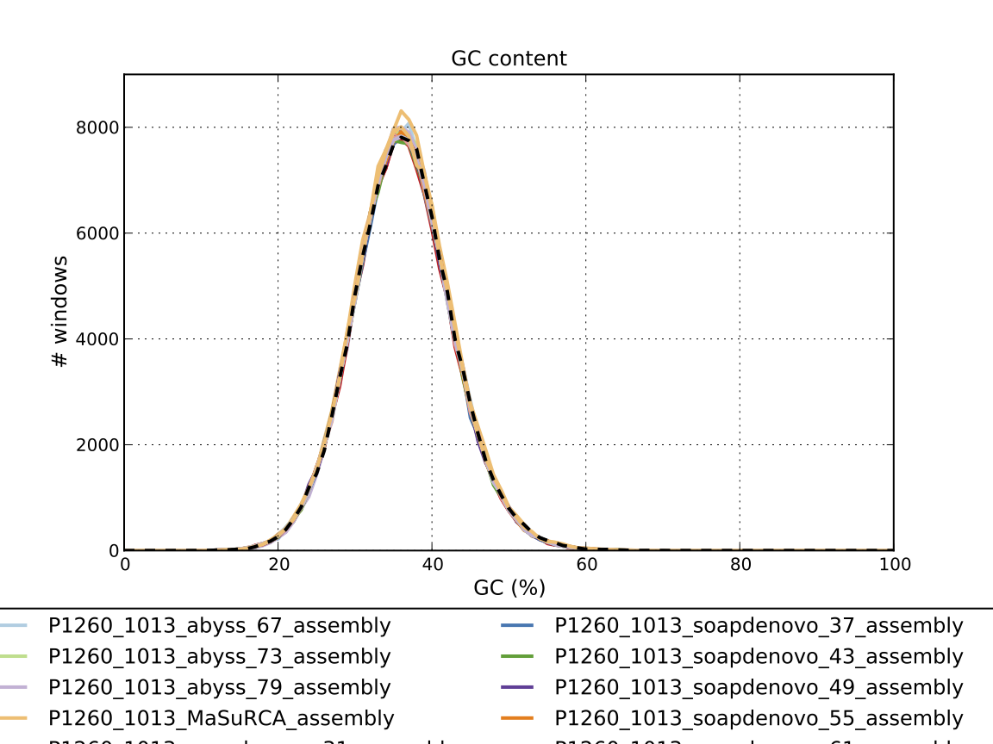

### Assembly Quality Assessment - Compass:

Compass shows that although the assembly is similar in size to the reference, a large portion does not align well, indicating contamination or a very large degree of divergence. The proportion of differing contigs is not clear due to the potential of multiple assembly contigs aligning to the same place on the reference.

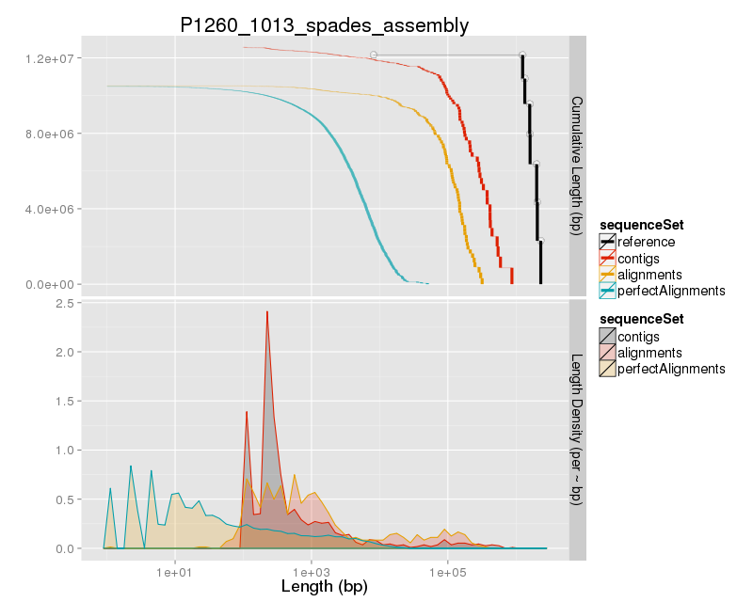

### Assembly Quality Assessment - KAT:

### Assembly Quality Assessment - FRCBAM:

### Assembly Quality Assessment - CEGMA:

CEGMA and BUSCO both attempt to validate the completeness of an assembly by looking at a known gene space, selected to be highly conserved, and present if most, if not all, organisms. CEGMA uses a gene space specifically designed for eukaryotic organisms, while BUSCO can be set for a number of taxonomic groups. Large variation within the completeness between assemblies may indicate that the data was hard to assemble, and thus might run a higher risk of misassembly. BUSCO will also report on duplications of genes, which may indicate chimera in the assembly, and mayneed to be further investigated after annotation.

The CEGMA report of the Spades assembly shows 94% completeness. The CEGMA completeness scores varied between 93.95% (MaSuRCA, Abyss k=55,67,73,79, SOAPdenovo k=31) to 95.16% (SOAPdenovo k=61).

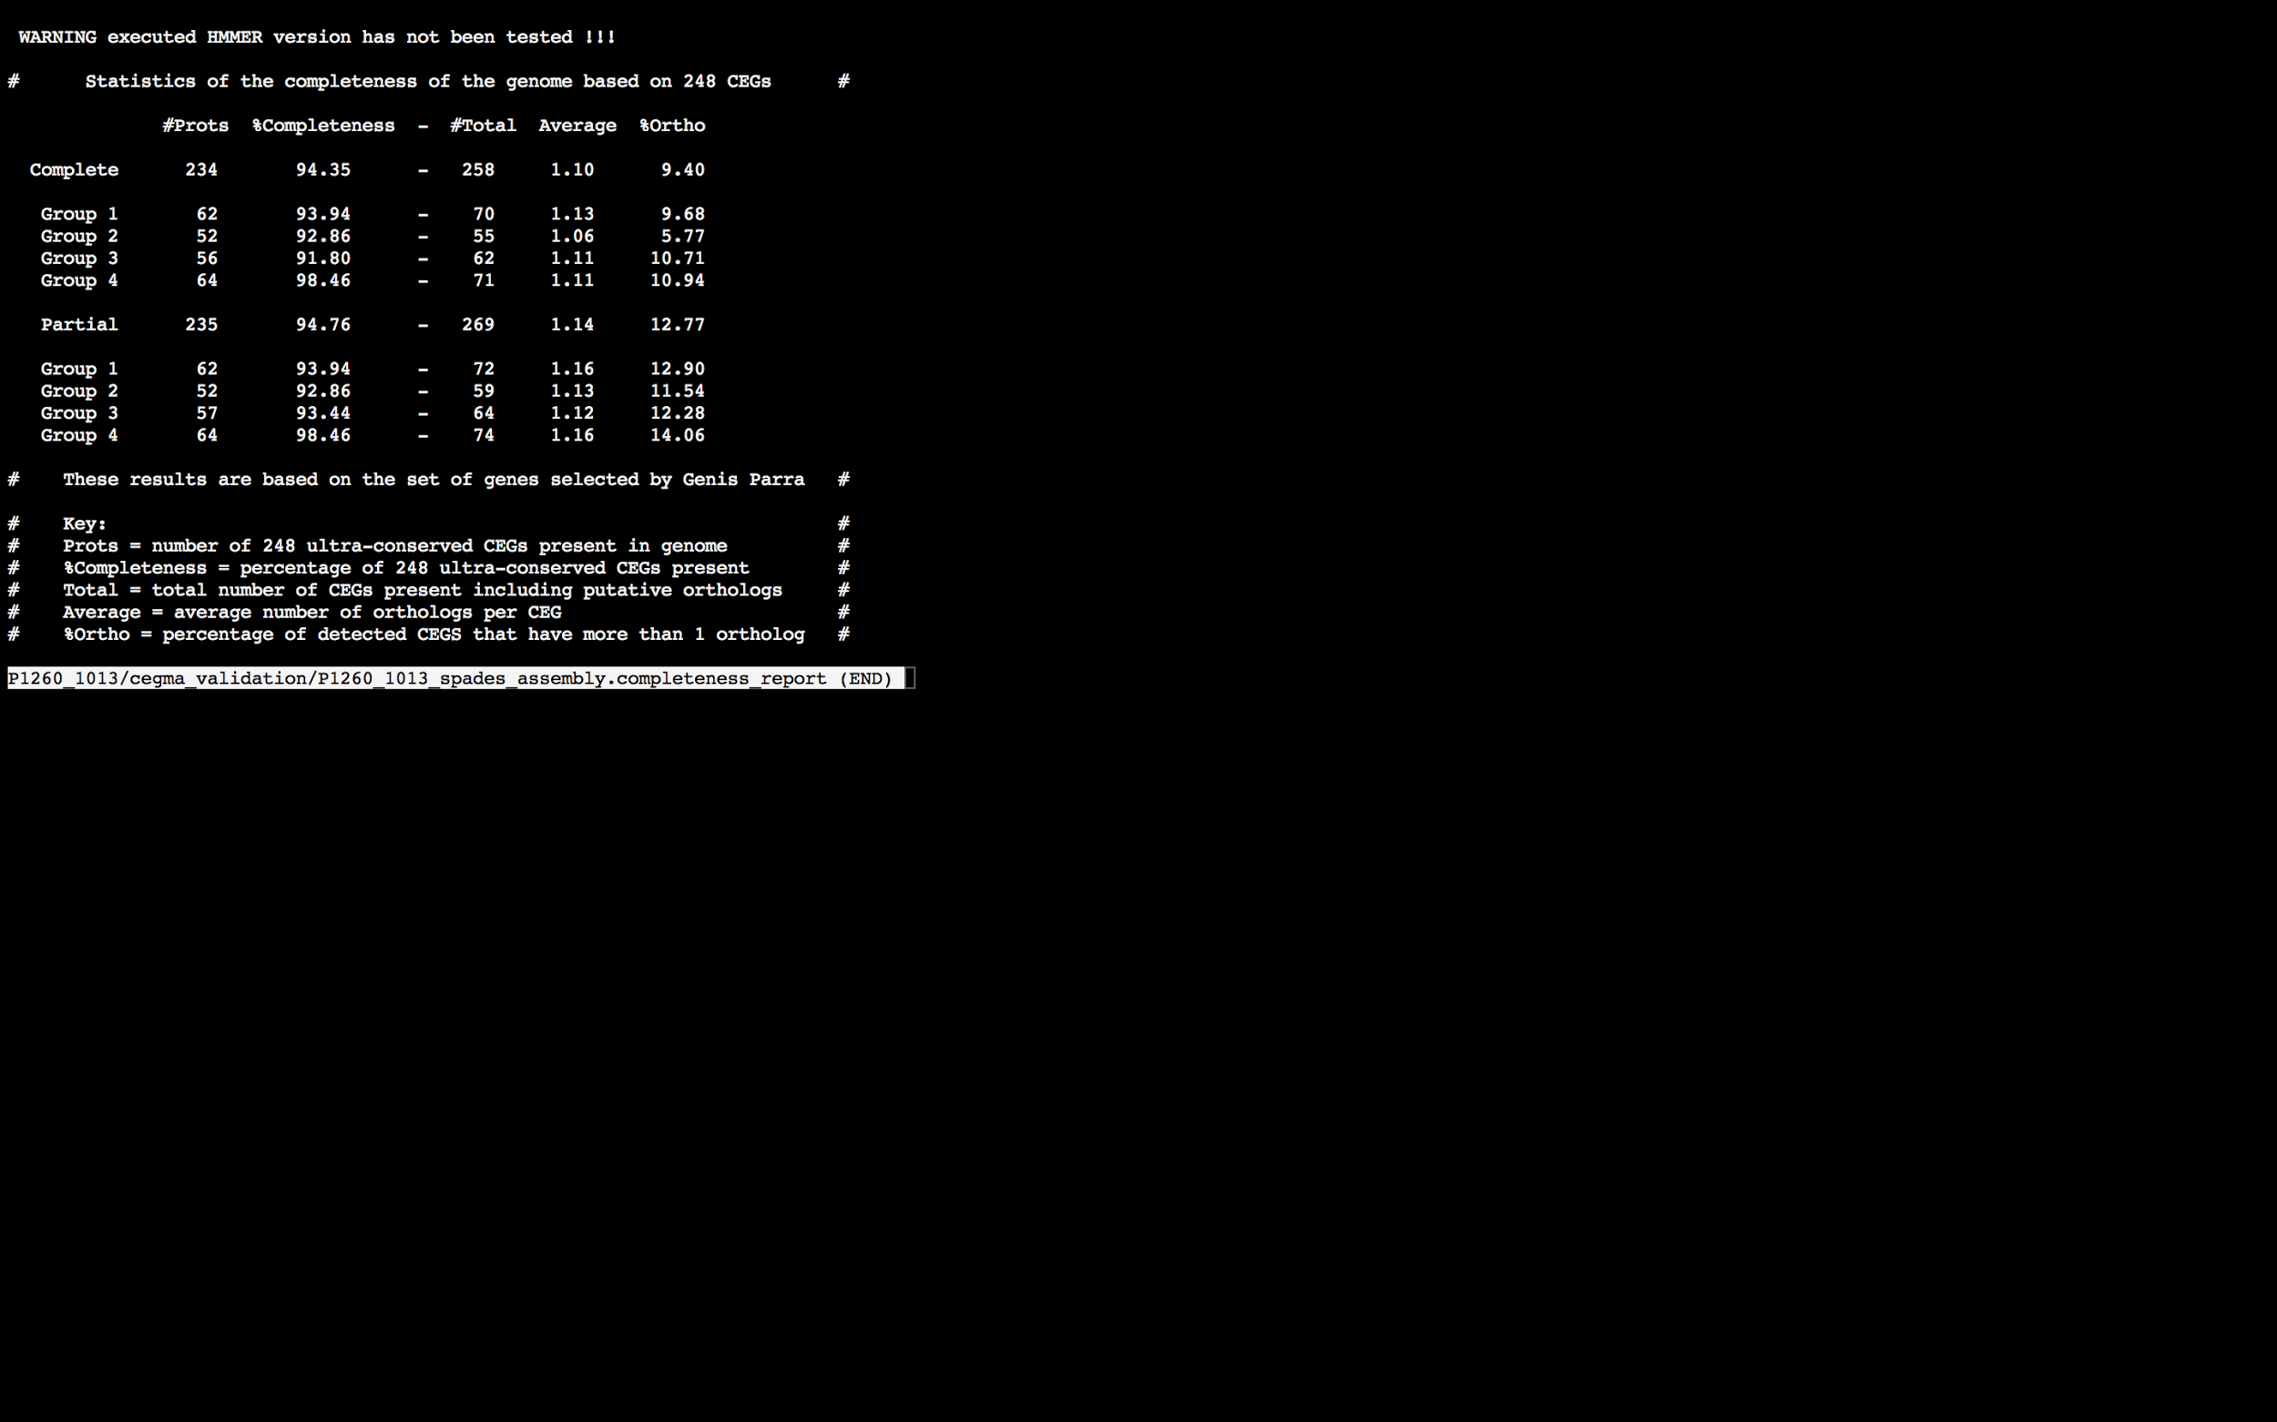

### Assembly Quality Assessment - BUSCO:

The BUSCO report of the Spades assembly shows 97% completeness and 10% duplication. The scores range from 95% (Abyss k=79) to 97% (Abyss k=43,49,55,61, SOAPdenovo k=37,43,49,55,61,67,73,79, and Spades).

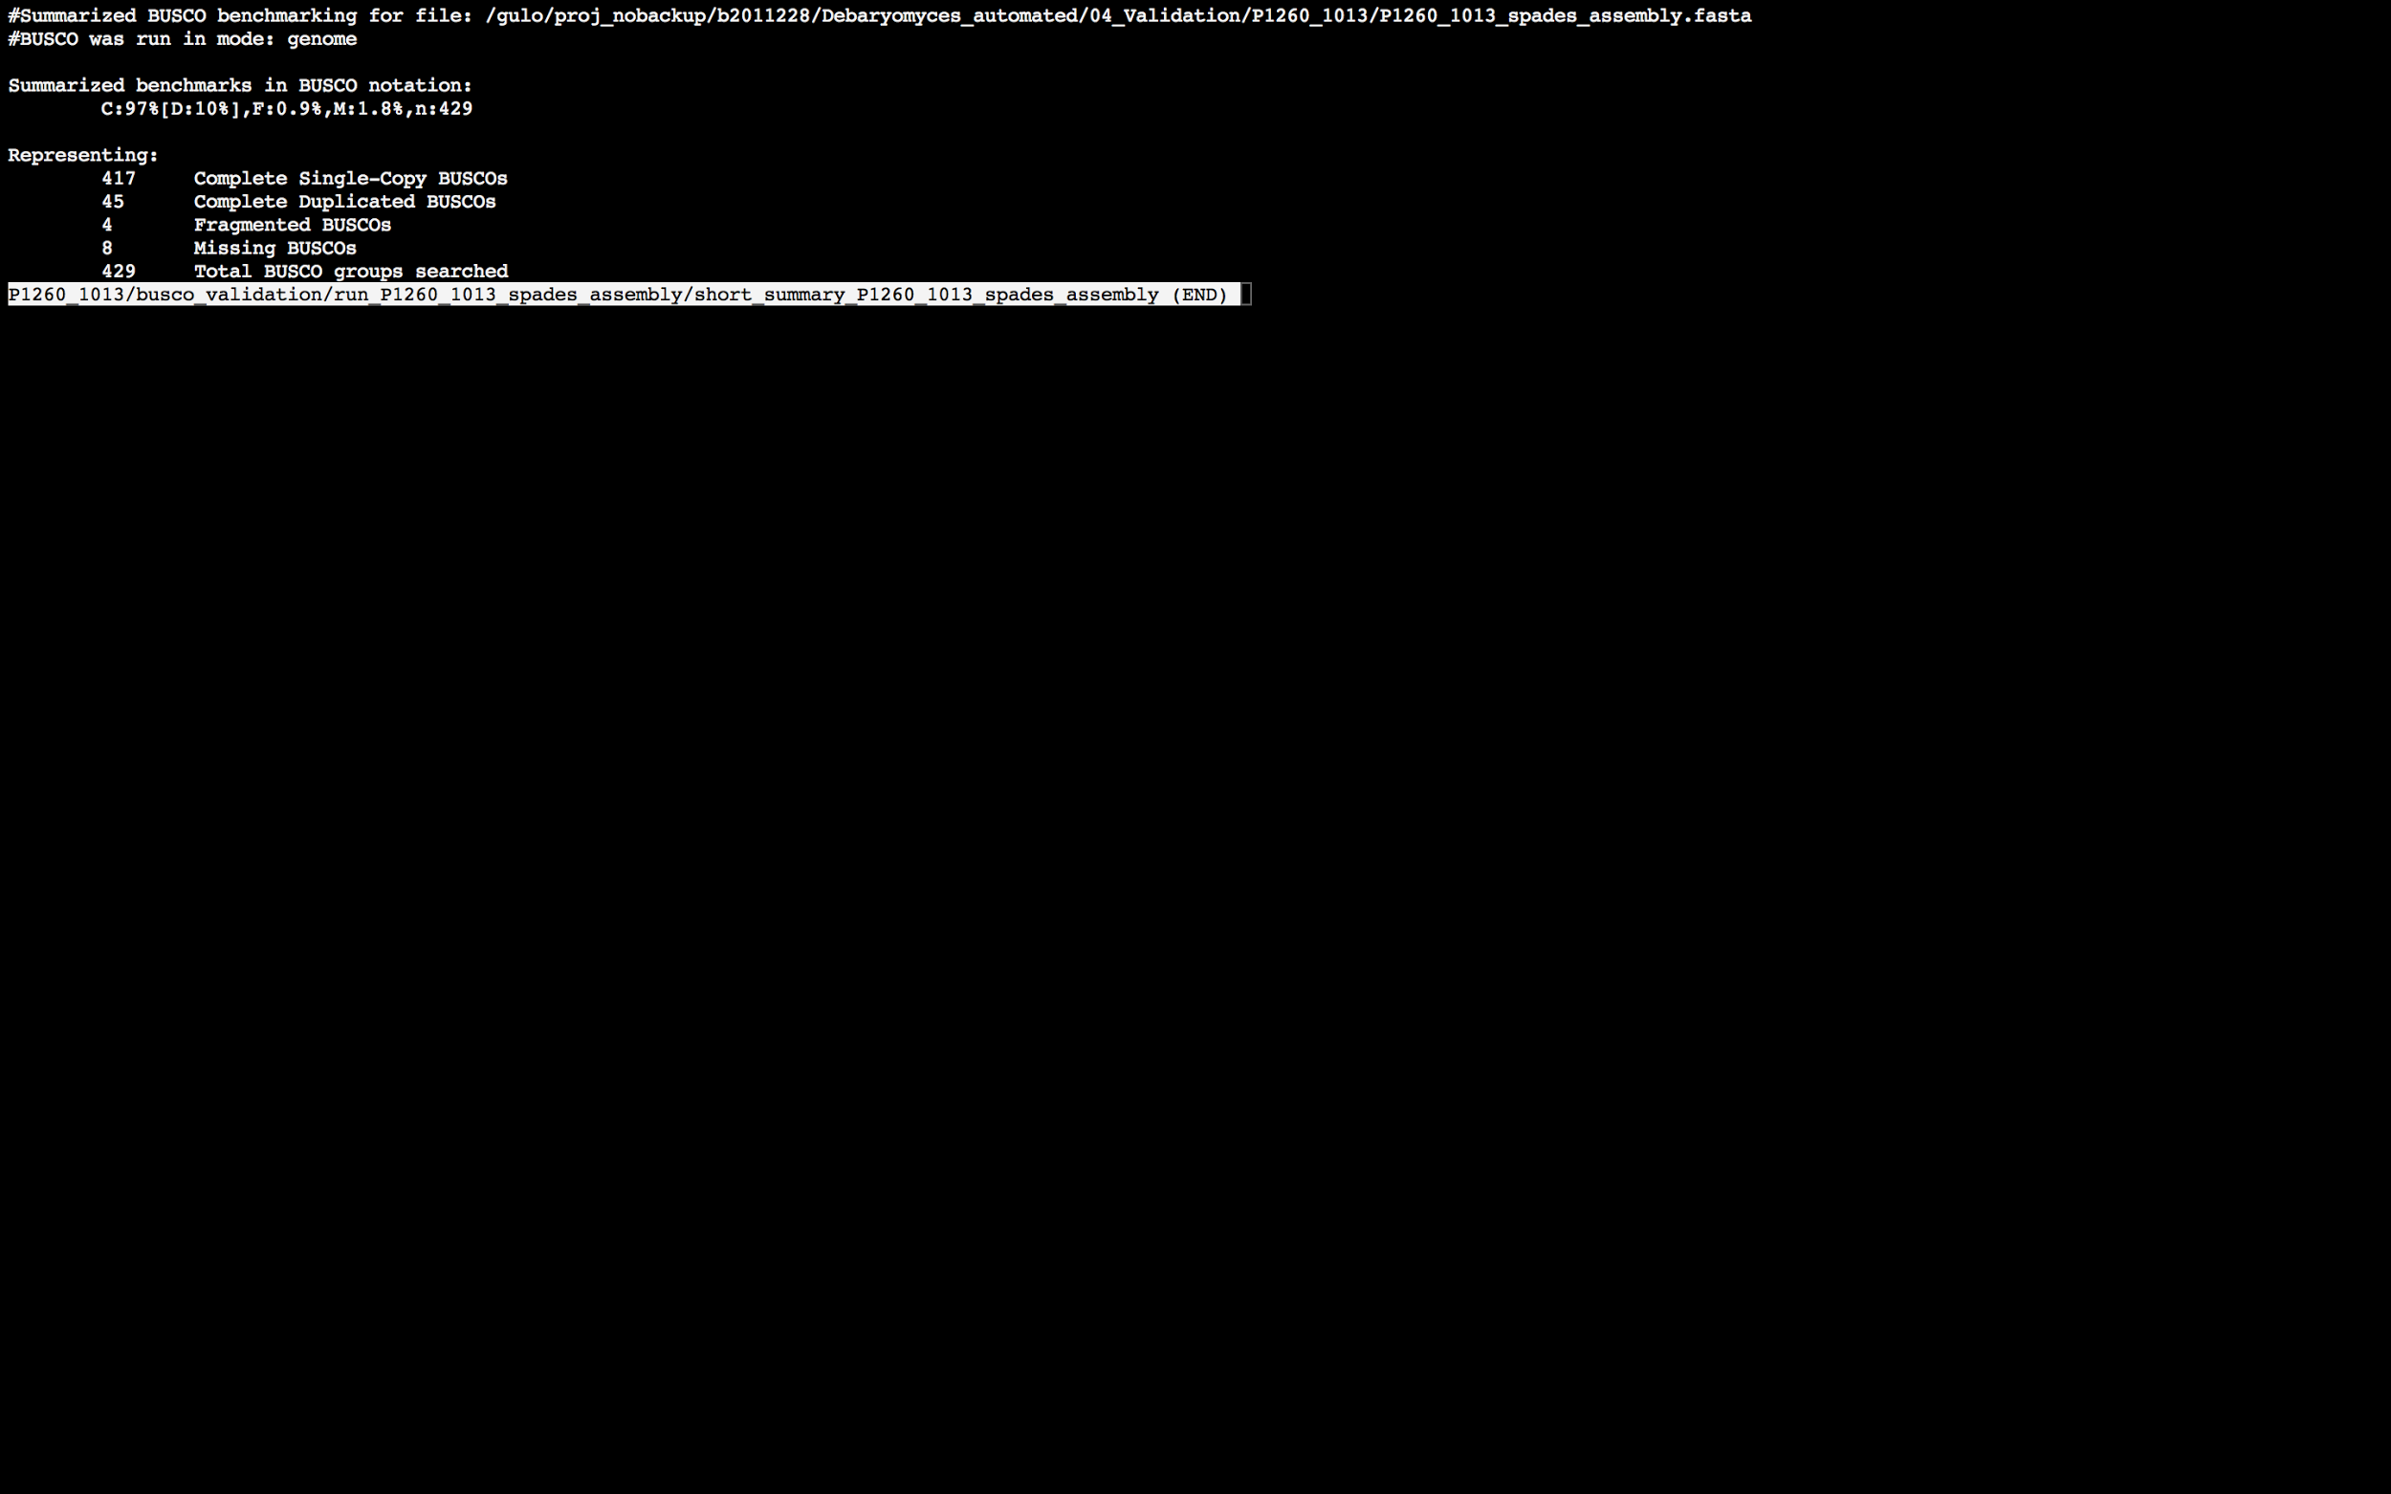

### Assembly Quality Assessment - Blobology:

Blobology indicates that while most contigs are likely Debaryomyces, bacteria may also be present. The blob plot shows a cluster of similar GC content contigs but with lower coverage that potentially indicates contamination. Contamination assessment is a difficult task, and should be interpreted as indicative rather than truth.

|  |  |
| --- | --- |
| # Contigs | Megablast hit |
| 1 | Actinobacillus suis |
| 1 | Bacillus anthracis |
| 1 | Bacillus subtilis |
| 1 | Bacillus thuringiensis |
| 1 | Capnocytophaga canimorsus |
| 2 | Carnobacterium maltaromaticum |
| 1 | Carnobacterium mobile |
| 12 | Carnobacterium sp. 17-4 |
| 1 | Carnobacterium sp. BBDP71 |
| 17 | Carnobacterium sp. WN1359 |
| 1 | Chlamydia pneumoniae |
| 4 | Citrobacter freundii |
| 1 | Clostridium saccharobutylicum |
| 413 | Debaryomyces hansenii |
| 1 | Enterococcus casseliflavus |
| 1 | Enterococcus faecium |
| 1 | Enterococcus hirae |
| 2 | Enterococcus mundtii |
| 1 | Escherichia coli |
| 1 | Halobacillus halophilus |
| 1 | Lacinutrix sp. 5H-3-7-4 |
| 1 | Lactobacillus reuteri |
| 1 | Lactobacillus ultunensis |
| 1 | Listeria ivanovii |
| 1 | Lysinibacillus fusiformis |
| 2 | Morganella morganii |
| 396 | Not annotated |
| 1 | Pasteurella multocida |
| 1 | Proteus vulgaris |
| 7 | Providencia stuartii |
| 12 | Pseudomonas phage OBP |
| 1 | Salmonella enterica |
| 1 | Scheffersomyces stipitis |
| 1 | Serratia plymuthica |
| 1 | Streptococcus dysgalactiae |
| 1 | Streptococcus gordonii |
| 1 | Tetragenococcus halophilus |
| 1 | Vibrio campbellii |
| 2 | Vibrio coralliilyticus |
| 1 | Weissella thailandensis |
| 1 | Xenorhabdus poinarii |

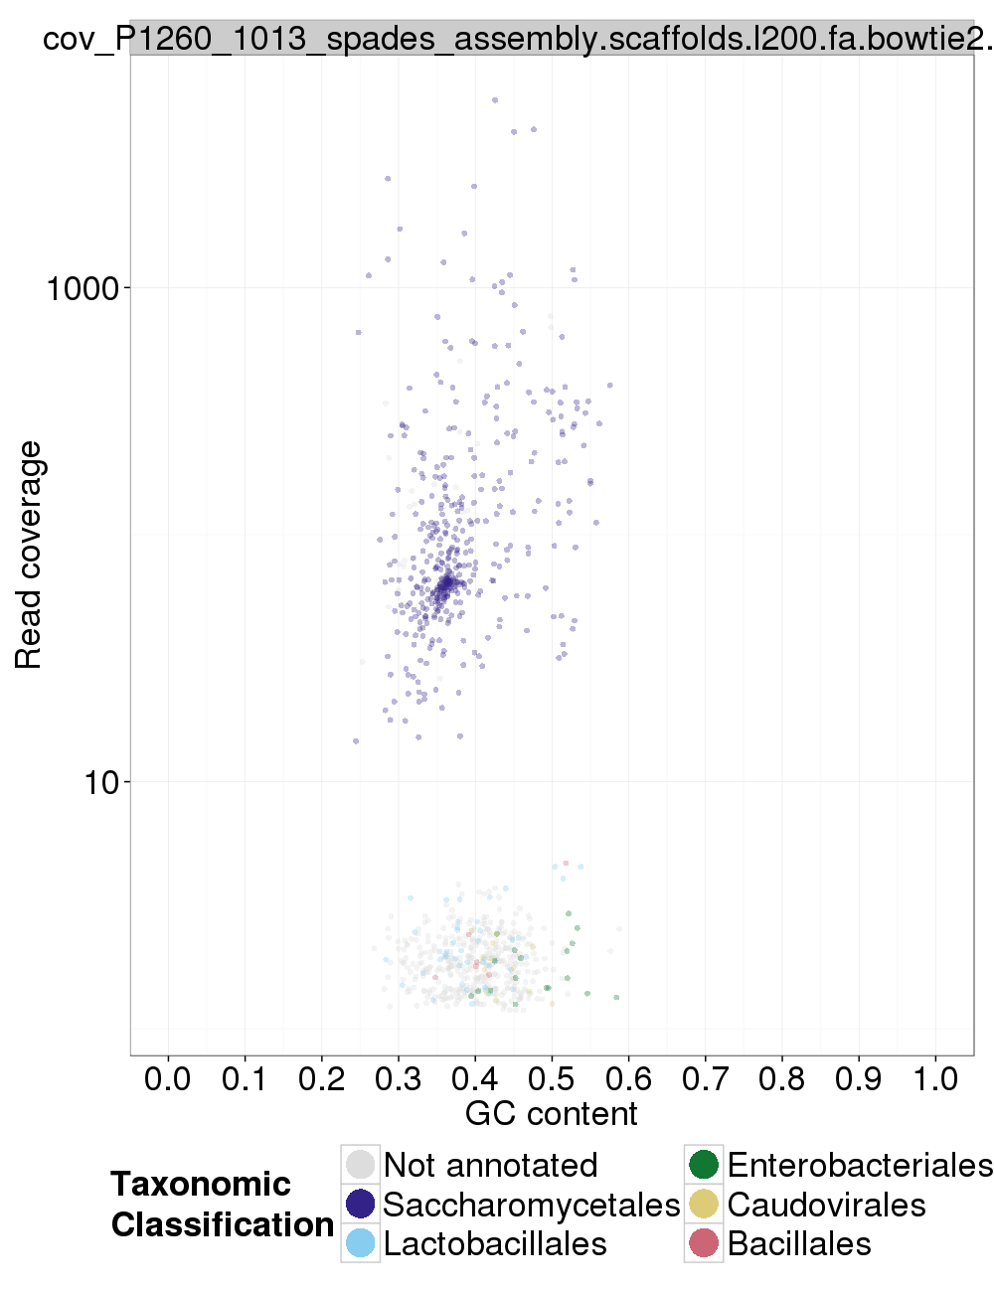

### Assembly Quality Assessment - Kraken:

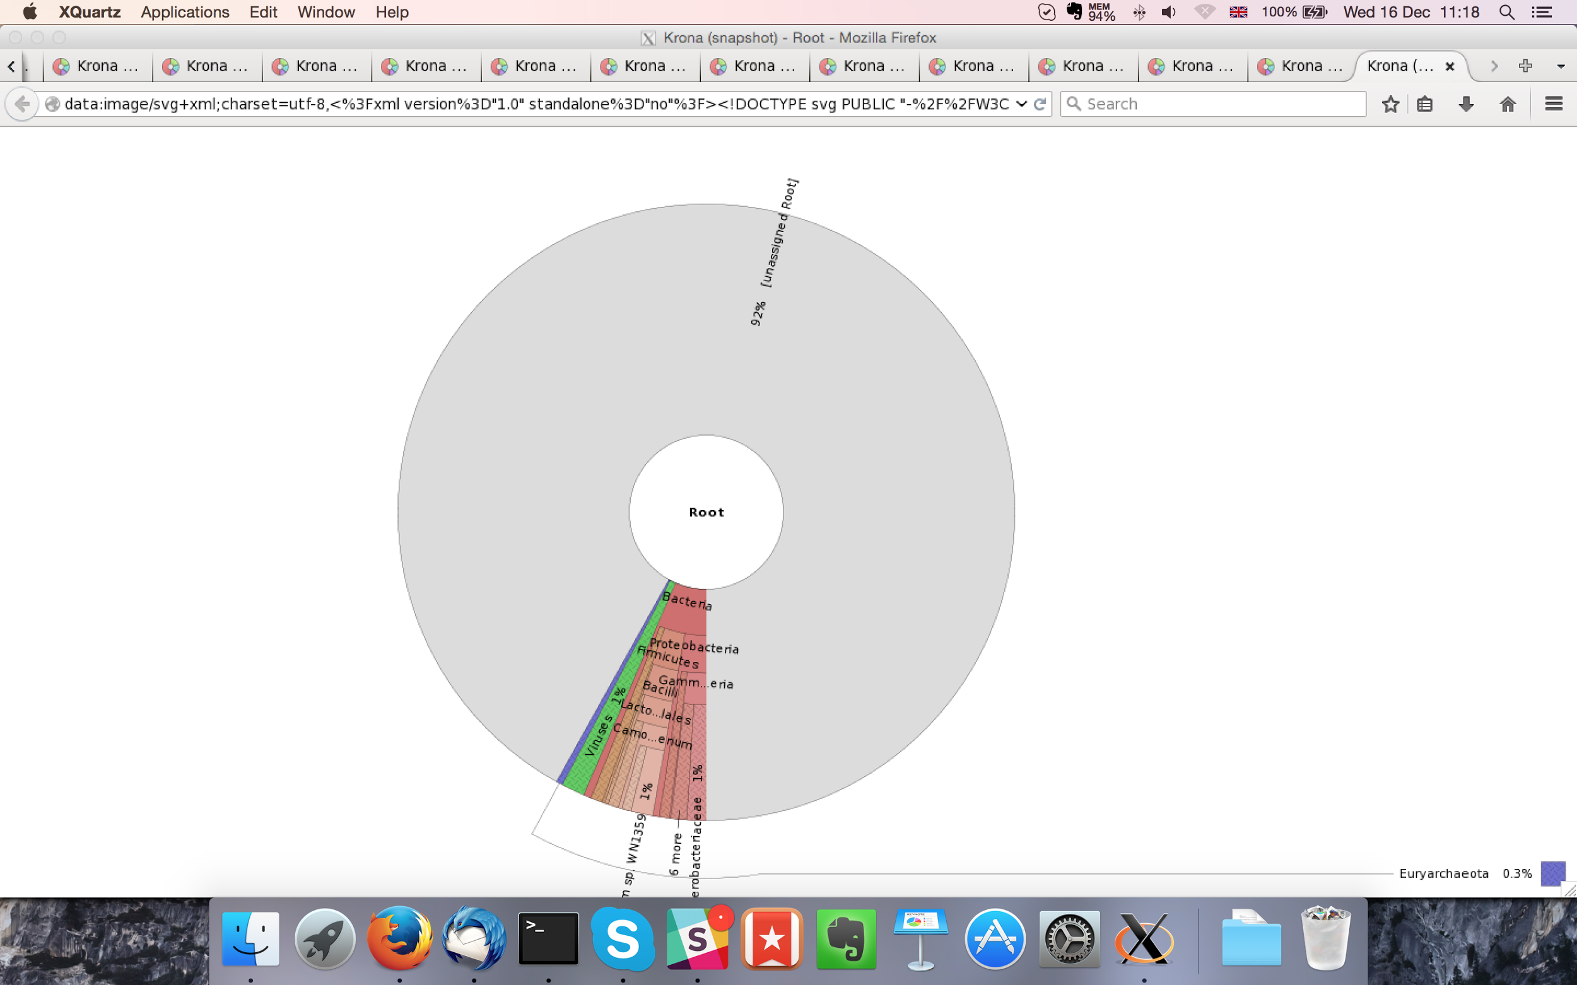

MaSuRCA kraken report below:

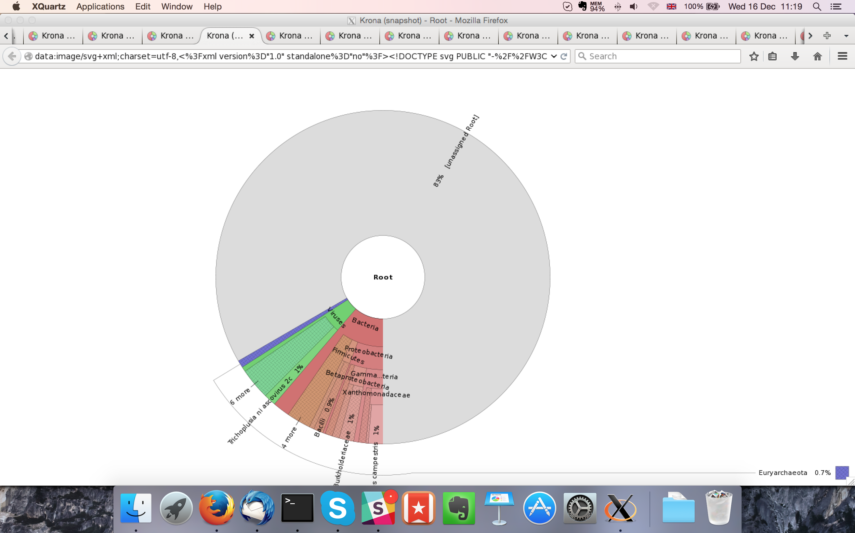

## Sample P1260_1014:

### Assembly Quality Assessment - Quast:

Spades followed by MaSuRCA gives the best assembly measured by comparing Cumulative length and Nx.

|  |  |
| --- | --- |
| Assembler | **Spades** |
| Number of contigs | 336 |
| Largest contig | 930,922 |
| Total assembly length | 12,027,948 |
| N50 | 195,335 |

Spades produced an assembly length of 12,027,948bp, comprised of 336 contigs with an N50 of 195,335bp.

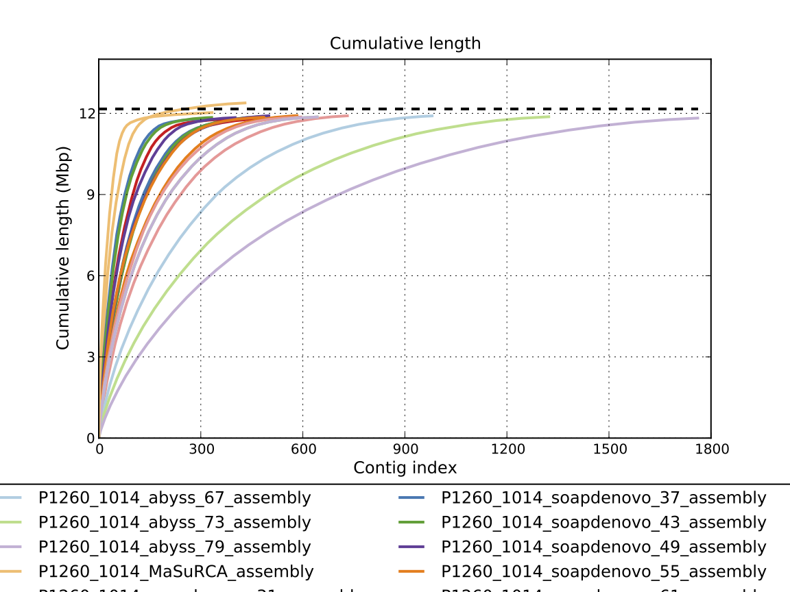

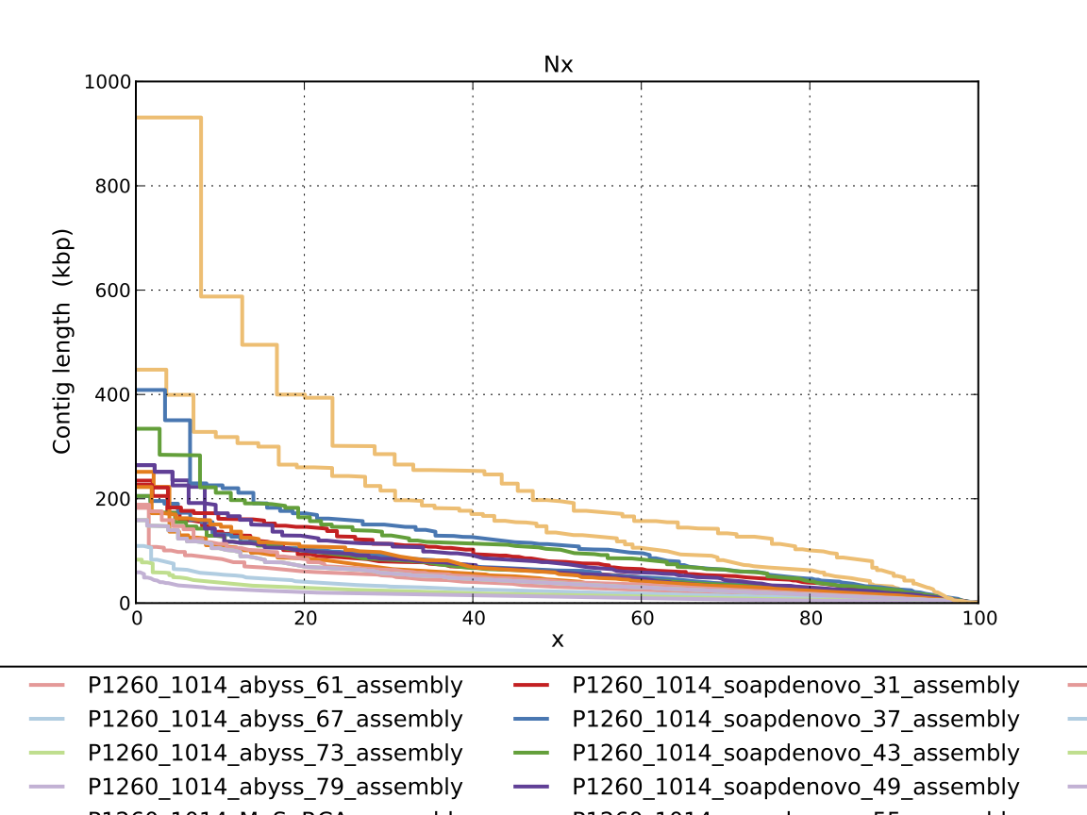

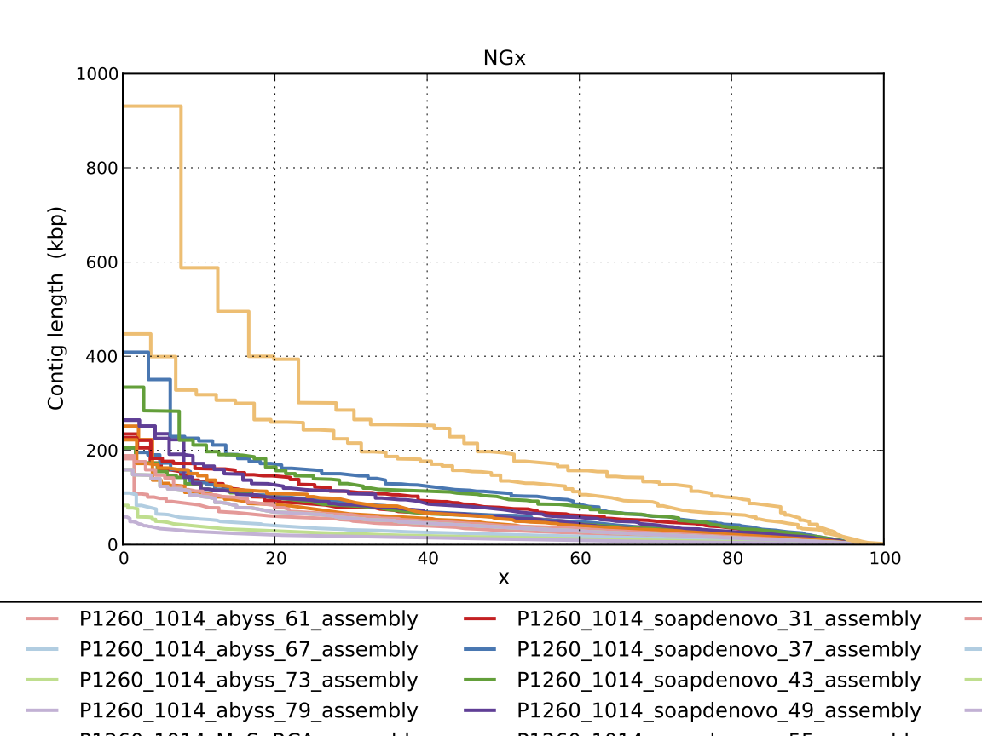

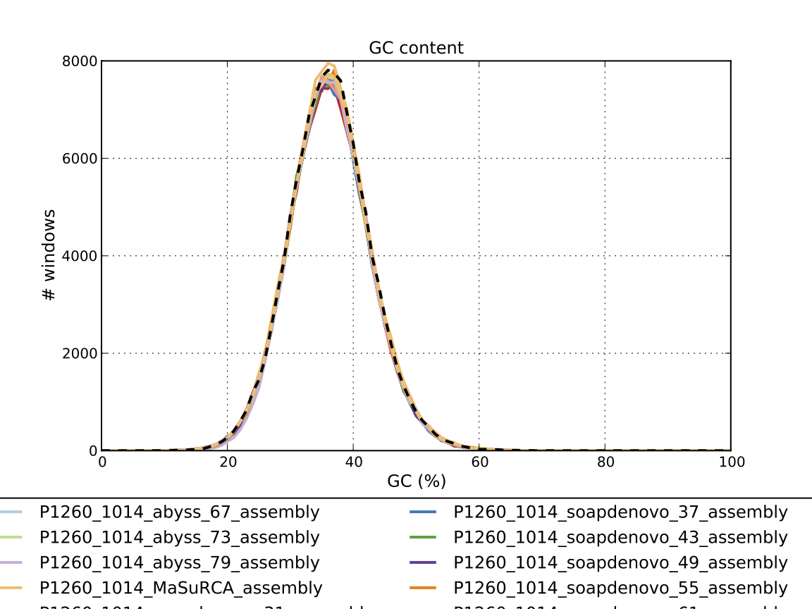

### Assembly Quality Assessment - Compass:

Compass shows that although the assembly is similar in size to the reference, a large portion does not align well, indicating contamination or a very large degree of divergence. The proportion of differing contigs is not clear due to the potential of multiple assembly contigs aligning to the same place on the reference.

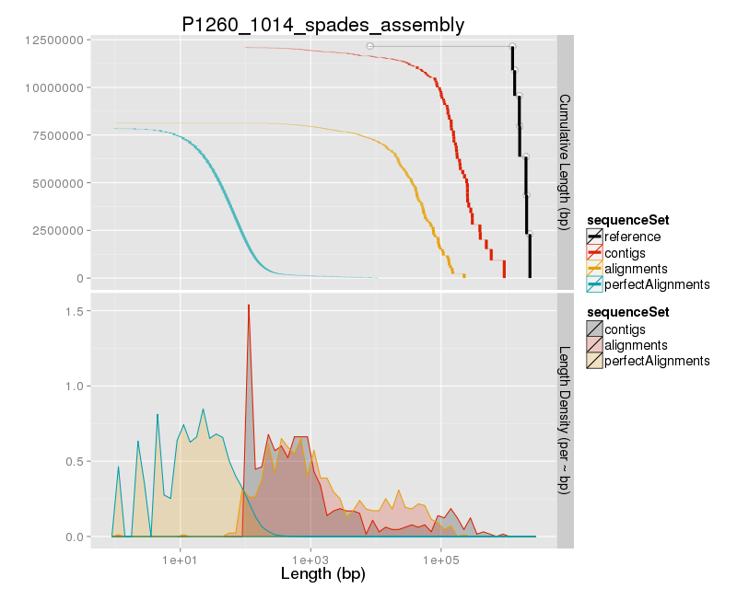

### Assembly Quality Assessment - KAT:

### Assembly Quality Assessment - FRCBAM:

### Assembly Quality Assessment - CEGMA:

CEGMA and BUSCO both attempt to validate the completeness of an assembly by looking at a known gene space, selected to be highly conserved, and present if most, if not all, organisms. CEGMA uses a gene space specifically designed for eukaryotic organisms, while BUSCO can be set for a number of taxonomic groups. Large variation within the completeness between assemblies may indicate that the data was hard to assemble, and thus might run a higher risk of misassembly. BUSCO will also report on duplications of genes, which may indicate chimera in the assembly, and mayneed to be further investigated after annotation.

The CEGMA report of the Spades assembly shows 94% completeness. The CEGMA completeness scores varied between 93.55% (Abyss k=43) to 95.16% (Abyss k=73).

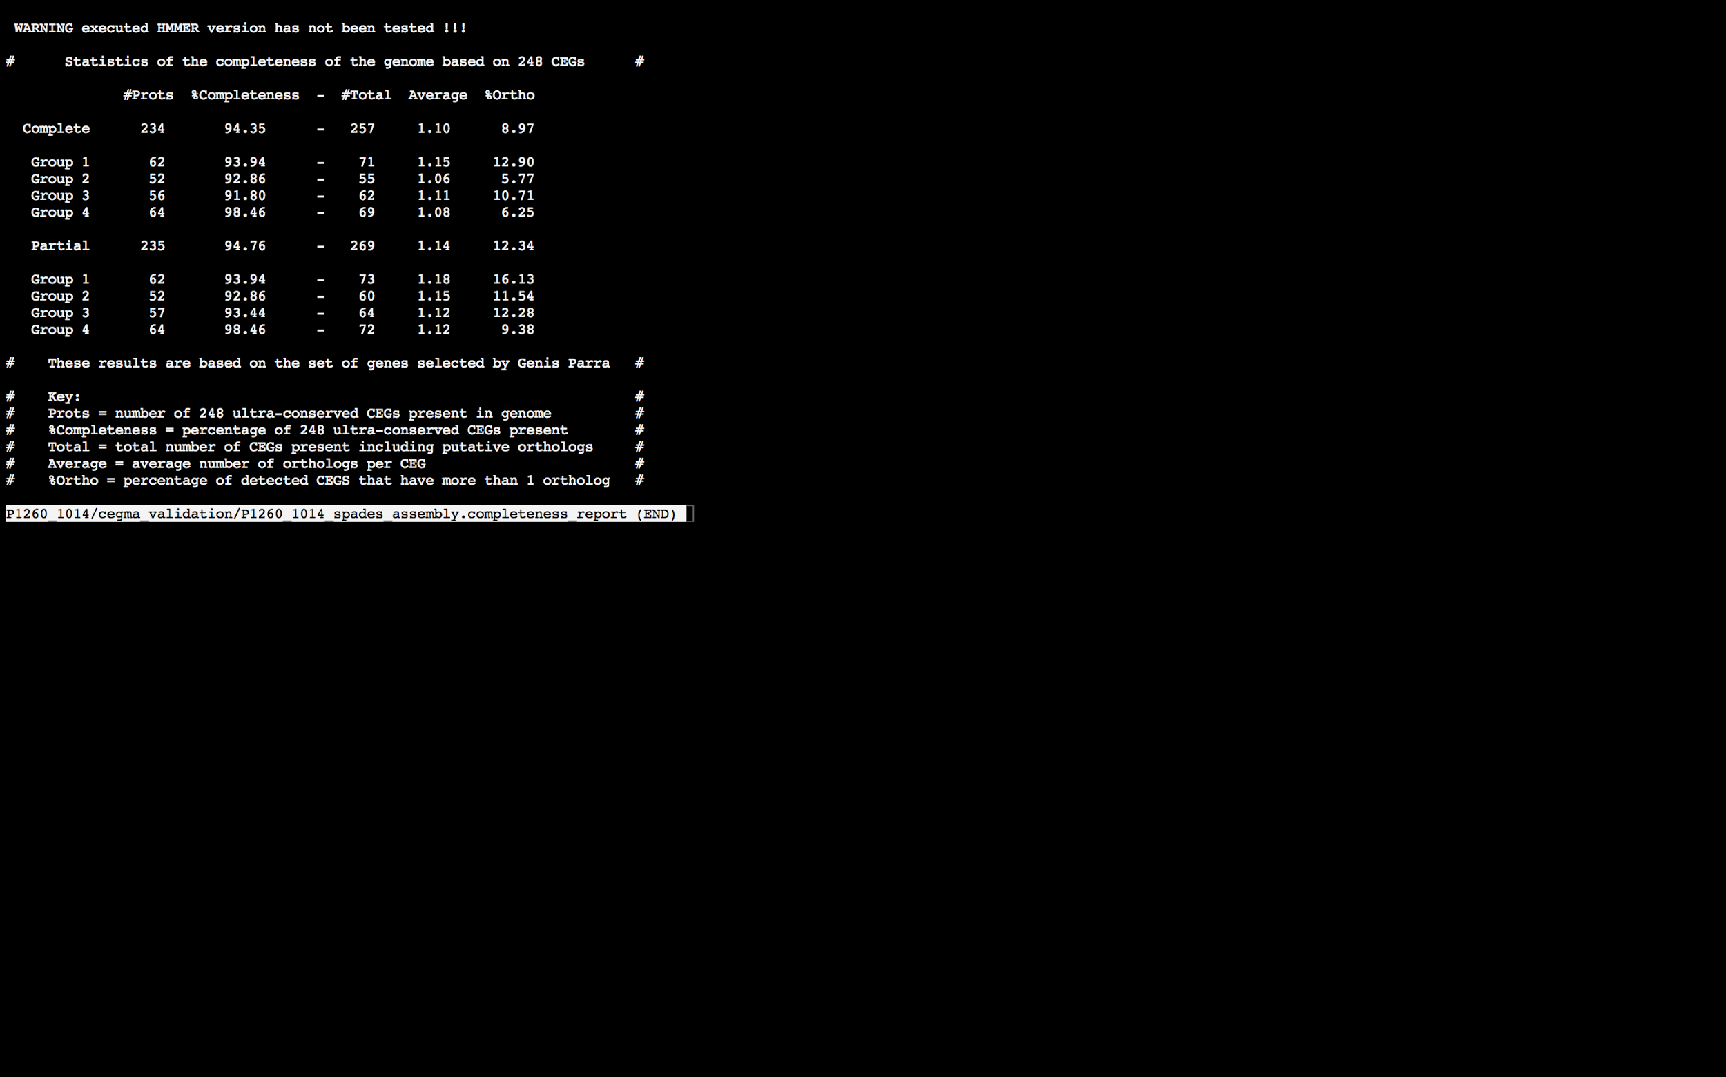

### Assembly Quality Assessment - BUSCO:

The BUSCO report of the Spades assembly shows 95% completeness and 9.5% duplication. The scores range from 91% (SOAPdenovo k=79) to 96% (MaSuRCA, Abyss k=37,43, and SOAPdenovo k=31,43,49,55).

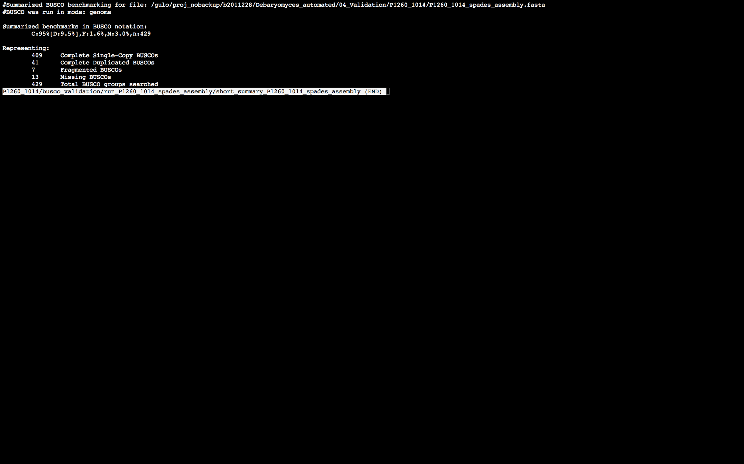

### Assembly Quality Assessment - Blobology:

Blobology indicates that while most contigs are likely Debaryomyces, bacteria may also be present. The blob plot shows a cluster of similar GC content contigs but with lower coverage that potentially indicates contamination. Contamination assessment is a difficult task, and should be interpreted as indicative rather than truth.

|  |  |
| --- | --- |
| # Contigs | Megablast hit |
| 446 | Debaryomyces hansenii |
| 1 | Debaryomyces hansenii virus JB-2008 |
| 36 | Not annotated |
| 1 | Pan troglodytes |
| 4 | Scheffersomyces stipitis |
| 1 | Thalassiosira pseudonana |
| 1 | Trichobilharzia regenti |

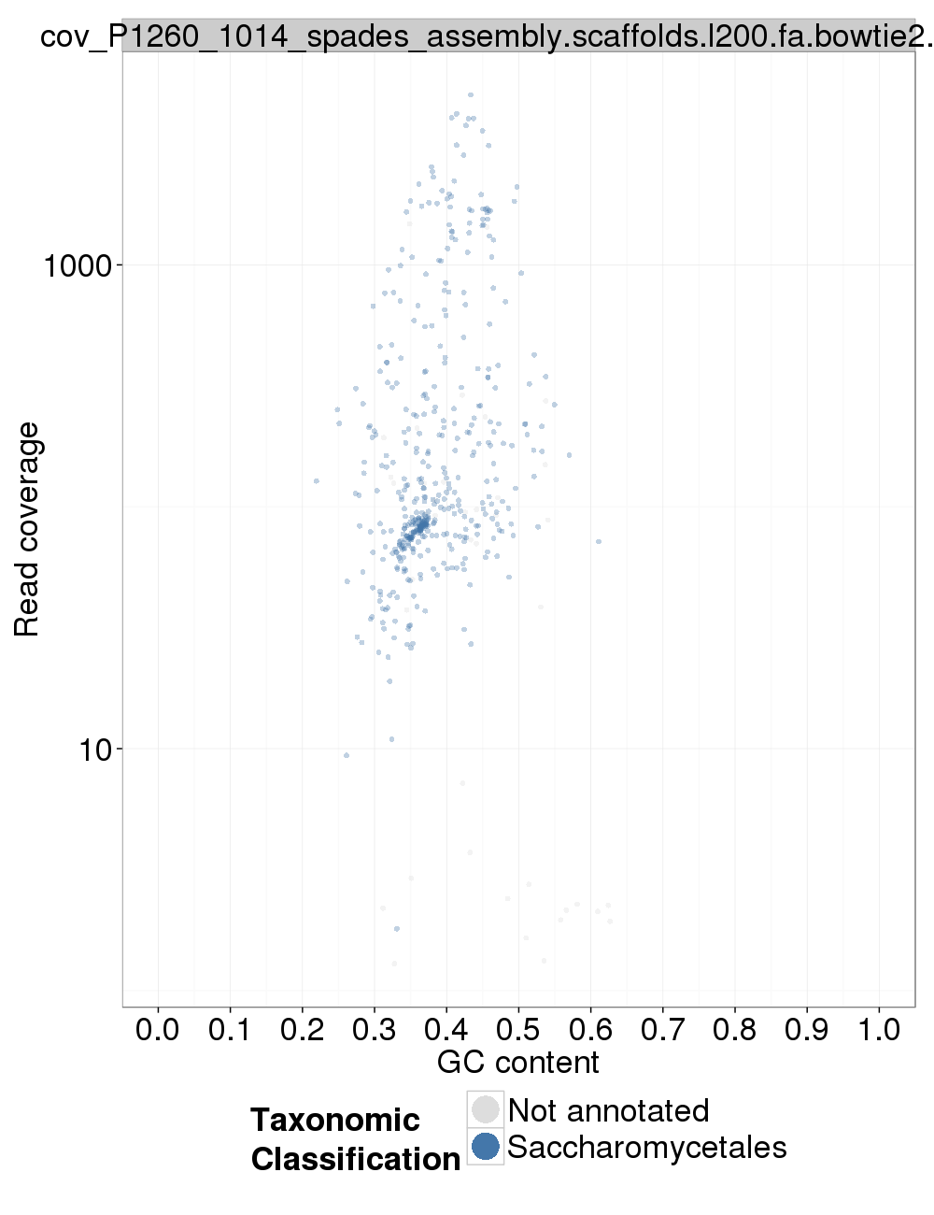

### Assembly Quality Assessment - Kraken:

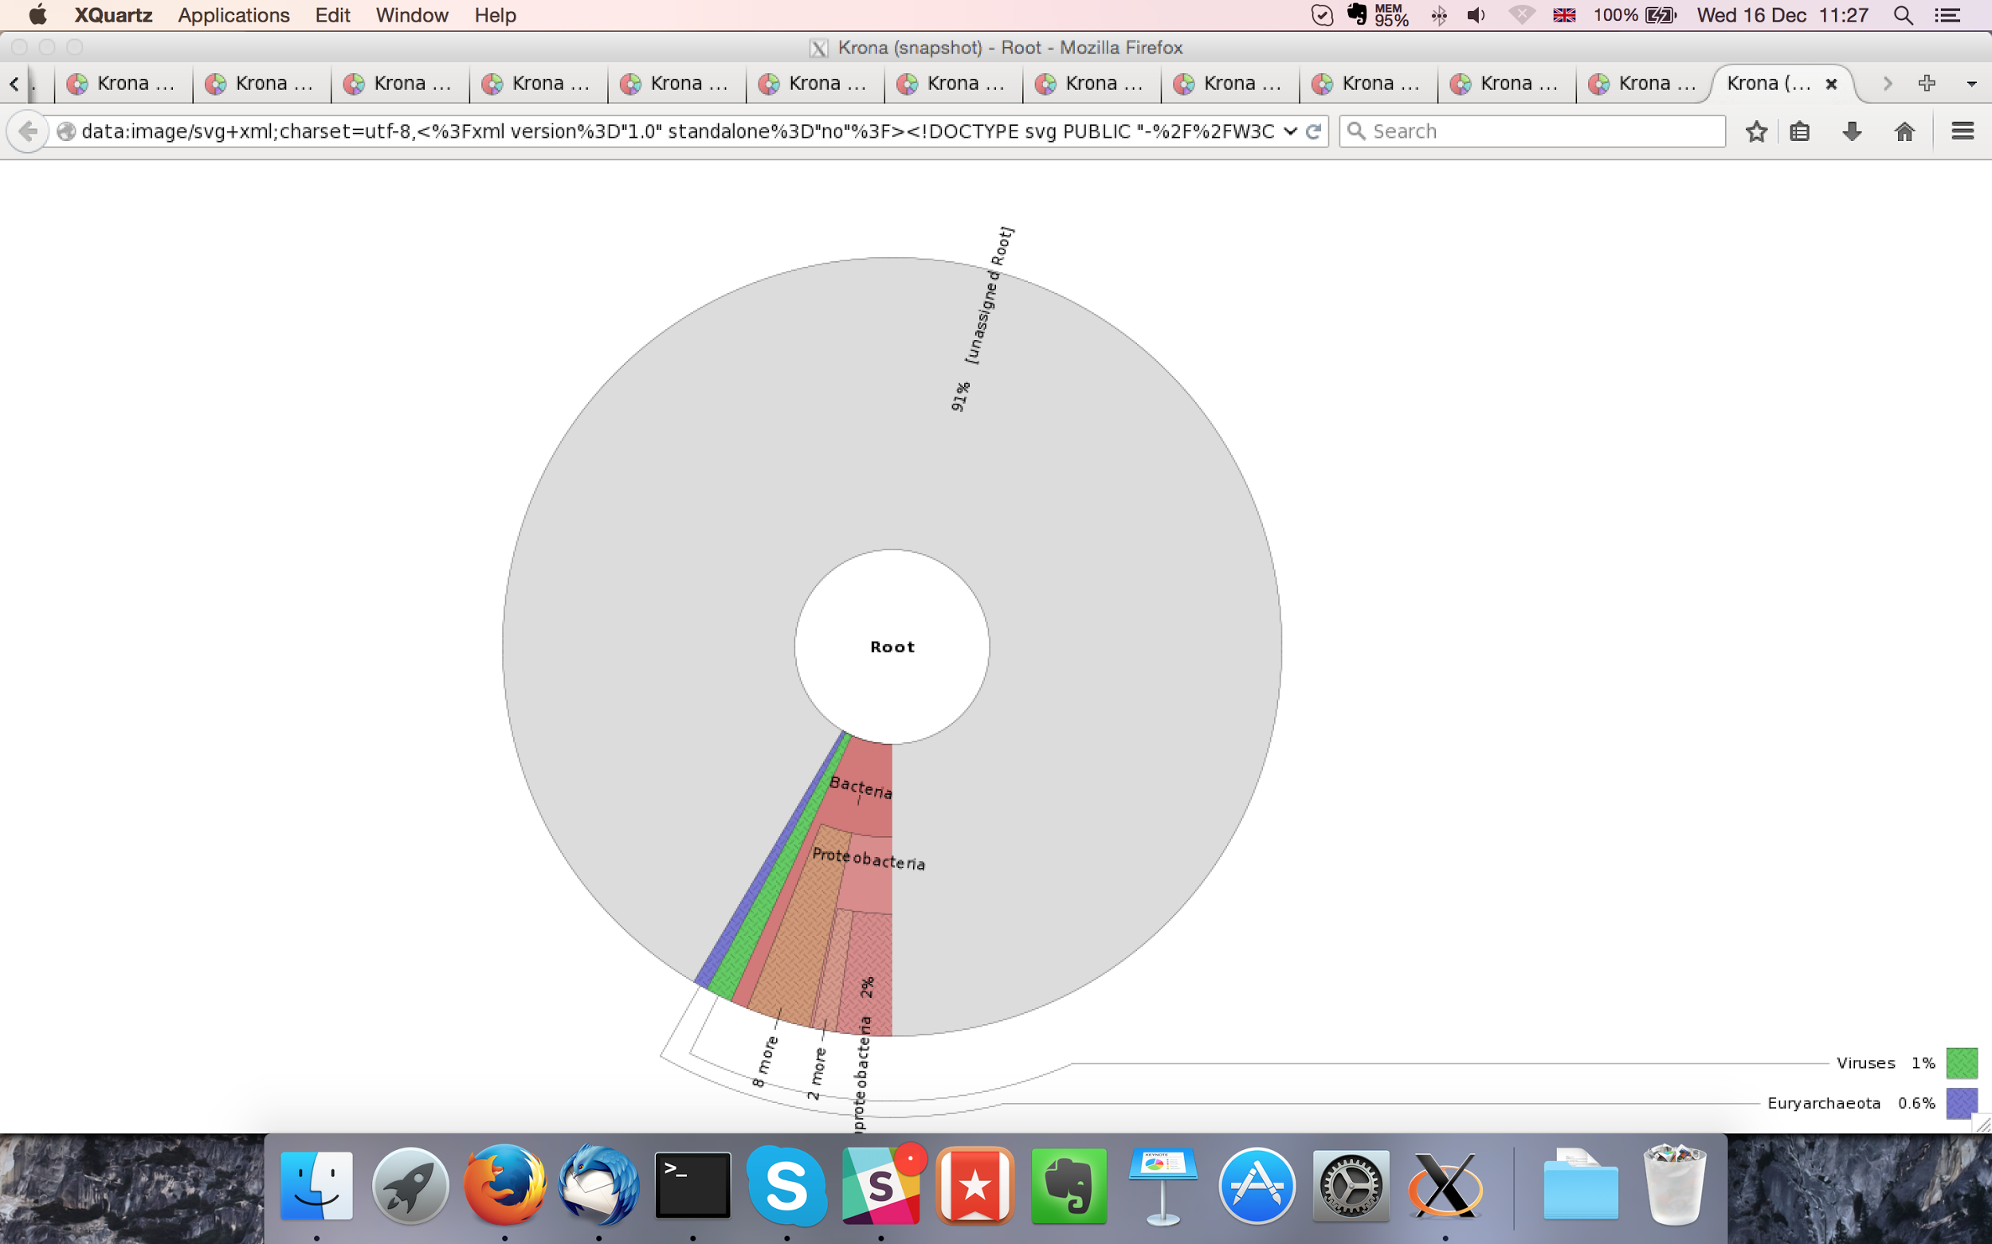

MaSuRCA kraken report below:

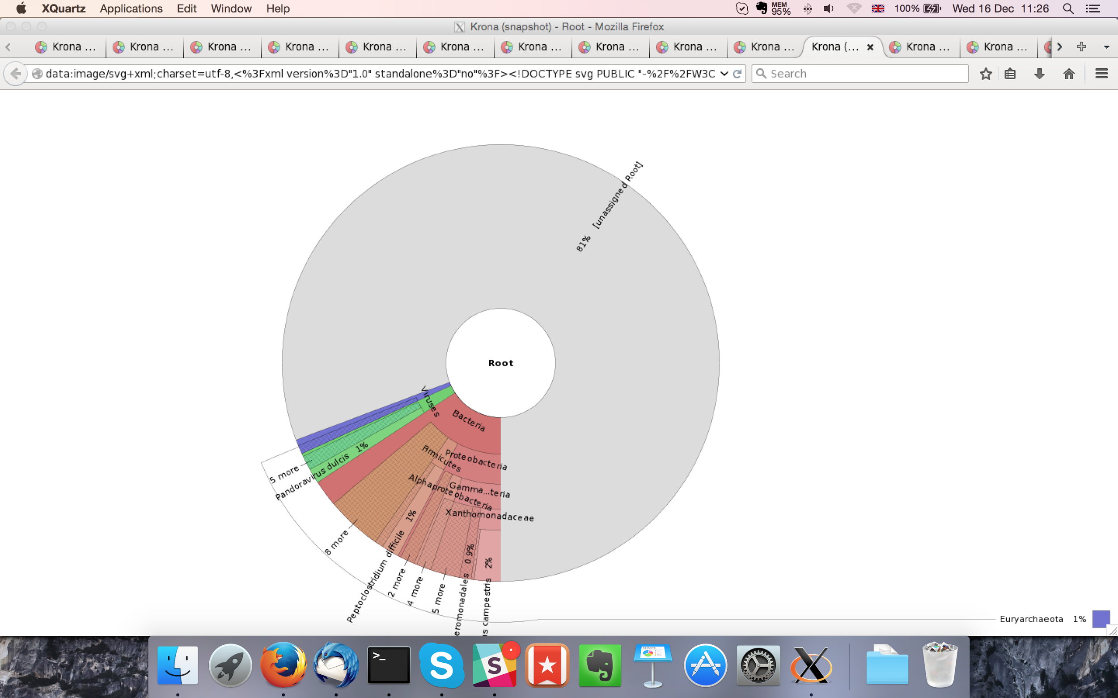

## Sample P1260_1015:

### Assembly Quality Assessment - Quast:

Spades followed by MaSuRCA gives the best assembly measured by comparing Cumulative length and Nx.

|  |  |
| --- | --- |
| Assembler | **Spades** |
| Number of contigs | 378 |
| Largest contig | 538,454 |
| Total assembly length | 12,240,957 |
| N50 | 163,777 |

Spades produced an assembly length of 12,240,957bp, comprised of 378 contigs with an N50 of 163,777bp.

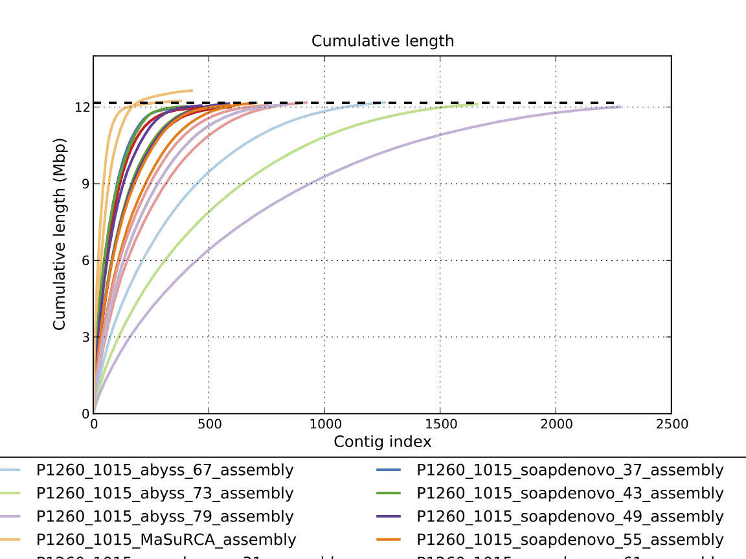

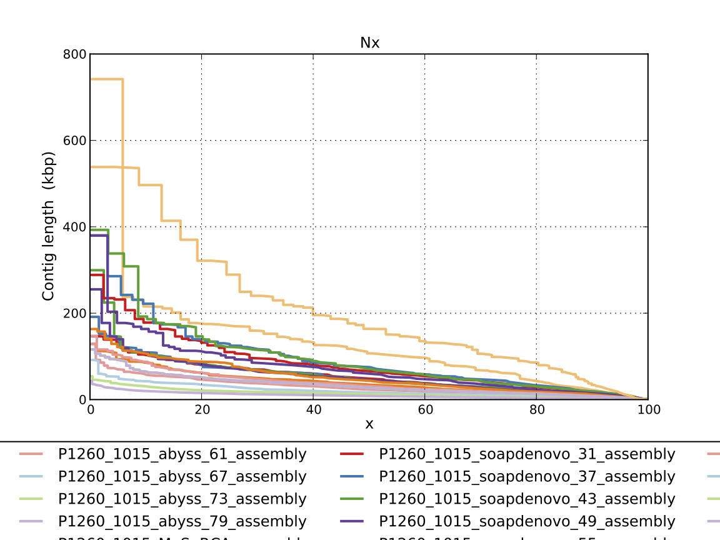

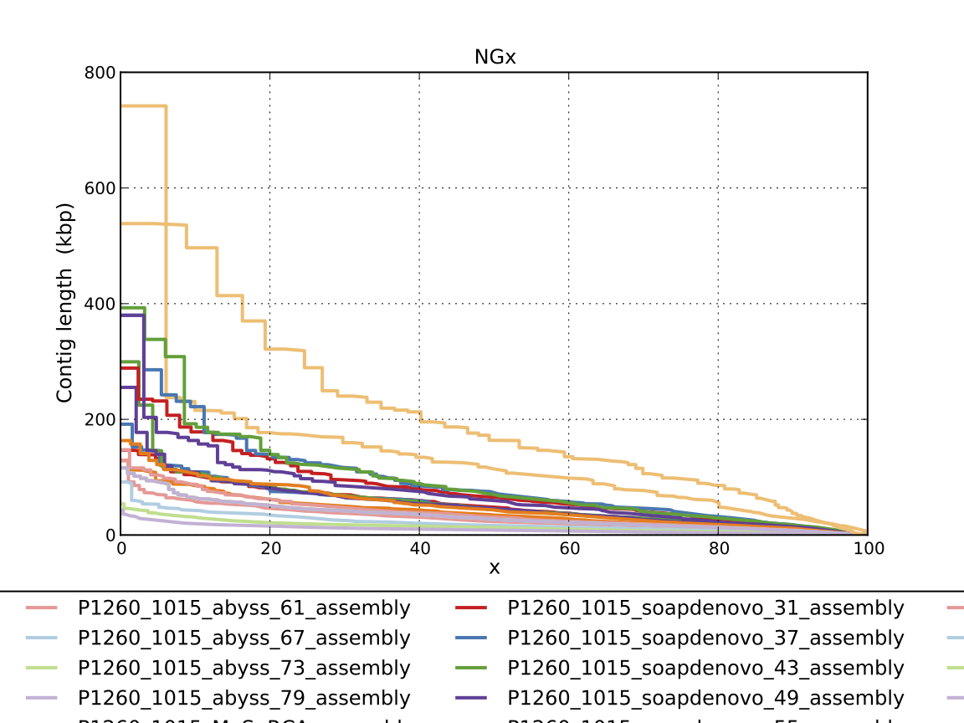

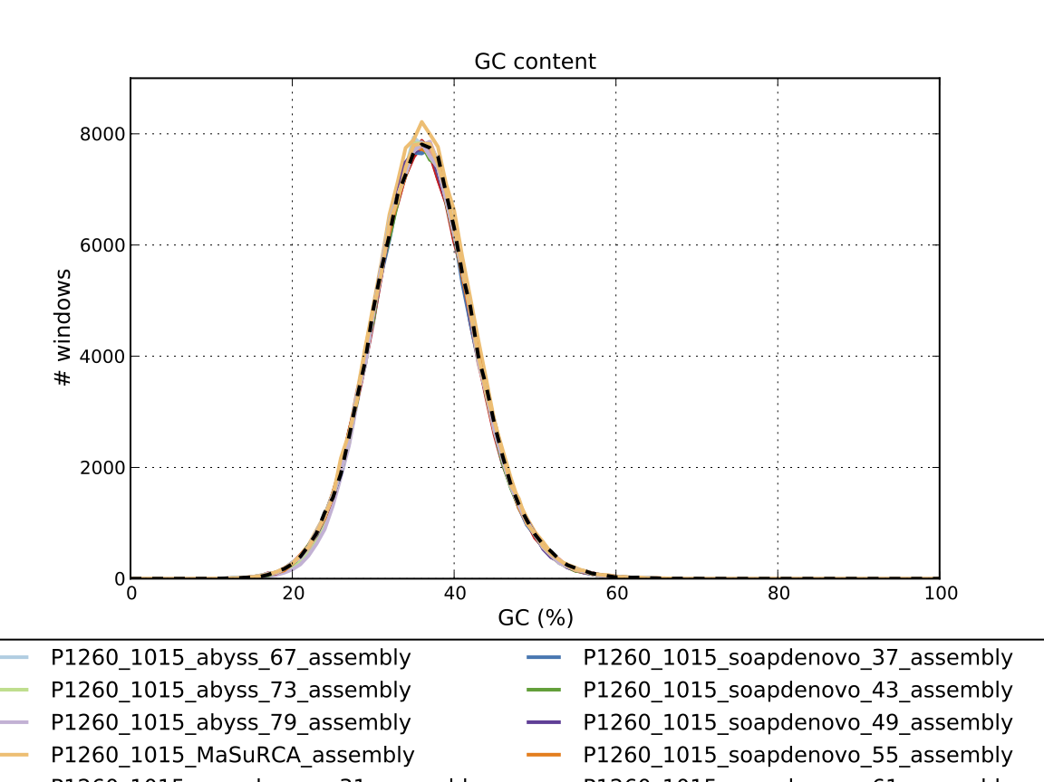

### Assembly Quality Assessment - Compass:

Compass shows that although the assembly is similar in size to the reference, a small portion does not align well, indicating contamination or a very large degree of divergence. The proportion of differing contigs is not clear due to the potential of multiple assembly contigs aligning to the same place on the reference.

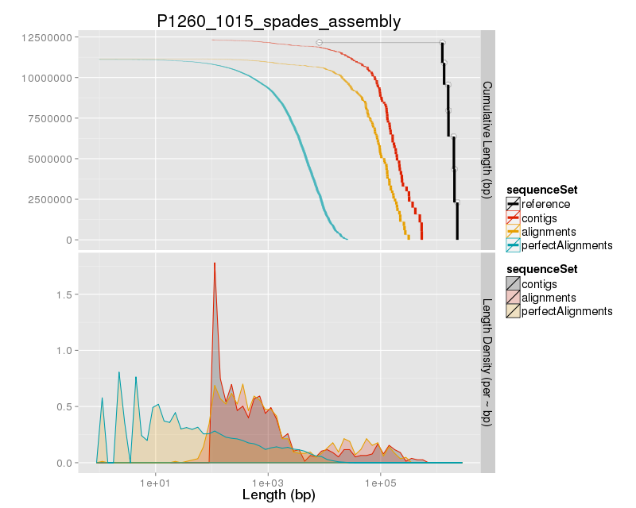

### Assembly Quality Assessment - KAT:

### Assembly Quality Assessment - FRCBAM:

### Assembly Quality Assessment - CEGMA:

CEGMA and BUSCO both attempt to validate the completeness of an assembly by looking at a known gene space, selected to be highly conserved, and present if most, if not all, organisms. CEGMA uses a gene space specifically designed for eukaryotic organisms, while BUSCO can be set for a number of taxonomic groups. Large variation within the completeness between assemblies may indicate that the data was hard to assemble, and thus might run a higher risk of misassembly. BUSCO will also report on duplications of genes, which may indicate chimera in the assembly, and mayneed to be further investigated after annotation.

The CEGMA report of the Spades assembly shows 94% completeness. The CEGMA completeness scores varied between 94.35% (MaSuRCA and Abyss k=37) to 95.16% (Abyss k=67).

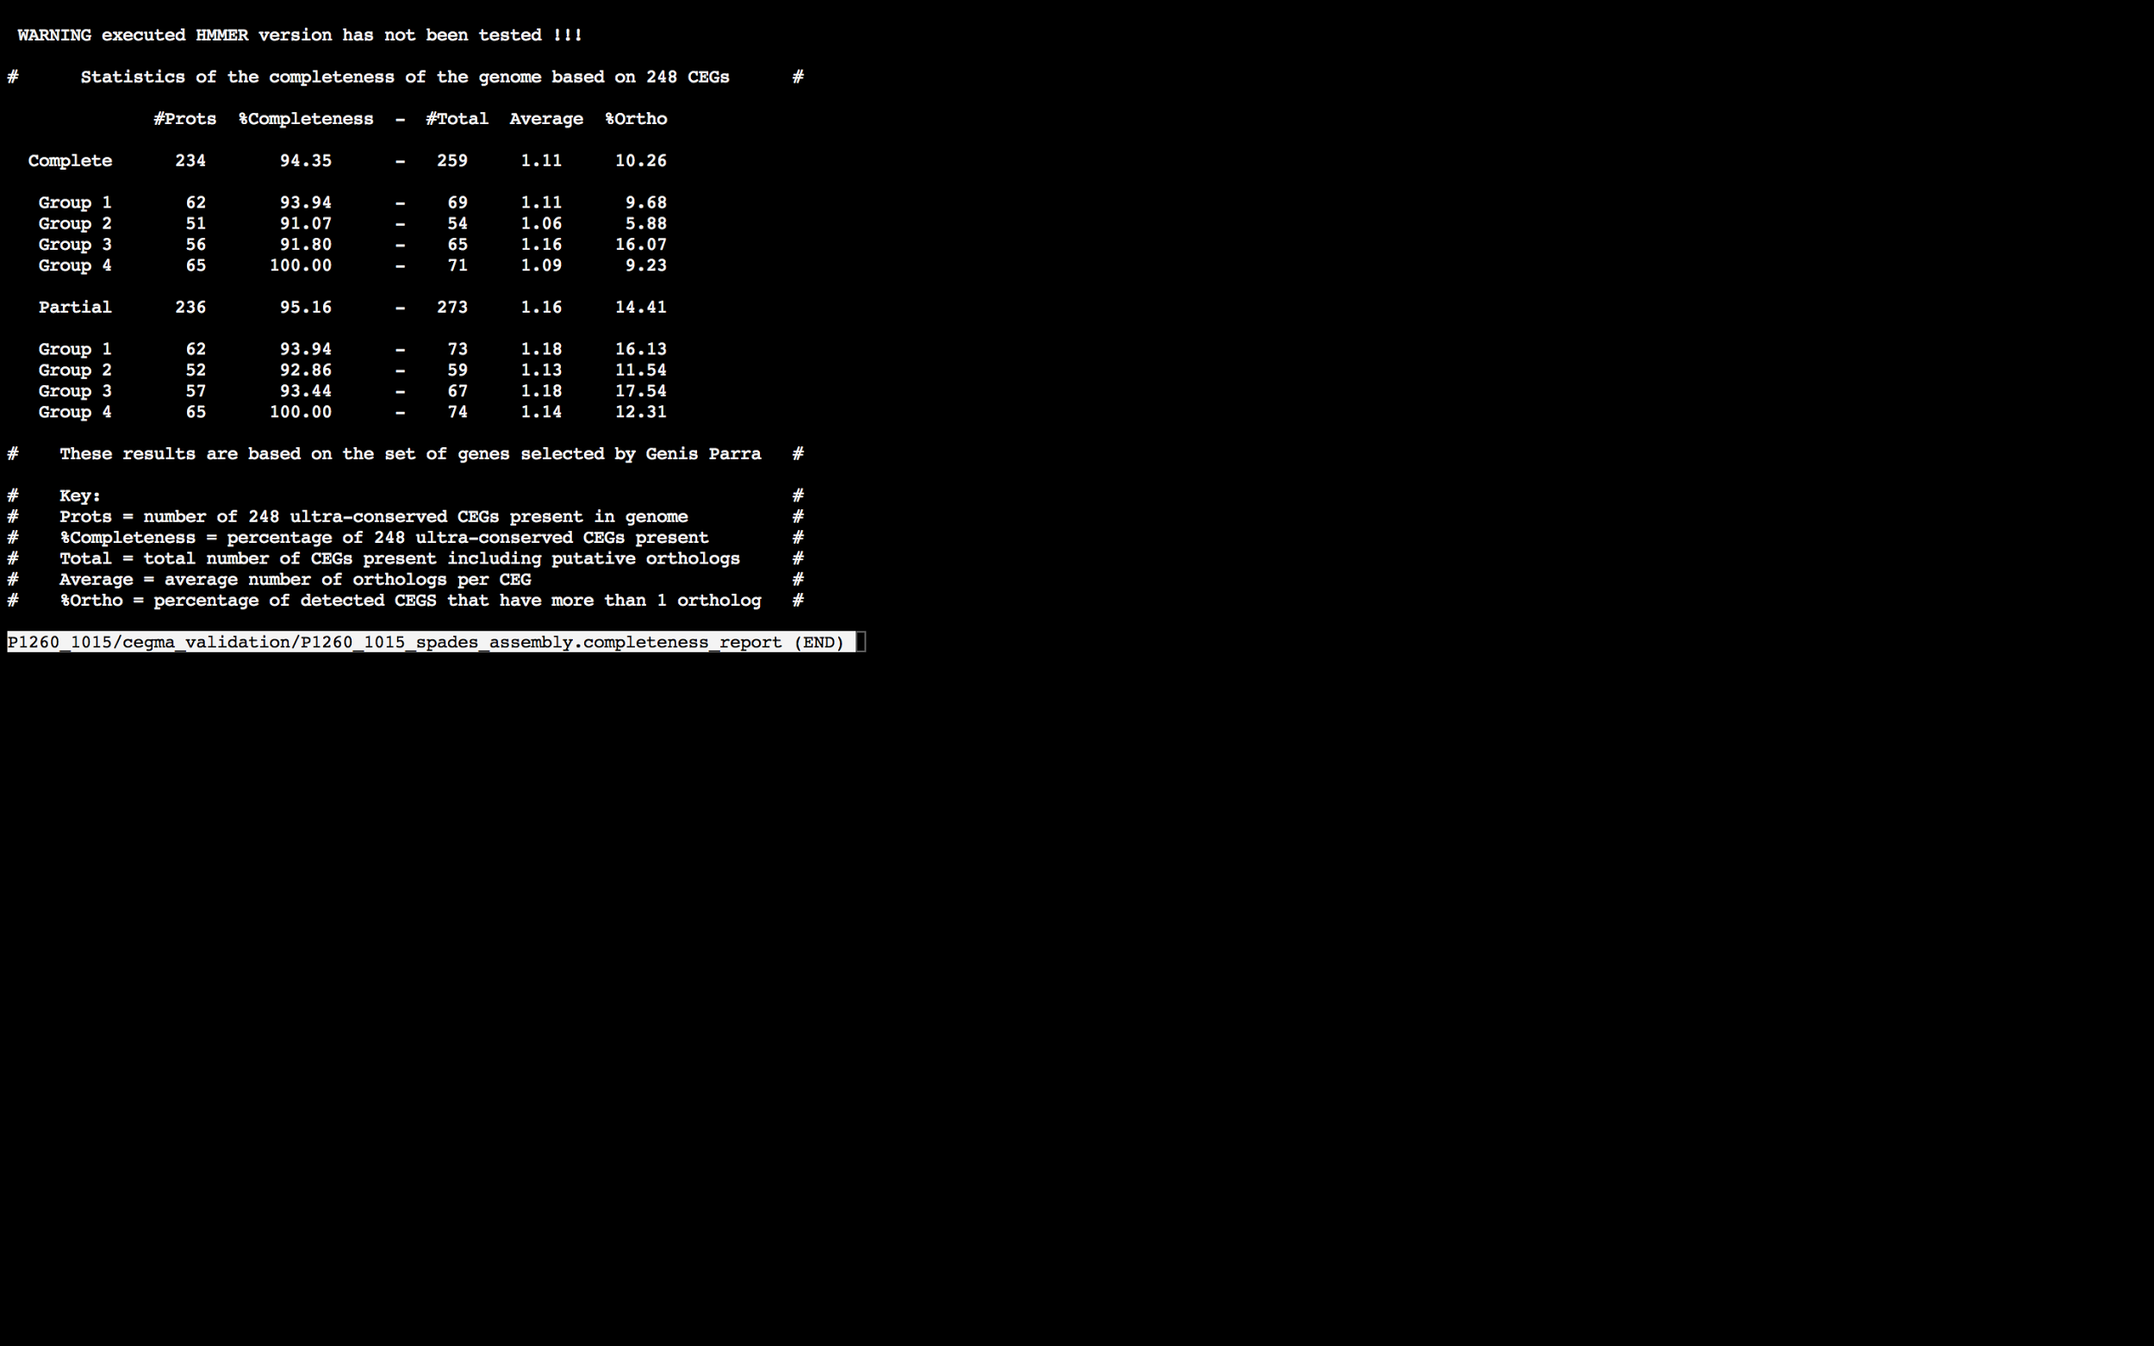

### Assembly Quality Assessment - BUSCO:

The BUSCO report of the Spades assembly shows 97% completeness and 10% duplication. The scores range from 92% (Abyss k=79) to 97% (Spades, and SOAPdenovo k=31,55).

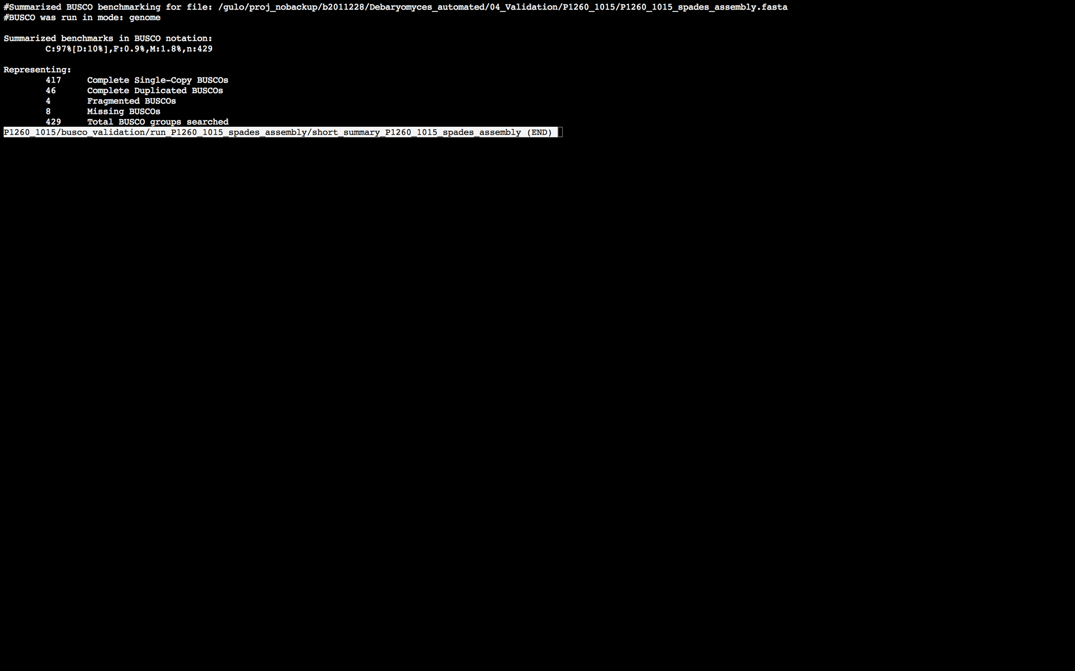

### Assembly Quality Assessment - Blobology:

Blobology indicates that while most contigs are likely Debaryomyces, contamination may also be present. The blob plot shows a cluster of similar GC content contigs but with lower coverage that potentially indicates contamination. Contamination assessment is a difficult task, and should be interpreted as indicative rather than truth.

|  |  |
| --- | --- |
| # Contigs | Megablast hit |
| 501 | Debaryomyces hansenii |
| 1 | Haemonchus placei |
| 4 | Homo sapiens |
| 30 | Not annotated |
| 1 | Scheffersomyces stipitis |

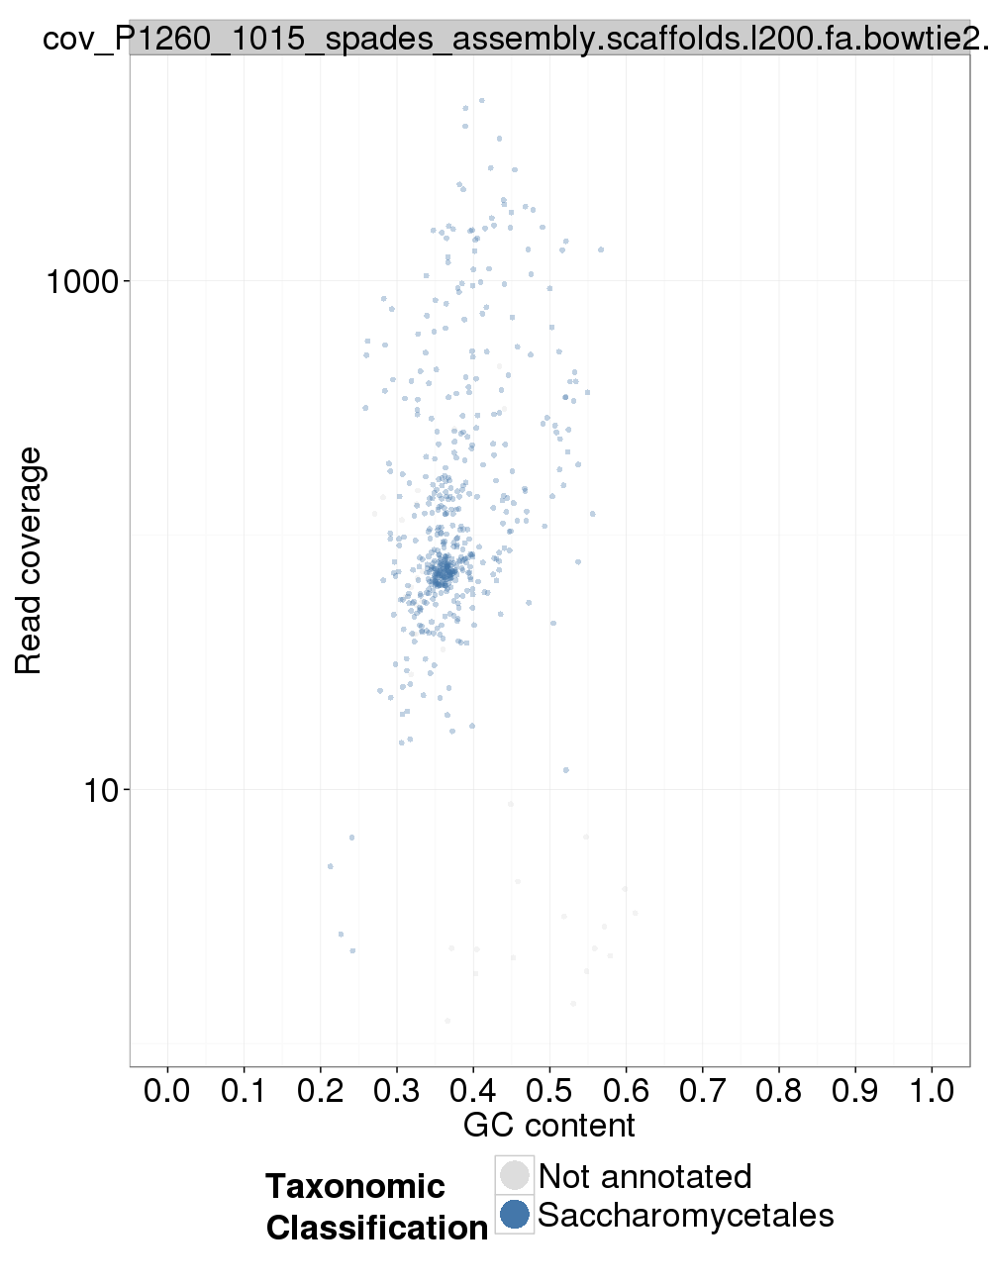

### Assembly Quality Assessment - Kraken:

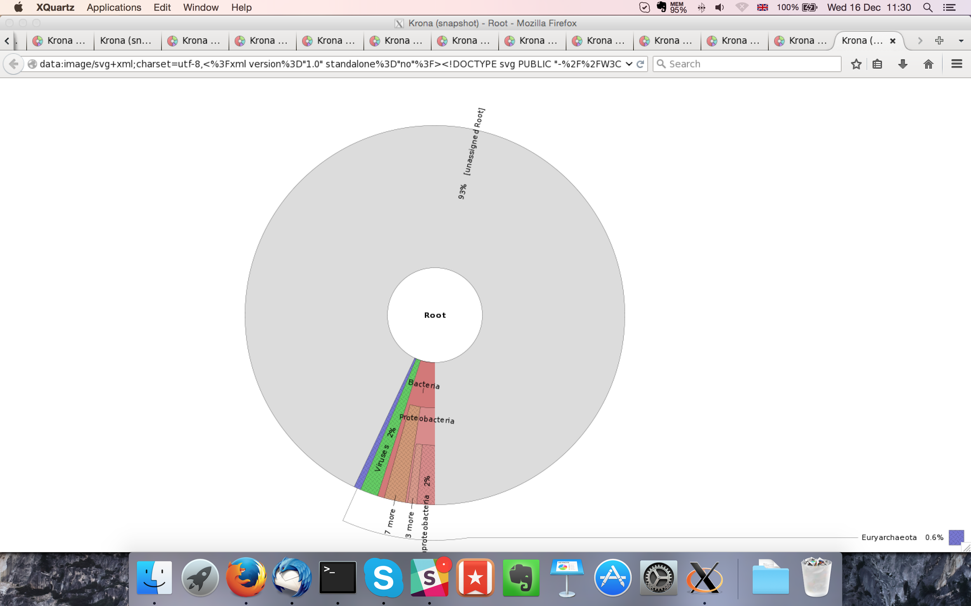

MaSuRCA kraken report below:

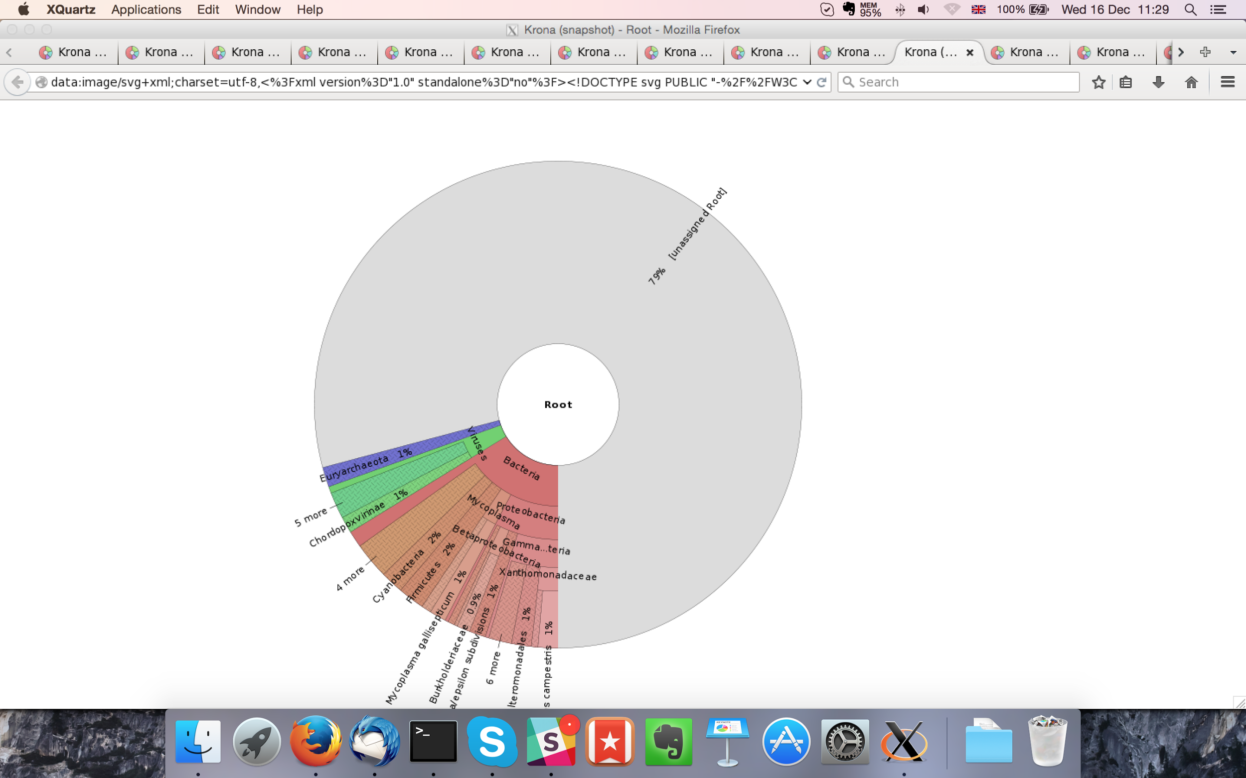

## Sample P1260_1016:

### Assembly Quality Assessment - Quast:

Spades followed by MaSuRCA gives the best assembly measured by comparing Cumulative length and Nx.

|  |  |
| --- | --- |
| Assembler | **Spades** |
| Number of contigs | 282 |
| Largest contig | 740,530 |
| Total assembly length | 12,271,850 |
| N50 | 287,164 |

Spades produced an assembly length of 12,271,850bp, comprised of 282 contigs with an N50 of 287,164bp.

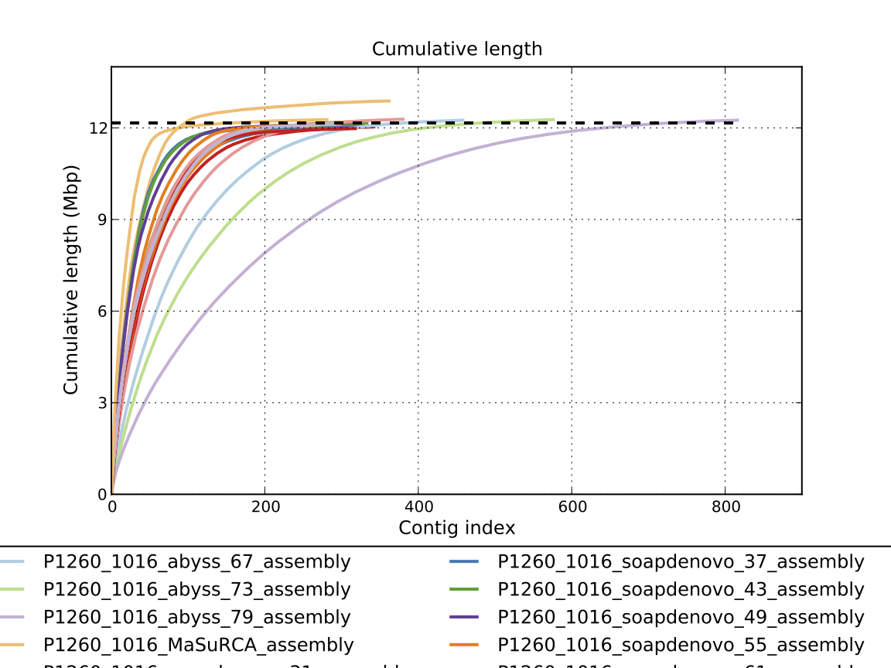

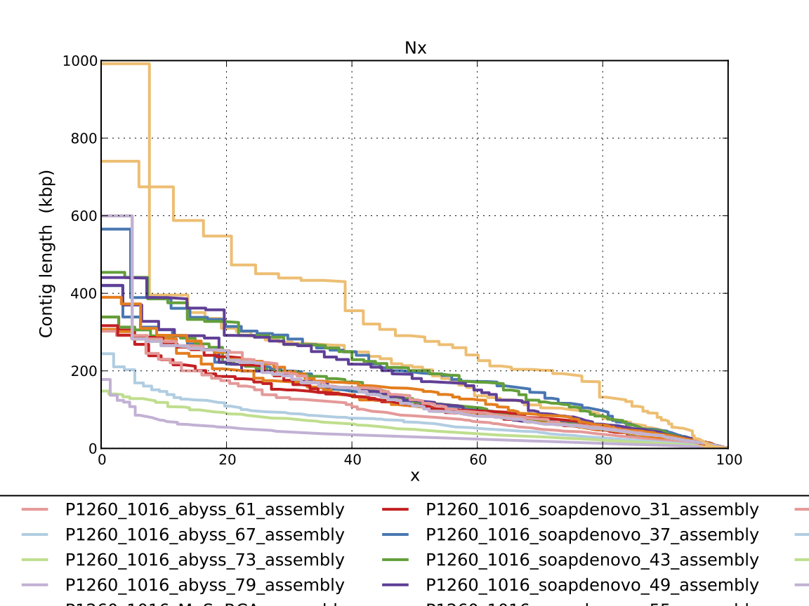

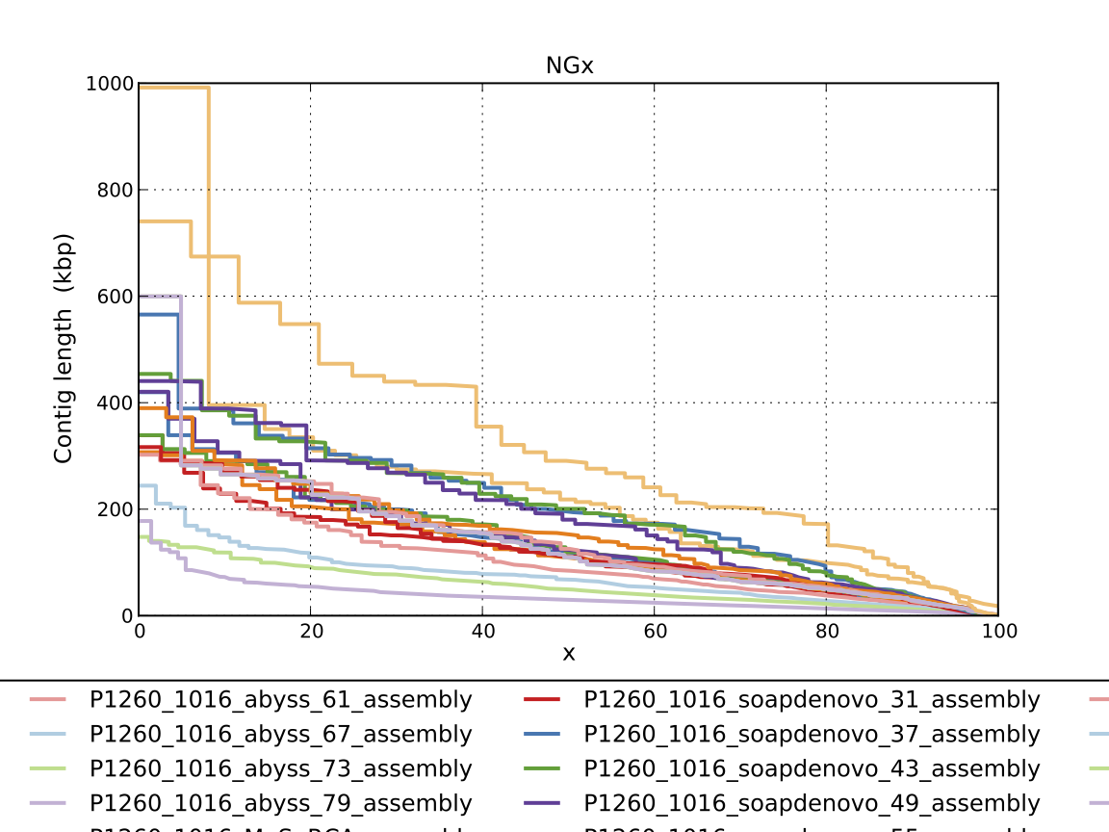

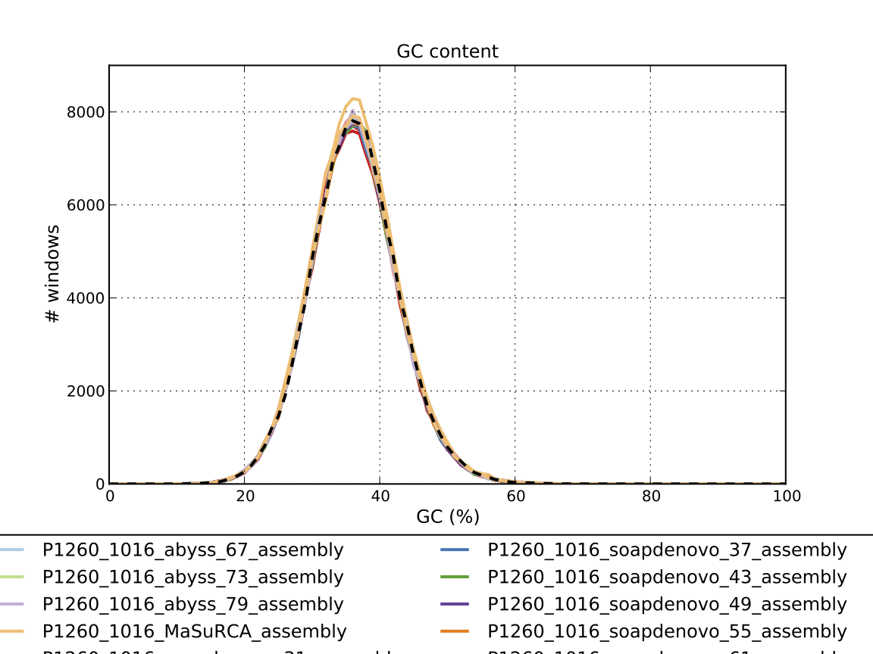

### Assembly Quality Assessment - Compass:

Compass shows that although the assembly is similar in size to the reference, a large portion does not align well, indicating contamination or a very large degree of divergence. The proportion of differing contigs is not clear due to the potential of multiple assembly contigs aligning to the same place on the reference.

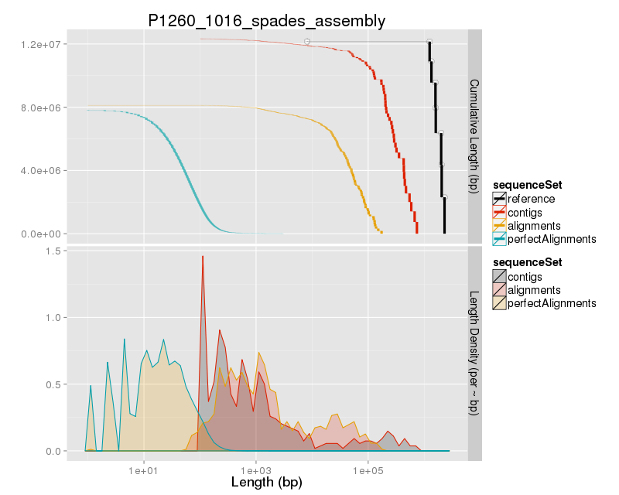

### Assembly Quality Assessment - KAT:

### Assembly Quality Assessment - FRCBAM:

### Assembly Quality Assessment - CEGMA:

CEGMA and BUSCO both attempt to validate the completeness of an assembly by looking at a known gene space, selected to be highly conserved, and present if most, if not all, organisms. CEGMA uses a gene space specifically designed for eukaryotic organisms, while BUSCO can be set for a number of taxonomic groups. Large variation within the completeness between assemblies may indicate that the data was hard to assemble, and thus might run a higher risk of misassembly. BUSCO will also report on duplications of genes, which may indicate chimera in the assembly, and mayneed to be further investigated after annotation.

The CEGMA report of the Spades assembly shows 96% completeness. The CEGMA completeness scores varied between 95.16% (Abyss k=37,43,49) to 95.97% (Abyss k=55,61,67,73,79, SOAPdenovo k=31,67,73,79).

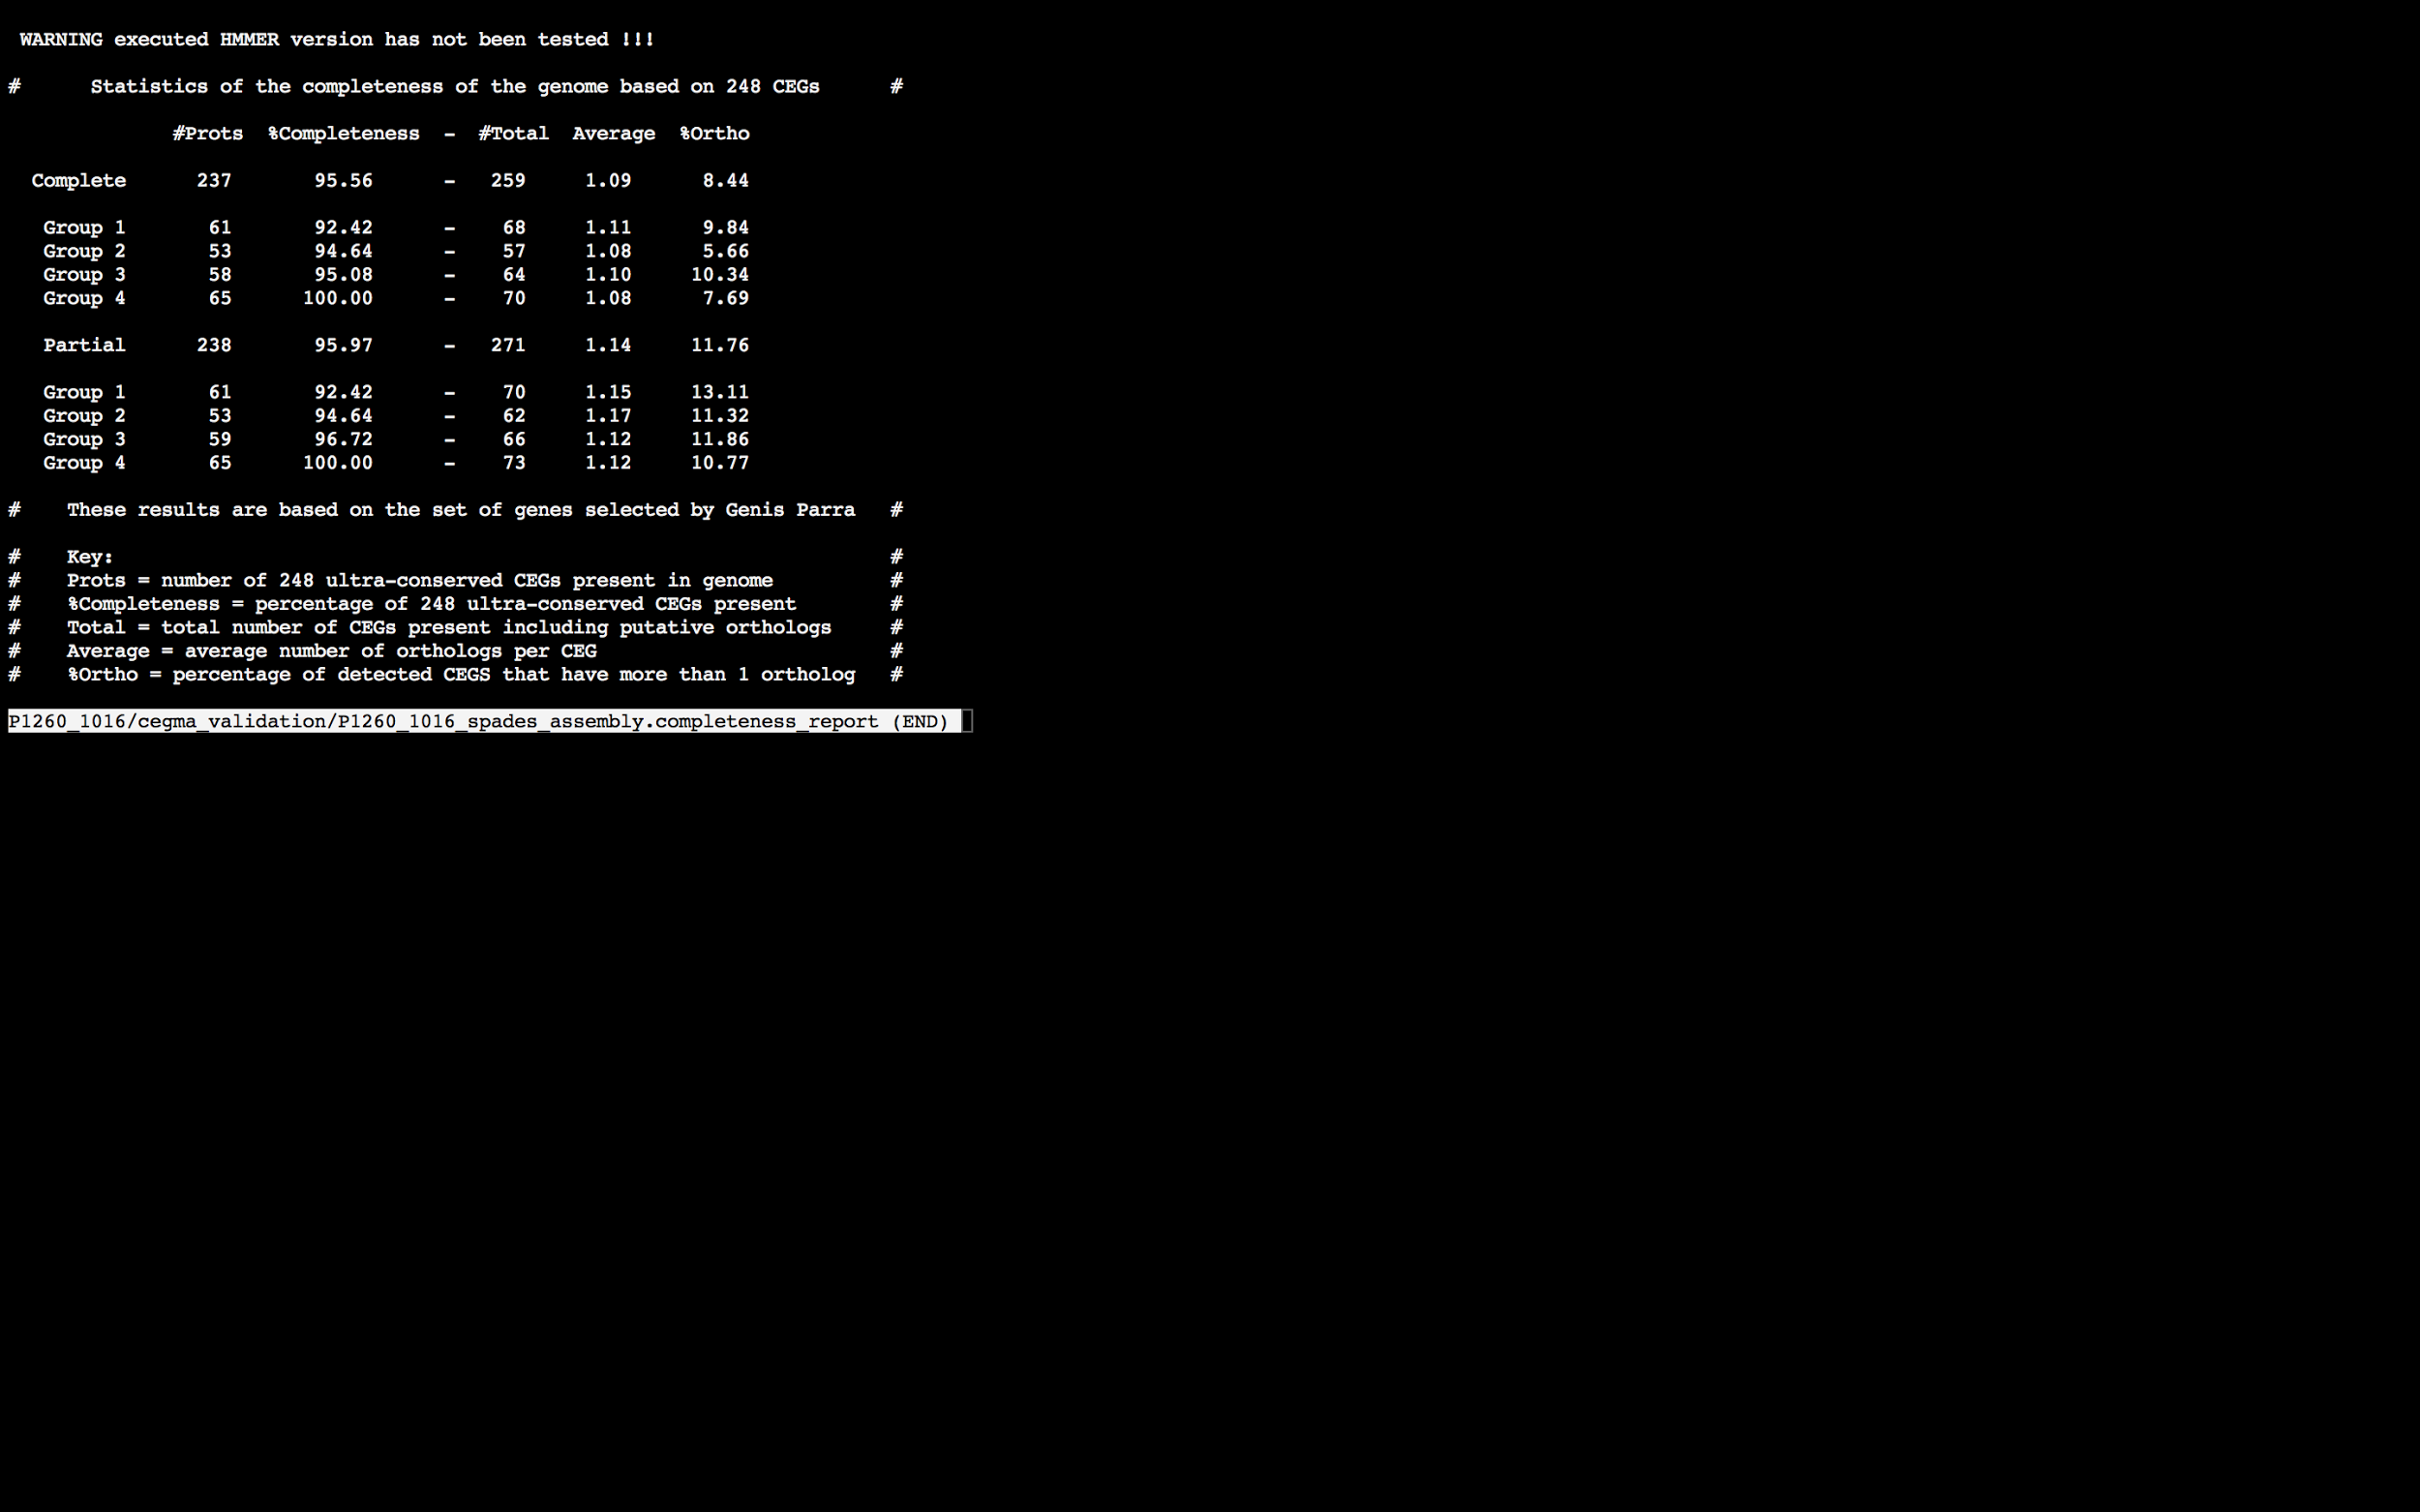

### Assembly Quality Assessment - BUSCO:

The BUSCO report of the Spades assembly shows 94% completeness and 10% duplication. The scores range from 93% (Abyss k=79) to 96% (SOAPdenovo k=31).

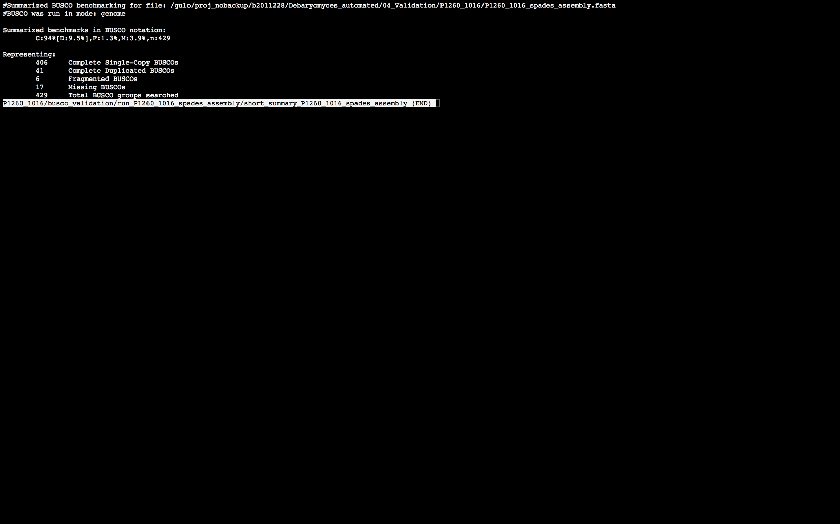

### Assembly Quality Assessment - Blobology:

Blobology indicates that while most contigs are likely Debaryomyces, bacteria may also be present. The blob plot shows a cluster of similar GC content contigs but with lower coverage that potentially indicates contamination. Contamination assessment is a difficult task, and should be interpreted as indicative rather than truth.

|  |  |
| --- | --- |
| # Contigs | Megablast hit |
| 1 | Cellulophaga baltica |
| 351 | Debaryomyces hansenii |
| 1 | Debaryomyces sp. CLIB 1604 |
| 58 | Not annotated |
| 1 | Scheffersomyces stipitis |
| 1 | Streptococcus sp. I-P16 |
| 1 | uncultured bacterium |

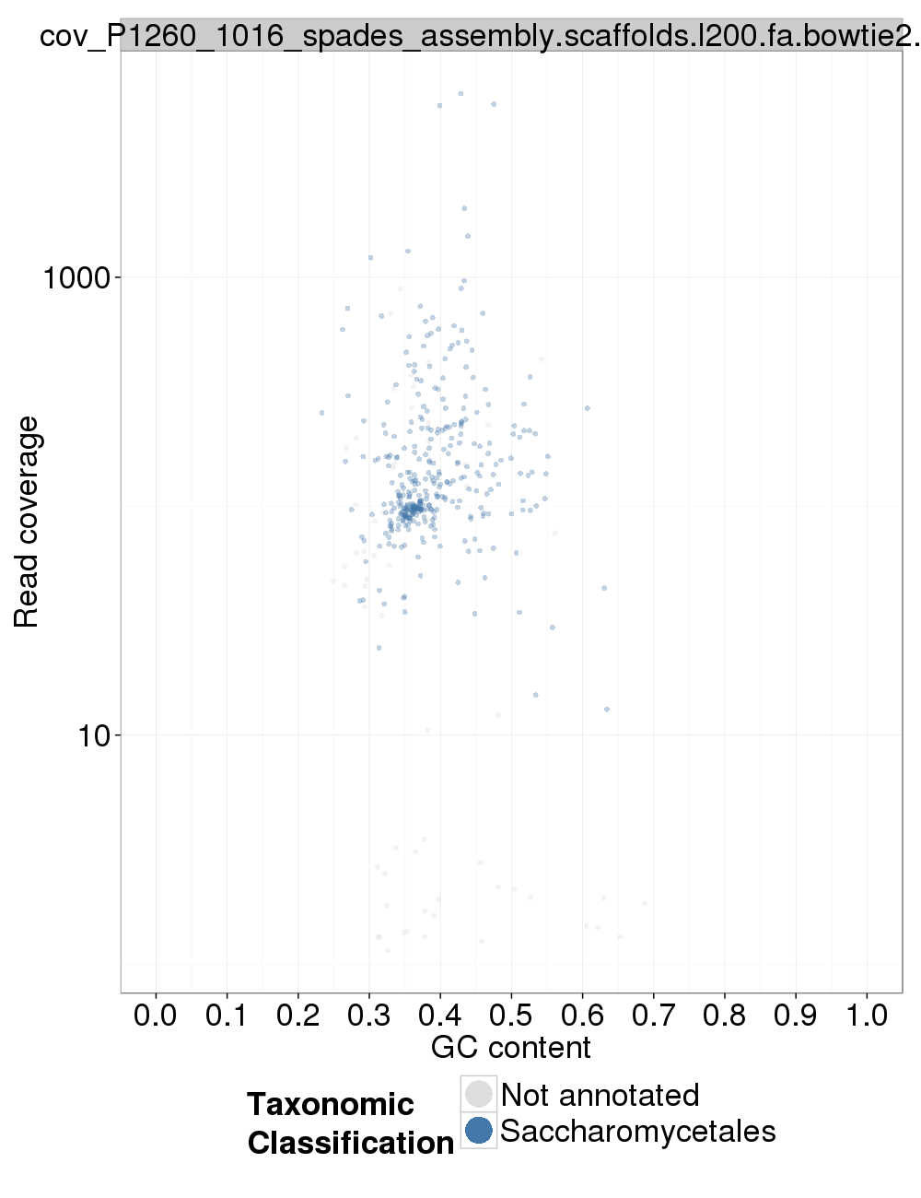

### Assembly Quality Assessment - Kraken:

## Sample P1260_1017:

### Assembly Quality Assessment - Quast:

MaSuRCA followed by Spades gives the best assembly measured by comparing Cumulative length and Nx.

|  |  |
| --- | --- |
| Assembler | **MaSuRCA** |
| Number of contigs | 590 |
| Largest contig | 655,595 |
| Total assembly length | 12,400,238 |
| N50 | 159,505 |

MuSuRCA produced an assembly length of 12.400.238bp, comprised of 590 contigs with an N50 of 159,505bp.

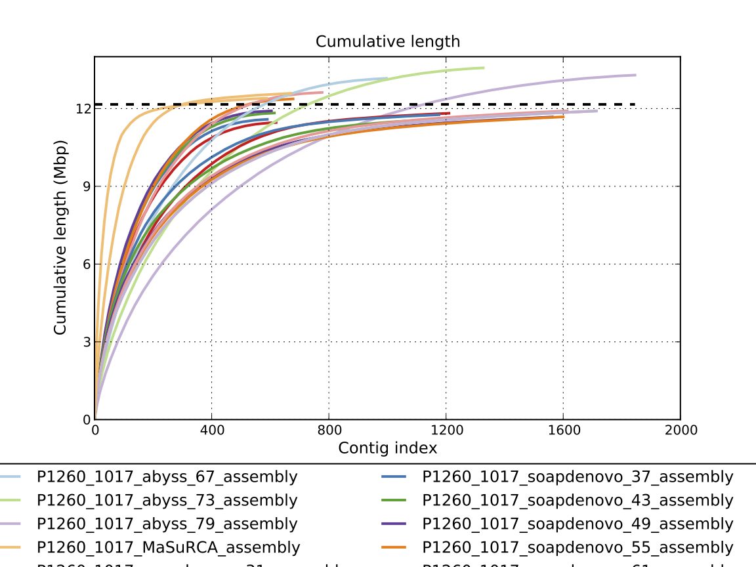

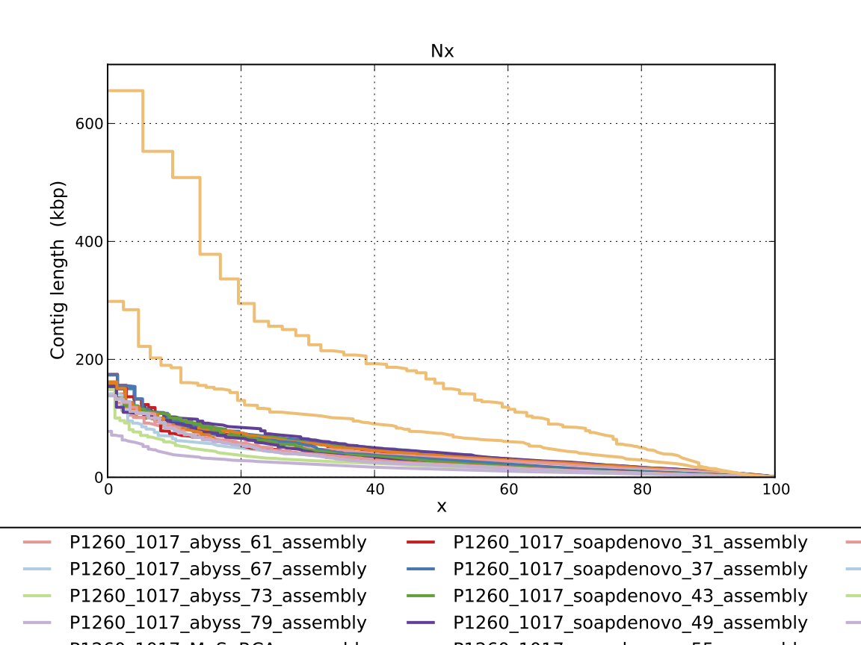

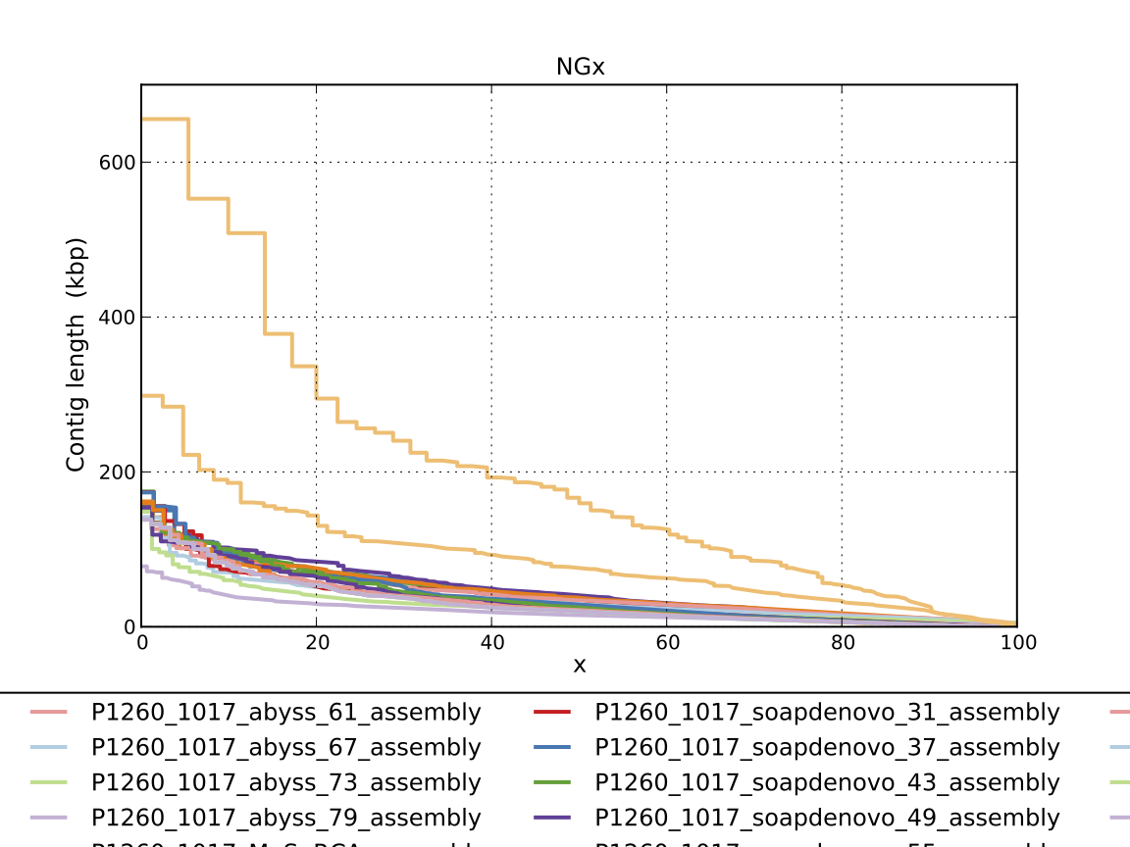

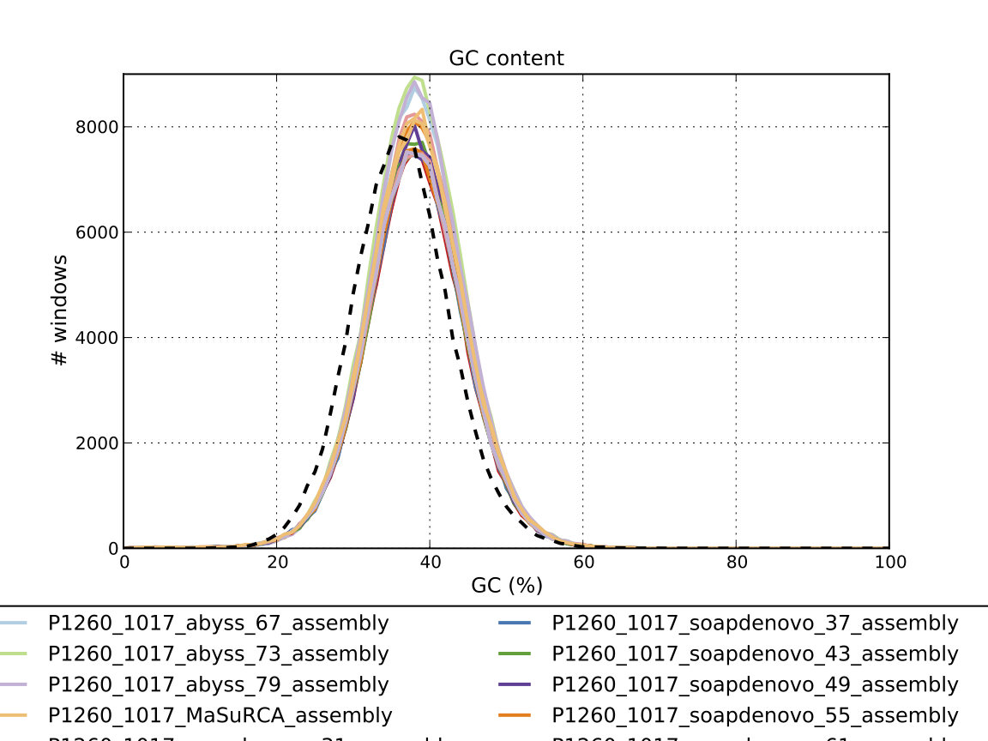

### Assembly Quality Assessment - Compass:

Compass shows that although the assembly is similar in size to the reference, but it does not align, indicating a different organism, or contamination or a very large degree of divergence. The proportion of differing contigs is not clear due to the potential of multiple assembly contigs aligning to the same place on the reference.

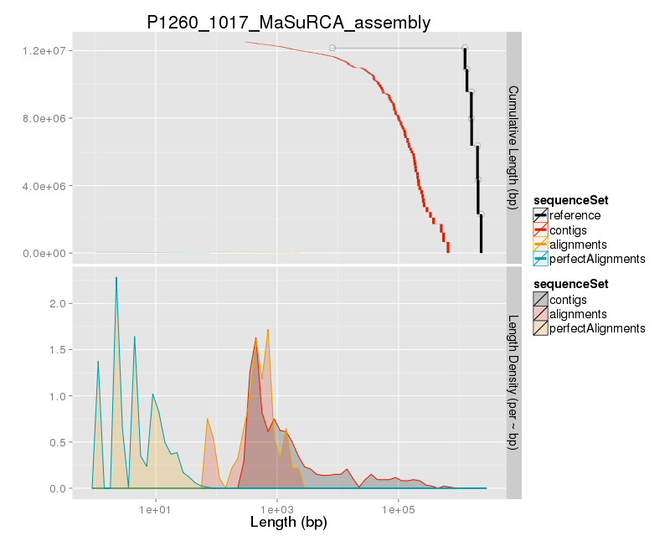

### Assembly Quality Assessment - KAT:

### Assembly Quality Assessment - FRCBAM:

### Assembly Quality Assessment - CEGMA:

CEGMA and BUSCO both attempt to validate the completeness of an assembly by looking at a known gene space, selected to be highly conserved, and present if most, if not all, organisms. CEGMA uses a gene space specifically designed for eukaryotic organisms, while BUSCO can be set for a number of taxonomic groups. Large variation within the completeness between assemblies may indicate that the data was hard to assemble, and thus might run a higher risk of misassembly. BUSCO will also report on duplications of genes, which may indicate chimera in the assembly, and mayneed to be further investigated after annotation.

The CEGMA report of the MaSuRCA assembly shows 98% completeness. The CEGMA completeness scores varied between 93.95% (SOAPdenovo k=67,73,79) to 98.79% (Abyss k=79).

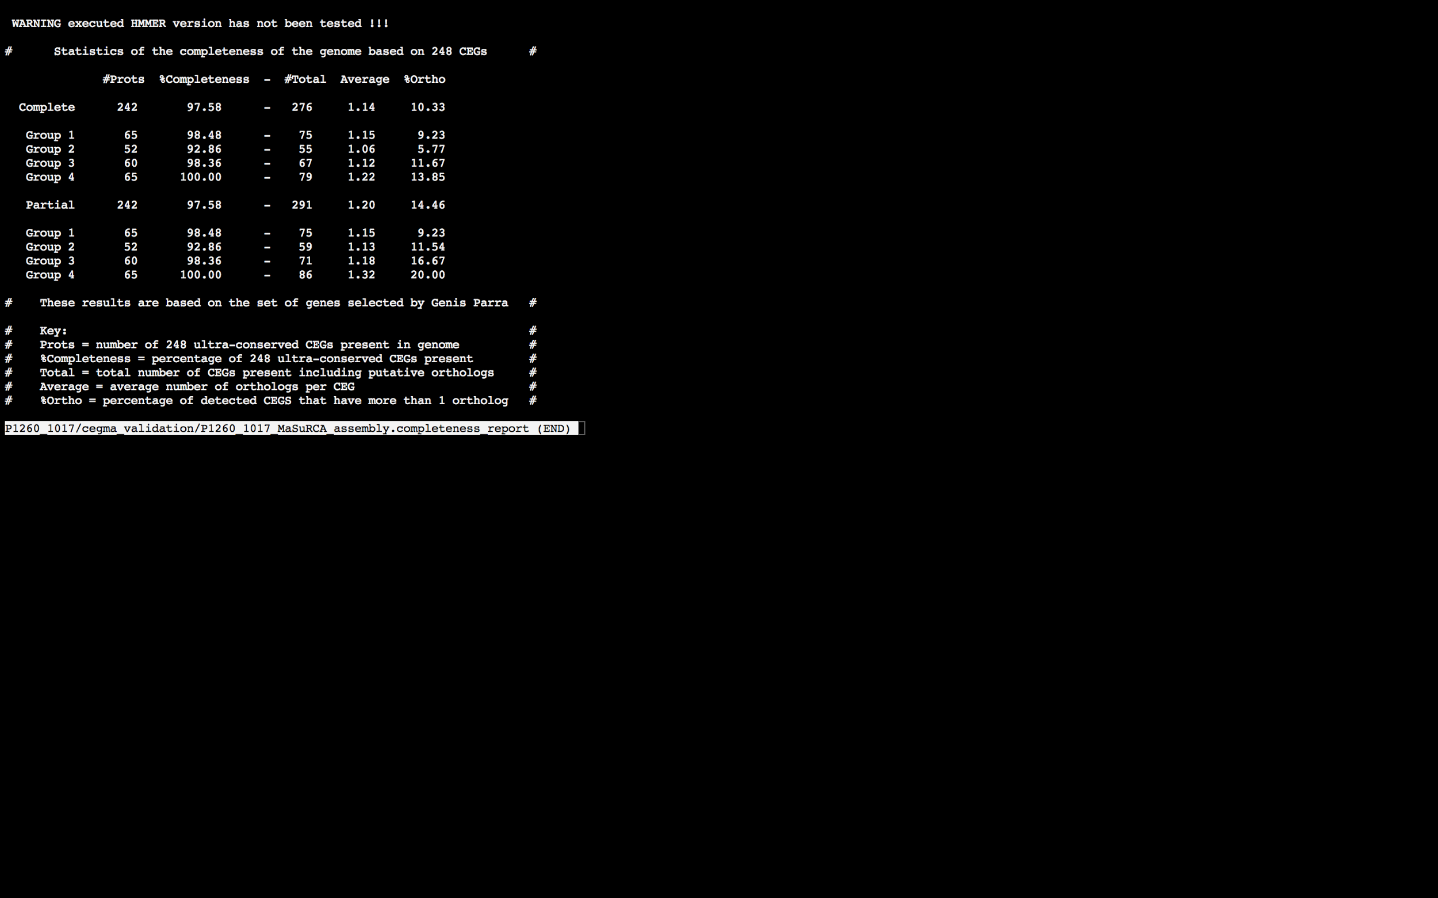

### Assembly Quality Assessment - BUSCO:

The BUSCO report of the MaSuRCA assembly shows 97% completeness with 12% duplication. The scores range from 82% (SOAPdenovo k=61) to 98% (Spades, Abyss k=67).

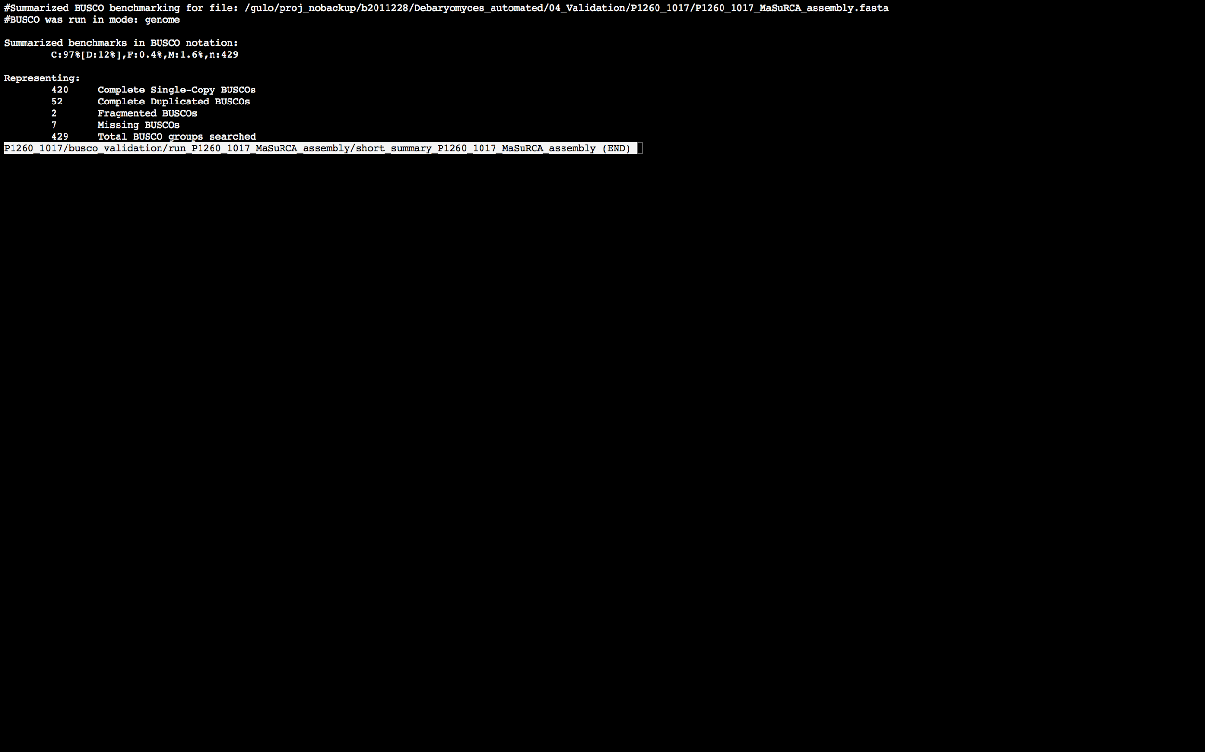

### Assembly Quality Assessment - Blobology:

Blobology indicates that most contigs are likely Saccharomyces cerevisiae. Contamination assessment is a difficult task, and should be interpreted as indicative rather than truth.

|  |  |
| --- | --- |
| # Contigs | Megablast hit |
| 4 | Apteryx australis |
| 1 | Debaryomyces hansenii |
| 1 | Glaciecola nitratireducens |
| 2 | Saccharomyces bayanus |
| 854 | Saccharomyces cerevisiae |
| 2 | Saccharomyces sp. 'boulardii' |
| 1 | uncultured fungus |

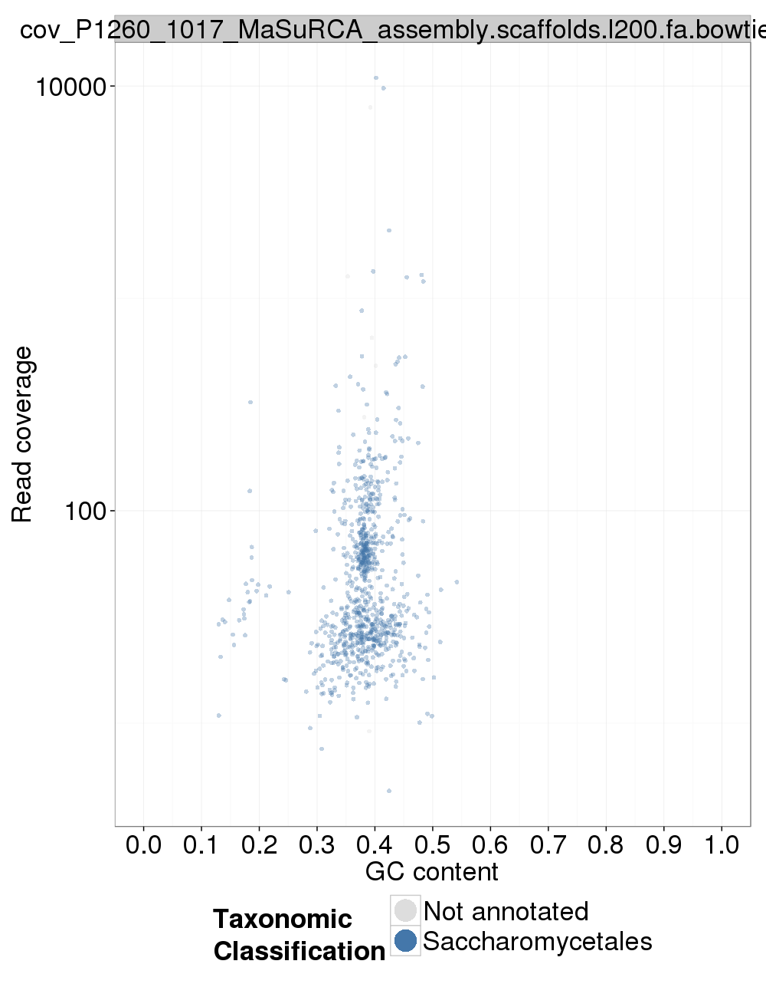

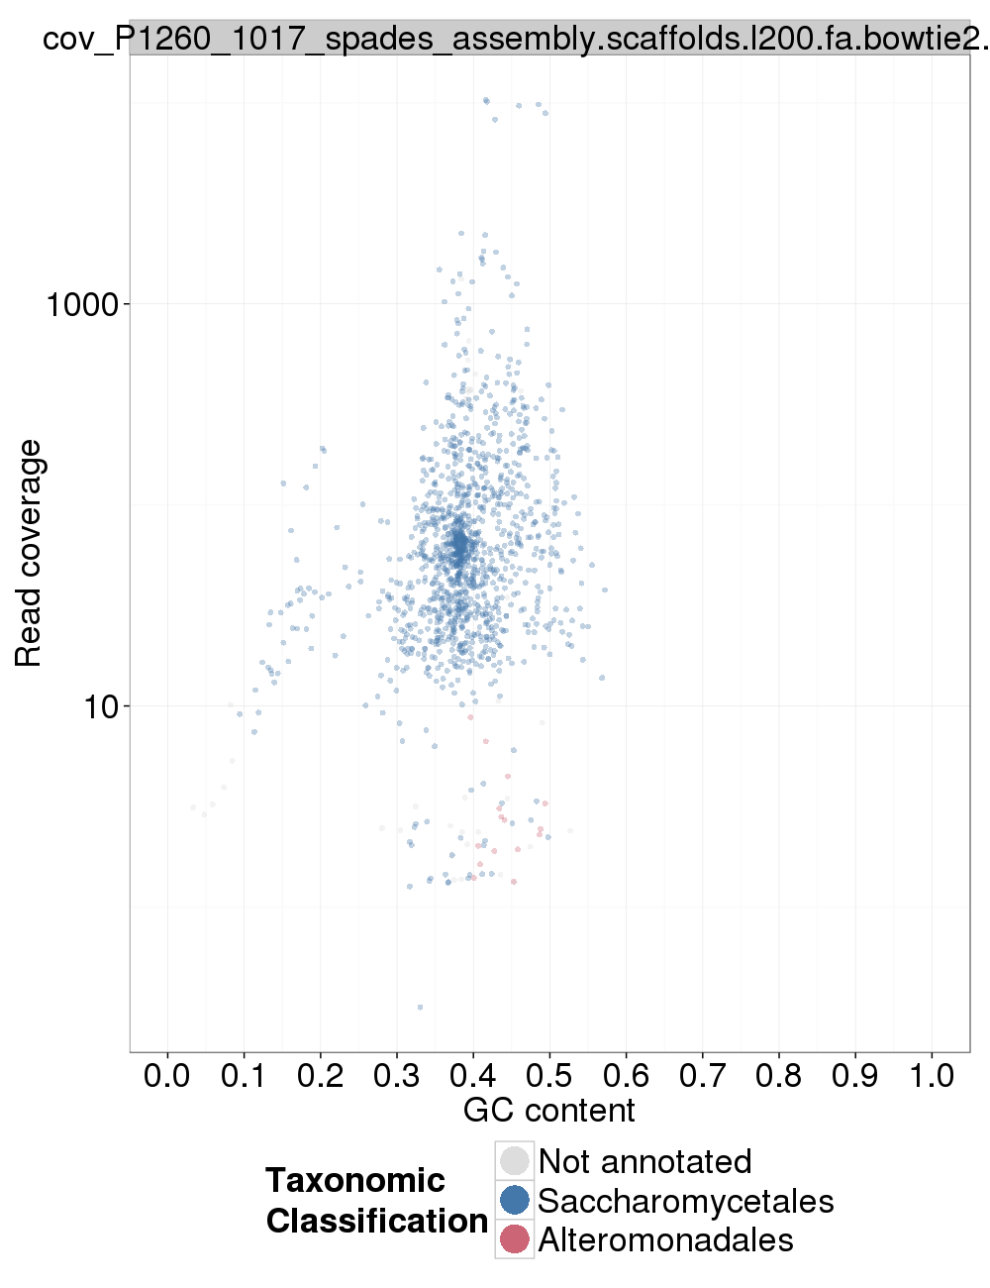

### Assembly Quality Assessment - Kraken:

## Sample P1260_1018:

### Assembly Quality Assessment - Quast:

MaSuRCA followed by Spades gives the best assembly measured by comparing Cumulative length and Nx.

|  |  |
| --- | --- |
| Assembler | **MaSuRCA** |
| Number of contigs | 603 |
| Largest contig | 532,598 |
| Total assembly length | 12,132,672 |
| N50 | 159,503 |

MuSuRCA produced an assembly length of 12,132,672bp, comprised of 603 contigs with an N50 of 159,503bp.

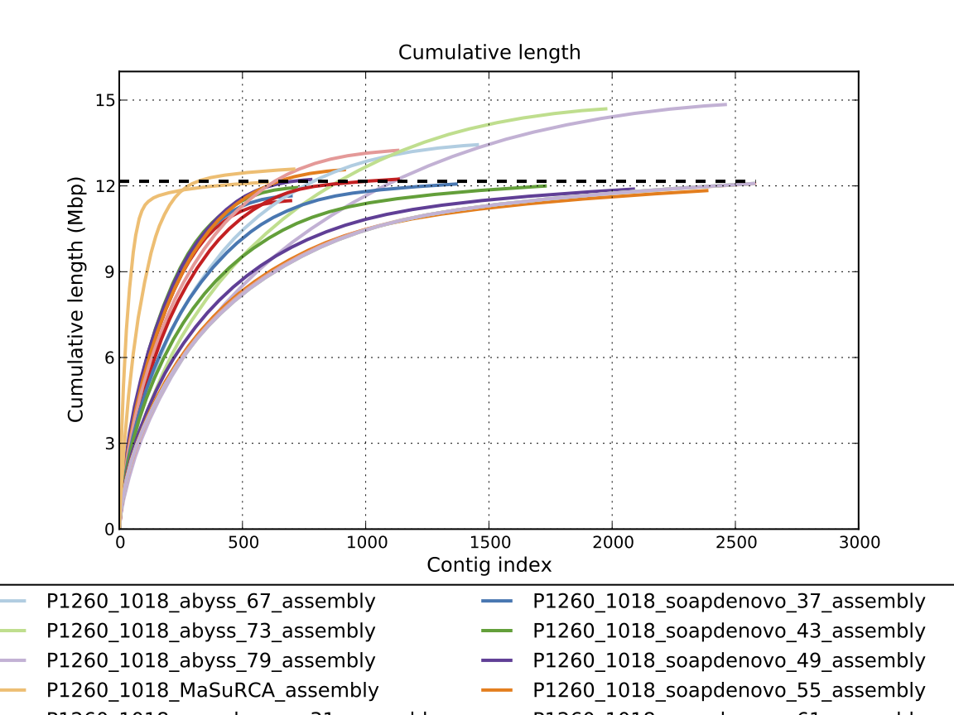

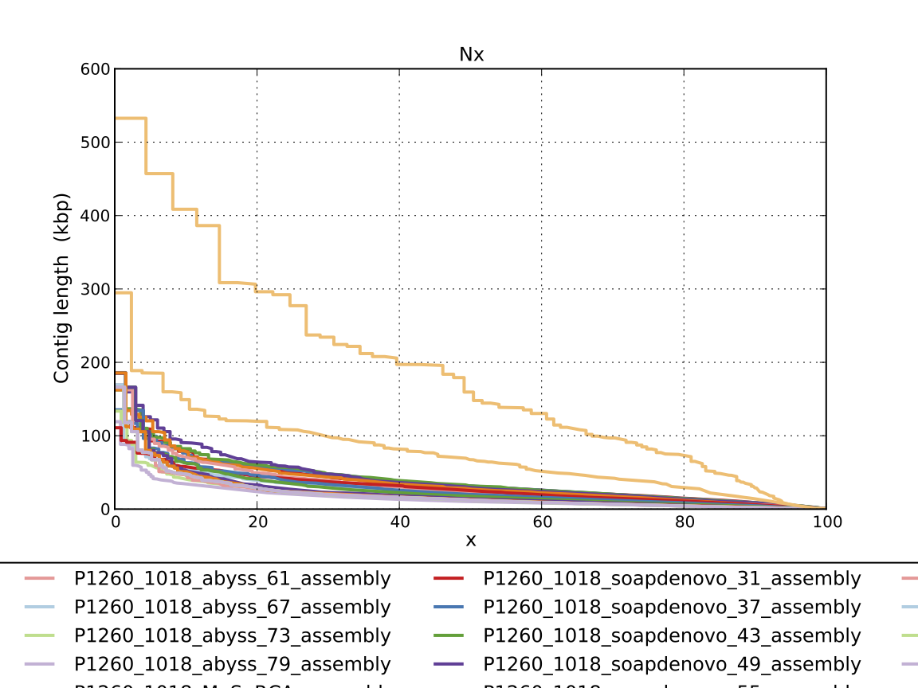

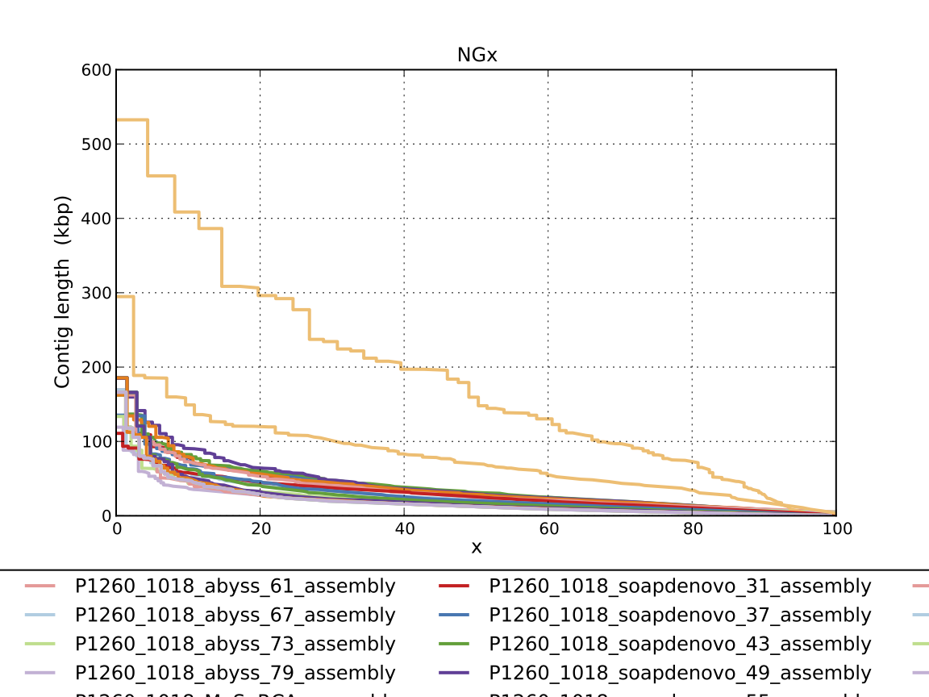

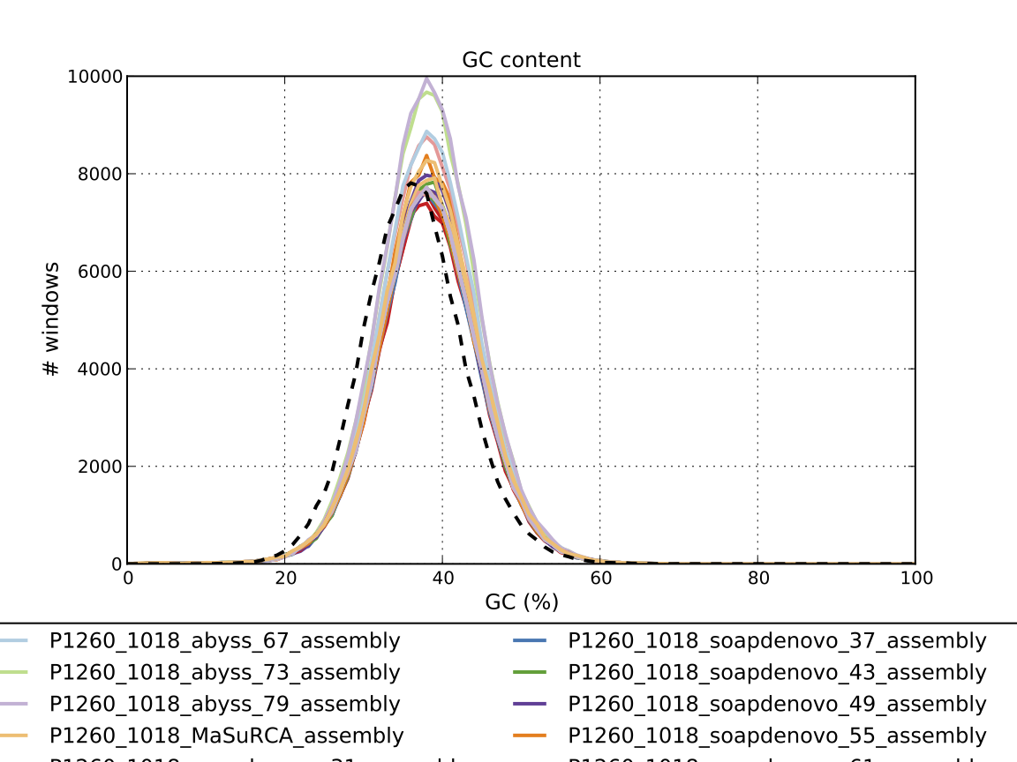

### Assembly Quality Assessment - Compass:

Compass shows that although the assembly is similar in size to the reference, but it does not align, indicating a different organism, or contamination or a very large degree of divergence. The proportion of differing contigs is not clear due to the potential of multiple assembly contigs aligning to the same place on the reference.

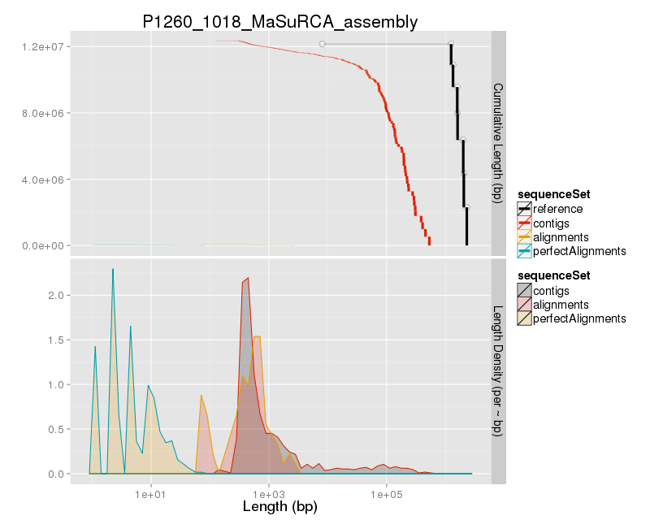

### Assembly Quality Assessment - KAT:

### Assembly Quality Assessment - FRCBAM:

### Assembly Quality Assessment - CEGMA:

CEGMA and BUSCO both attempt to validate the completeness of an assembly by looking at a known gene space, selected to be highly conserved, and present if most, if not all, organisms. CEGMA uses a gene space specifically designed for eukaryotic organisms, while BUSCO can be set for a number of taxonomic groups. Large variation within the completeness between assemblies may indicate that the data was hard to assemble, and thus might run a higher risk of misassembly. BUSCO will also report on duplications of genes, which may indicate chimera in the assembly, and mayneed to be further investigated after annotation.

The CEGMA report of the MaSuRCA assembly shows 98% completeness. The CEGMA completeness scores varied between 90.32% (SOAPdenovo k=61) to 98.39% (Abyss k=79).

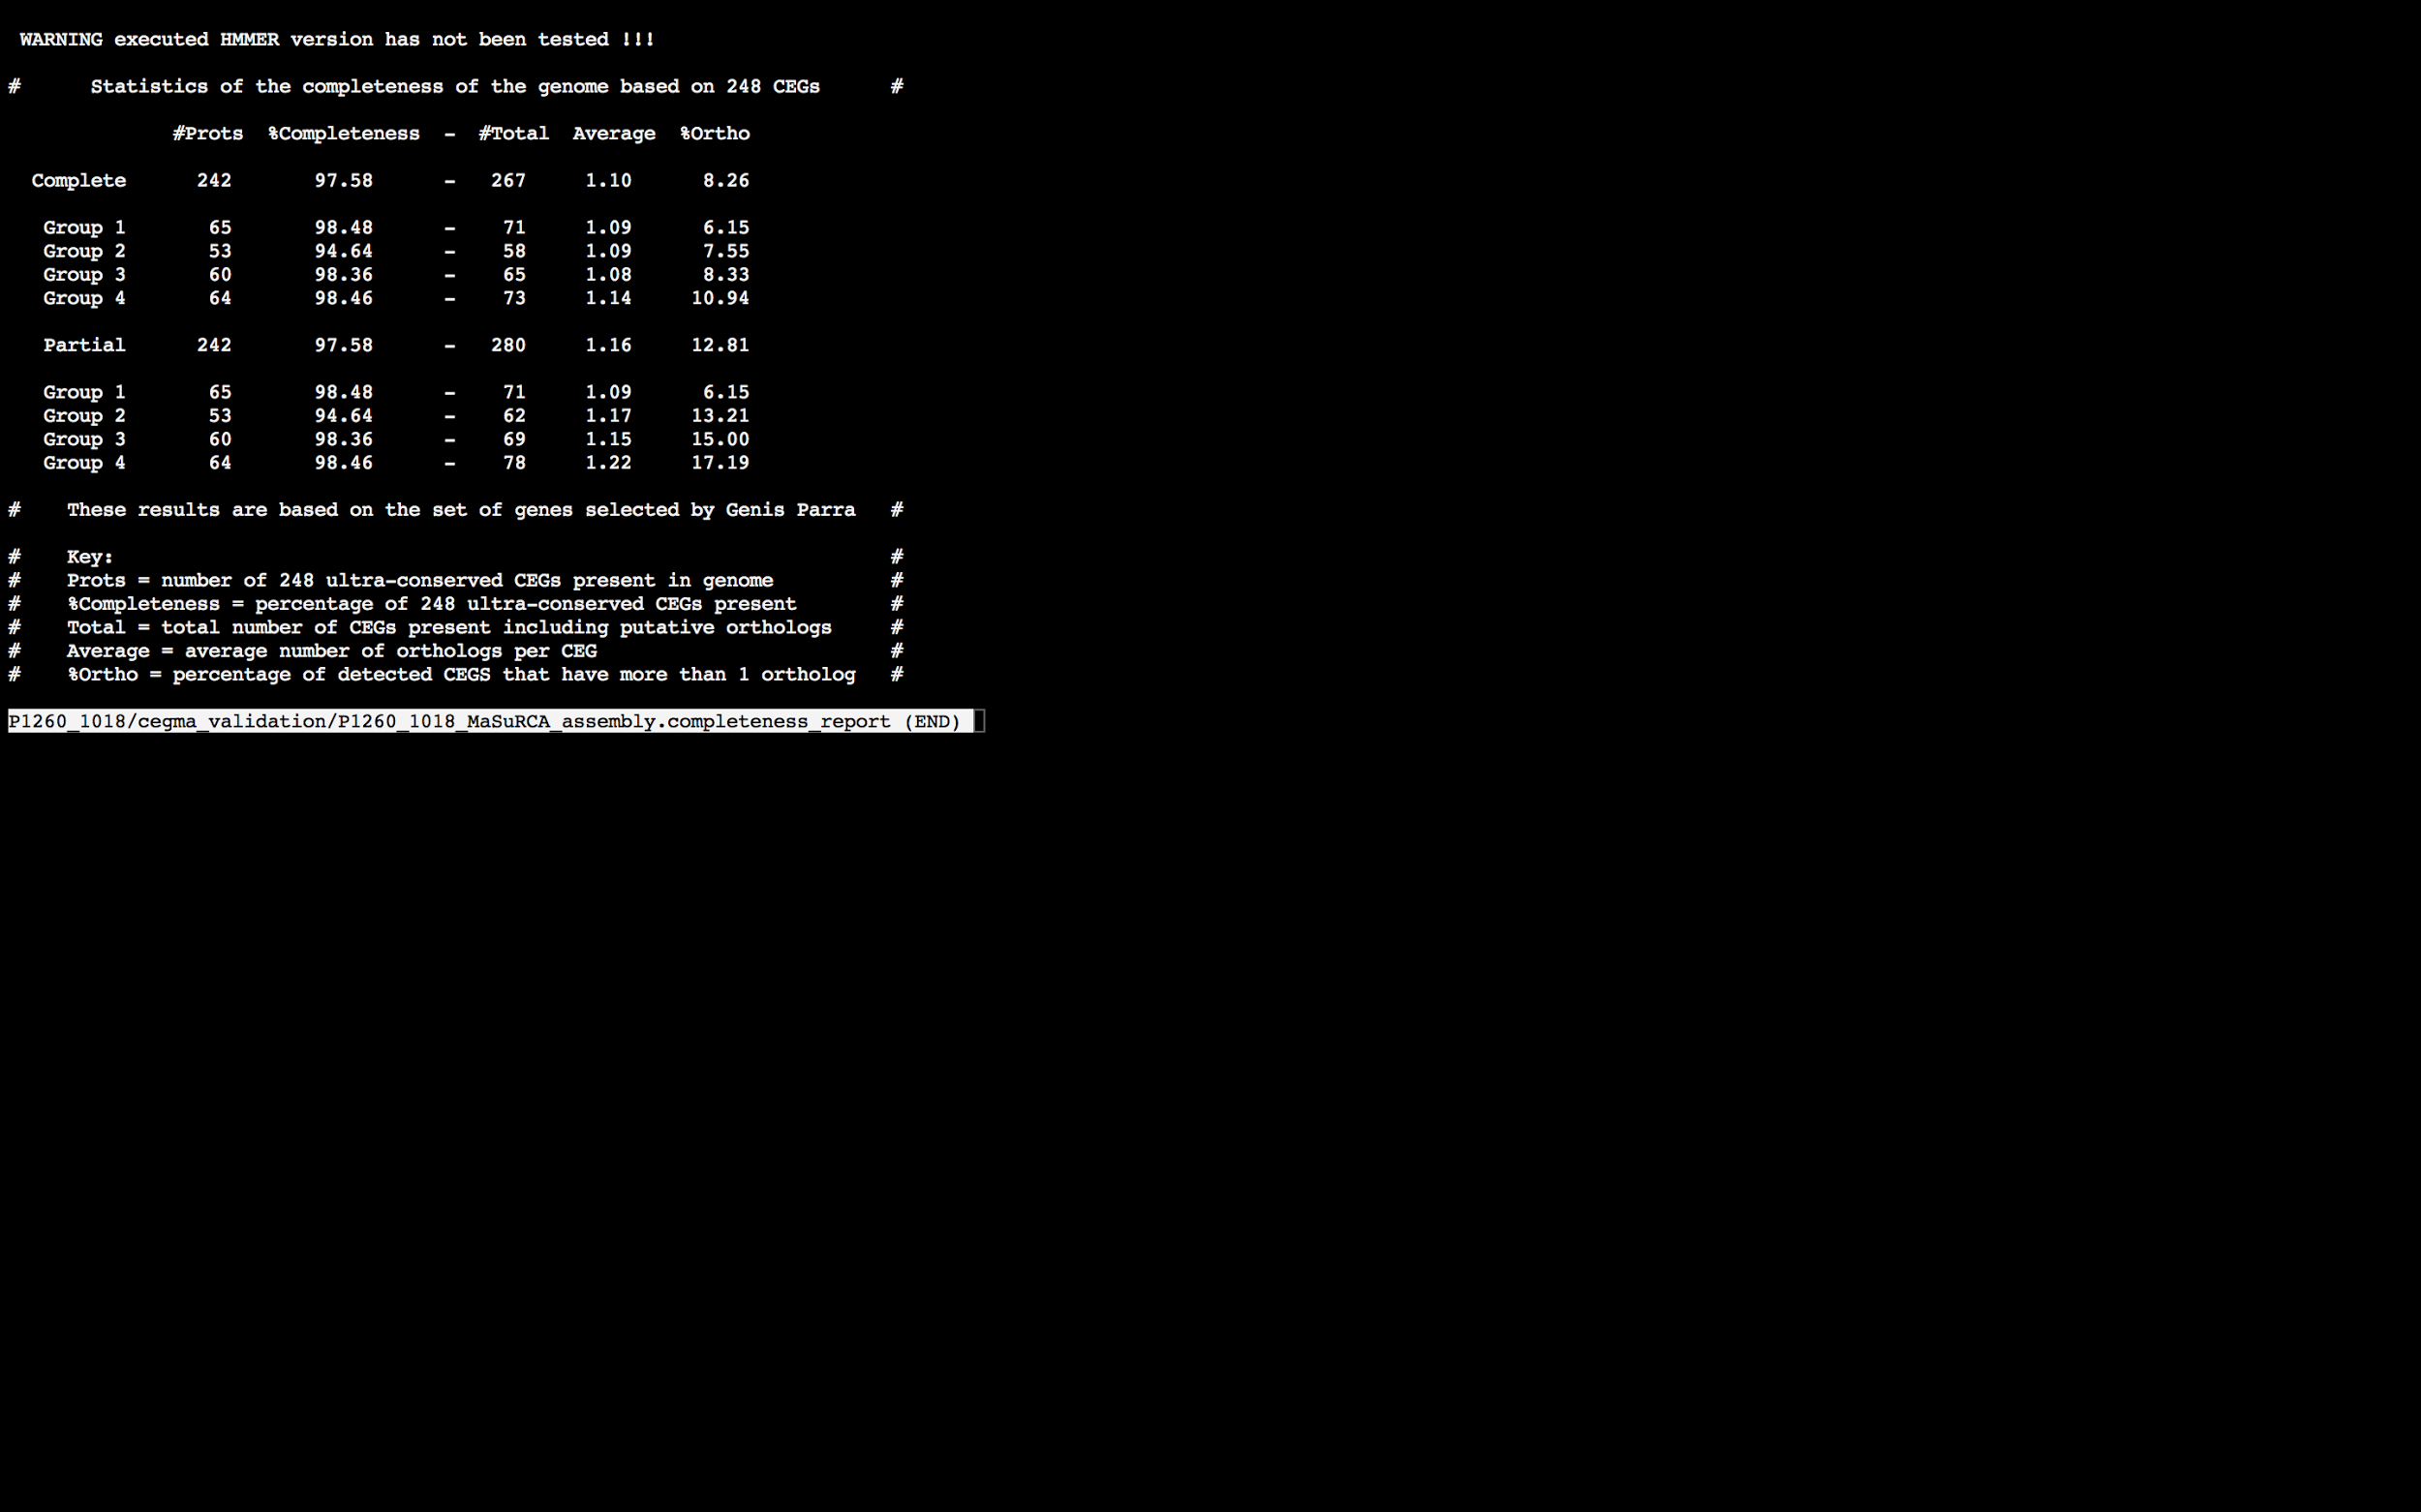

### Assembly Quality Assessment - BUSCO:

The BUSCO report of the MaSuRCA assembly shows 98% completeness and 11% duplication. The scores range from 79% (SOAPdenovo k=67,73,79) to 98% (MaSuRCA, and Spades).

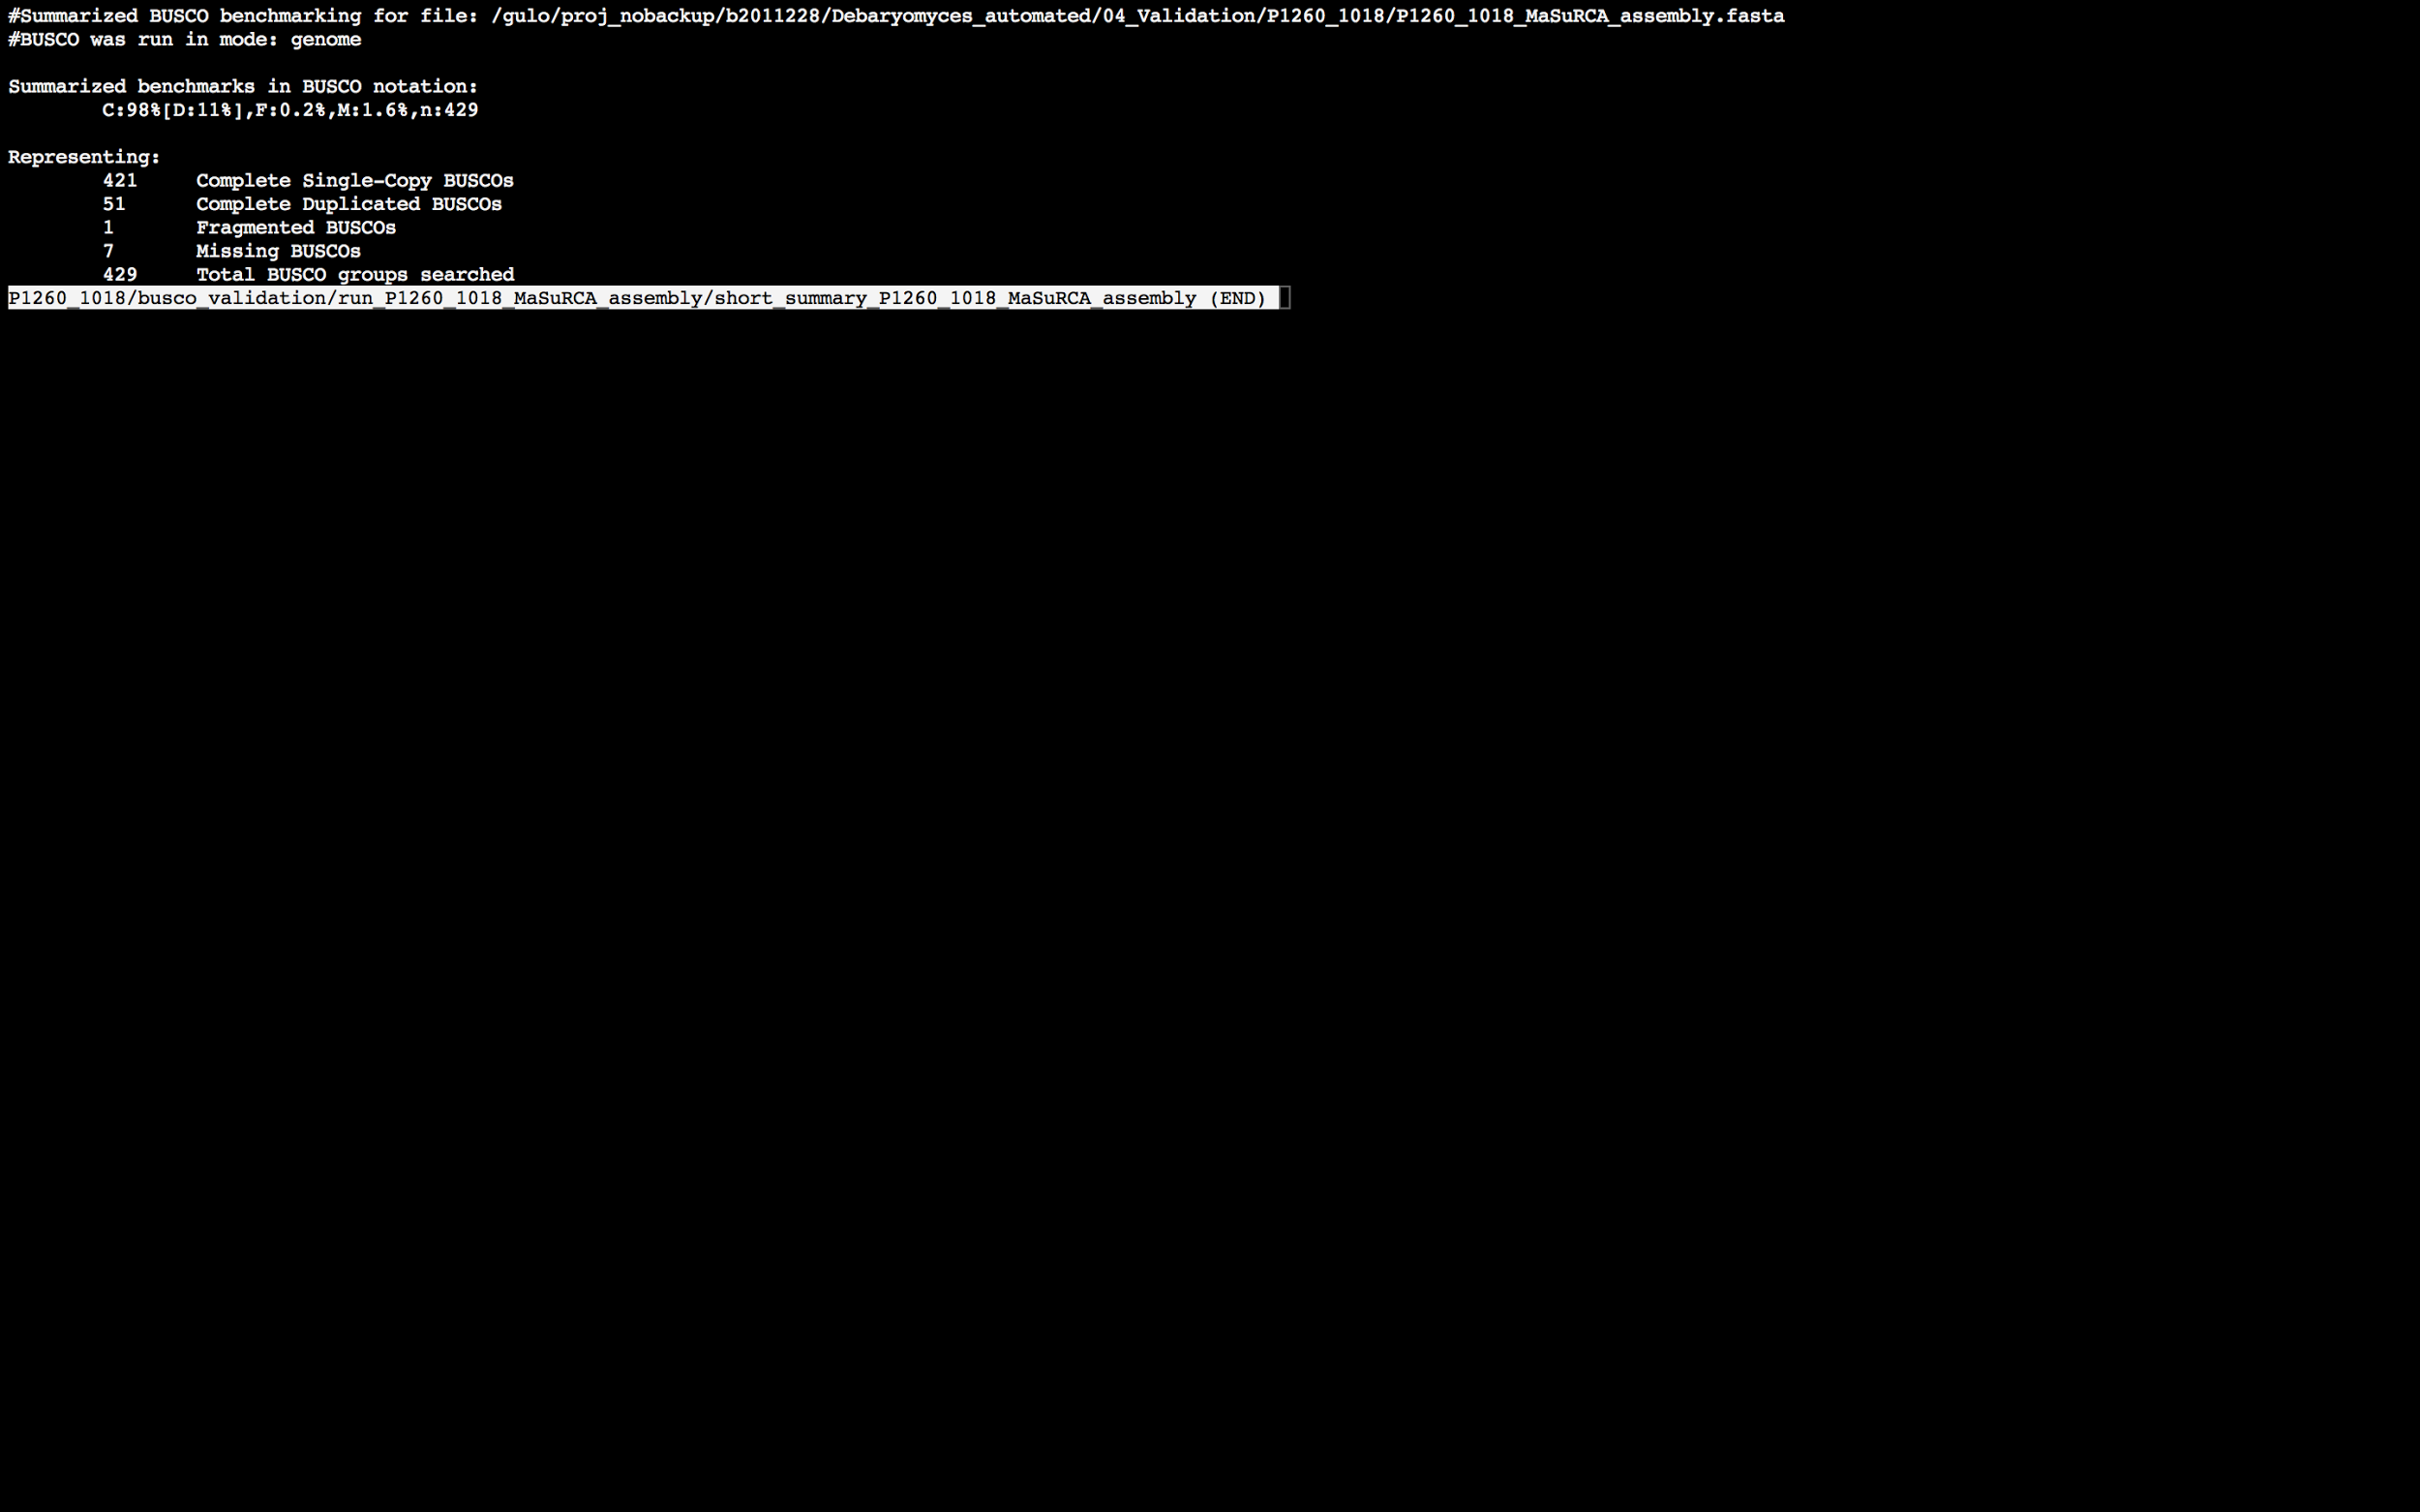

### Assembly Quality Assessment - Blobology:

Blobology indicates that most contigs are likely Saccharomyces cerevisiae. Contamination assessment is a difficult task, and should be interpreted as indicative rather than truth.

|  |  |
| --- | --- |
| # Contigs | Megablast hit |
| 8 | Apteryx australis |
| 2 | Homo sapiens |
| 1 | Saccharomyces bayanus |
| 1132 | Saccharomyces cerevisiae |
| 1 | Saccharomyces cerevisiae/Schizosaccharomyces pombe fusant |

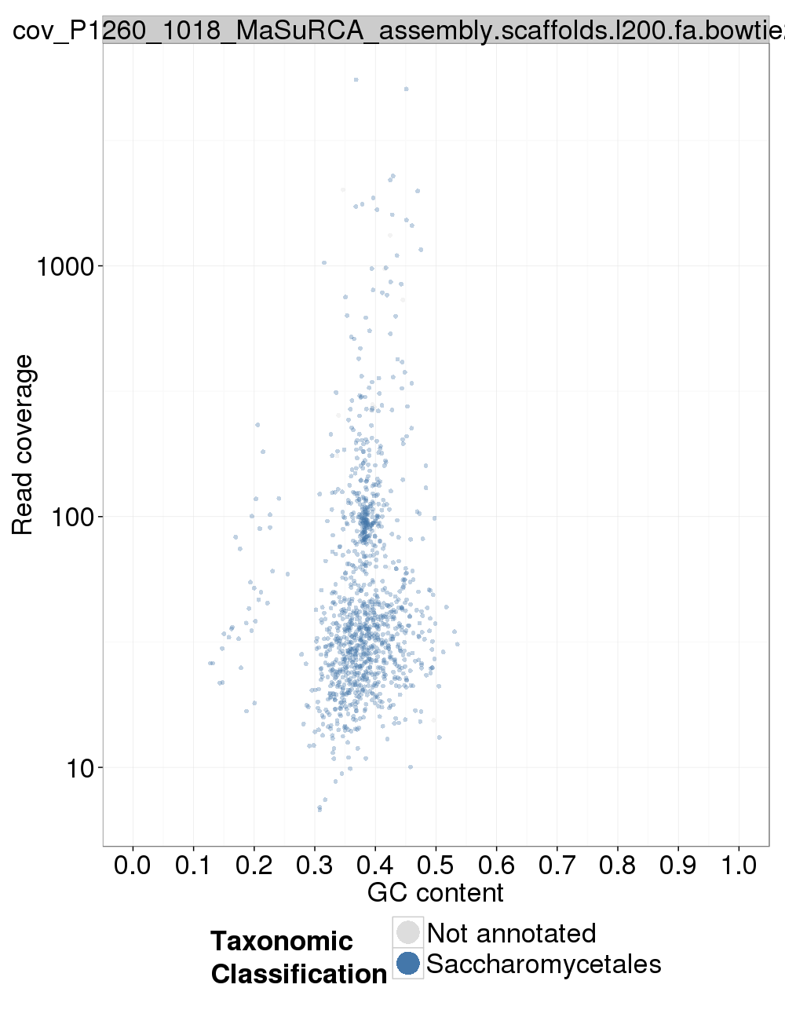

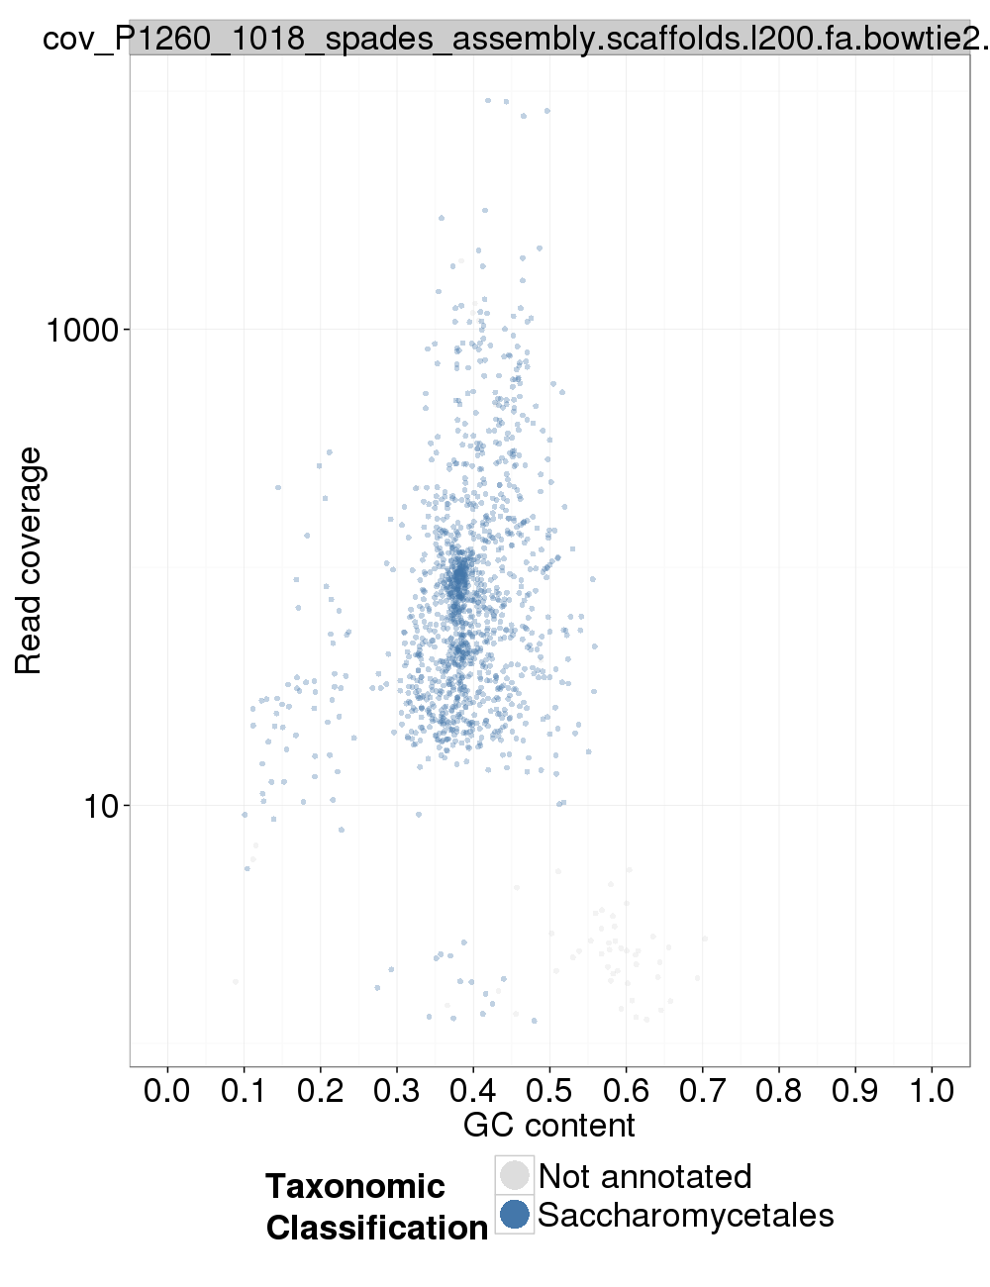

### Assembly Quality Assessment - Kraken:

## Sample P1260_1019:

### Assembly Quality Assessment - Quast:

Spades followed by MaSuRCA gives the best assembly measured by comparing Cumulative length and Nx.

|  |  |
| --- | --- |
| Assembler | **Spades** |
| Number of contigs | 258 |
| Largest contig | 876,801 |
| Total assembly length | 12,191,305 |
| N50 | 390,254 |

Spades produced an assembly length of 12,191,305bp, comprised of 258 contigs with an N50 of 390.254bp.

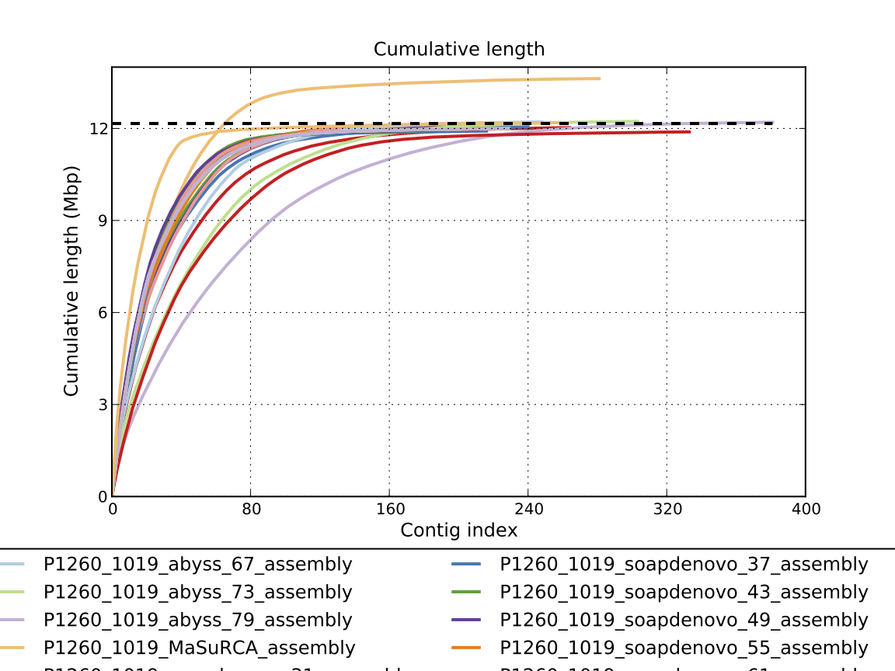

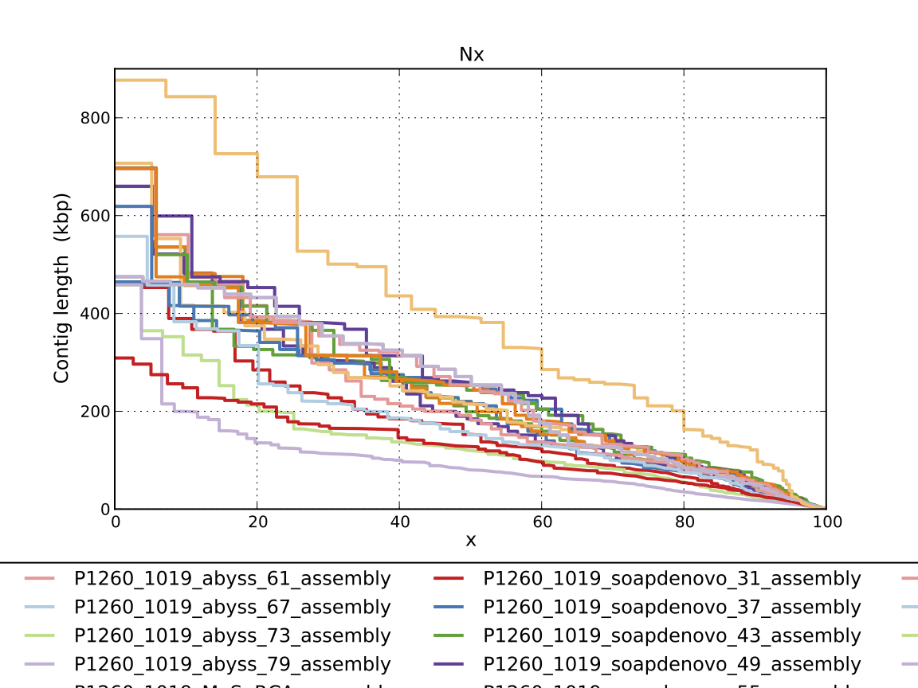

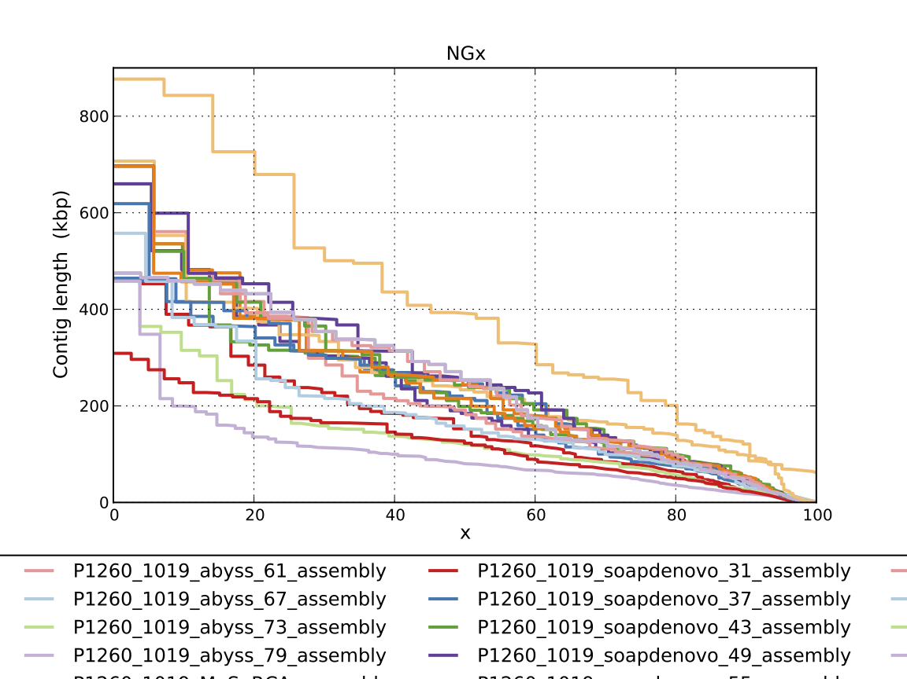

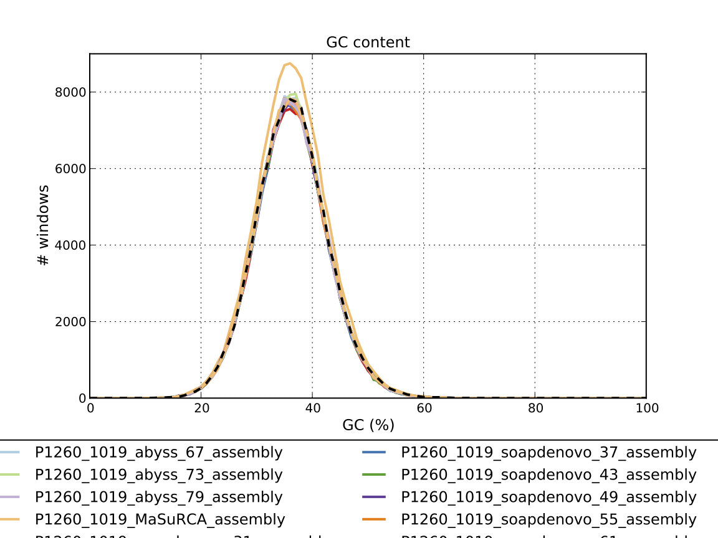

### Assembly Quality Assessment - Compass:

Compass shows that the assembly is similar in size to the reference and aligns well.

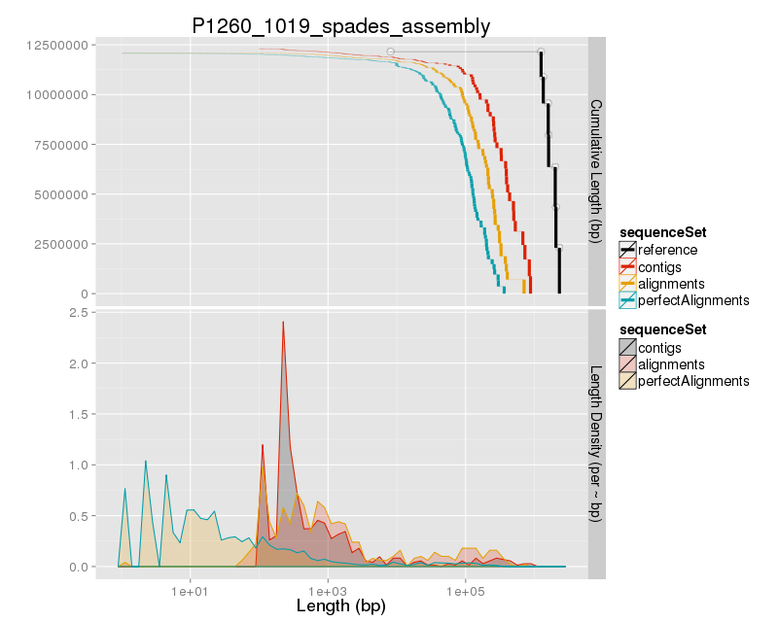

### Assembly Quality Assessment - KAT:

### Assembly Quality Assessment - FRCBAM:

### Assembly Quality Assessment - CEGMA:

CEGMA and BUSCO both attempt to validate the completeness of an assembly by looking at a known gene space, selected to be highly conserved, and present if most, if not all, organisms. CEGMA uses a gene space specifically designed for eukaryotic organisms, while BUSCO can be set for a number of taxonomic groups. Large variation within the completeness between assemblies may indicate that the data was hard to assemble, and thus might run a higher risk of misassembly. BUSCO will also report on duplications of genes, which may indicate chimera in the assembly, and may need to be further investigated after annotation.

The CEGMA report of the Spades assembly shows 94.35% completeness. The CEGMA completeness scores varied between 94.35% (Spades and Abyss k=31) to 95.16% (Abyss k=79).

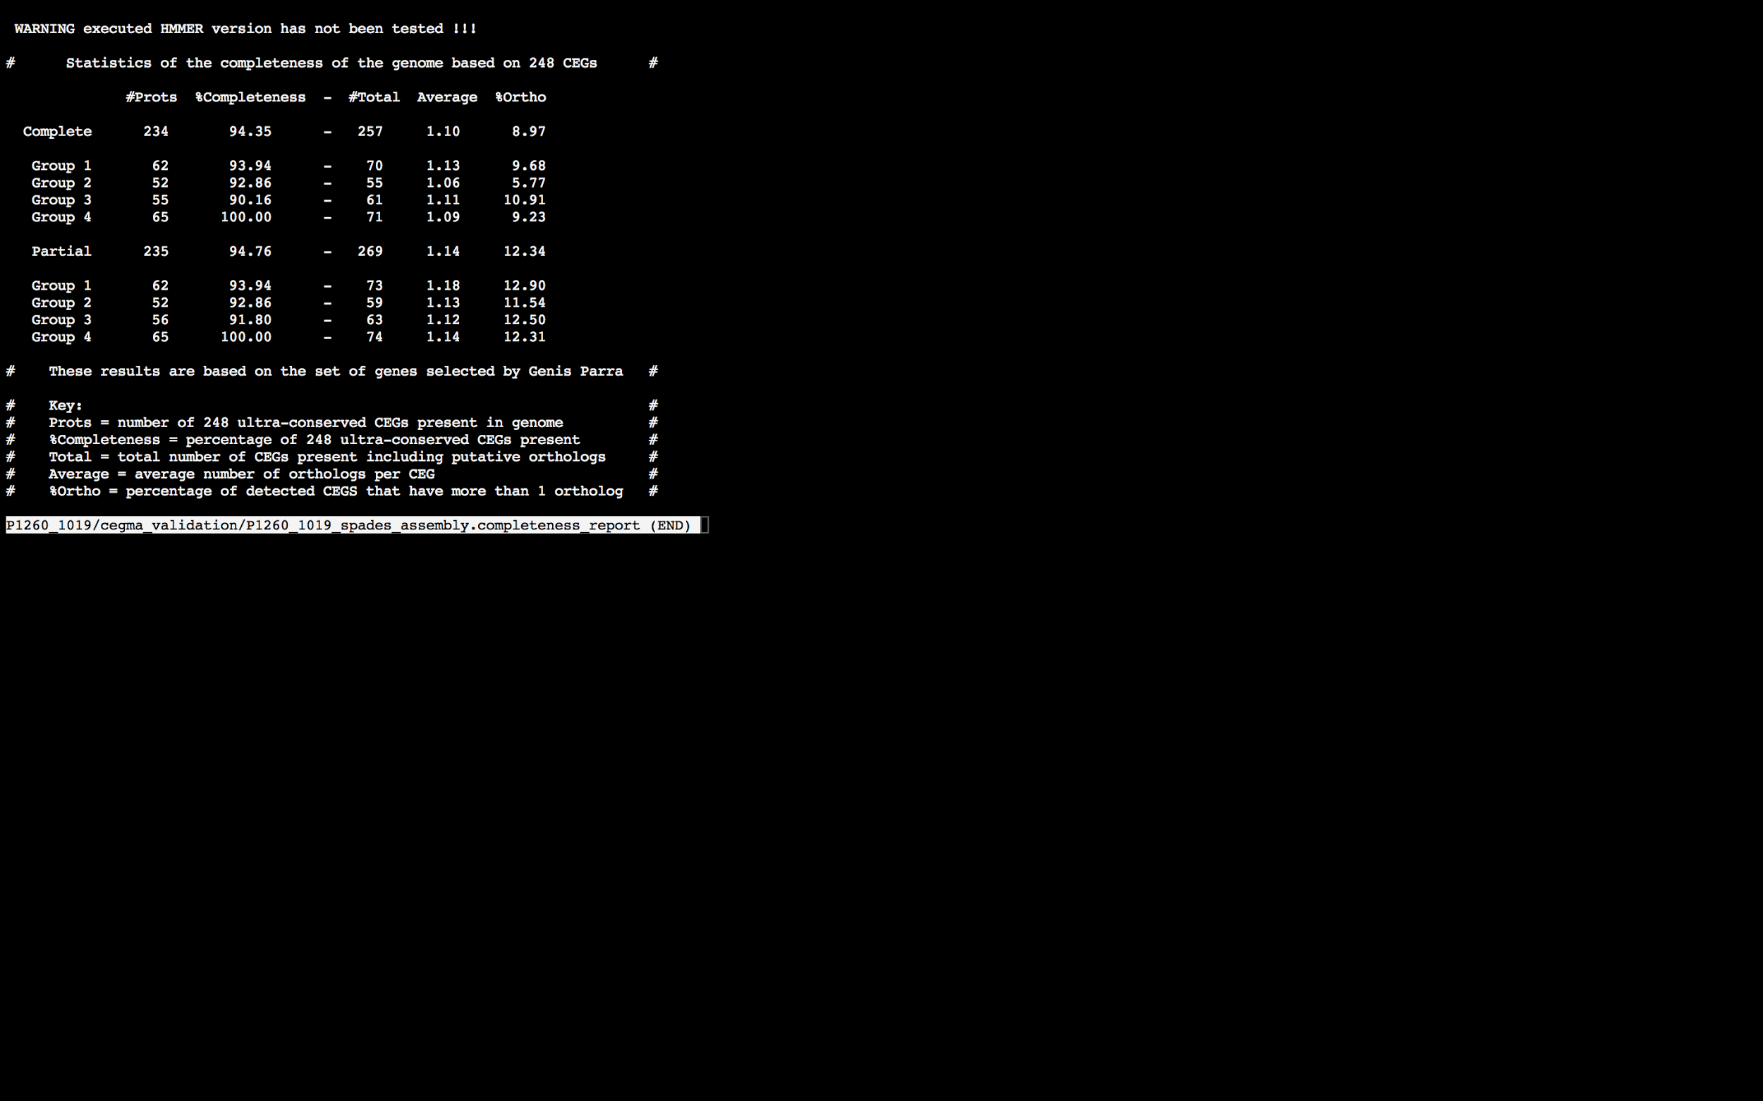

### Assembly Quality Assessment - BUSCO:

The BUSCO report of the Spades assembly shows 97% completeness and 10% duplication. The scores range from 95% (SOAPdenovo k=31) to 97% (MaSuRCA, Abyss k=31,43,49,67,73,79, SOAPdenovo k=37,43, and Spades).

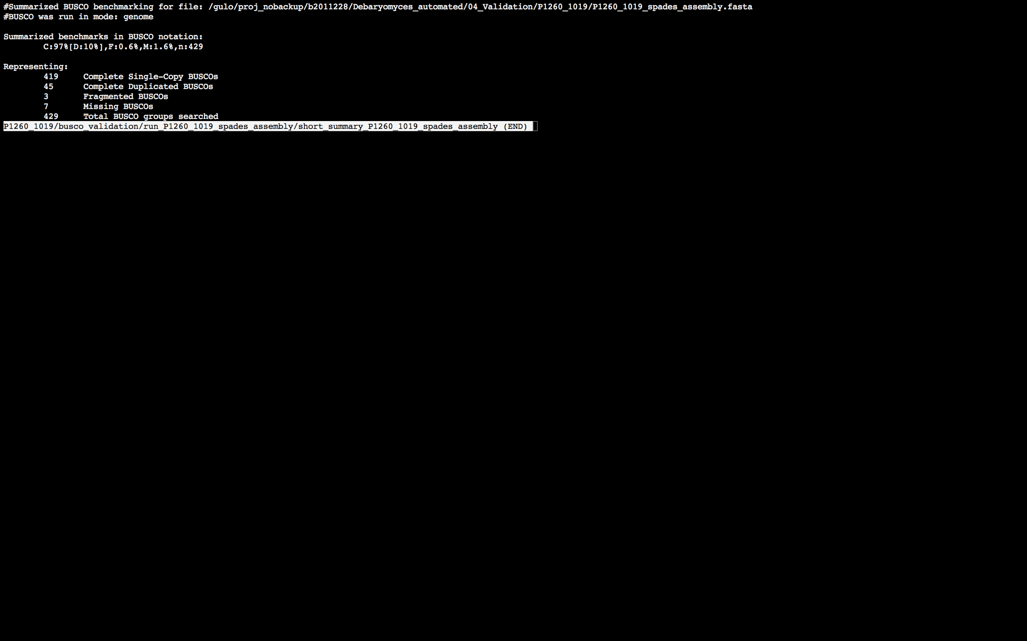

### Assembly Quality Assessment - Blobology:

Blobology indicates that while most contigs are likely Debaryomyces, bacteria may also be present. The blob plot shows a cluster of similar GC content contigs but with lower coverage that potentially indicates contamination. Contamination assessment is a difficult task, and should be interpreted as indicative rather than truth.

|  |  |
| --- | --- |
| # Contigs | Megablast hit |
| 1 | Carnobacterium maltaromaticum |
| 6 | Carnobacterium sp. 17-4 |
| 13 | Carnobacterium sp. WN1359 |
| 1 | Citrobacter freundii |
| 323 | Debaryomyces hansenii |
| 1 | Enterobacter cloacae |
| 1 | Enterobacteriaceae bacterium IG-V01 |
| 1 | Enterococcus faecalis |
| 1 | Enterococcus faecium |
| 1 | Geminocystis sp. NIES-3708 |
| 224 | Not annotated |
| 1 | Paenibacillus borealis |
| 1 | Photorhabdus asymbiotica |
| 1 | Photorhabdus temperata |
| 1 | Proteus mirabilis |
| 1 | Proteus vulgaris |
| 4 | Providencia stuartii |
| 1 | Pseudomonadaceae bacterium E5571 |
| 4 | Pseudomonas phage OBP |
| 2 | Saccharomyces cerevisiae |
| 1 | Scheffersomyces stipitis |
| 1 | Staphylococcus aureus |
| 1 | Streptococcus suis |
| 1 | Tetragenococcus halophilus |
| 4 | uncultured bacterium |
| 1 | uncultured Carnobacterium sp. |
| 1 | Vibrio coralliilyticus |

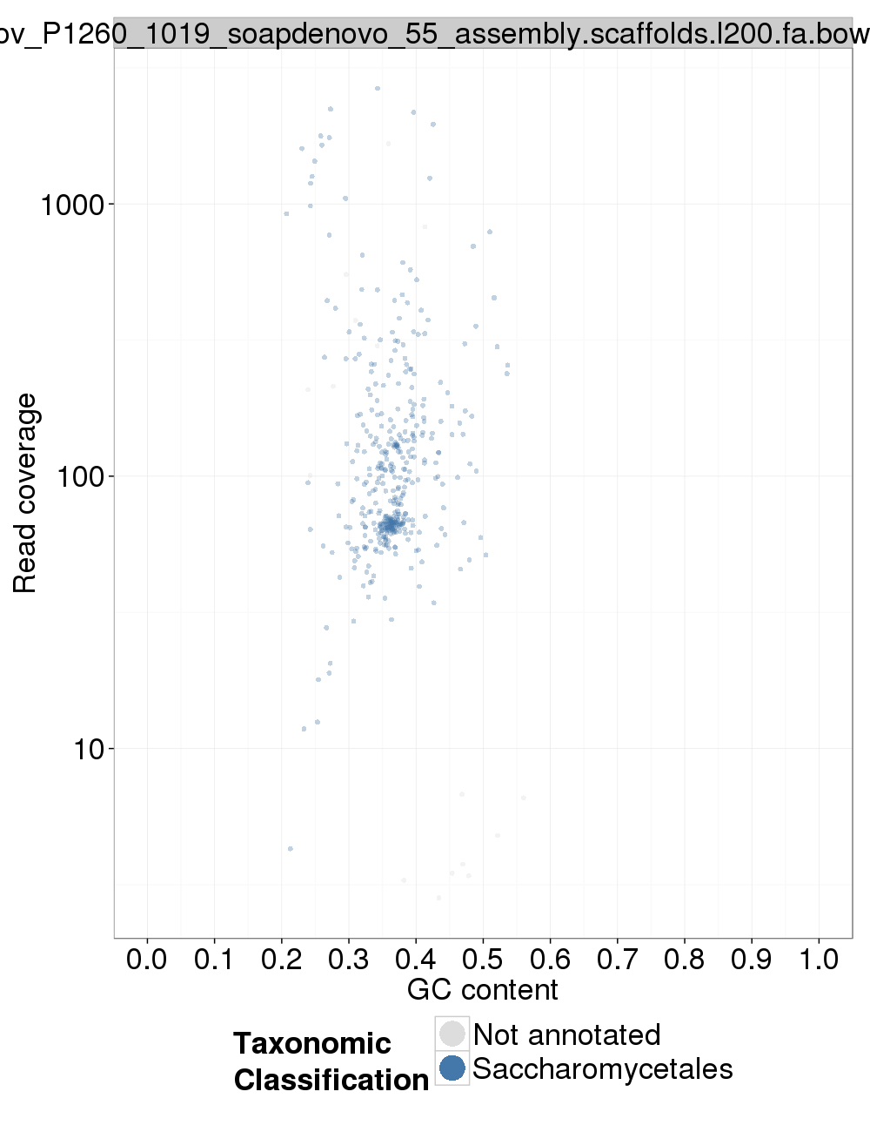

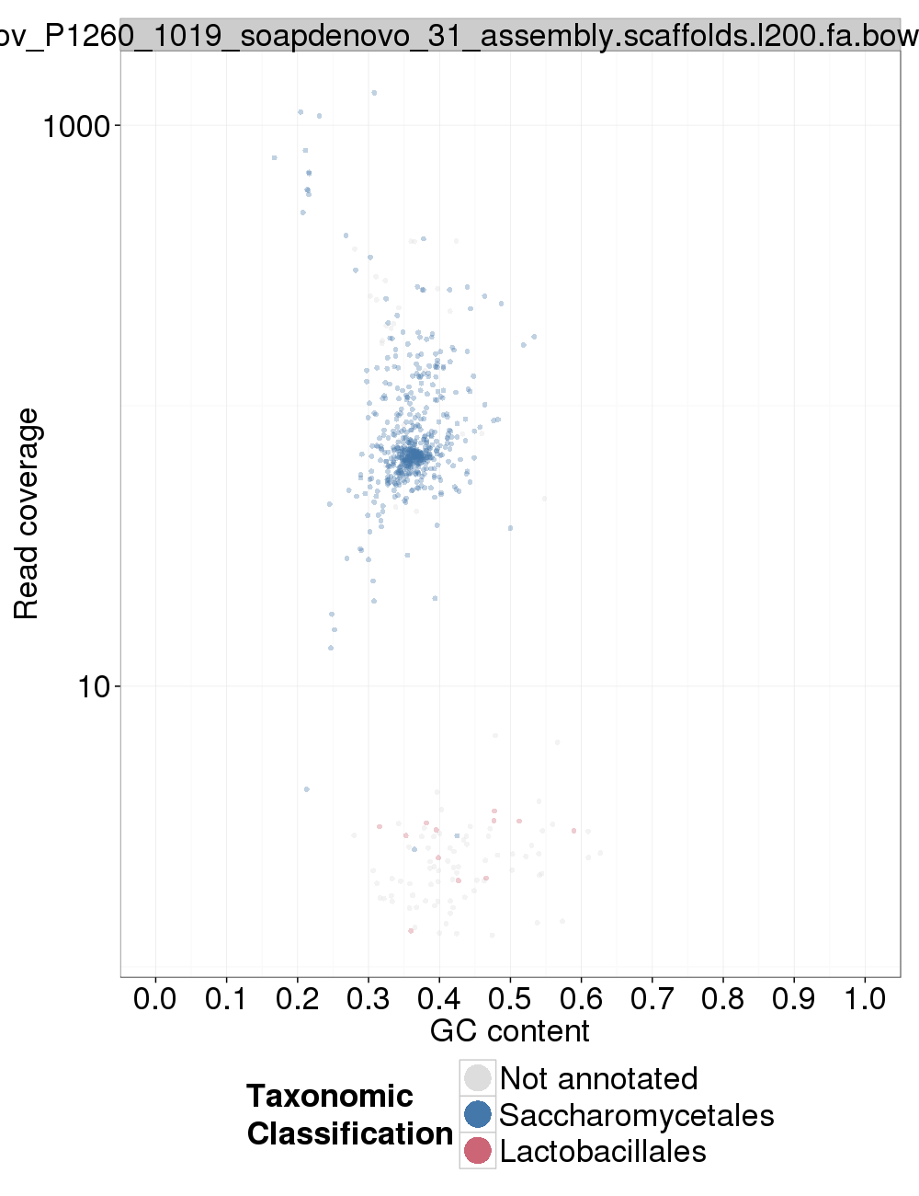

### Assembly Quality Assessment - Kraken:

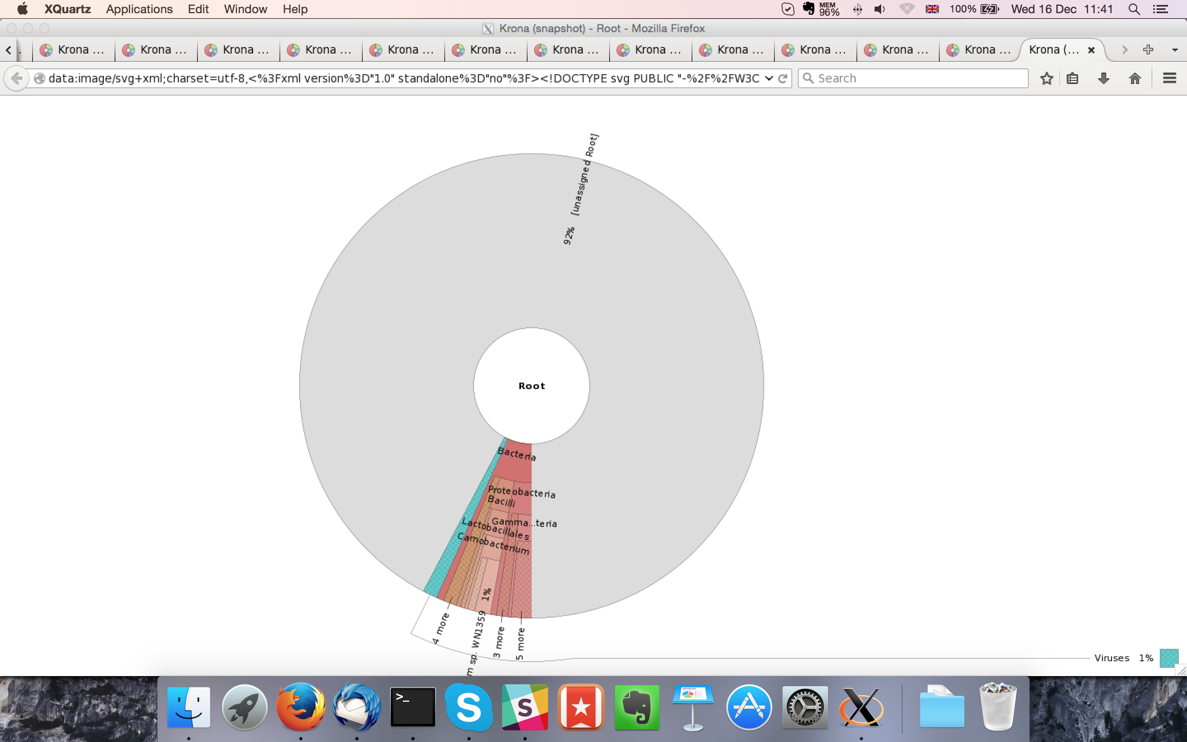

MaSuRCA kraken report below:

